项目课程系列之Atcrowdfunding

尚硅谷JavaEE教研组

版本：V1.0

项目计划(作业)
- zTree
- 许可（权限）树展示
- 许可（权限）模块(增删改)

加载许可(权限)树

1.1 权限树结构
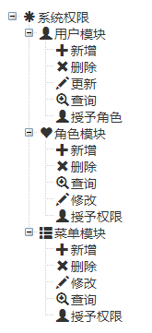

1.2 权限表
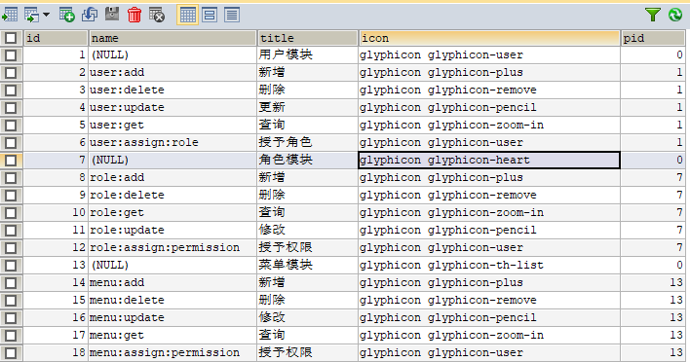
insert into `t_permission` (`id`, `name`, `title`, `icon`, `pid`) values('1',NULL,'用户模块','glyphicon glyphicon-user','0');
insert into `t_permission` (`id`, `name`, `title`, `icon`, `pid`) values('2','user:add','新增','glyphicon glyphicon-plus','1');
insert into `t_permission` (`id`, `name`, `title`, `icon`, `pid`) values('3','user:delete','删除','glyphicon glyphicon-remove','1');
insert into `t_permission` (`id`, `name`, `title`, `icon`, `pid`) values('4','user:update','更新','glyphicon glyphicon-pencil','1');
insert into `t_permission` (`id`, `name`, `title`, `icon`, `pid`) values('5','user:get','查询','glyphicon glyphicon-zoom-in','1');
insert into `t_permission` (`id`, `name`, `title`, `icon`, `pid`) values('6','user:assign:role','授予角色','glyphicon glyphicon-user','1');
insert into `t_permission` (`id`, `name`, `title`, `icon`, `pid`) values('7',NULL,'角色模块','glyphicon glyphicon-heart','0');
insert into `t_permission` (`id`, `name`, `title`, `icon`, `pid`) values('8','role:add','新增','glyphicon glyphicon-plus','7');
insert into `t_permission` (`id`, `name`, `title`, `icon`, `pid`) values('9','role:delete','删除','glyphicon glyphicon-remove','7');
insert into `t_permission` (`id`, `name`, `title`, `icon`, `pid`) values('10','role:get','查询','glyphicon glyphicon-zoom-in','7');
insert into `t_permission` (`id`, `name`, `title`, `icon`, `pid`) values('11','role:update','修改','glyphicon glyphicon-pencil','7');
insert into `t_permission` (`id`, `name`, `title`, `icon`, `pid`) values('12','role:assign:permission','授予权限','glyphicon glyphicon-user','7');
insert into `t_permission` (`id`, `name`, `title`, `icon`, `pid`) values('13',NULL,'菜单模块','glyphicon glyphicon-th-list','0');
insert into `t_permission` (`id`, `name`, `title`, `icon`, `pid`) values('14','menu:add','新增','glyphicon glyphicon-plus','13');
insert into `t_permission` (`id`, `name`, `title`, `icon`, `pid`) values('15','menu:delete','删除','glyphicon glyphicon-remove','13');
insert into `t_permission` (`id`, `name`, `title`, `icon`, `pid`) values('16','menu:update','修改','glyphicon glyphicon-pencil','13');
insert into `t_permission` (`id`, `name`, `title`, `icon`, `pid`) values('17','menu:get','查询','glyphicon glyphicon-zoom-in','13');
insert into `t_permission` (`id`, `name`, `title`, `icon`, `pid`) values('18','menu:assign:permission','授予权限','glyphicon glyphicon-user','13');

1.3 权限查询

1.3.1 控制器
@Controller
@RequestMapping("/permission")
public class PermissionController {

@Autowired
TPermissionService permisionService;

@GetMapping("/index")
public String index() {
return "permission/index";
}

@ResponseBody
@GetMapping("/listAllPermissionTree")
public List<TPermission> getAllPermissions() {
return permisionService.getAllPermissions();
}
}

1.3.2 业务层
/**
* 查询所有系统中的权限标识
* @return
*/
List<TPermission> getAllPermissions();
//查询所有系统中的权限标识
@Override
public List<TPermission> getAllPermissions() {
return permissionMapper.selectByExample(null);
}

1.3.3 postman测试

1.4 显示

1.4.1 页面代码
$(function(){
initTree();
});

function initTree(){
var setting = {
data: {
simpleData: {
enable: true,
pIdKey: "pid"
},
key: {
url: "xUrl",
name:"title"
}
},
view: {
addDiyDom: addDiyDom,
addHoverDom: addHoverDom, //显示按钮
removeHoverDom: removeHoverDom //移除按钮
}
};

//1.加载数据
$.get("${PATH}/permission/listAllPermissionTree",function(data){
data.push({"id":0,"title":"系统权限","icon":"glyphicon glyphicon-asterisk"});
var tree = $.fn.zTree.init($("#treeDemo"), setting, data);
var treeObj = $.fn.zTree.getZTreeObj("treeDemo");
treeObj.expandAll(true);
});
}

function addDiyDom(treeId,treeNode){
//console.log(treeNode);
//$("#"+treeNode.tId+"_ico").removeClass().addClass(treeNode.icon);
$("#"+treeNode.tId+"_ico").removeClass();
$("#"+treeNode.tId+"_span").before('<span class="'+treeNode.icon+'"></span>');
}

function addHoverDom(treeId,treeNode){
var aObj = $("#" + treeNode.tId + "_a");
aObj.attr("href", "javascript:;");
if (treeNode.editNameFlag || $("#btnGroup"+treeNode.tId).length>0) return;
var s = '<span id="btnGroup'+treeNode.tId+'">';
if ( treeNode.level == 0 ) {
s += '<a class="btn btn-info dropdown-toggle btn-xs" style="margin-left:10px;padding-top:0px;" href="#" onclick="addBtn('+treeNode.id+')" >&nbsp;&nbsp;<i class="fa fa-fw fa-plus rbg "></i></a>';
} else if ( treeNode.level == 1 ) {
s += '<a class="btn btn-info dropdown-toggle btn-xs" style="margin-left:10px;padding-top:0px;" href="#" onclick="updateBtn('+treeNode.id+')" title="修改权限信息">&nbsp;&nbsp;<i class="fa fa-fw fa-edit rbg "></i></a>';
if (treeNode.children.length == 0) {
s += '<a class="btn btn-info dropdown-toggle btn-xs" style="margin-left:10px;padding-top:0px;" href="#" onclick="deleteBtn('+treeNode.id+')" >&nbsp;&nbsp;<i class="fa fa-fw fa-times rbg "></i></a>';
}
s += '<a class="btn btn-info dropdown-toggle btn-xs" style="margin-left:10px;padding-top:0px;" href="#" onclick="addBtn('+treeNode.id+')" >&nbsp;&nbsp;<i class="fa fa-fw fa-plus rbg "></i></a>';
} else if ( treeNode.level == 2 ) {
s += '<a class="btn btn-info dropdown-toggle btn-xs" style="margin-left:10px;padding-top:0px;" href="#" onclick="updateBtn('+treeNode.id+')" title="修改权限信息">&nbsp;&nbsp;<i class="fa fa-fw fa-edit rbg "></i></a>';
s += '<a class="btn btn-info dropdown-toggle btn-xs" style="margin-left:10px;padding-top:0px;" href="#" onclick="deleteBtn('+treeNode.id+')" >&nbsp;&nbsp;<i class="fa fa-fw fa-times rbg "></i></a>';
}

s += '</span>';
aObj.after(s);
}

function removeHoverDom(treeId,treeNode){
$("#btnGroup"+treeNode.tId).remove();
}

许可树增删改（作业）

2.1 后台代码
@ResponseBody
@PostMapping("/add")
public String addPermission(TPermission permission){
permisionService.savePermission(permission);
return "ok";
}

@ResponseBody
@DeleteMapping("/delete")
public String deletePermission(Integer id){
permisionService.deletePermission(id);
return "ok";
}

@ResponseBody
@PostMapping("/edit")
public String editPermission(TPermission permission){
permisionService.editPermission(permission);
return "ok";
}

@ResponseBody
@GetMapping("/get")
public TPermission getPermission(Integer id){
return permisionService.getPermissionById(id);
}

2.2 页面代码
function addBtn(id){
$("#addFormPid").val(id);
$("#AddModal").modal({show:true,backdrop:'static',keyboard:false})
}

function savePermission(){
var pid = $("#addFormPid").val();
var name = $("#addFormName").val();
var icon = $("#addFormIcon").val();
var title = $("#addFormTitle").val();
$.post("${PATH}/permission/add",{pid:pid,name:name,icon:icon,title:title},function(result){
if(result=="ok"){
$("#AddModal").modal("hide");
initTree();
}
});
$("#addPermissionForm")[0].reset();
}

function updateBtn(id){
$.get("${PATH}/permission/get",{id:id},function(result){
$("#UpdateModal input[name='id']").val(result.id);
$("#UpdateModal input[name='name']").val(result.name);
$("#UpdateModal input[name='icon']").val(result.icon);
$("#UpdateModal input[name='title']").val(result.title);
$("#UpdateModal").modal({show:true,backdrop:'static',keyboard:false})
});
}

function deleteBtn(id){
layer.confirm("确定要删除这个许可吗?",{btn:["确定","取消"]},function(index){
$.post("${PATH}/permission/delete",{id:id,_method:"delete"},function(result){
if(result=="ok"){
initTree();
}
});
layer.close(index);
},function(index){
layer.close(index);
});
}

function updatePermission(){
var id = $("#UpdateModal input[name='id']").val();
var name = $("#UpdateModal input[name='name']").val();
var icon = $("#UpdateModal input[name='icon']").val();
var title = $("#UpdateModal input[name='title']").val();
$.post("${PATH}/permission/edit",{id:id,name:name,icon:icon,title:title},function(result){
if(result=="ok"){
$("#UpdateModal").modal("hide");
initTree();
}
});
}

