Sep 15

Discussion:

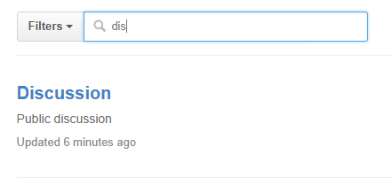

Class notes:

diron on computer = Git repo (teacking a remote repo on GitHub) = RStudio Project

Qn:

1. Unable to push
2. Cannot get data:
   1. ## get the Gapminder data
   2. gDat <- read.delim("gapminderDataFiveYear.txt")
3. If I do not submit by creating the new issue, will others see my work? (just push to GitHub)