Proposal

**Idea and Overview**

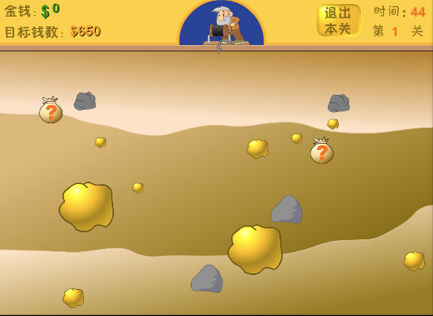For our final project, we are going to represent the classic game ‘gold miner’ which might be the childhood memory for a lot of people.

For this game we plan to have two kinds of playing method, one as cooperating mining by at most two player as what the original game does, the other is about competition which we will attach as extra so we do not represent to much here. First for scene, we plan two start backgrounds, game backing and shop background, all of them will be display using fix function as well as all our components like miner, hook, golden and so on. For game initialization, we plan to write c code to randomly generalize mineral resources based on the target score, then our component generalization modules just like isball.sv in lab 8 together with color mapper will decide the component’s appearance, moving and disappearance. Then, keep and change the score is also very important, so we are going to have a sore keeper module to keep, increase or decrease score. Also, a timer is needed to count down. Both score keeper and timer will be achieved taking the idea of front file.sv on blackboard. Then, a sound will be achieved by audio driver. Besides, we will use keyboard as our basic communicate device and if time is not limited, we would like to achieve mouse as well.

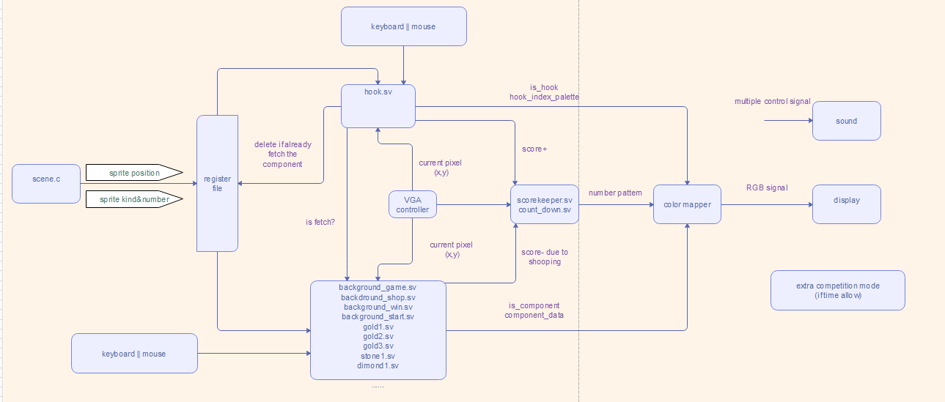**Block Diagram**

**List of Features**

Basic：

1. generate the locations of mines and [game](javascript:;) [props](javascript:;) in random
2. every level has 50s for players to reach the “target score”, a clock will appear on the top right [corner](javascript:;) of the screen
3. score keeper on the [top](javascript:;) [left](javascript:;) [corner](javascript:;) of the screen
4. infinite game levels.
5. shopping center appear when players Go through current level.
6. corresponding sounds will arise with players’ operation.

Additional features:

1, using mouse to purchase in the shopping center and control player2. Keyboard will still used to control player1.

2, add another mode. Competition mode. In this mode, player2 will act as a [rat](javascript:;) that can cut down the rope so that player1 can not get score.

**Expected Difficulty**

we expect to get 9~10 points.

Reason:

1, We have infinite levels! Every level is generated in random(of course, higher level will have less big golds and diamonds)

2, We have font drawing! We always keep the score unless players want to restart.

3, Multiplayer in game! We support two players play together, they can choose to cooperate or compete.

4, External hardware! We may use mouse so that player can purchase the [game](javascript:;) [props](javascript:;) by just clicking the mouse!

5, Sophisticated graphics drawing!

1,Our hook will move along a circle. So, that rotation matrix will be used

2,Our rope is shown using vector calculation instead of the static picture stored in memory.

3, need to use lots of knowledge from linear algebra to decide when golds need to move, which direction golds need to move to.

6, Addition of sound! corresponding sounds will arise with players’ operation.

**Proposed Timeline**

Project Week 1: 11/30

1,Only the Proposal!

#### Project Week 2: 12/7

#### 1, pictures can store in on chip memory

#### 2, implement hook.sv (hook can move along a circle)

#### 3, rough structure of fix function(we can display some scene)

#### Project Week 3: 12/14

#### 1, player can “fetch” the gold by using hook.

#### 2, try to start write secne.c to generate random scene.

#### 3, can save the data of "the count down time value"

#### Project Week 4: 12/21

#### 1, add different kind of golds, game props to enrich the game.

#### 2, player now can buy props from the shop

#### Project Week 5: 12/28

#### 1, mouse!

#### 2,additional competition mode.