**[Yichuan0712/MyTarget2 (github.com)](https://github.com/Yichuan0712/MyTarget2)**

**这个链接是我已经修改好的, 当您遇到问题时可以参考这个**

**在config.yaml**

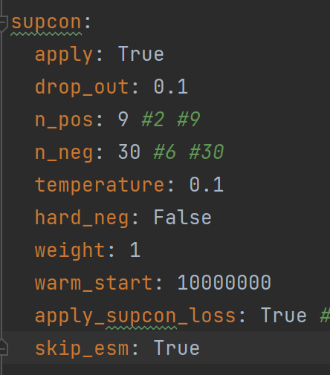

**在supcon里面增加一个skip_esm, 设置为true, 这个用来跳过esm2 infer, 可以像clean一样直接用保存好的embedding来训练contrastive learning的部分**

**接下来实现一下这个skip功能,**

**首先, 把5283_esm2_t33_650M_UR50D.pt这个文件放到项目里, 直接跟其他代码放在同一个目录下就行**

**之后, 在model.py, 找到class Encoder的__init__()**

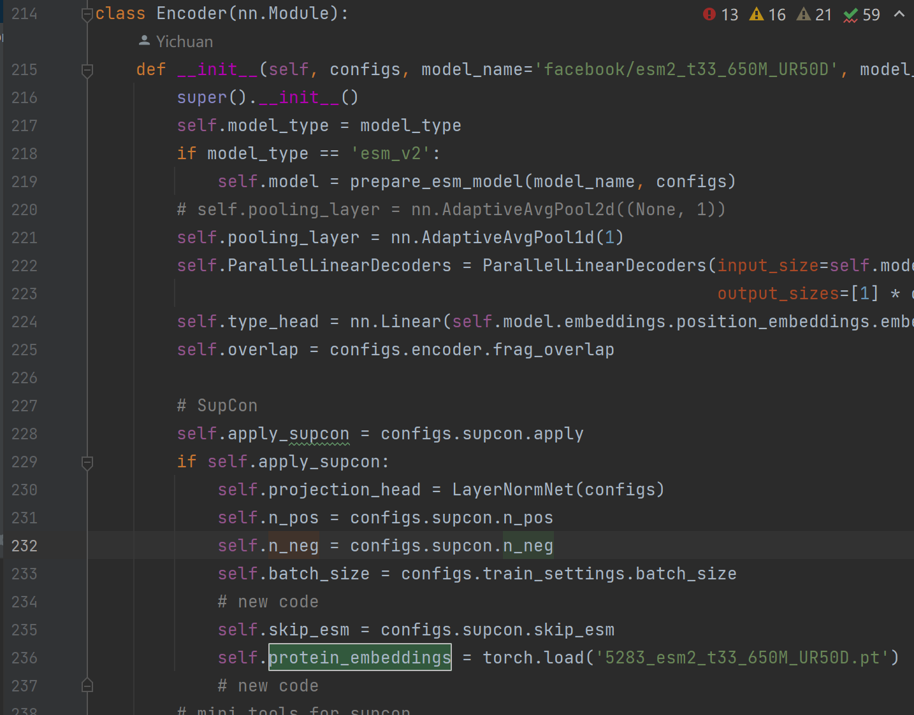

**找到if self.apply_supcon: (在大约229行左右)**

**在这个if条件的最末尾添加以下两行代码 (上图的行235和236已经添加)**

**self.skip_esm = configs.supcon.skip_esm**

**self.protein_embeddings = torch.load('5283_esm2_t33_650M_UR50D.pt')**

**接下来找到class Encoder的forward()**

**在大约294行的位置, 有四行代码, 如下**

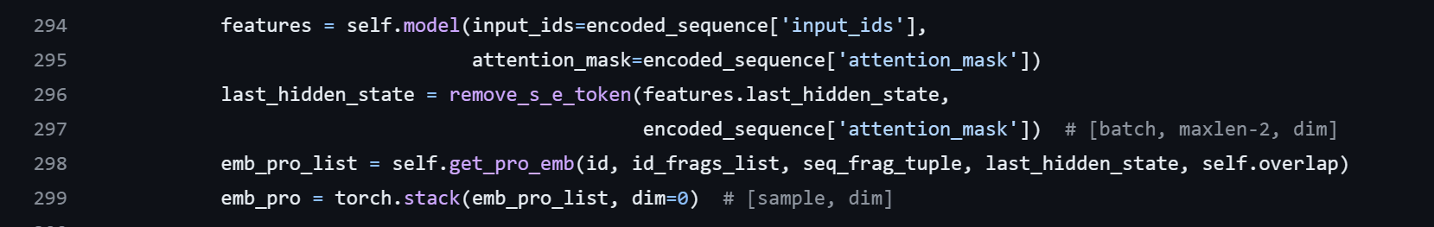

**把上面这段代码删掉, 换成下面的代码**

**if self.skip_esm:**

**emb_pro_list = []**

**for i in id:**

**emb_pro_list.append(self.protein_embeddings[i])**

**emb_pro = torch.stack(emb_pro_list, dim=0)**

**else:**

**features = self.model(input_ids=encoded_sequence['input_ids'],**

**attention_mask=encoded_sequence['attention_mask'])**

**last_hidden_state = remove_s_e_token(features.last_hidden_state,**

**encoded_sequence['attention_mask']) # [batch, maxlen-2, dim]**

**""""add something here? the 1+n_pos+n_neg"""**

**emb_pro_list = self.get_pro_emb(id, id_frags_list, seq_frag_tuple, last_hidden_state, self.overlap)**

**emb_pro = torch.stack(emb_pro_list, dim=0) # [sample, dim]**

**这样就增加了一个if self.skip_esm条件, 当条件满足时, 直接从.pt文件获取esm2 infer的embedding, 否则就执行老版本的代码**

**接下来到train.py, 在84行左右, 有一个if条件**

**if (configs.supcon.apply and not warm_starting and pos_neg is not None) or \**

**(configs.supcon.apply and warm_starting):**

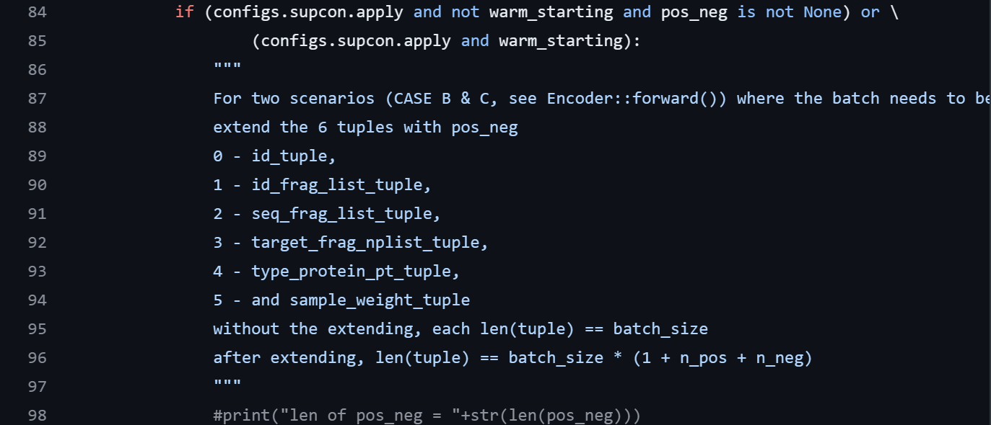

**把这个if 条件里的内容全部删除, 替换为以下代码**

**"""**

**For two scenarios (CASE B & C, see Encoder::forward()) where the batch needs to be extended,**

**extend the 6 tuples with pos_neg**

**0 - id_tuple,**

**1 - id_frag_list_tuple,**

**2 - seq_frag_list_tuple,**

**3 - target_frag_nplist_tuple,**

**4 - type_protein_pt_tuple,**

**5 - and sample_weight_tuple**

**without the extending, each len(tuple) == batch_size**

**after extending, len(tuple) == batch_size * (1 + n_pos + n_neg)**

**"""**

**flag_batch_extension = True**

**for one_in_a_batch in range(b_size):**

**# pos_neg[one_in_a_batch][0]**

**for one_of_pos in range(configs.supcon.n_pos):**

**# pos_neg[one_in_a_batch][0][one_of_pos]**

**id_tuple += (pos_neg[one_in_a_batch][0][one_of_pos][0],)**

**id_frag_list_tuple += (pos_neg[one_in_a_batch][0][one_of_pos][1],)**

**seq_frag_list_tuple += (pos_neg[one_in_a_batch][0][one_of_pos][2],)**

**target_frag_nplist_tuple += (pos_neg[one_in_a_batch][0][one_of_pos][3],)**

**type_protein_pt_tuple += (pos_neg[one_in_a_batch][0][one_of_pos][4],)**

**sample_weight_tuple += (pos_neg[one_in_a_batch][0][one_of_pos][5],)**

**for one_in_a_batch in range(b_size):**

**# pos_neg[one_in_a_batch][1]**

**for one_of_neg in range(configs.supcon.n_neg):**

**# pos_neg[one_in_a_batch][1][one_of_neg]**

**id_tuple += (pos_neg[one_in_a_batch][1][one_of_neg][0],)**

**id_frag_list_tuple += (pos_neg[one_in_a_batch][1][one_of_neg][1],)**

**seq_frag_list_tuple += (pos_neg[one_in_a_batch][1][one_of_neg][2],)**

**target_frag_nplist_tuple += (pos_neg[one_in_a_batch][1][one_of_neg][3],)**

**type_protein_pt_tuple += (pos_neg[one_in_a_batch][1][one_of_neg][4],)**

**sample_weight_tuple += (pos_neg[one_in_a_batch][1][one_of_neg][5],)**

**type_protein_pt_tuple_temp = [torch.from_numpy(x) if isinstance(x, np.ndarray) else x for x in type_protein_pt_tuple]**

**type_protein_pt_tuple = type_protein_pt_tuple_temp**

**上面的代码处理了旧代码在进行维度转换时的错误**

**完成上面的修改后, 还需要修改class Encoder, 请回到model.py**

**首先在class Encoder中增加下面这个类方法, 这个类方法用于进一步处理数据, 转换为(batch_size, 1+n_pos+n_neg, len_of_embedding)的格式**

**def reorganize_emb_pro(self, emb_pro):**

**n_batch = int(emb_pro.shape[0] / (1 + self.n_pos + self.n_neg))**

**bch_anchors, bch_positives, bch_negatives = torch.split(emb_pro,**

**[n_batch, n_batch * self.n_pos, n_batch * self.n_neg],**

**dim=0)**

**emb_pro_ = []**

**for i in range(n_batch):**

**anchor = bch_anchors[i].unsqueeze(0)**

**positive = bch_positives[(i * self.n_pos):(i * self.n_pos + self.n_pos)]**

**negative = bch_negatives[(i * self.n_neg):(i * self.n_neg + self.n_neg)]**

**triple = torch.cat((anchor, positive, negative), dim=0)**

**emb_pro_.append(triple)**

**emb_pro_ = torch.stack(emb_pro_, dim=0)**

**return emb_pro_**

**之后, 找到Encoder的forward()方法**

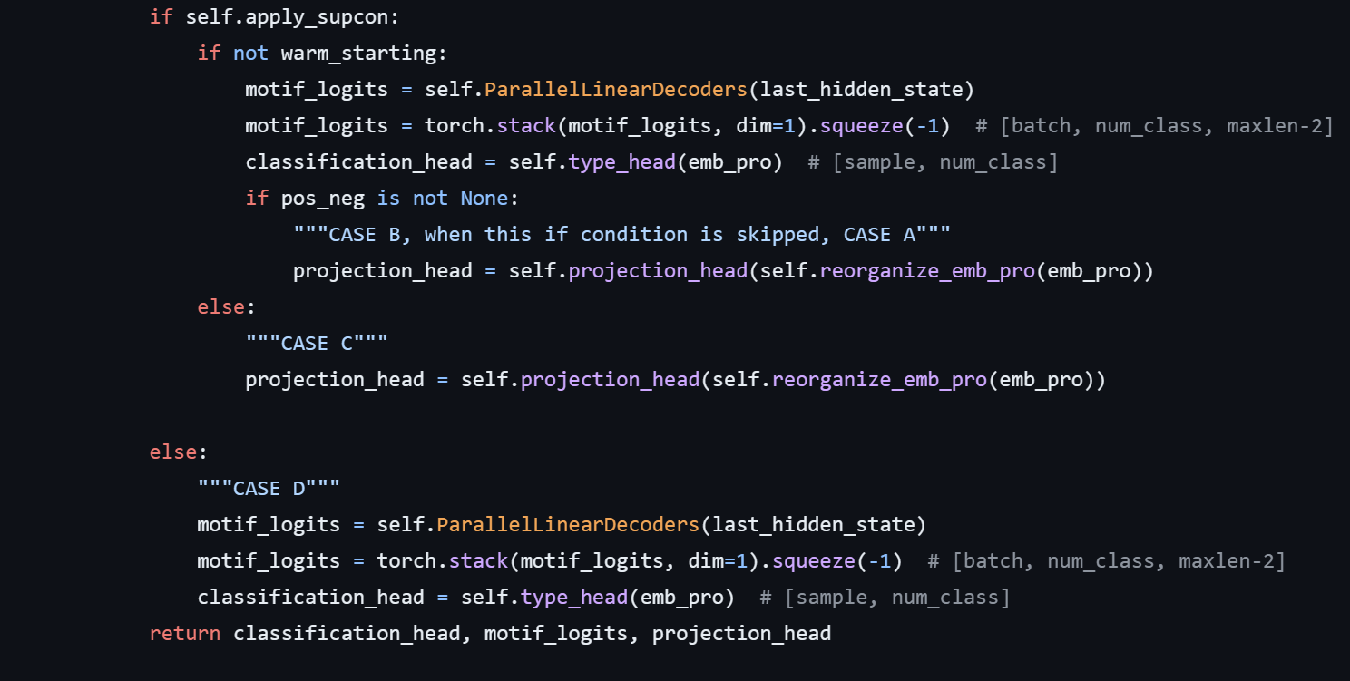

**找到CASE B和CASE C, 做如上图所示的修改**

**将原来的**

**~~emb_pro_ = emb_pro.view((self.batch_size, 1 + self.n_pos + self.n_neg, -1))~~**

**~~projection_head = self.projection_head(emb_pro_)~~**

**替换为**

**projection_head = self.projection_head(self.reorganize_emb_pro(emb_pro))**

**旧代码还有一个bug, 如果选择 ’clean’ 模式, batch size将会是8, 分别属于8个不同的类型**

**但是旧代码误用了错误的index导致取出的8个anchor不满足 ’属于8个不同的类型’**

**在data_clean.py中**

**找到class LocalizationDataset的__getitem__()方法**

**在约75行左右的这个位置做如下的修改**

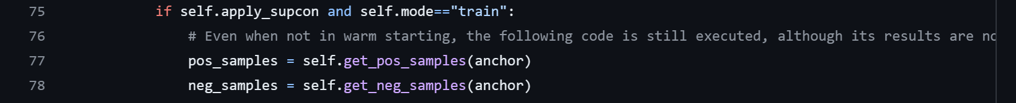

**将get_pos_samples(idx)和get_neg_samples(idx)改成**

**get_pos_samples(anchor)和get_neg_samples(anchor)**