Real-World Dimension and Metric Estimation of Physical Features from Street-Level Imagery Using 3D Reconstruction and Advanced Computer Vision
HERE Technologies
Kely Zhang, Anna Chen, Adaora Ezike
Advisor: Dr. Jeanette Shutay
A Capstone Project
Submitted to the University of Chicago in partial fulfillment of the requirements of the degree of Master of Science in Applied Data Science
Division of Physical Sciences
December 2026

Abstract
Metric map attributes such as bridge vertical clearance matter for truck routing but are expensive to collect with LiDAR surveys and field audits. With HERE Technologies, we evaluated whether existing crowd-sourced street-level imagery can estimate clearance at network scale. We built an automated, backbone-agnostic pipeline that retrieves Mapillary sequences approaching a structure, segments the structure and road, reconstructs metric 3D geometry with a feed-forward model (MapAnything, Depth Anything 3 or VGGT), measures clearance to a RANSAC-fitted road plane, and attaches a ground-truth-free confidence decision. We benchmarked it against FHWA National Bridge Inventory (NBI) Item 54B on a stratified 80-bridge Chicago sample, froze every rule, and tested it on 51 held-out Chicago bridges and on 120 bridges in two metropolitan areas never seen during development (Indianapolis and Milwaukee). On the benchmark, MapAnything single-view estimates had a median absolute error of 0.43 m; no backbone was significantly better than another. A second pipeline version that selects imagery by what the segmenter detects and removes lens distortion with Mapillary camera parameters raised benchmark coverage from 40% to 62.5% of bridges. In the external metros, accepted single-view estimates had a mean absolute error of 0.70 m (median 0.51 m, 80% within 1 m), matching the 0.68 m of the same configuration in Chicago, and the confidence rules removed most gross errors. Against a no-image baseline that always predicts the regional median clearance, the estimates are not yet more accurate in absolute terms overall (0.70 m versus 0.42 m), although they matched or beat it on the subset where single- and multi-view estimates agree in Milwaukee, and they rank structures usefully for screening (AUC 0.75 for clearances below 4.6 m in Chicago). The evidence supports deploying image-based clearance as a confidence-routed screening and discrepancy-detection layer, with single-view MapAnything as the default backbone, rather than as a replacement for surveyed values.
Keywords: street-level imagery, metric 3D reconstruction, vertical clearance, National Bridge Inventory, Mapillary, MapAnything, Depth Anything 3, VGGT, selective prediction, map attribute validation

Executive Summary
HERE Technologies maintains physical map attributes (clearances, widths, heights and offsets) that matter for truck routing, navigation and HD maps. They are usually collected with LiDAR surveys, manual audits or dedicated capture campaigns, which are costly to repeat across large road networks. This project asked whether crowd-sourced imagery that already exists can recover such measurements in real-world units, and if so, how HERE should use it.
What we built. An end-to-end pipeline for bridge vertical under-clearance (Figure 1): NBI record → Mapillary sequence → frame selection and segmentation → metric 3D reconstruction with an interchangeable backbone → road-plane measurement → quality control and a confidence decision (accept, review or reject) → GeoJSON output. The three team members each evaluated one backbone on the same frozen 80-bridge benchmark, with shared frames, masks and scoring code, so results are directly comparable.
What we found.
- Accuracy where it works. On quality-checked benchmark bridges, MapAnything single-view estimates had a median error of 0.43 m and a mean error of 0.92 m; on phone and action-camera imagery the mean error fell to 0.65 m. Depth Anything 3 was comparable (0.99 m multi-view); no backbone was statistically better on identical bridges.
- Coverage is the bottleneck, and it can be fixed in retrieval. Only 38 of 80 bridges first produced a usable frame, because the NBI coordinate marks the structure rather than where the road below crosses it. Choosing the image sequence by what the segmenter detects, plus lens undistortion, raised quality-checked coverage from 32 to 50 bridges (40% → 62.5%) without changing the 3D model.
- Failures are predictable without ground truth. Images captured since 2023 (mostly fleet cameras without calibration metadata) had twice the median error of earlier captures (1.20 m vs 0.59 m), and estimates below 3 m were almost always the wrong target. Rules fixed on the benchmark and applied unchanged to 51 new bridges lowered error from 0.87 m to 0.73 m while keeping 84% of estimates, and to 0.62 m when also requiring agreement between views (57% kept).
- It generalizes to new cities. Run unchanged on 120 bridges in Indianapolis and Milwaukee, accepted single-view estimates had MAE 0.70 m and 80% were within 1 m, the same as in Chicago (0.68 m). The same retrieval failure appeared in both cities, and the camera rule and plausibility gate removed three of the four largest errors. Multi-view reconstruction did not transfer as well (biased +1.1 m in Milwaukee), which makes single-view the safer default.
- Honest baseline. Most Chicago overpasses sit within a narrow 4.3–5.2 m band, so simply predicting the regional median (4.97 m) is a strong baseline that current image estimates do not beat on absolute error. Where the pipeline adds information is in ranking: it separates unusually low structures (AUC 0.75 for < 4.6 m) and unusually high ones (AUC 0.90 for > 5.5 m).
Recommendation for HERE. Use image-based clearance as a low-cost screening and discrepancy-detection layer, not as a replacement value: run it across the network, compare each confident estimate with the attribute already in the map, and route large disagreements and predicted low clearances to review or targeted survey. At roughly six seconds of GPU time per bridge, the full Illinois inventory could be screened in hours. Two of the three engineering changes needed to move from screening toward publishing values are implemented here (detection-guided retrieval and lens undistortion); the third, calibration on several hundred externally surveyed bridges per camera class, is the main remaining step.

Table of Contents
[Right-click → Update Field in Word to populate. Lists of Figures and Tables: References → Insert Table of Figures.]
Abstract
Executive Summary
Table of Contents
Introduction
Problem Statement
Analysis Goals
Scope
Background
Literature Review
Data
Data Sources
Descriptive Analysis
Methodology
Feature Engineering
Modeling Framework
Findings
Coverage: Where the Pipeline Loses Bridges
Fixing Coverage: Detection-Guided Retrieval
MapAnything Accuracy
Error Analysis
Camera Fingerprint and Lens Undistortion
Depth Anything 3
VGGT
Method Comparison
Pipeline v2 on the Benchmark
Absolute Accuracy against a No-Image Baseline
Generalization to Held-Out Bridges
Generalization to New Metropolitan Areas
Operational Value: Screening and Discrepancy Detection
Stop-Sign Size
Building Height
Discussion
Business Value for HERE
Conclusion
Future Work
References
Appendices
Appendix A. Pipeline v2 Implementation and Experiment Log
Appendix B. Benchmark and Held-Out Sets
Appendix C. Early Experiments (Spring 2026)

Introduction
Physical map attributes describe properties of the built environment that road connectivity alone cannot capture. Bridge clearance and traffic-sign dimensions, for example, can support navigation, logistics, and infrastructure analysis. Collecting these measurements through dedicated surveys and manual inspection requires substantial effort, creating interest in whether existing street-level imagery could provide a supplementary source. This project investigated that possibility in the context of HERE Technologies’ interest in extracting physical map attributes from imagery.
To assess the feasibility of this approach, we developed and evaluated workflows combining image retrieval, target segmentation, depth estimation, three-dimensional reconstruction, and geometric measurement. Mapillary supplied street-level images and sequences of roadway scenes. We explored pretrained models including MapAnything, Depth Anything 3 (DA3), and VGGT, using single-image and multi-image inputs where supported. The experiments examined whether the resulting geometry could yield useful dimensional estimates, how those estimates compared with available reference values and with a no-image baseline, and whether they held up on bridges that were not used to design the pipeline.
The study used street-level imagery from Chicago and the surrounding area, with the main quantitative evaluation on a stratified benchmark of 80 bridges and a held-out test on 51 further bridges. Mapillary images associated with these bridges were linked to reference records from the National Bridge Inventory (NBI) to assess measurement error, the availability of usable estimates, failure modes, and the operational value of the estimates for HERE. This paper presents the project’s research question, data, methods, and findings, and discusses the feasibility and limitations of estimating physical dimensions from street-level imagery.

Problem Statement
The project addressed the problem of estimating real-world dimensions of selected roadway features from ordinary street-level imagery. Using observations from Chicago and the surrounding area, we examined this problem primarily through bridge vertical underclearance, with sign dimensions as a supporting investigation. Detecting a bridge or sign identifies what is visible, but does not determine its physical dimensions. A measurement additionally requires the correct target, a usable geometric representation, a physical scale, and a definition of the boundaries or reference surfaces being measured. Perspective, lens distortion, occlusion, and incomplete views can affect these requirements at different stages of the workflow.
The central research question was whether pretrained vision models, combined with automated target localization and geometric processing, could produce useful dimensional estimates for the tested features, and under which input conditions those estimates were available and accurate. "Useful" was judged in two ways: absolute agreement with the inventory, and added information over what a map provider already knows without imagery. The practical motivation was to explore whether imagery already collected for other purposes could contribute measurement candidates for map enrichment. The study did not quantify acquisition-cost savings or establish a replacement for surveyed data.
Evaluation also required care about what counted as a reference. For bridges, the image-derived median distance between visible underside samples and a road plane differs from the minimum vertical underclearance represented by NBI Item 54B (Federal Highway Administration, 1995). For stop signs, agreement with a standard size does not establish agreement with an individually surveyed installation. The problem therefore included documenting reference correspondence and measurement definitions, as well as computing numerical errors.

Analysis Goals
The first goal was to develop a reproducible prototype connecting street-level imagery to feature-specific dimensional estimates. This included organizing image sequences and metadata, identifying the target and relevant reference regions, recovering depth or three-dimensional geometry, and producing measurements with traceable intermediate outputs. The aim was to evaluate a workable research process using existing pretrained models.
The second goal was to examine alternative segmentation and reconstruction approaches, including single-image and multi-image configurations, and determine how their outputs affected measurement quality. The 80-bridge benchmark provided a structured basis for the main quantitative evaluation within the broader Chicago-area imagery study. Comparisons were interpreted according to the actual cases, masks, scale sources, and quality rules used in each completed experiment. Supporting feature-sizing and model-capability experiments were considered separately.
The third goal was to assess measurement accuracy together with availability and failure modes. Error summaries were accompanied by the number of usable estimates, the reasons cases were rejected or could not be measured, and a comparison with a no-image baseline. The fourth goal was to test generalization: rules and thresholds were fixed on the benchmark and then applied unchanged to bridges outside it. The final goal was to translate the evidence into a deployment recommendation for HERE, identifying the limitations that matter for production, including camera geometry, target visibility, segmentation, metric scale, and reference matching.

Scope
The project was a proof-of-concept study of dimensional estimation using street-level RGB imagery from Chicago and the surrounding area. Within this geographic scope, the main quantitative evaluation focused on vertical underclearance for a frozen set of 80 bridges associated with the 2025 Illinois NBI, followed by a held-out test on 51 further Chicago-area bridges processed with the same code. Stop-sign width was a supporting task, evaluated separately against published standard sizes.
The work included image and metadata retrieval, automated segmentation, pretrained depth and reconstruction models, geometric measurement, quality checks, confidence scoring, and evaluation of saved experimental outputs. Single-image and multi-image settings were examined where the relevant model branch had been run. Additional object-reconstruction and cross-frame correspondence demonstrations formed supporting explorations; they were not evidence of improved clearance accuracy. The study did not train or fine-tune a foundation model: NBI provides one scalar per bridge, which cannot supervise a dense 3D model, so adaptation was limited to post-hoc rules and calibration.
The demonstrated scope was narrower than a general map-attribute extraction system. Building height, lane width, offsets, and comprehensive feature coverage were not established as validated measurement capabilities in this report. Generalization was tested on held-out Chicago bridges and in two further metropolitan areas, but not nationally; vehicle-specific safe passage, production deployment, and cost savings were not demonstrated.

Background
Mapillary organizes street-level imagery into georeferenced observations and sequences that can be retrieved for visual analysis (Mapillary, n.d.). In this study, these observations provided roadway views from Chicago and the surrounding area. Such imagery varies in viewpoint, resolution, capture date, and camera properties. Multiple frames may provide additional views of a feature, but nearby geographic coordinates do not by themselves establish that an observation corresponds to the intended structure or travel lane. These characteristics make imagery useful for investigation while introducing selection and correspondence challenges.
Image-based measurement combines semantic and geometric reasoning. Segmentation identifies the pixels associated with a target or reference surface. Depth estimation and three-dimensional reconstruction provide spatial information for those pixels. Camera geometry connects image coordinates to three-dimensional coordinates, but physical dimensions also require metric scale (Hartley & Zisserman, 2004). An accurate mask cannot resolve unknown scale, and a plausible point cloud cannot compensate for selecting the wrong object. The resulting measurement depends on the interaction of these stages.
The reference sources reflected the distinction between the main bridge evaluation and supporting sign-sizing experiments. The Illinois NBI supplied inventory values for the bridge evaluation, with the coding guide defining minimum vertical underclearance (Federal Highway Administration, 1995, 2025). The Manual on Uniform Traffic Control Devices supplied standard stop-sign dimensions (Federal Highway Administration, 2009). These sources supported different forms of evaluation: agreement with inventory records for bridges and consistency with standard sizes for signs. Their meanings and limitations informed how the team interpreted image-derived estimates.

Literature Review
Classical camera geometry provides the basis for relating image coordinates to spatial measurements. The pinhole model describes perspective projection through camera intrinsics and pose (Hartley & Zisserman, 2004). With depth and the corresponding intrinsics, image pixels can be back-projected into three-dimensional coordinates. That geometric operation preserves the units of the supplied depth; it does not resolve an unknown physical scale by itself. This distinction is central when selecting reconstruction methods for dimensional measurement.
Recent feed-forward models provide complementary sources of scene geometry. MapAnything predicts metric reconstruction from flexible visual and geometric inputs (Keetha et al., 2026). VGGT predicts scene and camera attributes from one or more images (Wang et al., 2025); when its output is used at relative scale, dimensional measurement requires an additional scale source. Depth Anything introduced a broadly trained monocular depth model (Yang et al., 2024), while DA3 extends the setting to geometry recovery from arbitrary visual inputs (Lin et al., 2025). These methods motivate alternative pipeline designs, but their reconstruction benchmarks do not establish their accuracy for the roadway measurements studied here.
Metric depth has also been used for dimensional measurement beyond depth-map evaluation. Metric3D combines metric-depth prediction and camera information to reconstruct scene geometry and measure object and structural dimensions from photographs (Yin et al., 2023). This provides a precedent for using learned depth in a measurement workflow. Its results also highlight the importance of camera parameters and scale recovery. In the present capstone, the depth or scale source was therefore treated as an explicit part of each method rather than assuming that every model output was directly expressed in metres.
Semantic localization supplies the regions to which geometric measurement is applied. Mask2Former uses masked attention for universal image segmentation (Cheng et al., 2022), and Mapillary Vistas provides a street-scene dataset relevant to bridge, road, and sign localization (Neuhold et al., 2017). SAM3 detects and segments objects using concept prompts, such as short noun phrases or image exemplars (Carion et al., 2025). In the DA3 extension, text prompts specified bridge undersides and road surfaces; the resulting masks localized the regions used for geometric measurement. These approaches differ in how targets are specified and selected. Their usefulness for measurement depends on whether the resulting masks isolate the physical boundaries and reference surfaces required by the task, rather than on detection confidence alone.
Robust geometric estimation addresses a further source of uncertainty after localization and reconstruction. RANSAC estimates model parameters in the presence of outliers (Fischler & Bolles, 1981), providing a basis for fitting reference surfaces such as a road plane. A robust fit can reduce the influence of inconsistent points, but cannot verify target identity, correct systematic scale error, or make a visible-sample statistic equivalent to an inventory minimum.
Finally, deploying an imperfect estimator depends on knowing when to trust it. Selective prediction trades coverage for accuracy by abstaining on low-confidence inputs and is evaluated with risk–coverage curves (Geifman & El-Yaniv, 2017). Agreement between independent measurements is conventionally assessed against bias and limits of agreement rather than correlation alone (Bland & Altman, 1986). We adopt both ideas: the pipeline reports a confidence decision for each estimate, and accuracy is reported relative to a no-image baseline. The specific configurations, back-projection equations, and thresholds are described in Methodology.

Data
The study combines crowd-sourced street-level imagery with two kinds of independent reference data: an official bridge inventory for clearance and a national signage standard for stop-sign size.

Data Sources
Street-level imagery. Images and metadata were retrieved from the Mapillary Graph API (Mapillary, n.d.). For each image we requested its identifier, sequence, capture time, raw and computed compass angle, raw and computed geometry, camera type, width, height and a 2048-pixel thumbnail URL. Spherical, equirectangular and fisheye images were excluded because the 3D models assume near-pinhole perspective input. Camera make and model, which Mapillary derives from EXIF metadata, were retrieved for the selected anchor frames.
Bridge clearance ground truth. The reference is the Federal Highway Administration National Bridge Inventory for Illinois, 2025 release (Federal Highway Administration, 2025). We used Item 54B, the minimum vertical under-clearance in metres, restricted to structures whose under-clearance reference (Item 54A) is a highway ('H'). Records were kept if the clearance was between 3.5 m and 8.5 m and the structure lay in a Chicago-metro bounding box (41.45–42.35° N, 88.35–87.52° W). Twin structures closer than 60 m (for example separate northbound and southbound decks) were de-duplicated, leaving 523 candidate bridges. Candidates were ordered round-robin across clearance bins (< 4.45, 4.45–4.75, 4.75–5.2, 5.2–6.0 and > 6.0 m) and service type so that the benchmark covers the full range of clearances and structure types.
Benchmark construction (development set). For each candidate bridge, Mapillary images within 170 m of the NBI coordinate were retrieved. Frames were kept if they were 12–140 m from the structure and the camera heading was within 25° of the bearing to the structure, i.e. the vehicle was driving toward it. Among qualifying sequences, the one with the most frames 22–85 m from the structure (with a preference for recent captures) was selected, and up to eight frames spaced at least 5 m apart were downloaded. Of the first 87 bridges attempted, 80 yielded a usable sequence; four had no imagery and three had no sequence with at least three suitable frames. These 80 cases form the frozen benchmark used for every 3D backbone in this paper, and every rule and threshold reported later was chosen on them.
Held-out set. The same retrieval and MapAnything measurement code was subsequently run over a larger draw from the 523 candidates. It produced 83 quality-checked estimates, of which 32 are benchmark bridges and 51 are bridges never used for development. These 51 form the held-out test. Because they were drawn in candidate order rather than stratified, their clearances are concentrated in the common 4.3–5.2 m range (standard deviation 0.60 m versus 0.96 m on the benchmark), which makes them a realistic sample of the network but a harder test for absolute accuracy.
External metros. To test geographic transfer, the same selection was applied to the 2025 NBI releases for Indiana (Indianapolis area, 39.60–40.00° N, 86.40–85.90° W) and Wisconsin (Milwaukee area, 42.85–43.25° N, 88.20–87.80° W): highway under-reference, clearance 3.5–8.5 m, twin structures de-duplicated, and stratified ordering by clearance bin and service type. The first 60 bridges with imagery in each metro were processed with the frozen code and thresholds. Their clearances (median 5.0 m, standard deviation 0.87–0.88 m) span a range similar to the Chicago benchmark. The two cities differ in imagery: Indianapolis anchors range from 2017 to 2026 and include 17 without EXIF metadata, whereas Milwaukee anchors are almost all phone captures from 2018–2022.
Stop-sign reference. As a second feature type, Mapillary map features of class regulatory--stop--g1 were sampled over Chicago. For each sign, two to four perspective frames from one sequence, 5–28 m from the sign and facing it, were used. Ground truth is the Manual on Uniform Traffic Control Devices standard R1-1 size: 30 in (0.762 m) on conventional roads and 36 in (0.914 m) on multi-lane approaches (Federal Highway Administration, 2009). Because the installed size of each sign is not recorded, accuracy is reported against both standard sizes.

Descriptive Analysis
The 80 benchmark bridges have NBI clearances from 3.94 m to 7.92 m (median 4.97 m, mean 5.20 m, standard deviation 0.96 m). The sample is balanced across clearance bins (18 below 4.45 m, 16 at 4.45–4.75 m, 19 at 4.75–5.2 m, 14 at 5.2–6.0 m and 13 above 6.0 m) and across structures carrying a highway (40), interchange overpasses (36) and third-level interchanges (4). Each case contributes a median of eight candidate frames.
The most important descriptive finding concerns usability rather than distributions. In 41 of the 80 cases the segmenter found no overhead structure in any candidate frame. Inspection of these cases shows two causes: the NBI coordinate marks the structure rather than the exact road crossing, so the nearest sequence often runs parallel to or on top of the bridge, and some sequences pass the structure only at the edge of the frame. One further case had no visible road surface. The imagery itself is heterogeneous: capture years range from 2015 to 2026, with most anchors from 2018. On the benchmark, every anchor without EXIF camera information was captured in 2023 or later, and all but one EXIF anchor earlier (31 of 32 agree), so capture year serves as an available proxy for camera type on bridges where make is not recorded. Across all 83 quality-checked bridges, 16 anchors date from 2023–2026.
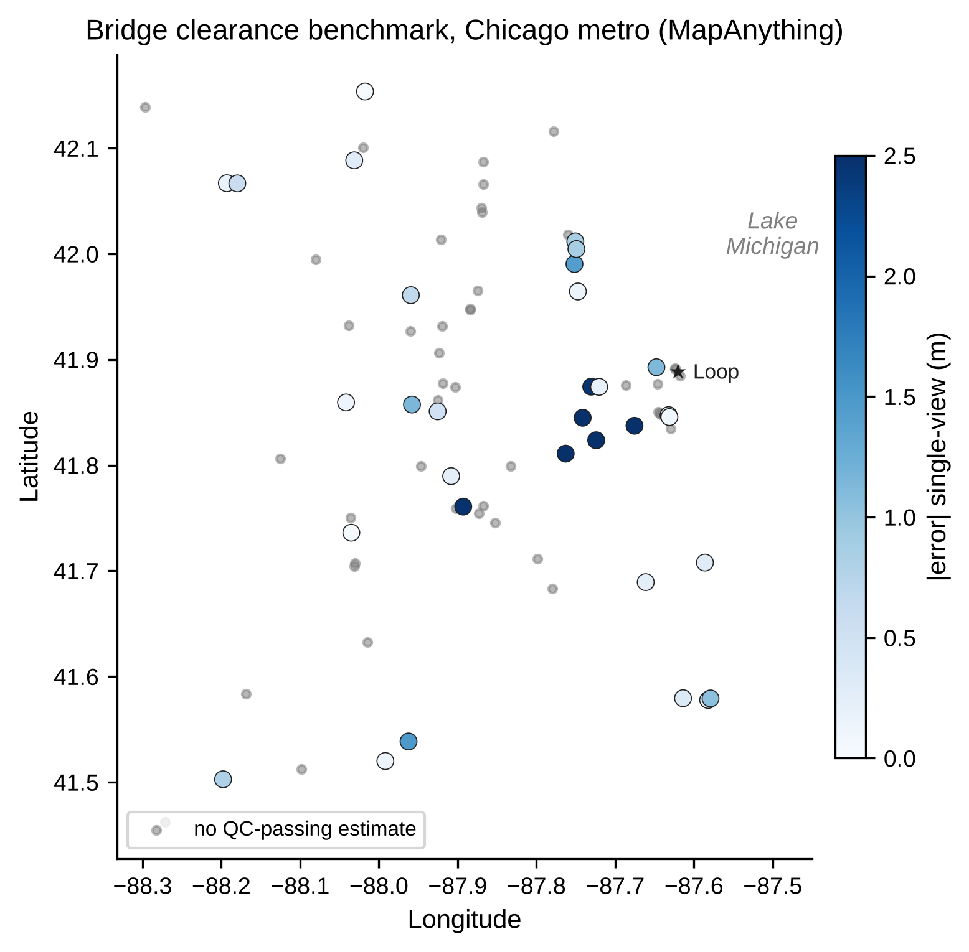
Figure 2. Benchmark bridges in the Chicago metro area. Coloured points passed the automatic quality check and are shaded by single-view absolute error; grey points had no quality-checked estimate. An interactive version is in the project repository.

Methodology
The pipeline is modular: image retrieval, frame selection, segmentation, metric 3D reconstruction, geometric measurement, and quality control with a confidence decision are separate steps (Figure 1). Only the 3D backbone changes between the methods compared in this paper; every backbone receives the same frames and the same masks and is scored with the same measurement code and metrics. The final stage converts a raw measurement into an operational decision (accept, review or reject) using only information available without ground truth.
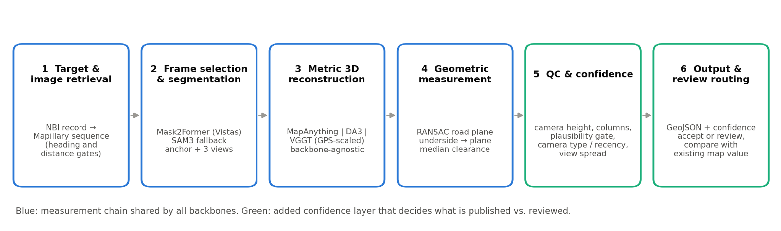
Figure 1. End-to-end clearance pipeline. Stages 1–4 are shared by all backbones; stages 5–6 decide whether an estimate is published, reviewed or rejected.

Feature Engineering
For target segmentation, the main bridge benchmark used Mask2Former with a Swin-L backbone trained on Mapillary Vistas (Cheng et al., 2022; Neuhold et al., 2017). A separate DA3 experiment used SAM3 (Carion et al., 2025), as described below. The Mask2Former street-level label set includes Bridge, Road, lane-marking and crosswalk classes. Each connected Bridge component is a candidate structure; road, lane-marking, crosswalk, service-lane and manhole pixels form the road mask.
Structure and anchor-frame selection. A candidate structure must span at least 18% of the image width, start in the upper 55% of the image, have its lower edge above 65% of the image height, and have road visible directly beneath it in at least five sampled columns. Each frame is scored by the best candidate's width and the vertical position of its lower edge, and the highest-scoring frame becomes the anchor. The three frames closest to the anchor in distance form the multi-view set (four frames in total).
Clearance measurement. In each image column, the pipeline identified the lowest structure pixel with road beneath it and retrieved its corresponding three-dimensional point from the reconstruction. Points whose distance from the camera differed from the median by more than three scaled median absolute deviations were removed. A road plane was then fitted to points at a similar distance from the camera using RANSAC (Fischler & Bolles, 1981), with 400 iterations and a 0.12 m inlier threshold. Only underside points more than 0.3 m above the camera were retained to help exclude walls, abutments, and barriers also labeled as Bridge by the segmentation model. Clearance was calculated as the median perpendicular distance from the retained underside points to the fitted road plane; the 10th and 25th percentiles were also recorded to test which statistic best matches the inventory definition. The distance from the camera centre to this plane was recorded as the recovered camera height.

Modeling Framework

MapAnything
MapAnything (Keetha et al., 2026) is a feed-forward model that predicts metric 3D points, confidences and camera poses from one or more images. It was run in two settings: single-view on the anchor frame, and multi-view on the four selected frames, reading the anchor frame's point map. A third variant ("multi-view, all frames") took the median clearance over the per-frame measurements of the multi-view reconstruction. Points were filtered by model confidence (50th percentile for road points, 15th percentile for structure points). Inference used bfloat16 on a single NVIDIA L4 GPU and took about six seconds per bridge, including segmentation of all candidate frames.

Depth Anything 3
[Owner: Anna — text unchanged from the Anna-edited version except figure numbers.]
The DA3 branch used DA3NESTED-GIANT-LARGE-1.1 to predict metric-scale depth, camera intrinsics, and camera poses (Lin et al., 2025). Single-view inference used the frozen anchor image; multi-view inference used the frozen ordered sequence and retained the anchor output for measurement. The adapter required a true is_metric flag and available camera parameters. This metric-depth configuration supplied the physical scale needed to express reconstructed coordinates in metres.
We converted image pixels into three-dimensional camera coordinates using back-projection under the standard pinhole camera model (Hartley & Zisserman, 2004, Section 6.1). For a pixel at coordinates (u, v), the corresponding three-dimensional point was computed as
$P_{c} = Z K^{−1}{[u, v, 1]}^{T}, Z = D(u, v)$
Here, D(u, v) is the predicted optical-axis depth and K is the camera intrinsic matrix. Assuming zero skew, this relationship expands to
$X_{c} = \frac{(u − c_{x})Z}{f_{x}}, Y_{c} = \frac{(v − c_{y})Z}{f_{y}}, Z_{c} = Z$
The focal lengths fx and fy are expressed in pixels, and (c_x, c_y) is the principal point. Because the normalized image coordinates are dimensionless and Z is expressed in metres, the resulting coordinates (Xc, Yc, Zc) are also expressed in metres. This calculation assumes a pinhole camera model; uncorrected lens distortion remains a potential source of error.
The predicted world-to-camera transformation was inverted to place the reconstructed points and camera centre in a common world coordinate system. Finite points with positive depth were retained, with confidence thresholds at the 50th percentile for road points and the 15th percentile for underside points. The resulting point map and anchor masks were passed to the clearance procedure described in Feature Engineering. Figure 3 illustrates the geometry and reference surface used by this procedure.
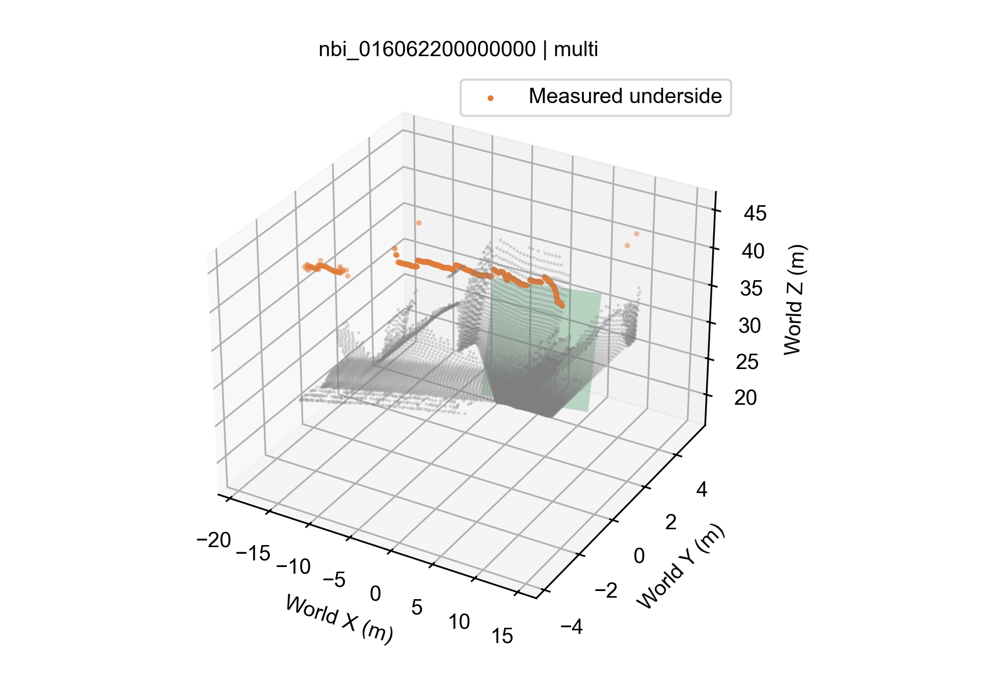
Figure 3. Example DA3 reconstruction with Mask2Former masks, showing scene points in grey, the fitted road plane in green, and the retained bridge-underside samples in orange. Clearance is estimated from the perpendicular distances between the underside samples and the road plane.
The main DA3 comparison used the shared Mask2Former masks. In the separate SAM3 configuration, the prompts bridge underside and road were applied with a confidence threshold of 0.5. The original candidate-selection gates were retained, and structure masks were rejected when more than 5% of their area overlapped the road mask.

VGGT
[Owner: Adaora — VGGT paragraph incl. GPS-based scale recovery. Please also export per-bridge rows in the standard schema (Appendix A) so VGGT enters the unified comparison.]

Building Height (Exploratory)
[Owner: Adaora — building-height method.]

Pipeline v2: Detection-Guided Retrieval and Lens Undistortion
Two extensions target the two largest failure modes found on the benchmark. Both reuse the original segmentation, reconstruction and measurement code unchanged, so any change in results is attributable to the inputs alone.
Detection-guided retrieval. The original planner chose the Mapillary sequence with the most frames 22–85 m from the NBI coordinate. When that coordinate does not lie on the road beneath the structure, the most frequent sequence often runs along or over the bridge. Pipeline v2 instead lists up to twelve sequences within 220 m whose frames face the NBI coordinate, downloads the two frames of each sequence closest to 40 m, and runs the segmenter on them. The sequence whose frames contain the strongest overhead-structure candidate with road beneath it is selected, and the original frame-selection logic is then applied to that sequence only. An OpenStreetMap-based variant that intersects bridge ways with the road below was also implemented, but the public Overpass servers were unavailable during the experiment window, and the detection-guided variant needs no external map.
Lens undistortion. Mapillary reports a perspective camera model for each image as a normalised focal length f and radial coefficients k1 and k2. Pipeline v2 builds the intrinsic matrix with focal length f·max(w, h) pixels and principal point at the image centre, and removes radial distortion with OpenCV before reconstruction. All candidate frames of a bridge are corrected, and the anchor-selection, reconstruction and measurement steps then run as before.

Quality Control and Confidence Routing
A raw measurement is not yet a map attribute. The final stage assigns each bridge one of three decisions using only information available at inference time; all thresholds were set on the development benchmark and frozen before the held-out test.
- Quality check (QC). An estimate passes if the recovered camera height is between 0.7 m and 3.5 m, at least 10 underside columns are measured, and the structure is within 90 m. This removes geometrically broken reconstructions.
- Plausibility gate (reject). The fused estimate (median of the single-view, multi-view and all-frames values) must lie between 3.0 m and 9.0 m. Highway underpasses below 3 m are vanishingly rare, while on the development set all five estimates below 3 m were wrong by 2.1–5.3 m and were typically caused by measuring a barrier, sign or lower structure instead of the deck.
- Camera rule (review). Anchors whose Mapillary camera model shows strong barrel distortion (k1 < −0.06) are routed to review. On the benchmark this flags every camera without EXIF metadata and every action camera and no phone (Figure 9). Where camera parameters are unavailable, a missing EXIF make or a capture date of 2023 or later is used as a proxy.
- View-agreement rule (review). If the single-view and multi-view estimates differ by more than 1.05 m (the 75th percentile of the spread on accepted development bridges), the estimate is routed to review.
Estimates passing all four steps are labelled accept. The ordering of the rules also defines a confidence score used to draw risk–coverage curves: higher view spread, a recent or uncalibrated camera, an implausible value, and a recovered camera height far from 1.35 m each lower confidence.

Evaluation Protocol
Each backbone is reported on three subsets: S1, all cases that pass its own QC; S2, the S1 cases captured with phone or action cameras (EXIF make present); and S3, the 32 bridges whose MapAnything multi-view estimate passed QC, so that backbones can be compared on identical bridges (a method contributes the S3 bridges for which it produced a QC-passing estimate, so n can be below 32). Metrics are the number of cases, mean absolute error (MAE) with a bootstrap 95% confidence interval (1,000 resamples, seed 42), median absolute error, mean signed error (bias), mean absolute percentage error (MAPE) and the share of estimates within 0.5 m. The camera split in S2 was identified after inspecting errors and is therefore reported as a diagnostic, not as the headline result.
Two additions make the evaluation decision-relevant. First, every error is compared with a no-image baseline that predicts the benchmark-wide median NBI clearance (4.97 m) for every bridge; skill is defined as 1 − MAE_model / MAE_baseline, so positive values mean the imagery adds absolute accuracy. Because absolute error on a narrow range can hide ranking ability, we also report Spearman rank correlation and the area under the ROC curve (AUC) for flagging clearances below 4.6 m (about 15 ft, a common truck-routing threshold) and above 5.5 m. Second, generalization is tested at two levels, always with every threshold frozen: the rules are applied unchanged to 51 held-out Chicago bridges, and the complete pipeline is rerun in two other metropolitan areas (Indianapolis and Milwaukee). Paired differences between methods and configurations are evaluated on identical bridges with bootstrap intervals.

Findings
Table 1 summarises the bridge-clearance results by reconstruction backbone, view setting, and evaluation subset. Sections that follow examine coverage, accuracy, error sources, backbone comparison, generalization, and operational value.
Table 1. Bridge vertical under-clearance versus NBI Item 54B (metres), 80-bridge benchmark.
Method | View | Subset | n | MAE (95% CI) | Median AE | Bias | MAPE % | ≤0.5 m %
MapAnything | single | S1 | 30 | 0.92 (0.54–1.45) | 0.43 | −0.69 | 16.8 | 50
MapAnything | single | S2 | 24 | 0.65 (0.40–1.00) | 0.32 | −0.43 | 12.4 | 54
MapAnything | single | S3 | 30 | 0.92 (0.54–1.45) | 0.43 | −0.69 | 16.8 | 50
MapAnything | multi | S1 | 32 | 1.09 (0.75–1.51) | 0.58 | −0.28 | 19.9 | 47
MapAnything | multi | S2 | 24 | 0.77 (0.50–1.12) | 0.47 | +0.28 | 14.6 | 54
MapAnything | multi | S3 | 32 | 1.09 (0.75–1.51) | 0.58 | −0.28 | 19.9 | 47
Depth Anything 3 | single | S1 | 35 | 1.21 (0.84–1.63) | 0.73 | −0.59 | 21.9 | 34
Depth Anything 3 | single | S2 | 26 | 0.86 (0.58–1.18) | 0.62 | −0.25 | 16.3 | 38
Depth Anything 3 | single | S3 | 31 | 1.22 (0.79–1.70) | 0.68 | −0.64 | 21.9 | 39
Depth Anything 3 | multi | S1 | 32 | 0.99 (0.63–1.43) | 0.55 | −0.20 | 17.5 | 44
Depth Anything 3 | multi | S2 | 25 | 0.68 (0.49–0.87) | 0.51 | +0.14 | 13.0 | 48
Depth Anything 3 | multi | S3 | 29 | 1.04 (0.63–1.56) | 0.54 | −0.25 | 18.2 | 45
VGGT (GPS-scaled) | multi | S1 | 35
VGGT (GPS-scaled) | multi | S2
VGGT (GPS-scaled) | multi | S3
VGGT | single | — | n/a
No-image baseline (4.97 m) | — | MA single S1 | 30 | 0.71 | 0.44

S1 = own QC-passing estimates; S2 = S1 with EXIF camera make present; S3 = available QC-passing estimates on the 32 bridges where MapAnything multi-view passed QC (MapAnything single-view lacks two of them, hence n = 30). Bias = mean(estimate − reference). VGGT single-view: n/a — VGGT is not metric from one image. The last row scores a constant prediction of the benchmark median on the same 30 bridges as MapAnything single-view S1.

Coverage: Where the Pipeline Loses Bridges
Coverage was the largest source of loss (Figure 4). Of 80 benchmark bridges, 42 produced no anchor: 41 because no overhead structure appeared in any candidate frame and one because no road was visible. Of the 38 remaining, MapAnything measured clearance on 34 multi-view and 32 single-view reconstructions (the others retained no underside points above the camera), and 32 and 30 respectively passed QC. After the plausibility and camera rules, 22 bridges (28%) would be accepted without review.
The 41 structure-detection failures are not a model failure. NBI Item 16/17 coordinates mark the structure, while the measurement requires a vehicle travelling on the road under it. Among bridges that were measured, the distance between the NBI coordinate and the anchor camera did not predict error (Spearman ρ = 0.03), which indicates that once the right sequence is found, the location offset is harmless; the problem is finding that sequence. Pipeline v2 therefore chooses the sequence by what the segmenter actually sees rather than by proximity to the inventory point (next section).
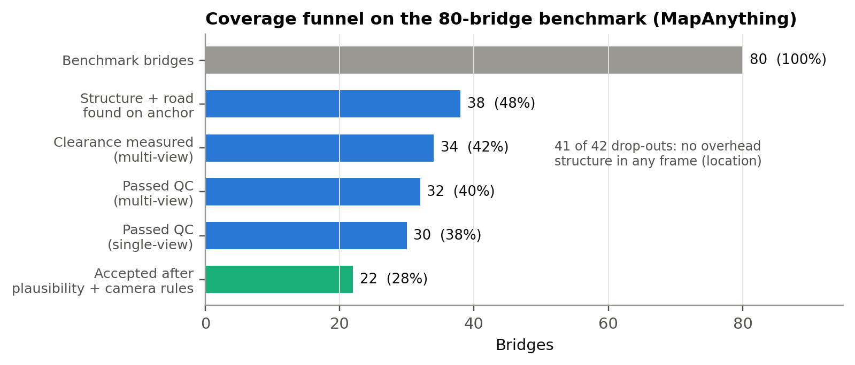
Figure 4. Coverage funnel for MapAnything on the 80-bridge benchmark. Grey: all benchmark bridges; blue: stages of the measurement chain; green: estimates accepted after the plausibility and camera rules.

Fixing Coverage: Detection-Guided Retrieval
Detection-guided retrieval was applied to the 42 benchmark bridges without an anchor frame. For 24 of them, at least one nearby sequence contained an overhead structure with road beneath it, and in every case it was a different sequence from the one the original planner had chosen. The remaining 18 had no sequence in which the segmenter found an underpass, consistent with imagery that never passes beneath those structures. Nine of the 24 had too few frames facing the structure for a multi-view reconstruction, and 15 produced a measurement that passed QC. Coverage of QC-passing multi-view estimates therefore rose from 32 to 47 bridges, from 40% to 59% of the benchmark, and to 50 bridges (62.5%) once lens undistortion was added (Figure 5).
The rescued bridges are harder cases: their anchors were captured farther from the inventory coordinate (median 57 m versus 46 m originally). Their multi-view MAE was 1.16 m (median 0.87 m), close to the 1.09 m of the original multi-view set, while single-view estimates on them were biased low by 1.32 m. For rescued bridges the multi-view value is therefore the better default. Retrieval, not reconstruction, was the cheapest lever in the whole project: a short addition to the retrieval step added 15 measured bridges without touching the 3D model.
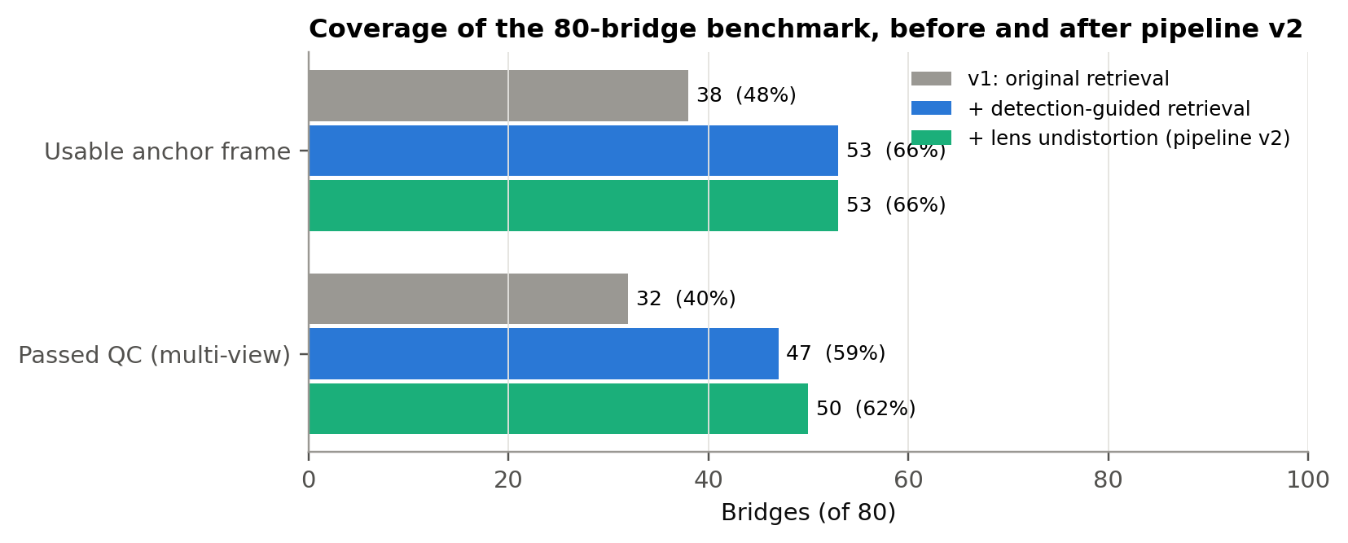
Figure 5. Benchmark coverage before and after pipeline v2. Detection-guided retrieval adds 15 quality-checked bridges; undistortion lets three more previously failing reconstructions pass QC.

MapAnything Accuracy
On S1, single-view estimates had an MAE of 0.92 m (95% CI 0.54–1.45 m), a median absolute error of 0.43 m and a MAPE of 16.8%; 50% of estimates were within 0.5 m and 70% within 1 m. Multi-view estimates were slightly less accurate on average (MAE 1.09 m, median 0.58 m). On the 30 bridges where both settings passed QC, the paired difference in absolute error (single minus multi) was −0.07 m (95% CI −0.30 to 0.16 m), so neither setting is reliably better. The settings differ in bias: single-view under-estimates on average (−0.69 m), while multi-view is closer to unbiased (−0.28 m) but includes several over-estimates of 1.5 m or more (Figure 6). Averaging the single- and multi-view values reduced MAE to 0.86 m on the paired set and raised the share within 1 m from 70% to 77%.
Recovered camera heights on QC-passing cases had a median of 1.29 m (multi-view) and 1.25 m (single-view), consistent with car- or handlebar-mounted cameras, which indicates that MapAnything's metric scale is broadly correct. A direct test confirms this: rescaling each reconstruction so that the camera sits at a fixed 1.25–1.50 m increased MAE from 0.86 m to 1.17–1.49 m. The remaining error is therefore local (wrong target, distortion, underside geometry) rather than a global scale error, which rules out simple scale calibration as a fix.
The road-plane measurement was essential. The earlier point-to-point measure produced clearances of roughly 13–79 m on the same cases, with a single-view MAE of 25.8 m, because its road point lay near the camera rather than beneath the structure.
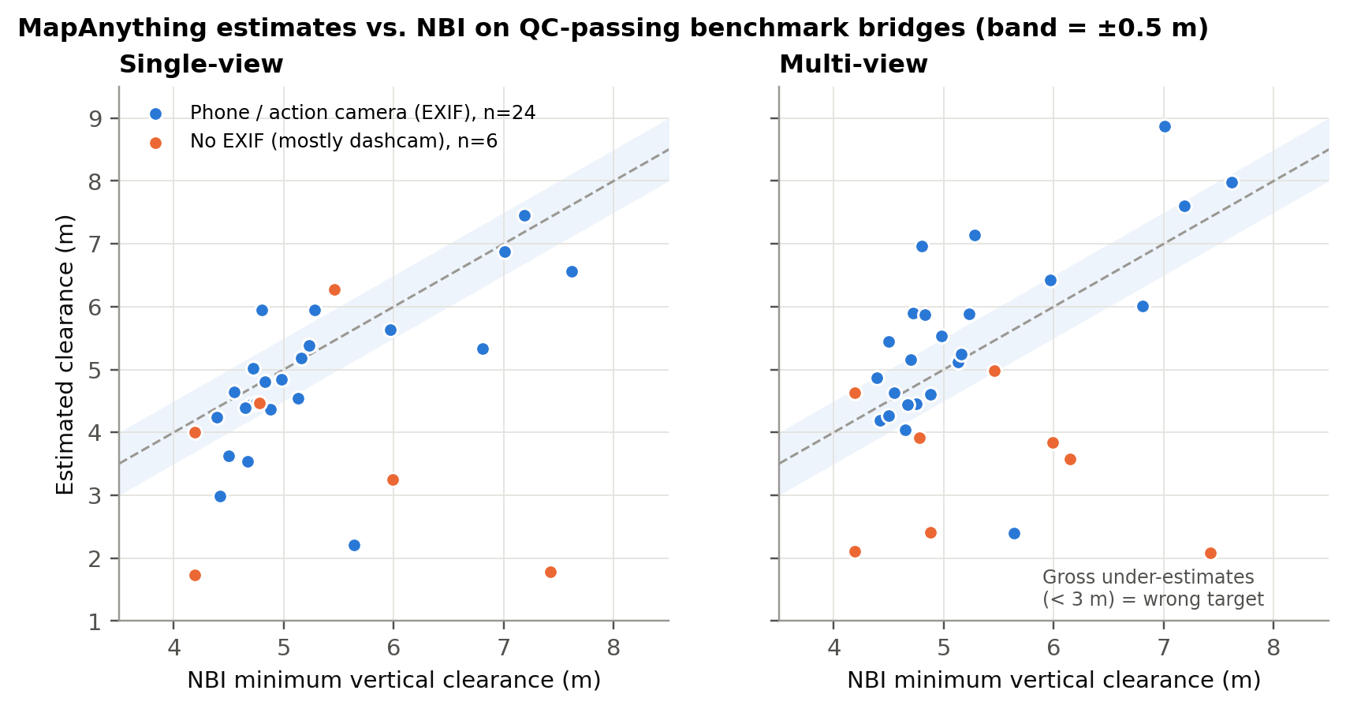
Figure 6. MapAnything estimates versus NBI on QC-passing benchmark bridges. Blue: phone or action cameras (EXIF make present); orange: no EXIF (mostly wide-angle dashcams). Dashed line: perfect agreement; band: ±0.5 m.

Error Analysis
Three factors explain most of the error (Figure 7, Table 2). Camera: the six single-view S1 anchors without EXIF metadata had MAE 2.03 m and bias −1.75 m, against 0.65 m and −0.43 m for phone and action cameras. MapAnything assumes near-pinhole input, and uncorrected wide-angle distortion compresses the apparent height of the structure. Distance: anchors closer than 30 m to the structure were under-estimated by 1.35 m on average, while those at 30–45 m had MAE 0.60 m; at short range the underside occupies the top edge of the frame, where distortion is strongest and depth is least constrained. Clearance: structures above 5.5 m had MAE 1.89 m, largely because this group contains three of the four largest failures, in which a lower element was measured instead of the deck.
Table 2. MapAnything single-view S1 error by factor (metres).
Factor | Group | n | MAE | Median AE | Bias
Camera | Phone / action camera (EXIF) | 24 | 0.65 | 0.32 | −0.43
Camera | No EXIF (mostly dashcam) | 6 | 2.03 | 1.64 | −1.75
Distance to structure | < 30 m | 10 | 1.37 | 0.96 | −1.35
Distance to structure | 30–45 m | 14 | 0.60 | 0.29 | −0.34
Distance to structure | > 45 m | 6 | 0.95 | 0.42 | −0.43
NBI clearance | < 4.75 m | 12 | 0.69 | 0.29 | −0.63
NBI clearance | 4.75–5.5 m | 10 | 0.44 | 0.41 | +0.13
NBI clearance | > 5.5 m | 8 | 1.89 | 1.27 | −1.82

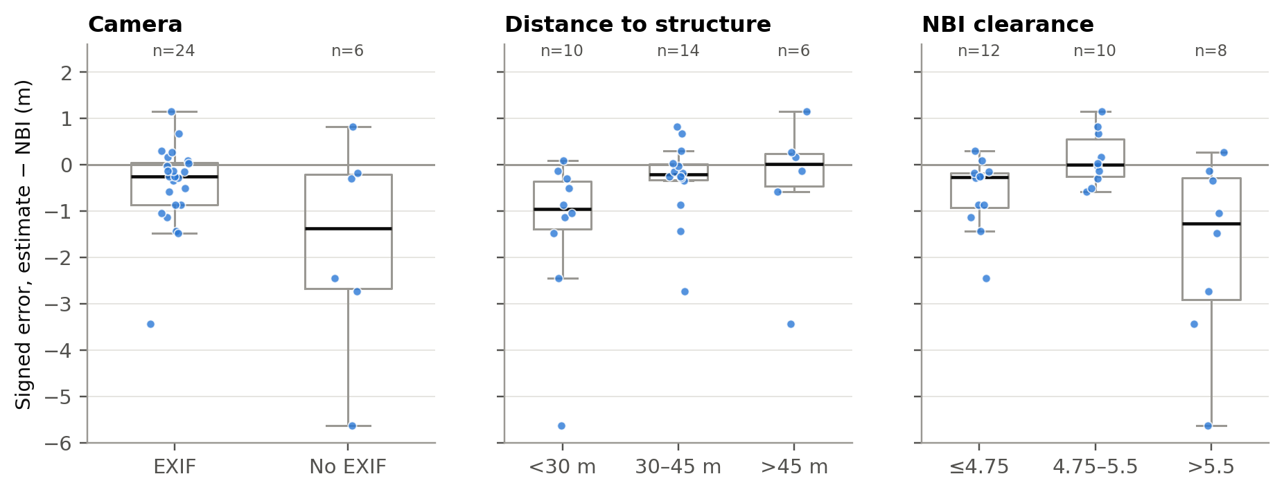
Figure 7. Signed single-view error by camera type, distance from camera to structure, and NBI clearance. Boxes show the interquartile range; points are individual bridges.
Measurement definition. NBI Item 54B is a minimum clearance, which suggests a low percentile of the underside heights should match it better than the median. The data show the opposite (Figure 8): the 10th percentile had MAE 1.79 m and bias −1.71 m, nearly double the median's error. Low percentiles are dominated by abutments, barriers and mask-edge pixels rather than the true lowest point of the deck, so the median is the more faithful estimator of what the inventory records with current masks. Estimating a true minimum would require cleaner underside segmentation, not a different statistic.
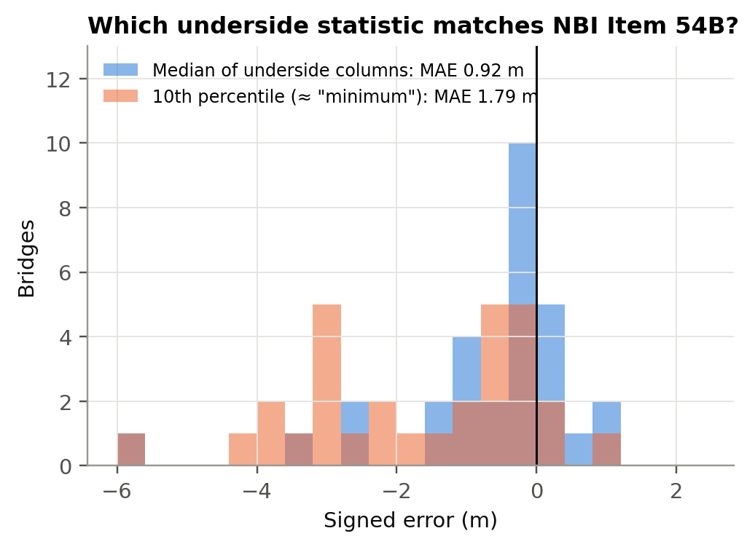
Figure 8. Error of the median versus the 10th percentile of underside heights (single-view, S1). The median is the better match to NBI Item 54B despite the item's minimum-clearance definition.

Camera Fingerprint and Lens Undistortion
Mapillary camera parameters explain the camera effect directly (Figure 9). All 13 benchmark anchors without EXIF metadata have a normalised focal length of 0.32–0.39, roughly a 115–120° horizontal field of view, and strong barrel distortion (k1 between −0.12 and −0.09). The three action cameras fall in the same region, whereas all 64 phone and tablet anchors have k1 above −0.05. The camera rule can therefore be stated from calibration data rather than inferred from missing metadata or capture year, and it transfers to any city without retuning.
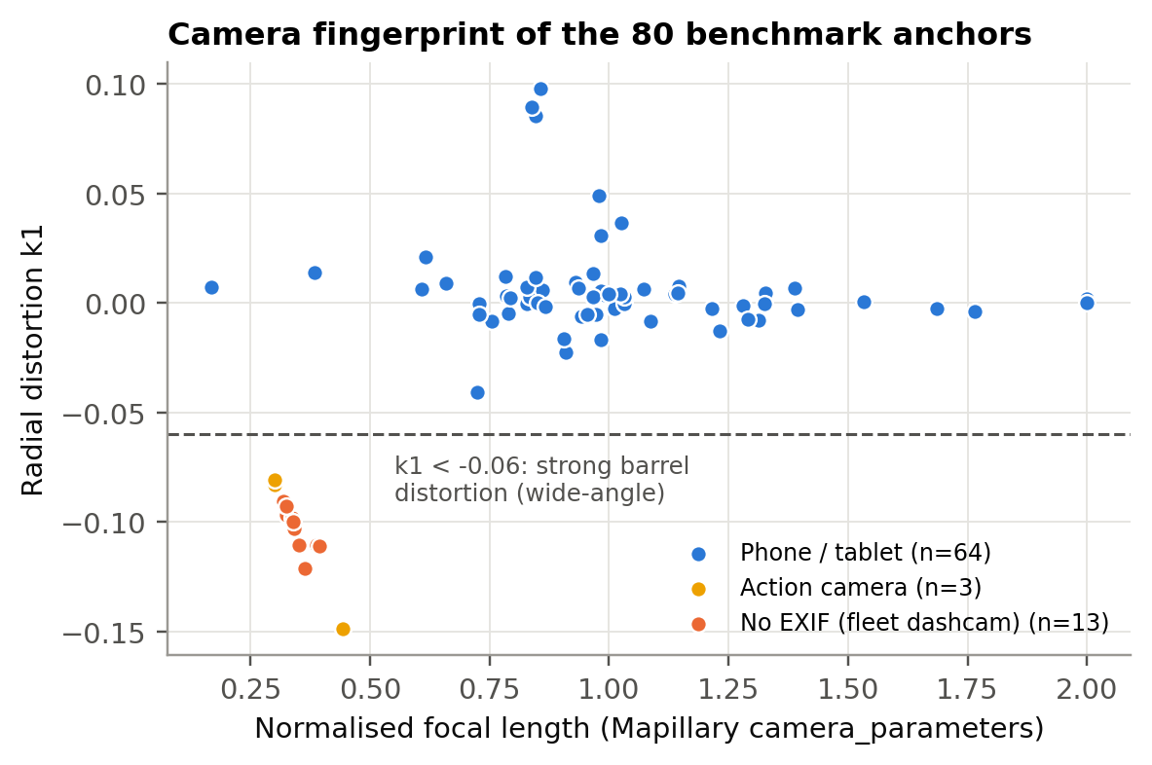
Figure 9. Normalised focal length and first radial distortion coefficient of the 80 benchmark anchor frames, from Mapillary camera parameters. Wide-angle fleet and action cameras separate cleanly from phones.
Undistorting all frames before reconstruction (Figure 10) had three effects. First, it removed most of the systematic under-estimation on wide-angle cameras: single-view bias on anchors without EXIF moved from −1.75 m to −0.77 m and multi-view bias from −1.94 m to +0.59 m, and the bridge with the largest error in the benchmark (NBI 7.42 m, previously measured at 2.1 m) was measured at 7.43 m multi-view. Second, it did not make wide-angle estimates reliable: their multi-view MAE fell only from 2.05 m to 1.48 m, and individual estimates moved by up to 4 m in both directions, plausibly because the strongly cropped undistorted frames retain little road and underside. Third, it helped phones slightly: single-view MAE on EXIF anchors fell from 0.65 m to 0.56 m and the share within 1 m rose from 75% to 88% (paired difference −0.09 m, 95% CI −0.23 to +0.01 m), while phone multi-view accuracy was unchanged (0.77 m versus 0.79 m).
Three reconstructions that had previously failed now passed QC, raising the single-view S1 set from 30 to 34 bridges with a lower MAE (0.80 m versus 0.92 m). Undistortion is therefore worth applying to every frame, but wide-angle captures should still be routed to review rather than published.
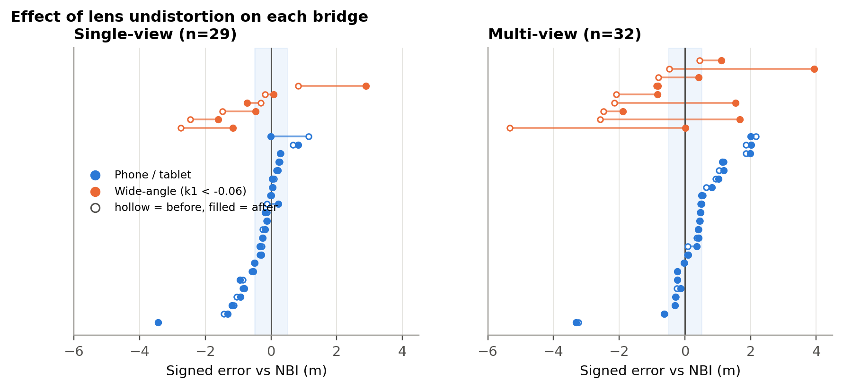
Figure 10. Signed error of each bridge before (hollow) and after (filled) lens undistortion. Orange: wide-angle cameras (k1 < −0.06); blue: phones and tablets. Shaded band: ±0.5 m.

Depth Anything 3
All 80 bridges were represented in both DA3 view settings. The archived measurement check reproduced the stored measurement or failure status for all 76 available case-mode geometry files. With the shared Mask2Former masks, 35 single-view estimates passed QC (43.75% coverage), compared with 32 multi-view estimates (40.00%). S1 MAE was 1.207 m (95% CI 0.838–1.630 m) for single-view and 0.992 m (0.629–1.431 m) for multi-view. The corresponding median absolute errors were 0.727 m and 0.548 m, and 34.29% and 43.75% of retained estimates were within 0.5 m. Figure 11 shows the spread of these estimates. Because the two modes retained different bridges, these averages alone do not establish a paired benefit from adding views.
Most missing estimates arose before clearance measurement: in each mode, 41 anchors had no selected structure and one had no road mask. Single-view had three measurement failures; multi-view had five measurement failures and one additional QC rejection. On S2, MAE was 0.860 m for single-view (n = 26) and 0.680 m for multi-view (n = 25). On S3, 31 single-view and 29 multi-view estimates were available, with MAEs of 1.220 m and 1.036 m, respectively. The complete statistics and confidence intervals for all six subsets are reported in Table 1.
The separate SAM3 configuration processed all 319 frame instances and reused the 40 archived DA3 case-mode geometries required for its selected cases. It yielded 20 QC-passing single-view estimates (25.00% coverage), with MAE 0.543 m (95% CI 0.336–0.771 m), and 19 multi-view estimates (23.75%), with MAE 0.610 m (0.408–0.854 m). Its lower error on its own retained cases coincided with substantially fewer usable estimates than the Mask2Former configuration (Figure 12a).
On the identical QC intersections, Mask2Former and SAM3 had MAEs of 0.589 m and 0.543 m for 20 single-view bridges, and 0.626 m and 0.610 m for 19 multi-view bridges (Figure 12b). The paired MAE differences, Mask2Former minus SAM3, were 0.045 m (95% CI −0.050 to 0.141 m) and 0.017 m (−0.079 to 0.115 m). Neither interval excluded zero. Across all 80 bridges, estimates both passing QC and within 0.5 m numbered 12 versus 10 in single-view and 14 versus 10 in multi-view. Thus, the tested SAM3 configuration did not improve useful measurement coverage at this threshold.
An exploratory thumbnail review classified 40 anchors as lacking a clear visible overhead underside, 28 as showing an overhead region, five as distant structures, five as side or oblique views, and two as inverted images. This helped identify input limitations but did not independently verify bridge identity or explain every failure. One bridge had informed SAM3 prompt and overlap-gate development, and the benchmark had previously been inspected, so the results remain retrospective. Validation on an untouched, geographically separate sample is needed. Metric scale, segmentation boundaries, roadway correspondence, and the difference between inventory minimum clearance and the visible-column median remain sources of uncertainty.
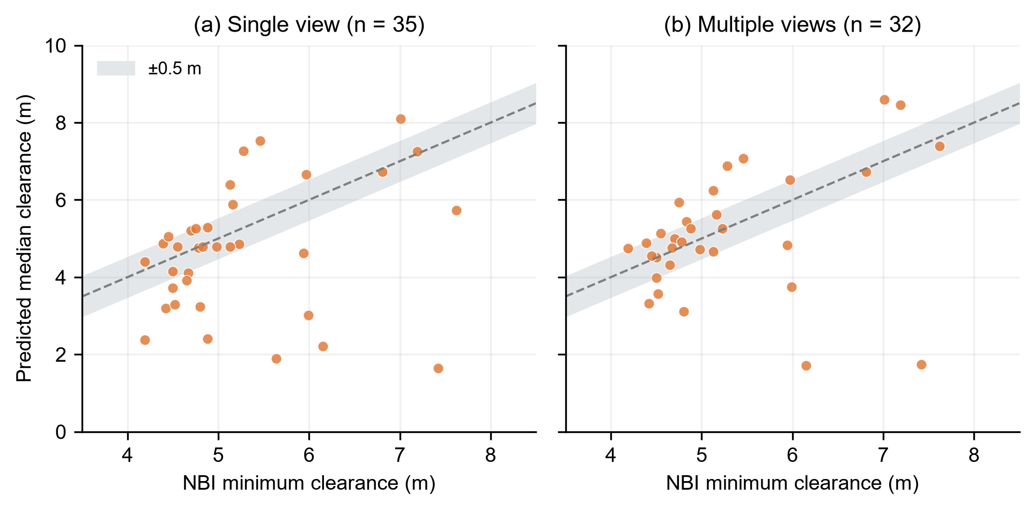
Figure 11. DA3 with Mask2Former: predicted visible-column median clearance versus NBI minimum underclearance for QC-passing (a) single-view and (b) multi-view estimates. Dashed lines indicate equality; grey bands show ±0.5 m. The two clearance definitions differ in spatial coverage.
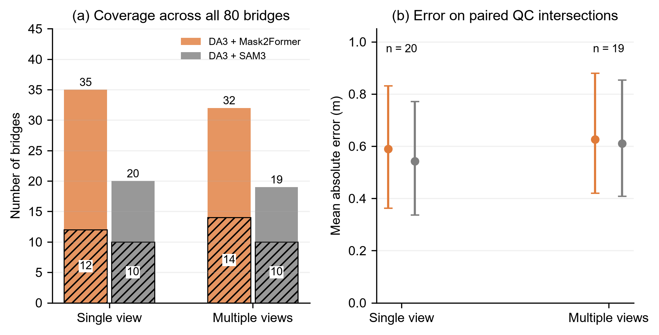
Figure 12. DA3 segmentation comparison. (a) QC-passing counts across all 80 bridges; hatched portions also fall within 0.5 m of the NBI reference. (b) MAE on identical QC intersections, with 95% bootstrap intervals for each configuration's MAE. The paired difference intervals are reported in the text.

VGGT
[Owner: Adaora — VGGT findings. Fill the VGGT rows of Table 1 and send the per-bridge CSV for the unified comparison.]

Method Comparison
No backbone was clearly superior (Table 1). On each method's own QC-passing set, MapAnything single-view had the lowest MAE (0.92 m) and median error (0.43 m), DA3 multi-view the lowest bias (−0.20 m), and DA3 single-view the highest coverage (35 bridges). On the common set S3, MapAnything single-view (0.92 m, n = 30) and DA3 multi-view (1.04 m, n = 29) were within each other's confidence intervals, and on phone and action-camera imagery both reached about 0.65–0.68 m. The camera effect was larger than the backbone effect for both models, which is the main practical conclusion: improving inputs (camera-aware selection, undistortion) matters more than switching backbones.
For deployment we recommend MapAnything single-view as the default backbone: it is the most accurate on the shared set, needs only one usable frame (important where Mapillary coverage is sparse), and runs in about six seconds per bridge. DA3 multi-view is the natural second opinion; because the two models fail on partly different bridges, disagreement between them is a candidate confidence signal for a cross-backbone ensemble (Future Work). The VGGT comparison will be added when its per-bridge results are available.

Pipeline v2 on the Benchmark
Table 4 combines both extensions with the confidence rules. Pipeline v2 measures 50 of the 80 benchmark bridges and accepts 34 of them without review, against 22 for the original pipeline. The share of accepted single-view estimates within 1 m stayed essentially unchanged (81% versus 82%), but MAE rose from 0.49 m to 0.68 m because the 12 added bridges are the harder ones: farther from the inventory coordinate, or reconstructed from frames the original planner had rejected. This is the expected trade-off when a system stops discarding difficult cases, and it is why the confidence rules remain part of the pipeline rather than an afterthought.
Table 4. Original pipeline versus pipeline v2 on the 80-bridge benchmark (MapAnything).
Pipeline | QC-passing | Accepted | Accepted MAE, fused | Accepted MAE, single | Within 1 m (single) | Baseline MAE
v1 (original) | 32 (40%) | 22 (28%) | 0.65 | 0.49 | 82% | 0.59
v2 (retrieval + undistortion) | 50 (62.5%) | 34 (42.5%) | 0.79 | 0.68 | 81% | 0.64

Accepted = passed QC, plausibility gate and camera rule. v1 applies the capture-year proxy for the camera rule; v2 applies the k1 rule. Baseline = constant 4.97 m on the same accepted bridges.

Absolute Accuracy against a No-Image Baseline
An inventory-based map provider already knows the typical clearance of an urban overpass. To ask whether imagery adds information beyond that, we scored a constant prediction of the benchmark median (4.97 m) on the same bridges (Figure 13, Table 3). On the benchmark the constant baseline had MAE 0.71 m on the 30 MapAnything S1 bridges, lower than the 0.92 m of the single-view estimates. After the plausibility gate and camera rule the gap nearly closed (0.65 m versus 0.59 m on 22 bridges), but the pipeline did not beat the baseline in absolute terms.
The baseline is strong for a structural reason: highway overpasses are built to a small set of design clearances, so most bridges cluster near the median. Median absolute error tells the same story (0.44 m versus 0.31 m on accepted development bridges). This does not make the estimates useless; it locates their value. A constant prediction can never identify the bridges that matter most for routing (the unusually low ones) or detect a map value that is wrong. The next two sections test exactly those capabilities.
Table 3. Pipeline (median of views) versus the no-image baseline, MapAnything.
Set | Rule set | n | Coverage | MAE | Baseline MAE | Spearman ρ
Development | All QC-passing | 32 | 100% | 1.11 | 0.70 | 0.32
Development | + plausibility gate | 27 | 84% | 0.70 | 0.64 | 0.60
Development | + camera / recency rule | 22 | 69% | 0.65 | 0.59 | 0.76
Held-out | All QC-passing | 51 | 100% | 0.87 | 0.40 | 0.08
Held-out | + plausibility gate | 49 | 96% | 0.76 | 0.34 | 0.13
Held-out | + camera / recency rule | 43 | 84% | 0.73 | 0.37 | 0.32
Held-out | + view agreement | 29 | 57% | 0.62 | — | —

Coverage is relative to QC-passing estimates in each set. Baseline = constant 4.97 m. Rules are applied in sequence and were fixed on the development set.
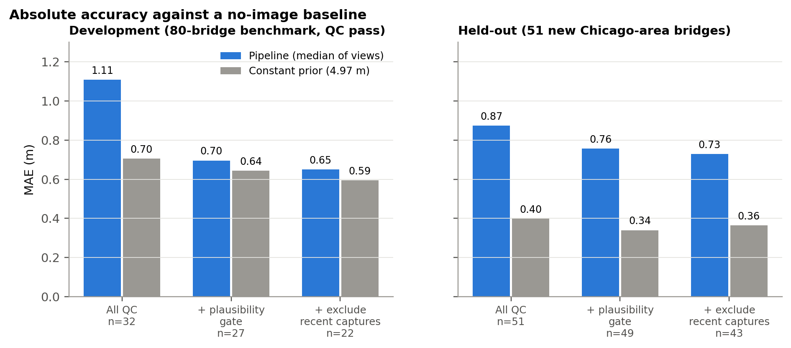
Figure 13. MAE of the pipeline and of the constant baseline on the development benchmark and the held-out bridges, after each rule.

Generalization to Held-Out Bridges
The 51 held-out bridges were processed with the identical code, and every threshold was taken from the development set. Three results carry over and one does not.
- Raw accuracy carries over. Held-out MAE was 0.93 m single-view and 0.94 m multi-view, matching the benchmark (0.92 m and 1.09 m), with 67–69% of estimates within 1 m. There was no sign of overfitting to the benchmark.
- The rules carry over. The plausibility gate and the camera rule reduced held-out MAE from 0.87 m to 0.73 m while keeping 84% of estimates, and adding the view-agreement rule reduced it to 0.62 m at 57% coverage (Table 3). On held-out bridges the gate fired twice, removing errors of 1.6 m and 5.8 m. Across all 83 bridges, the share of gross errors (> 1.5 m) fell from 18.1% to 10.8% after the rules.
- Capture recency carries over. Anchors from 2023–2026 had a median error of 1.20 m against 0.59 m for earlier captures (Figure 14), the same pattern as the camera split on the benchmark, now observed on bridges that played no part in defining it.
- Bias does not carry over. After the rules, development estimates were biased by +0.46 m and held-out estimates by +0.56 m, while before the rules the signs differed (−0.32 m versus +0.27 m). A linear calibration fitted on development bridges (slope 0.53, intercept 2.18 m) lowered held-out MAE from 0.73 m to 0.42 m, but that slope mostly shrinks estimates toward the regional mean, and the constant baseline still scored 0.37 m on the same bridges. We therefore do not recommend post-hoc calibration until a larger validation set exists; with 22 development bridges it cannot be distinguished from regression to the mean.
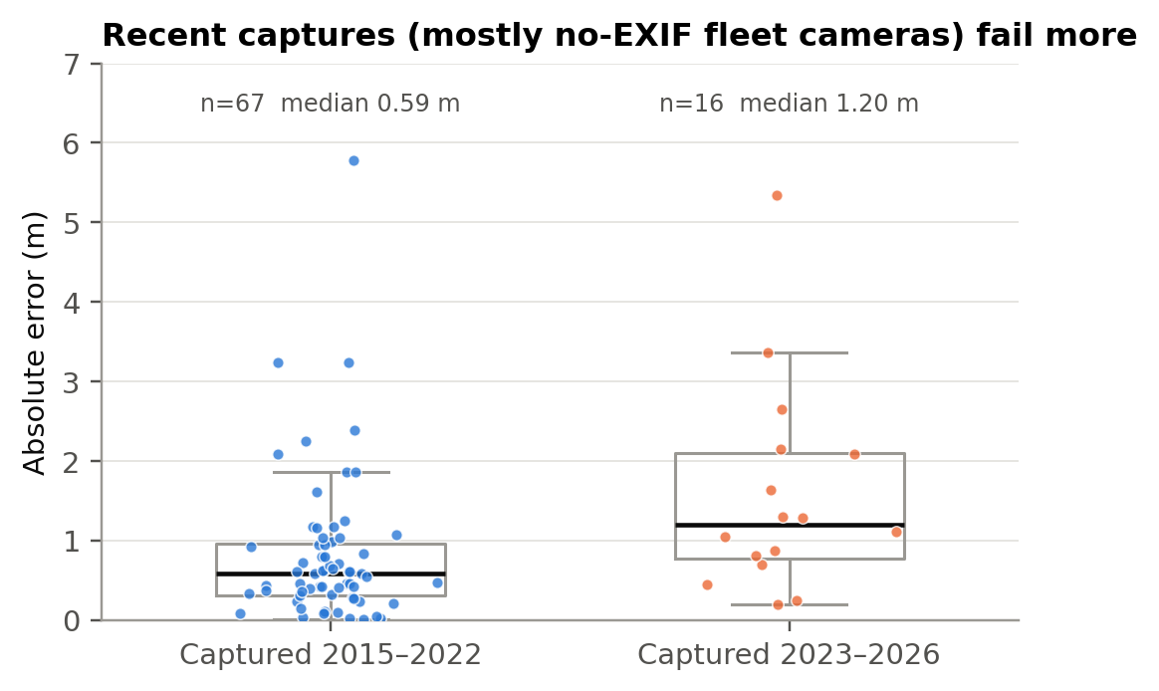
Figure 14. Absolute error by capture year across all 83 quality-checked bridges. Recent captures are mostly from fleet cameras without EXIF metadata.
The held-out set is concentrated in the common 4.3–5.2 m range (after the rules its standard deviation is 0.35 m), which explains both the strong baseline and the low rank correlation on that set (ρ = 0.32): when nearly every bridge has the same clearance, a 0.6 m measurement error is larger than the true differences between bridges. The external metros below provide a geographically separate test with a wider clearance range.

Generalization to New Metropolitan Areas
The frozen pipeline was run on 60 bridges in each of Indianapolis and Milwaukee with every threshold taken from Chicago (Table 5, Figure 15). The external test supports four conclusions.
- Coverage behaves the same way. 25 of 60 bridges passed QC in each city (42%, against 40% for the original Chicago pipeline), and the dominant failure was again no overhead structure in the selected sequence (30 and 25 bridges). The retrieval problem is a property of inventory coordinates, not of Chicago, so detection-guided retrieval should transfer as well.
- Single-view accuracy transfers. Accepted single-view estimates had MAE 0.73 m in Indianapolis (median 0.39 m) and 0.68 m in Milwaukee (median 0.64 m), 0.70 m overall with 80% within 1 m, essentially equal to the 0.68 m of accepted single-view estimates on the Chicago benchmark under pipeline v2.
- The confidence rules transfer. Of the 50 QC-passing external estimates, the camera rule and plausibility gate rejected four; three of them had errors of 1.7, 2.4 and 4.8 m. The k1 rule flagged the only QC-passing wide-angle fleet capture in Indianapolis (error 2.4 m) without any retuning.
- Multi-view does not transfer reliably. In Milwaukee, multi-view estimates were biased high by 1.12 m (MAE 1.20 m), which also pulled the fused value off (MAE 1.14 m), while single-view stayed nearly unbiased (−0.25 m). In Indianapolis multi-view was the most accurate setting (0.61 m). Multi-view quality therefore depends on how a city's sequences were captured (frame spacing, resolution and older phone models in the Milwaukee imagery are plausible causes), so it is better used as an agreement check than as the published value.
Table 5. Frozen pipeline in two external metros (accepted estimates; MapAnything).
Metro | Bridges | QC-passing | Accepted | Single MAE (median) | Multi MAE | Fused MAE | Within 1 m (single) | Baseline MAE
Chicago, benchmark (v2) | 80 | 50 | 34 | 0.68 (0.48) | — | 0.79 | 81% | 0.64
Indianapolis | 60 | 25 | 22 | 0.73 (0.39) | 0.61 | 0.64 | 76% | 0.37
Milwaukee | 60 | 25 | 24 | 0.68 (0.64) | 1.20 | 1.14 | 83% | 0.47
External, combined | 120 | 50 | 46 | 0.70 (0.51) | 0.92 | 0.90 | 80% | 0.42

Accepted = passed QC, plausibility gate (3–9 m) and camera rule (k1 < −0.06 or no EXIF → review). Chicago single-view statistics are on the 32 accepted bridges with a single-view value. Baseline = constant 4.97 m on the same bridges. External runs use the original (v1) retrieval so that coverage is comparable with the first Chicago run.
Absolute accuracy relative to the constant baseline also replicates: the baseline scored 0.42 m on the 46 accepted external bridges against 0.70 m for the pipeline. The view-agreement rule narrows the gap. On the 25 external bridges where single- and multi-view estimates agree within 1.05 m, single-view MAE was 0.50 m against 0.46 m for the baseline, and in Milwaukee it was 0.48 m against 0.60 m (n = 11), the first subset in this study on which imagery beat the regional prior in absolute terms, although 11 bridges are too few for that difference to be conclusive. Ranking was weaker than in Chicago (AUC 0.62 for clearances below 4.6 m across both metros; 0.70 in Milwaukee, where 9 of the 24 accepted bridges are low), partly because each city contributed only two to four structures above 5.5 m. Together with the held-out Chicago bridges, this is the strongest evidence in the study that the pipeline's behaviour, including its weaknesses, is predictable outside the city where it was designed.
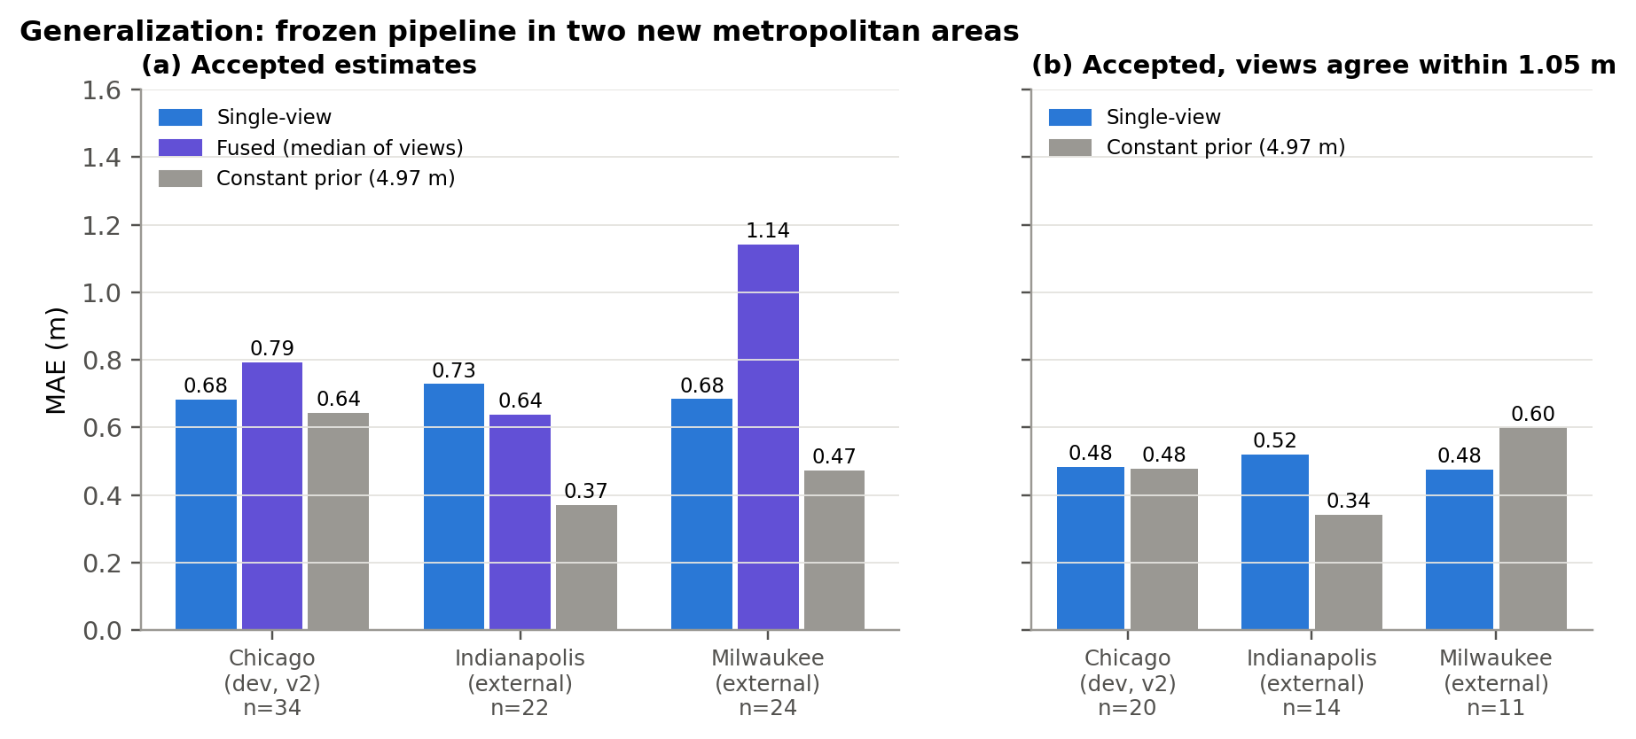
Figure 15. MAE of accepted estimates in Chicago (pipeline v2) and the two external metros, against the constant 4.97 m baseline on the same bridges. (a) All accepted estimates; (b) accepted estimates whose single- and multi-view values agree within 1.05 m.

Operational Value: Screening and Discrepancy Detection
Ranking is what a screening layer needs. On the 65 accepted estimates across both sets, the pipeline separated bridges below 4.6 m (about 15 ft, 21 positives) from the rest with AUC 0.75, and bridges above 5.5 m (5 positives) with AUC 0.90 (Figure 16). Using a simple rule that flags any accepted estimate below 4.9 m as possibly below 4.6 m, the pipeline flagged 24 bridges and caught 13 of the 21 truly low ones (recall 62%, precision 54%). On the development set, where clearances span the full range, the rank correlation between accepted estimates and NBI was 0.76.
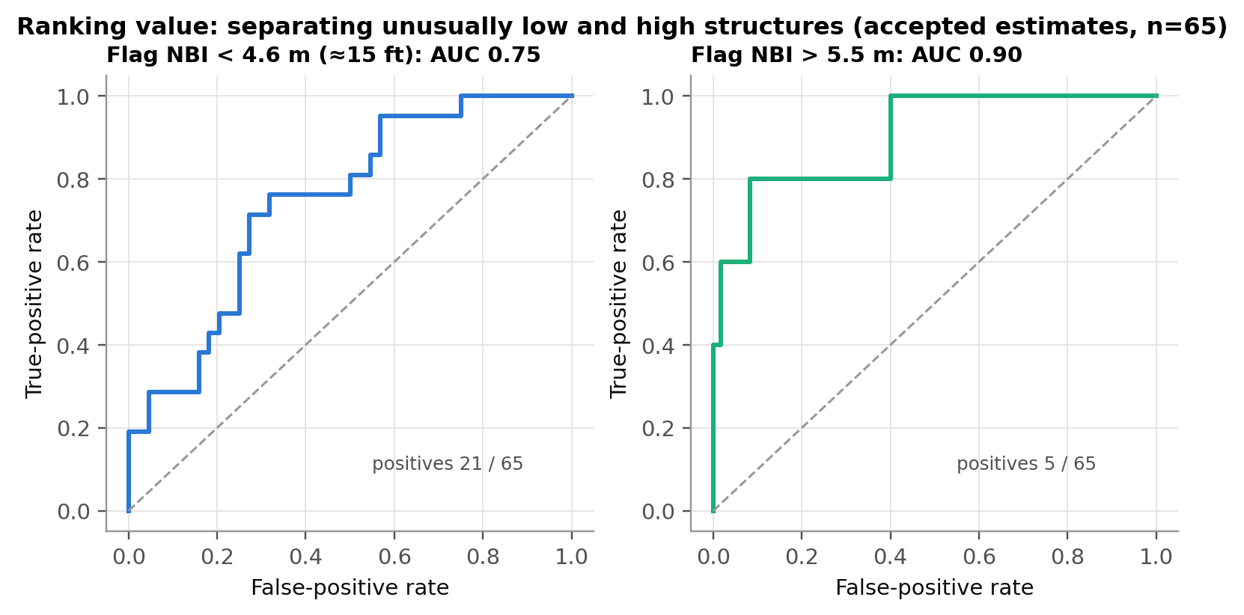
Figure 16. ROC curves for flagging low (< 4.6 m) and high (> 5.5 m) clearances from accepted estimates (n = 65, development and held-out combined).
Selective prediction gives a second lever. On the development set, publishing only the most confident half of the estimates halved the error, from 1.11 m to 0.49 m (Figure 17). On the held-out set the same score reduced error from 0.87 m to 0.65–0.66 m at 50–75% coverage but was not monotonic at the top: some of the most confident held-out bridges were still wrong by more than 1 m. The confidence score is therefore useful for triage at moderate coverage, but it should not be read as a calibrated probability, and the most confident estimates still need spot checks.
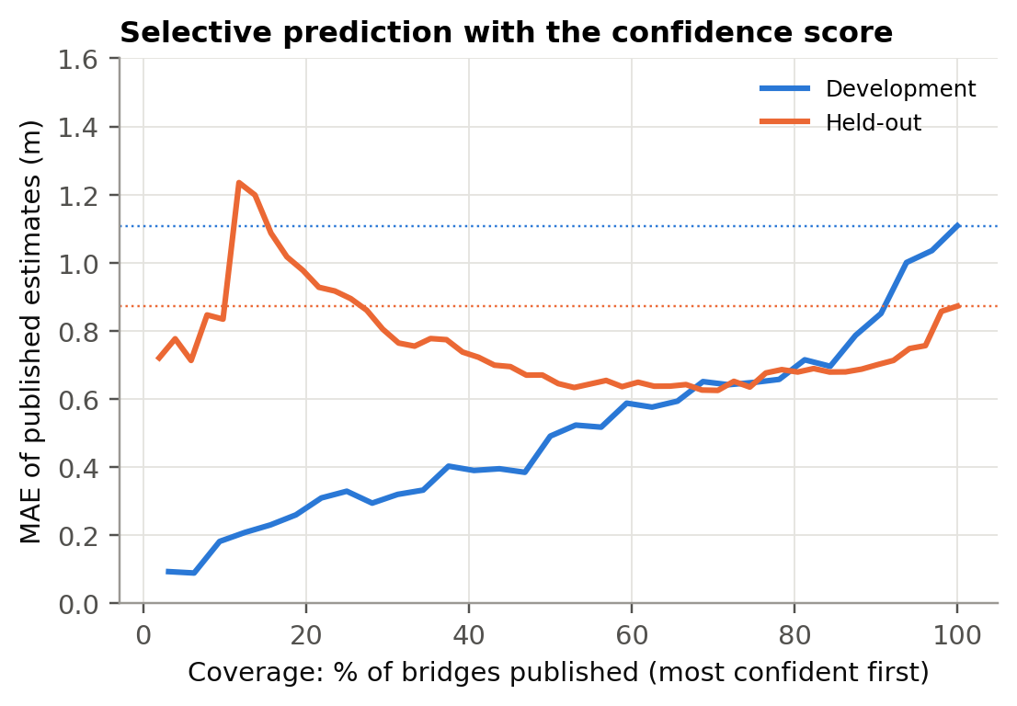
Figure 17. Risk–coverage curves for the confidence score. Dotted lines show the MAE when every estimate is published.

Stop-Sign Size
Of 25 sampled stop signs, 15 were segmented in at least one frame; the other ten were not detected by the combined red-colour and Vistas traffic-sign filter. Sign width was computed as the sign's pixel width multiplied by MapAnything depth and divided by the focal length.
Single-view estimates (n = 14) had a median of 0.88 m. Against the nearest standard size (0.762 m or 0.914 m) the MAE was 0.11 m, and 71% of estimates were within 15% of a standard size. Multi-view estimates (n = 15) had a median of 0.94 m and were biased high relative to the 30-inch standard (MAE vs. nearest standard 0.10 m; 67% within 15%). Because signs occupy only 50–150 pixels, a one- or two-pixel error at the mask edge changes the estimate by several percent, so mask quality rather than depth dominates the error (Figure 18). The same pipeline therefore transfers to a second feature type without modification, but small objects need higher-resolution imagery or sub-pixel boundary refinement.
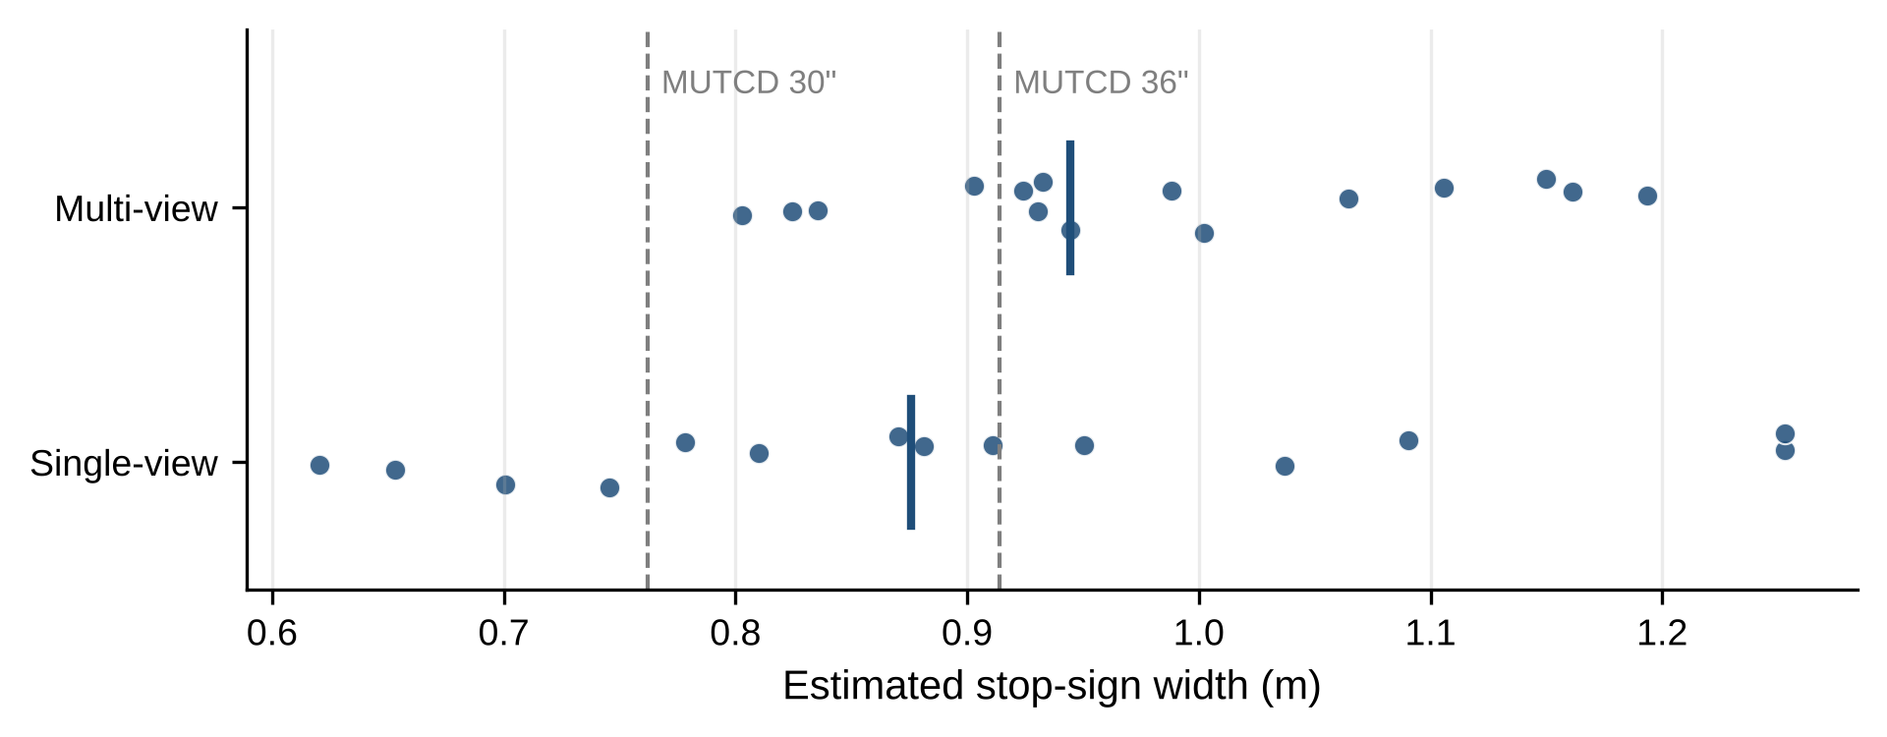
Figure 18. Estimated stop-sign widths. Vertical bars mark the median; dashed lines mark the MUTCD 30-inch and 36-inch standard sizes.

Building Height
[Owner: Adaora — building-height findings or pointer to Future Work.]

Discussion
[Kely draft replacing the spring text; Adaora to revise.]
The project's central idea is technically sound. A fully automated chain from an inventory record to a metric clearance works without manual point selection, its metric scale is broadly correct (recovered camera heights of about 1.3 m), and it produces estimates within half a metre of the inventory for about half of the bridges it measures. Moving from the spring prototype, which reported a handful of hand-picked cases, to a frozen benchmark and a held-out set changed the picture in three ways that are more useful to HERE than a single accuracy number.
The binding constraint is retrieval, not reconstruction. More than half of the benchmark failed before any 3D model ran, and the cause is a mismatch between the inventory coordinate and the road the camera must travel on. Backbone choice moved MAE by about 0.1–0.2 m, while the camera effect moved it by more than 1 m and the location effect removed half of the bridges. Engineering effort should follow that ranking.
Errors are structured and mostly detectable. Wide-angle fleet cameras, very short camera-to-structure distances, and measuring the wrong element produce most large errors, and all three can be flagged from metadata or from the estimate itself. Rules derived from 32 development bridges transferred to 51 new bridges, which is the strongest evidence in this study that the approach generalizes within the region. The external metros extend this beyond Chicago: single-view accuracy, the coverage failure and the value of the rules all replicated in Indianapolis and Milwaukee, while multi-view did not.
Inputs matter more than models. The largest improvements in this project came from changing what the model sees, not which model runs. Detection-guided retrieval added 15 measured bridges; undistortion removed most of the wide-angle bias; a calibration-based camera rule replaced a proxy and transferred unchanged to new cities. By contrast, backbones differed by 0.1–0.2 m, and post-hoc scale or linear calibration did not survive held-out testing. For HERE this suggests investing in retrieval, camera metadata and quality routing around an off-the-shelf backbone rather than in fine-tuning: NBI supplies one scalar per bridge, which is enough to calibrate and route but not to supervise a dense 3D model.
Absolute accuracy should be judged against what is already known. A constant prediction of the regional median is hard to beat for a feature with a narrow design range. Reporting the baseline does not weaken the result; it shows where imagery adds information (identifying atypical structures and checking existing values) and prevents over-claiming. The same logic applies to other attributes with standard values, such as sign sizes and lane widths, where detecting deviations from the standard is the useful output.
Limitations remain. The benchmark is modest and was inspected during development, so its own results are retrospective; the held-out Chicago set is concentrated in a narrow clearance range, and the external metros contribute 46 accepted bridges, enough to confirm transfer but not to fit city- or camera-specific calibration. The image-derived median and the inventory minimum are different quantities, and NBI values themselves can be outdated after resurfacing. Finally, lens undistortion with Mapillary camera parameters removed the systematic bias of wide-angle cameras but not their variance, so these captures, which dominate recent Mapillary coverage, are still routed to review rather than used.

Business Value for HERE
[Kely draft for the new subsection; Adaora to revise.]
The results support three uses, in increasing order of required accuracy.
- Map-attribute validation. Compare each accepted estimate with the clearance already in the map and route large disagreements (for example more than 1 m) to an analyst. Because the largest errors are mostly caught by the rules and the median error of accepted estimates is about 0.6 m, a disagreement well above that level on an accepted estimate is a strong candidate for a stale or missing map value; reviewing a first batch of flagged cases would measure how often that holds. This uses the pipeline as a change detector rather than a measuring tool.
- Low-clearance screening for truck routing. Rank structures by estimated clearance and prioritise the lowest for verification. With AUC 0.75 for clearances below 4.6 m, screening the lowest third of estimates would concentrate field effort on the bridges most likely to restrict trucks.
- Coverage expansion where no value exists. For structures with no clearance attribute, an accepted estimate with its confidence tier is better than no value for internal prioritisation, but it should not be published to drivers without verification at current accuracy.
The cost profile is favourable. Inference takes about six seconds per bridge on a single L4 GPU, so the full Illinois highway-under inventory (several thousand records) can be processed in a few GPU-hours using imagery that already exists. Costs scale with compute rather than with field crews, and each additional city requires only Mapillary coverage and an inventory for validation. The pipeline outputs GeoJSON with the estimate, confidence tier and the reasons for any flag, which fits directly into a review queue. Because the frozen rules transferred to Indiana and Wisconsin without retuning, onboarding a new region is a configuration change (state NBI file and bounding box) rather than a modelling project.

Conclusion
This project moved image-based dimension estimation from a handful of hand-picked examples to an automated, backbone-agnostic pipeline evaluated against official ground truth, a no-image baseline, and bridges held out from development. The pipeline retrieves Mapillary imagery for a target structure, isolates the structure and road automatically, reconstructs the scene in metres, measures clearance against a fitted road plane, and decides whether each estimate should be accepted, reviewed or rejected without using ground truth.
On quality-checked Chicago bridges, MapAnything single-view estimates were within 0.43 m of the NBI value at the median and within 0.65 m on average for phone and action-camera imagery; DA3 performed comparably. The main limits are where the imagery is captured (inventory coordinates that miss the road crossing) and how (uncalibrated wide-angle cameras), both identifiable in advance. Pipeline v2 raised benchmark coverage from 40% to 62.5% by fixing retrieval and correcting lens distortion. Rules set on the benchmark transferred to 51 held-out Chicago bridges and, unchanged, to 120 bridges in Indianapolis and Milwaukee, where accepted single-view estimates matched their Chicago accuracy (0.70 m versus 0.68 m). Against a constant regional baseline, the estimates do not yet improve absolute accuracy, but they rank structures well enough to screen for unusually low clearances and to detect inconsistent map values. That is the recommended first deployment: a low-cost validation and screening layer that directs survey effort, with single-view MapAnything as the default value, multi-view agreement as a confidence check, and publication of image-derived values reserved for after the calibration steps below.

Future Work
- Map-matched retrieval at scale. Combine detection-guided retrieval with OpenStreetMap crossing geometry (implemented, but not run while public Overpass servers were overloaded) so that the probe searches along the road beneath each structure rather than around its inventory point.
- Wide-angle cameras. Undistortion removed the systematic bias of fleet cameras but not their variance. Test whether passing the corrected intrinsics directly to the backbone, or rejecting frames with too little visible road after undistortion, makes these captures usable, since they dominate recent Mapillary coverage.
- Cross-backbone ensemble. Combine MapAnything, DA3 and VGGT per bridge using the shared per-bridge schema, and test whether disagreement between backbones is a better confidence signal than disagreement between views, which did not transfer to the held-out set.
- Calibration on a larger reference set. With several hundred external bridges, refit the bias correction per camera class and re-evaluate against the regional baseline before publishing any image-derived value.
- SAM3 as a fallback. Run SAM3 only when Mask2Former finds no valid structure, so it can add bridges rather than remove them; this needs gated model access in the shared environment.
- Beyond bridges. Extend to overhead sign structures (IDOT vertical-clearance records), lane width and building height, and use vision-language models for frame selection and review triage.

References
Bland, J. M., & Altman, D. G. (1986). Statistical methods for assessing agreement between two methods of clinical measurement. The Lancet, 327(8476), 307–310. https://doi.org/10.1016/S0140-6736(86)90837-8
Carion, N., Gustafson, L., Hu, Y.-T., Debnath, S., Hu, R., Suris, D., Ryali, C., Alwala, K. V., Khedr, H., Huang, A., Lei, J., Ma, T., Guo, B., Kalla, A., Marks, M., Greer, J., Wang, M., Sun, P., Rädle, R., ... Feichtenhofer, C. (2025). SAM 3: Segment anything with concepts. arXiv. https://doi.org/10.48550/arXiv.2511.16719
Cheng, B., Misra, I., Schwing, A. G., Kirillov, A., & Girdhar, R. (2022). Masked-attention mask transformer for universal image segmentation. In Proceedings of the IEEE/CVF Conference on Computer Vision and Pattern Recognition (pp. 1290–1299).
Federal Highway Administration. (1995). Recording and coding guide for the structure inventory and appraisal of the nation’s bridges (Report No. FHWA-PD-96-001). https://rosap.ntl.bts.gov/view/dot/38886
Federal Highway Administration. (2009). Manual on Uniform Traffic Control Devices for streets and highways (2009 ed., Part 2B, Table 2B-1). U.S. Department of Transportation. https://mutcd.fhwa.dot.gov/pdfs/2009/part2b.pdf
Federal Highway Administration. (2025). National Bridge Inventory 2025 delimited data: Illinois, Indiana and Wisconsin [Data set]. https://www.fhwa.dot.gov/bridge/nbi/2025/delimited/
Fischler, M. A., & Bolles, R. C. (1981). Random sample consensus: A paradigm for model fitting with applications to image analysis and automated cartography. Communications of the ACM, 24(6), 381–395. https://doi.org/10.1145/358669.358692
Geifman, Y., & El-Yaniv, R. (2017). Selective classification for deep neural networks. In Advances in Neural Information Processing Systems 30 (pp. 4878–4887).
Hartley, R., & Zisserman, A. (2004). Multiple view geometry in computer vision (2nd ed.). Cambridge University Press. https://doi.org/10.1017/CBO9780511811685
Illinois Department of Transportation. (n.d.). Vertical clearance [Data set]. ArcGIS. Retrieved November 1, 2026, from https://gis1.dot.illinois.gov/arcgis/rest/services/Permits/TruckPermitRoutes/MapServer/15
Keetha, N., Müller, N., Schönberger, J., Porzi, L., Zhang, Y., Fischer, T., Knapitsch, A., Zauss, D., Weber, E., Antunes, N., Luiten, J., Lopez-Antequera, M., Rota Bulò, S., Richardt, C., Ramanan, D., Scherer, S., & Kontschieder, P. (2026). MapAnything: Universal feed-forward metric 3D reconstruction. In 2026 International Conference on 3D Vision (3DV) (pp. 499–509). IEEE. https://doi.org/10.1109/3DV69130.2026.00054
Lin, H., Chen, S., Liew, J., Chen, D. Y., Li, Z., Shi, G., Feng, J., & Kang, B. (2025). Depth Anything 3: Recovering the visual space from any views. arXiv. https://doi.org/10.48550/arXiv.2511.10647
Mapillary. (n.d.). mapillary.config.api.entities. In Mapillary Python SDK documentation. https://mapillary.github.io/mapillary-python-sdk/docs/mapillary.config.api/mapillary.config.api.entities/
Neuhold, G., Ollmann, T., Rota Bulò, S., & Kontschieder, P. (2017). The Mapillary Vistas dataset for semantic understanding of street scenes. In Proceedings of the IEEE International Conference on Computer Vision (pp. 4990–4999).
OpenStreetMap contributors. (2026). OpenStreetMap [Data set]. Retrieved via the Overpass API. https://www.openstreetmap.org
Wang, J., Chen, M., Karaev, N., Vedaldi, A., Rupprecht, C., & Novotny, D. (2025). VGGT: Visual geometry grounded transformer. In Proceedings of the IEEE/CVF Conference on Computer Vision and Pattern Recognition (pp. 5294–5306).
Yang, L., Kang, B., Huang, Z., Xu, X., Feng, J., & Zhao, H. (2024). Depth Anything: Unleashing the power of large-scale unlabeled data. In Proceedings of the IEEE/CVF Conference on Computer Vision and Pattern Recognition (pp. 10371–10381).
Yin, W., Zhang, C., Chen, H., Cai, Z., Yu, G., Wang, K., Chen, X., & Shen, C. (2023). Metric3D: Towards zero-shot metric 3D prediction from a single image. In Proceedings of the IEEE/CVF International Conference on Computer Vision (pp. 9043–9053).

Appendices

Appendix A. Pipeline v2 Implementation and Experiment Log
All new experiments ran in a single Colab notebook on an NVIDIA L4 GPU, importing the existing benchmark notebook’s configuration, retrieval, segmentation, MapAnything and measurement functions unchanged and writing every output to a separate pipeline_v2 folder on Drive, so the original runs were never modified. Each experiment logs per-bridge rows (status, QC flag, single-view, multi-view and all-frames clearance, recovered camera height, measured columns, structure distance, anchor capture year, and anchor camera make, model and distortion coefficients) to CSV.
- Experiment A (detection-guided retrieval): 42 benchmark bridges without an anchor; up to 12 candidate sequences probed per bridge with two frames each; about 30 minutes.
- Experiment B (lens undistortion): all 38 anchored benchmark bridges, every candidate frame undistorted with its own Mapillary camera parameters; about 15 minutes.
- Experiment C (external metros): NBI 2025 releases for Indiana and Wisconsin, the same filters, stratified ordering, retrieval and frame selection as the Chicago benchmark, and the original (v1) retrieval so that coverage is comparable; about 20 minutes per metro.
- OpenStreetMap crossing retrieval: implemented and unit-tested on synthetic geometry, but not run because the public Overpass endpoints returned capacity errors throughout the experiment window.
The standalone module clearance_v2.py packages the same pipeline as independent, testable functions (NBI loading for any state, OSM crossing search, Mapillary retrieval with camera parameters, undistortion, segmentation with fallback, a backbone registry, measurement, QC and confidence, and evaluation with baseline-relative skill), so that a new backbone can be compared by adding one adapter that returns a metric point map, confidence and anchor camera centre.
[Adaora: merge your implementation notes (VGGT, Pi3 testing, PCA plane fitting for signs) here or into Appendix C.]

Appendix B. Benchmark and Held-Out Sets
The development benchmark contains 80 Illinois NBI bridges selected as described in Data, with frozen anchor and view frames; per-case JSON files record the NBI attributes, selected images, intermediate statistics and status. The held-out set contains the 51 additional bridges from the expanded MapAnything run that passed QC; their identifiers are listed in the results file alongside capture year, service type and the distance between the NBI coordinate and the anchor camera. The three spring sign-structure cases are retained in Appendix C for history only.

Appendix C. Early Experiments (Spring 2026)
Before the NBI benchmark, the team compared models on three manually selected Illinois Department of Transportation (IDOT) overhead sign structures with documented vertical clearance, measured point-to-point between selected image points. These experiments guided model selection but are too few to estimate accuracy, and they used a different measurement definition from the main results. Table C1 lists them for completeness.
Table C1. Early experiments on IDOT overhead sign structures (feet).
Experiment Configuration | Ground Truth (ft) | Estimate (ft) | Accuracy | Error
Single-image baseline | 18.08 | 15.604 | 86.31% | 13.69%
Five-image same-sequence input with manual selection | 18.08 | 19.048 | 94.65% | 5.35%
Five-image workflow with SAM3 automated selection | 18.08 | 19.788 | 90.55% | 9.45%
Depth Anything v3 + SAM3, baseline case | 18.08 | 17.39 | 96.18% | 3.82%
Depth Anything v3 + SAM3, image set 1 | 18.00 | 17.01 | 94.50% | 5.50%
Depth Anything v3 + SAM3, image set 2 | 18.83 | 25.60 | 64.05% | 35.95%

