Real-World Dimension and Metric Estimation of Physical Features from Street-Level Imagery Using 3D Reconstruction and Advanced Computer Vision
HERE Technologies

Kely Zhang, Anna Chen, Adaora Ezike
Advisor: Dr. Jeanette Shutay

A Capstone Project
Submitted to the University of Chicago in partial fulfillment of the requirements of the degree of
Master of Science in Applied Data Science

Division of Physical Sciences
December 2026

Abstract
[Owner: Kely — draft; final numbers after Table 1 is complete]
Metric map attributes such as bridge vertical clearance are expensive to collect with LiDAR surveys and field audits. This project, conducted with HERE Technologies, evaluates whether existing street-level imagery can estimate such attributes at scale. We built an automated pipeline that retrieves Mapillary image sequences approaching a target structure, segments the structure and road surface with Mask2Former trained on Mapillary Vistas, reconstructs metric 3D geometry with a feed-forward model, and measures clearance as the distance from the structure underside to a RANSAC-fitted road plane. Estimates are benchmarked against the FHWA National Bridge Inventory (NBI) minimum vertical under-clearance for an 80-bridge Chicago-area sample. With MapAnything as the 3D backbone, 32 bridges passed an automatic quality check that uses no ground truth; single-view estimates reached a mean absolute error (MAE) of 0.92 m (median 0.43 m), and 0.65 m on phone and action-camera imagery. Wide-angle dashcam imagery was the dominant failure mode. The same pipeline sized stop signs to within 15% of a standard size in 71% of measured cases. The results support image-based clearance estimation as a scalable screening layer for map attributes, with camera-aware filtering and human review of flagged cases.
Keywords: street-level imagery, metric 3D reconstruction, vertical clearance, National Bridge Inventory, Mapillary, MapAnything, Depth Anything 3, VGGT, Mask2Former

Executive Summary
[Owner: Kely — draft; final numbers after Table 1 is complete]
HERE Technologies maintains physical map attributes — clearances, widths, heights and offsets — that matter for truck routing, navigation and HD maps. These attributes are usually collected with LiDAR surveys, manual audits or dedicated capture campaigns, which are costly to repeat across large road networks. This project asked whether crowd-sourced street-level imagery that already exists can recover such measurements in real-world units.
We built and benchmarked an end-to-end pipeline for bridge vertical under-clearance, the attribute with the clearest operational value and the best public ground truth. For each bridge in the FHWA National Bridge Inventory (Illinois, Chicago metro), the pipeline finds a Mapillary sequence driving toward the structure, selects the frame where the overhead structure is best visible, segments the structure and road, reconstructs the scene in metres, and measures the height of the structure underside above a fitted road plane. An automatic quality check rejects implausible reconstructions without using ground truth, and results are exported as GeoJSON.
Of 80 benchmark bridges, 38 had a frame in which the overhead structure was detected and 32 passed the quality check. On these, MapAnything single-view estimates had a mean absolute error of 0.92 m (median 0.43 m, 16.8% mean absolute percentage error); half were within 0.5 m of the NBI value. On imagery from phones and action cameras the error fell to 0.65 m (median 0.32 m), while wide-angle dashcams were under-estimated by about 2 m. The main limits are camera geometry, the fact that NBI coordinates often do not coincide with the road crossing, and segmentation errors at abutments. Comparisons with Depth Anything 3 and VGGT on the same cases are reported in Table 1.
For HERE, the evidence supports using the pipeline as a low-cost screening layer: it can propose clearance values and flag likely errors at network scale, with confident cases published and flagged cases routed to review. Production use would require camera-model-aware processing, a larger and more diverse validation set, and integration of map-matched crossing locations.

Table of Contents
[Owner: Adaora — insert automatic TOC + Lists of Figures and Tables on Wed Oct 28]

List of Figures
(to be generated)

List of Tables
(to be generated)

Introduction
[Owner: Anna — spring text below; update to the NBI benchmark by Tue Oct 27]
The proliferation of street-level imagery has expanded the possibilities for extracting structured geographic information directly from visual data. As organizations increasingly rely on high-resolution spatial information, the ability to estimate real-world dimensions from ordinary images has become more valuable for mapping, navigation, and infrastructure analysis. This report documents the progress of a capstone project conducted with HERE Technologies that explores whether recent computer vision methods can estimate physical dimensions of roadway features from street-level imagery in a way that is sufficiently accurate, scalable, and operationally useful (HERE Technologies, 2024; Mapillary, n.d.).
The project investigates a pipeline that combines image sequence retrieval, segmentation, depth estimation, and 3D reconstruction to estimate feature dimensions from Mapillary imagery. Rather than treating street-level images only as a source of visual reference, the work treats them as a source of measurable geometry. The present draft captures the rationale, data, methodology, and preliminary findings developed so far, while also identifying the remaining gaps that must be addressed before a final client-ready deliverable can be produced.

Problem Statement
[Owner: Anna — spring text below; update to the NBI benchmark by Tue Oct 27]
HERE Technologies maintains mapping products that increasingly depend on accurate physical feature attributes such as road width, sign dimensions, bridge clearance, and spatial offsets. These attributes are important for applications including route optimization, high-definition maps for autonomy, urban planning, and infrastructure analysis (HERE Technologies, 2024). However, the traditional methods used to collect such information, including LiDAR surveys, manual audits, and targeted data collection campaigns, are costly, time-intensive, and difficult to scale across large geographies.
At the same time, street-level imagery already exists in large volumes through platforms such as Mapillary and through imagery assets available to industry partners (Mapillary, n.d.). Much of this imagery has historically been used for visual inspection or feature recognition rather than physical measurement. This creates a business opportunity: if existing imagery can be repurposed to recover real-world dimensions with acceptable accuracy, then metric map attribute collection could become faster, cheaper, and more scalable.
The central challenge is that image-based measurement is not straightforward. Real-world dimensions must be inferred from perspective images in which depth, scale, occlusion, lighting, and camera viewpoint can all introduce error. The client’s desired outcome is a practical proof of concept showing whether image-based estimation can serve as a scalable complement to existing collection methods for selected feature classes. A successful solution would allow HERE to enrich map layers more efficiently and to update physical attributes more frequently than would be feasible through manual or sensor-heavy methods alone.

Analysis Goals
[Owner: Anna — spring text below; update to the NBI benchmark by Tue Oct 27]
The first goal of the analysis is to develop an end-to-end pipeline capable of ingesting street-level imagery and producing estimated physical dimensions for selected features. The current implementation centers on road signs and similar measurable objects because they offer visually identifiable structure and can support initial benchmarking.
The second goal is to evaluate multiple modeling approaches for the intermediate tasks required by this pipeline. These tasks include identifying the target object, reconstructing local 3D geometry, and converting that geometry into real-world measurements. The analysis therefore compares alternative methods for segmentation, depth estimation, and reconstruction rather than assuming a single architecture will perform best in every scene.
The third goal is to assess the accuracy and stability of the resulting measurements. This includes testing whether multiple images improve estimates relative to single-image inference, whether automated object selection can replace manual point selection, and whether some model combinations yield more reliable measurements across different image sequences.
The final goal is to determine whether the workflow can plausibly be extended into a map-ready measurement pipeline. This requires more than technical feasibility alone. The pipeline must also produce outputs that can be evaluated systematically, interpreted by the client, and eventually integrated into existing geospatial workflows.

Scope
[Owner: Anna — spring text below; update to the NBI benchmark by Tue Oct 27]
The present phase of the project is a proof of concept rather than a production system. The work focuses on using street-level imagery, especially Mapillary sequences, to estimate real-world dimensions for visible roadside features. Sign dimensions serve as the primary benchmark target during the current stage because they are comparatively well-defined, visually accessible, and easier to isolate than more complex scene-level attributes.
The scope currently includes experiments with single-image and multi-image inputs, automated segmentation, and alternative reconstruction backbones. It does not yet include a finalized large-scale benchmark, a fully automated production pipeline, or a comprehensive validation dataset covering all intended feature classes. Although the broader project vision includes attributes such as vertical clearance, lane width, and spatial offsets, the results reported in this draft primarily concern early sign-related measurement experiments and pipeline validation tasks. Accordingly, the conclusions of this interim report should be interpreted as preliminary and limited to the tested cases.

Background
[Owner: Anna — spring text below; update to the NBI benchmark by Tue Oct 27]
HERE Technologies is a global location intelligence company whose products support industries including transportation, logistics, mobility, automotive, and the public sector (HERE Technologies, 2024). Its strategic direction emphasizes the development of a continuously updated, AI-enabled live map that contains not only topological information, but also richer physical attributes describing the built environment. As demand for such information grows, efficient methods for deriving physical map attributes have become increasingly important.
The broader domain context is geospatial computer vision. Traditional map enrichment methods often rely on specialized sensors or manual collection processes, both of which can provide high-quality data but are difficult to scale. Recent advances in 3D reconstruction and deep learning have created new possibilities for recovering scene structure from ordinary RGB imagery. If these methods can be adapted to produce measurements in real-world units, then existing image assets may become a viable source for scalable metric map attribute estimation (Keetha et al., 2026; Yang et al., 2024).
In the current project, street-level image sequences are treated as observations of a physical scene that can be reconstructed, segmented, and measured. The analysis builds on recent work in monocular depth estimation, multi-view reconstruction, and promptable object segmentation (Carion et al., 2025; Keetha et al., 2026; Yang et al., 2024). Because the final client value depends on reliable measurement rather than only visual recognition, the project emphasizes metric reconstruction quality and validation rather than image understanding alone.

Literature Review
[Owner: Anna — spring text below; update to the NBI benchmark by Tue Oct 27]
Recent work in computer vision suggests that image-based estimation of physical scene geometry is becoming more practical, especially when multiple complementary models are combined. MapAnything represents an important development because it is designed to recover metric-scale 3D geometry from flexible visual inputs (Keetha et al., 2026). This is especially relevant when the goal is not simply to classify objects in a scene, but to estimate dimensions such as sign height, sign width, or overhead clearance in physical units. Compared with older multi-stage reconstruction pipelines that require separate feature matching, camera estimation, and scale recovery steps, MapAnything offers a more unified feed-forward reconstruction framework (Keetha et al., 2026).
Depth Anything provides a different but complementary capability. As a monocular depth foundation model, it predicts dense depth structure from a single RGB image and generalizes across many scene types due to large-scale training data (Yang et al., 2024). However, monocular depth alone does not guarantee metric accuracy, because relative depth structure must still be anchored to a physical scale. For that reason, Depth Anything is most useful in this project as a baseline, a supporting signal, or an auxiliary input rather than a complete solution on its own (Yang et al., 2024). The current experimental work uses Depth Anything v3 in combination with automated SAM3 segmentation and sequence-based image inputs to test whether a depth-centered pipeline can recover dimensions accurately enough for selected clearance cases.
Promptable segmentation models such as SAM3 address another critical requirement of the project: identifying which part of the scene should be measured. Street-level imagery often includes clutter, occlusion, and multiple objects competing for attention. A segmentation model that can isolate the relevant object from text prompts or other guidance is therefore essential for turning a general scene reconstruction into a feature-specific measurement (Carion et al., 2025; Hugging Face, n.d.). In this project, segmentation is a means of localizing the measurement target, after which 3D reconstruction methods can estimate the geometry associated with that target.
The literature also suggests that no single model should be assumed to dominate across all conditions. Reconstruction accuracy can degrade because of lighting, weak parallax, unreliable metadata, occlusion, or limited target visibility (Keetha et al., 2026; Yang et al., 2024). This reinforces the need for comparative evaluation across multiple model families. The present project therefore treats MapAnything, VGGT, Depth Anything, and Pi3 not as interchangeable tools, but as competing or complementary components whose value must be determined empirically through targeted benchmarks. It also treats the measurement step itself as a methodological problem, since even high-quality reconstruction outputs still require a defensible procedure for selecting points, isolating object regions, and translating reconstructed geometry into a real-world dimension.

Data
[Owner: Kely — update for the final draft by Tue Oct 27]
The study combines crowd-sourced street-level imagery with two kinds of independent reference data: an official bridge inventory for clearance and a national signage standard for stop-sign size.

Data Sources
Street-level imagery. Images and metadata were retrieved from the Mapillary Graph API (Mapillary, n.d.). For each image we requested its identifier, sequence, capture time, raw and computed compass angle, raw and computed geometry, camera type, width, height and a 2048-pixel thumbnail URL. Spherical, equirectangular and fisheye images were excluded because the 3D models assume near-pinhole perspective input. Camera make and model, which Mapillary derives from EXIF metadata, were retrieved for the selected anchor frames.
Bridge clearance ground truth. The reference is the Federal Highway Administration National Bridge Inventory for Illinois, 2025 release (Federal Highway Administration, 2025). We used Item 54B, the minimum vertical under-clearance in metres, restricted to structures whose under-clearance reference (Item 54A) is a highway ('H'). Records were kept if the clearance was between 3.5 m and 8.5 m and the structure lay in a Chicago-metro bounding box (41.45–42.35° N, 88.35–87.52° W). Twin structures closer than 60 m (for example separate northbound and southbound decks) were de-duplicated, leaving 523 candidate bridges. Candidates were ordered round-robin across clearance bins (<4.45, 4.45–4.75, 4.75–5.2, 5.2–6.0 and >6.0 m) and service type so that the benchmark covers the full range of clearances and structure types.
Benchmark construction. For each candidate bridge, Mapillary images within 170 m of the NBI coordinate were retrieved. Frames were kept if they were 12–140 m from the structure and the camera heading was within 25° of the bearing to the structure, i.e. the vehicle was driving toward it. Among qualifying sequences, the one with the most frames 22–85 m from the structure (with a preference for recent captures) was selected, and up to eight frames spaced at least 5 m apart were downloaded. Of the first 87 bridges attempted, 80 yielded a usable sequence; four had no imagery and three had no sequence with at least three suitable frames. These 80 cases form the frozen benchmark used for every 3D backbone in this paper.
Stop-sign reference. As a second feature type, Mapillary map features of class regulatory--stop--g1 were sampled over Chicago. For each sign, two to four perspective frames from one sequence, 5–28 m from the sign and facing it, were used. Ground truth is the Manual on Uniform Traffic Control Devices standard R1-1 size: 30 in (0.762 m) on conventional roads and 36 in (0.914 m) on multi-lane approaches (Federal Highway Administration, 2009). Because the installed size of each sign is not recorded, accuracy is reported against both standard sizes.

Descriptive Analysis
The 80 benchmark bridges have NBI clearances from 3.94 m to 7.92 m (median 4.96 m, mean 5.20 m). The sample is balanced across clearance bins (18 below 4.45 m, 16 at 4.45–4.75 m, 19 at 4.75–5.2 m, 14 at 5.2–6.0 m and 13 above 6.0 m) and across structures carrying a highway (40), interchange overpasses (36) and third-level interchanges (4). Each case contributes a median of eight candidate frames.
The most important descriptive finding concerns usability rather than distributions. In 41 of the 80 cases the segmenter found no overhead structure in any candidate frame. Inspection of these cases shows two causes: the NBI coordinate marks the structure rather than the exact road crossing, so the nearest sequence often runs parallel to or on top of the bridge, and some sequences pass the structure only at the edge of the frame. One further case had no visible road surface. The imagery itself is heterogeneous: among cases with a detected structure, capture years range from 2015 to 2026 (15 of 34 from 2018), and most images come from consumer phones, with a minority from wide-angle dashcams that carry no EXIF camera information.
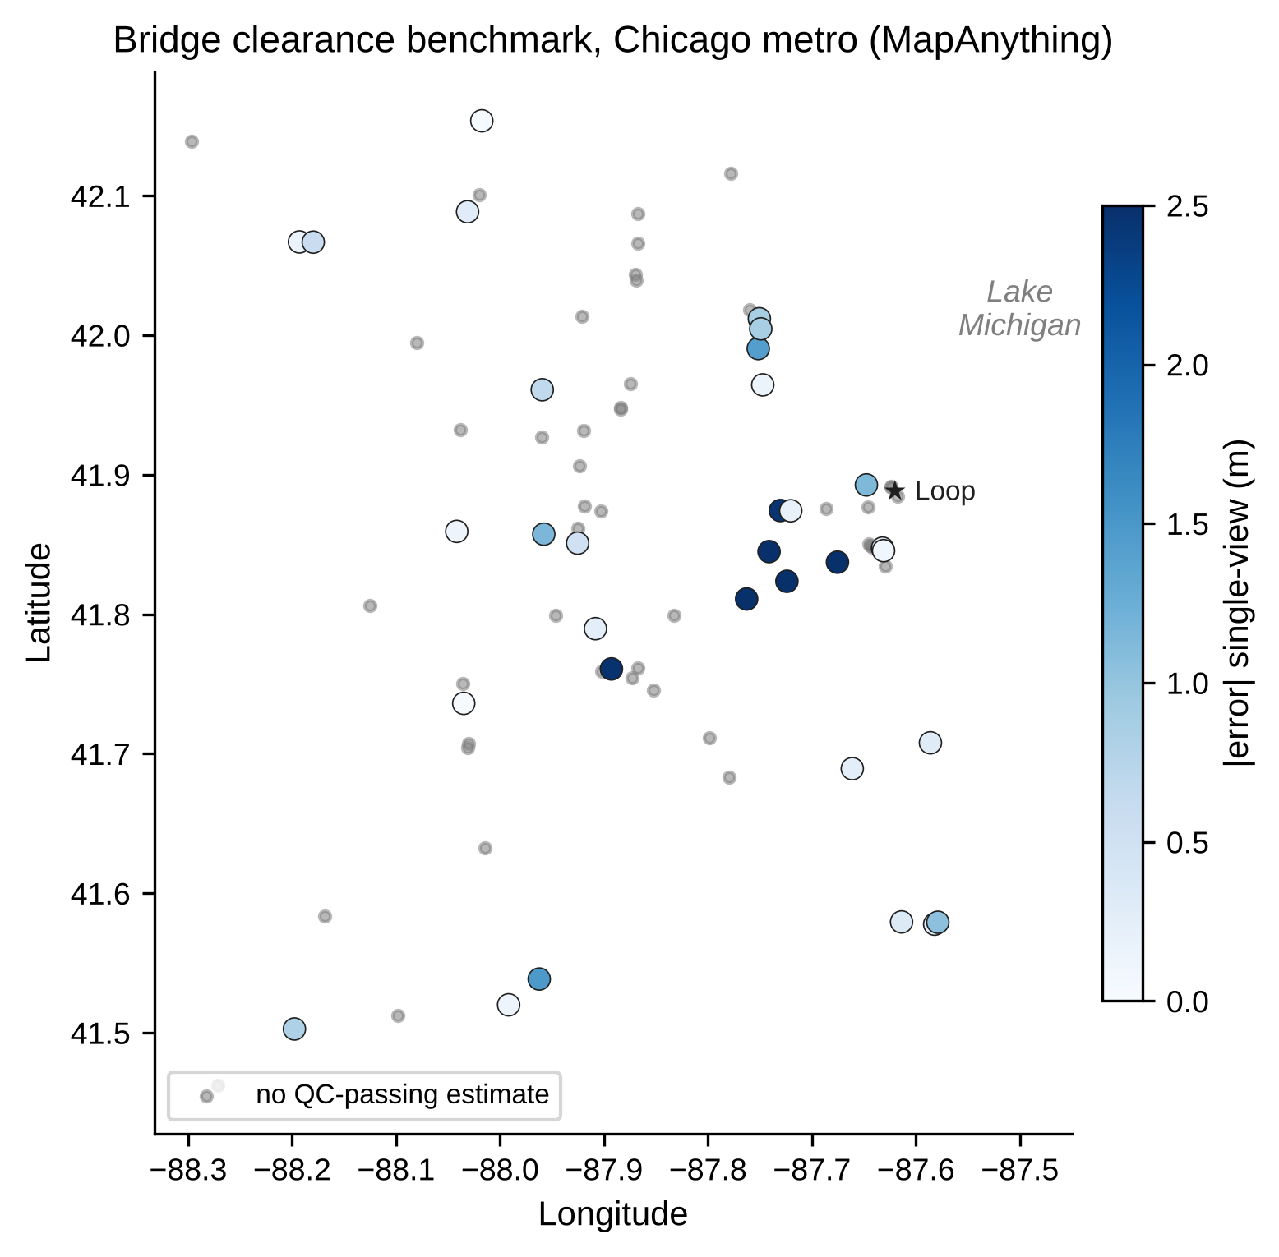
Figure 2. Benchmark bridges in the Chicago metro area. Coloured points passed the automatic quality check and are shaded by single-view absolute error; grey points had no quality-checked estimate. An interactive version is in the project repository.

Methodology
[Owner: Kely (intro, Feature Engineering, MapAnything, Evaluation) — update for the final draft by Tue Oct 27]
The pipeline is modular: image retrieval, frame selection, segmentation, metric 3D reconstruction, geometric measurement and quality control are separate steps. Only the 3D backbone changes between the methods compared in this paper; every backbone receives the same frames and the same masks and is scored with the same measurement code and metrics. Figure 1 summarises the pipeline.
[Figure 1 — pipeline diagram — Adaora inserts here]

Feature Engineering
Segmentation. SAM3 (Carion et al., 2025), used in earlier experiments, requires gated model access that was not granted in time, so target localisation uses Mask2Former with a Swin-L backbone trained on Mapillary Vistas (Cheng et al., 2022; Neuhold et al., 2017). Its street-level label set includes Bridge, Road, lane-marking and crosswalk classes. Each connected Bridge component is a candidate structure; road, lane-marking, crosswalk, service-lane and manhole pixels form the road mask.
Structure and anchor-frame selection. A candidate structure must span at least 18% of the image width, start in the upper 55% of the image, have its lower edge above 65% of the image height, and have road visible directly beneath it in at least five sampled columns. Each frame is scored by the best candidate's width and the vertical position of its lower edge, and the highest-scoring frame becomes the anchor. The three frames closest to the anchor in distance form the multi-view set (four frames in total).
Measurement geometry. For every image column under the structure, the lowest structure pixel with road beneath it is located, and its 3D point is taken from the reconstruction. Points whose camera distance deviates strongly from the median (beyond three scaled median absolute deviations) are removed. A plane is fitted to road points at a similar range with RANSAC (Fischler & Bolles, 1981; 400 iterations, 0.12 m inlier threshold). Clearance is the median, over columns, of the distance from underside points to the road plane. Only underside points more than 0.3 m above the camera are kept, which removes walls, abutments and barriers that the segmenter also labels Bridge. The distance from the camera centre to the road plane is recorded as the recovered camera height.
An earlier point-to-point measure (distance from one structure pixel to one road pixel) was retained only as a comparison; at bridge distances its road point lies close to the camera rather than under the structure.

Modeling Framework

MapAnything
[Owner: Kely — update for the final draft by Tue Oct 27]
MapAnything (Keetha et al., 2026) is a feed-forward model that predicts metric 3D points, confidences and camera poses from one or more images. It was run in two settings: single-view on the anchor frame, and multi-view on the four selected frames, reading the anchor frame's point map. Points were filtered by model confidence (50th percentile for road points, 15th percentile for structure points). Inference used bfloat16 on a single NVIDIA L4 GPU and took about six seconds per bridge, including segmentation of all candidate frames.

Depth Anything 3
[Owner: Anna — update for the final draft by Tue Oct 27]
[DA3 paragraph — Anna]

VGGT
[Owner: Adaora — update for the final draft by Tue Oct 27]
[VGGT paragraph incl. GPS-based scale recovery — Adaora]

Building Height (Exploratory)
[Owner: Adaora — update for the final draft by Tue Oct 27]
[Building-height method — Adaora]

Evaluation Protocol
[Owner: Kely — update for the final draft by Tue Oct 27]
Automatic quality control (QC) uses no ground truth: an estimate passes if the recovered camera height is between 0.7 m and 3.5 m, at least 10 underside columns are measured, and the structure is within 90 m. Each backbone is reported on three subsets: S1, all cases that pass its own QC; S2, the S1 cases captured with phone or action cameras (EXIF make present); and S3, a common set of 32 cases that passed MapAnything QC, so that backbones can be compared on identical bridges. Metrics are the number of cases, mean absolute error (MAE) with a bootstrap 95% confidence interval (1,000 resamples, seed 42), median absolute error, mean signed error (bias), mean absolute percentage error (MAPE) and the share of estimates within 0.5 m. The camera split in S2 was identified after inspecting errors and is therefore reported as a diagnostic, not as the headline result.

Findings
Table 1 reports all backbones on the bridge-clearance benchmark. Each owner fills in their own rows.
[Owner: all — each person fills their own rows by Sun Oct 25]
Table 1. Bridge vertical under-clearance versus NBI Item 54B (metres).
Method | View | Subset | n | MAE (95% CI) | Median AE | Bias | MAPE % | ≤0.5 m %
MapAnything | single | S1 | 30 | 0.92 (0.54–1.45) | 0.43 | -0.69 | 16.8 | 50
MapAnything | single | S2 | 24 | 0.65 (0.40–1.00) | 0.32 | -0.43 | 12.4 | 54
MapAnything | single | S3 | 30 | 0.92 (0.54–1.45) | 0.43 | -0.69 | 16.8 | 50
MapAnything | multi | S1 | 32 | 1.09 (0.75–1.51) | 0.58 | -0.28 | 19.9 | 47
MapAnything | multi | S2 | 24 | 0.77 (0.50–1.12) | 0.47 | +0.28 | 14.6 | 54
MapAnything | multi | S3 | 32 | 1.09 (0.75–1.51) | 0.58 | -0.28 | 19.9 | 47
Depth Anything 3 | single | S1
Depth Anything 3 | single | S2
Depth Anything 3 | single | S3
Depth Anything 3 | multi | S1
Depth Anything 3 | multi | S2
Depth Anything 3 | multi | S3
VGGT (GPS-scaled) | multi | S1
VGGT (GPS-scaled) | multi | S2
VGGT (GPS-scaled) | multi | S3
VGGT | single | — | n/a — VGGT is not metric from one image
S1 = own QC pass, all cameras; S2 = own QC pass, phone/action cameras with EXIF; S3 = common 32-case set. Bias = mean(estimate − ground truth).

MapAnything
[Owner: Kely — update for the final draft by Tue Oct 27]
Of the 80 benchmark bridges, 38 had an anchor frame with a detected overhead structure and visible road. Four of these failed during measurement because no underside points remained above the camera, leaving 34 estimates, of which 32 passed QC. The two QC failures were a reconstruction with a recovered camera height of 6.0 m and a structure placed 146 m from the camera. Recovered camera heights on QC-passing cases had a median of 1.29 m (multi-view) and 1.25 m (single-view), consistent with car- or handlebar-mounted cameras, which indicates that MapAnything's metric scale is broadly correct.
On S1, single-view estimates had an MAE of 0.92 m (95% CI 0.54–1.45 m), a median absolute error of 0.43 m and a MAPE of 16.8%; 50% of estimates were within 0.5 m. Multi-view estimates were slightly less accurate (MAE 1.09 m, median 0.58 m). The two settings differ in bias: single-view under-estimates on average (-0.69 m), while multi-view is close to unbiased overall (-0.28 m) but includes several over-estimates of 1.5 m or more (Figure 3).
Error depends strongly on the camera. On phone and action-camera imagery (S2, n = 24), single-view MAE fell to 0.65 m (median 0.32 m, MAPE 12.4%). The eight QC-passing cases without EXIF metadata, mostly wide-angle dashcams, were under-estimated by about 2 m on average (multi-view MAE 2.05 m, bias −1.94 m). MapAnything assumes near-pinhole input, and uncorrected lens distortion compresses the apparent height of the structure. Because this split was found after inspecting the errors, it is a diagnostic that motivates camera-aware filtering rather than a pre-registered result.
The road-plane measurement was essential. The earlier point-to-point measure produced 'clearances' of roughly 13–79 m (multi-view) on the same cases, with a single-view MAE of 25.8 m,, because its road point lay near the camera rather than beneath the structure.
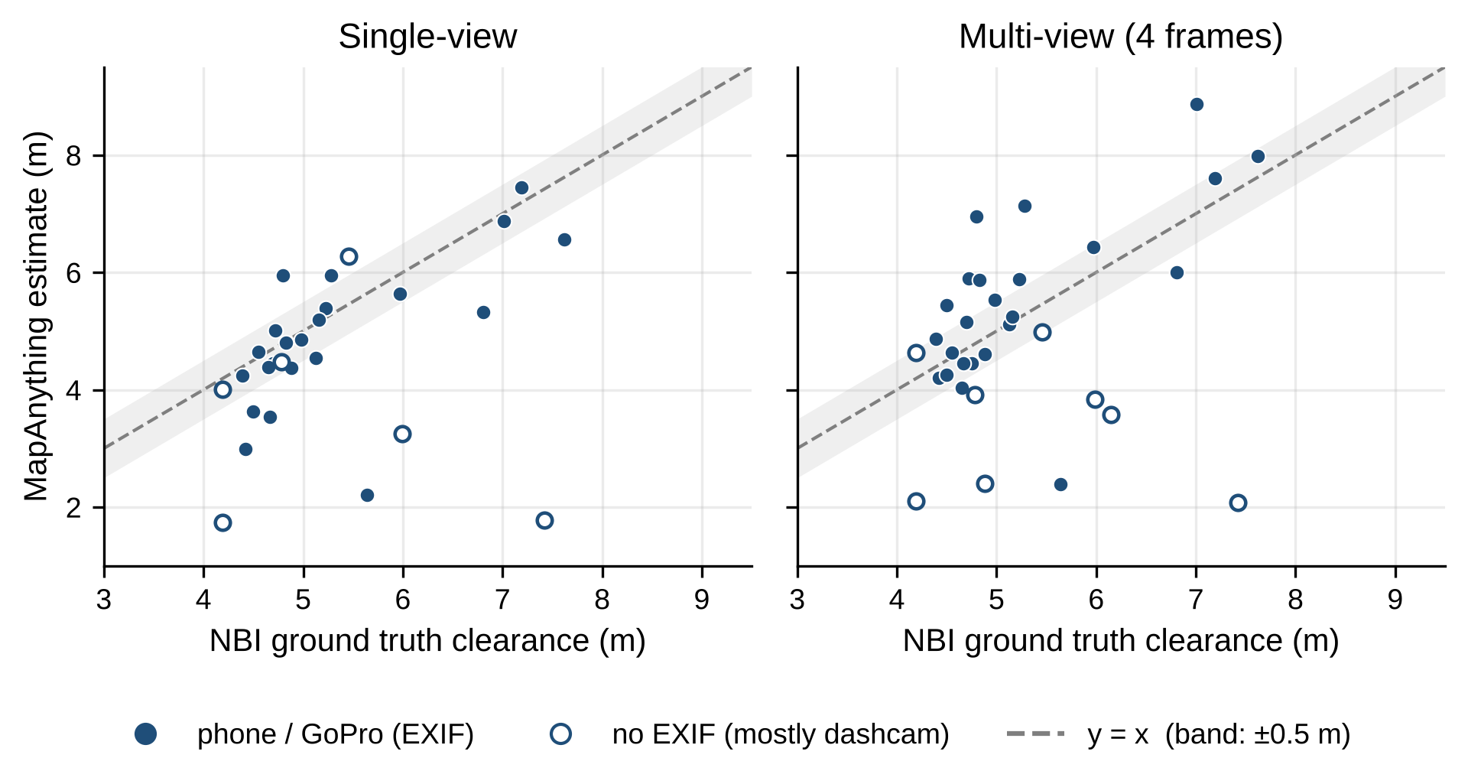
Figure 3. MapAnything estimates versus NBI ground truth on QC-passing bridges. Filled markers: phone or action cameras; hollow markers: no EXIF (mostly wide-angle dashcams). Dashed line: perfect agreement; band: ±0.5 m.

Depth Anything 3
[Owner: Anna — update for the final draft by Tue Oct 27]
[DA3 findings — Anna]

VGGT
[Owner: Adaora — update for the final draft by Tue Oct 27]
[VGGT findings — Adaora]

Stop-Sign Size
[Owner: Kely — update for the final draft by Tue Oct 27]
Of 25 sampled stop signs, 15 were segmented in at least one frame; the other ten were not detected by the combined red-colour and Vistas traffic-sign filter. Sign width was computed as the sign's pixel width multiplied by MapAnything depth and divided by the focal length.
Single-view estimates (n = 14) had a median of 0.88 m. Against the nearest standard size (0.762 m or 0.914 m) the MAE was 0.11 m, and 71% of estimates were within 15% of a standard size. Multi-view estimates (n = 15) had a median of 0.94 m and were biased high relative to the 30-inch standard (MAE vs. nearest standard 0.10 m; 67% within 15%). Because signs occupy only 50–150 pixels, a one- or two-pixel error at the mask edge changes the estimate by several percent, so mask quality rather than depth dominates the error (Figure 4).
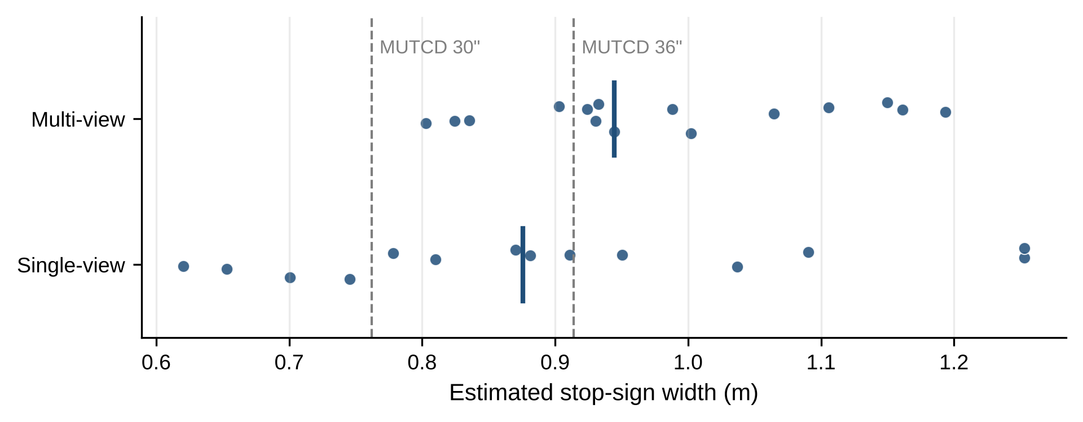
Figure 4. Estimated stop-sign widths. Vertical bars mark the median; dashed lines mark the MUTCD 30-inch and 36-inch standard sizes.

Building Height
[Owner: Adaora — update for the final draft by Tue Oct 27]
[Building-height findings or pointer to Future Work — Adaora]

Method Comparison
[Owner: Kely — write on Wed Oct 28 from the completed Table 1]
[Compare MapAnything, DA3 and VGGT on S3; name the recommended backbone and why.]

Discussion
[Owner: Adaora — spring text below; rewrite by Tue Oct 27]
The preliminary findings suggest that the project’s central idea is technically plausible. Image-based metric estimation from street-level imagery appears capable of producing measurements that are close to ground truth under favorable conditions. In particular, the improvement from the original single-image baseline to the multi-image configurations supports the hypothesis that additional spatial context reduces ambiguity and improves reconstruction quality.
The results also suggest that the most effective solution may not come from a single component in isolation, but rather from the interaction between segmentation quality, reconstruction quality, and the number of informative views. The strong performance of the Depth Anything v3 and SAM3 combination on the main benchmark case indicates that accurate measurements can emerge from a pipeline in which reliable target isolation is paired with strong depth reasoning. Likewise, the operational success of Adaora’s VGGT and SAM3 pipeline shows that a fully automated object-to-geometry workflow is achievable and can produce interpretable intermediate outputs rather than only a final number.
At the same time, the large error observed on one of the alternate image sets shows that the project’s objectives have only been partially achieved so far. The current workflow can produce highly accurate estimates in some cases, but it is not yet consistently reliable across diverse scenes. The available evidence suggests several possible reasons. Lighting conditions may degrade target visibility or depth prediction quality. Some sequences may not provide enough overlapping geometry for stable multi-view reconstruction. Perspective distortion, occlusion, and segmentation imperfections may also propagate through the pipeline and amplify final measurement error.
The results also imply that automated selection does not guarantee improvement in every case, even though it is highly valuable from a workflow perspective. Replacing manual point selection with SAM3 increases scalability and reduces the need for direct human intervention, but the quality of the final estimate still depends on whether the segmented pixels correspond cleanly to the physical boundaries needed for measurement. This means that segmentation quality must be evaluated not only visually, but also in terms of its downstream effect on reconstructed geometry and dimension estimates. The difference between the 19.048-foot five-image manual result and the 19.788-foot automated result on the same 18.08-foot benchmark illustrates this point. Automation makes the workflow more realistic for operational use, but the automation step itself becomes a source of measurement variance.
An additional limitation is the current size and structure of the benchmark set. The reported experiments provide a meaningful starting point, but they are not yet broad enough to characterize overall model performance across object types, weather conditions, scene clutter, or camera geometries. The present discussion must therefore remain within the limits of the tested work. The project can currently claim promising proof-of-concept evidence, but not yet a general-purpose and fully validated measurement system.

Business Value for HERE
[Owner: Adaora — update for the final draft by Tue Oct 27]
[New subsection — Adaora]

Conclusion
[Owner: Kely — draft; finalise after Table 1 and Discussion]
This project moved image-based dimension estimation from a handful of hand-picked examples to an automated benchmark against official ground truth. The pipeline retrieves Mapillary imagery for a target structure, isolates the structure and road automatically, reconstructs the scene in metres and measures clearance against a fitted road plane, with a quality check that requires no ground truth. On 32 quality-checked Chicago bridges, MapAnything single-view estimates were within 0.43 m of the NBI value at the median and within 0.65 m on average for phone and action-camera imagery. The same components sized stop signs to within 15% of a standard size in most measured cases.
The evidence also shows where the approach is not yet reliable: wide-angle dashcam imagery, structures far from the camera, and bridges whose inventory coordinates do not match the road crossing. These limits are identifiable in advance from metadata and from the recovered camera geometry, which makes the pipeline suitable as a screening layer in which confident estimates are accepted and flagged ones are reviewed.

Future Work
- Correct lens distortion using Mapillary camera parameters, or exclude uncalibrated wide-angle cameras before reconstruction.
- Replace NBI point coordinates with map-matched crossing locations (structure line geometry intersected with the road below) to raise the share of usable cases above the current 48%.
- Swap Mask2Former for SAM3 once access is granted, and evaluate the effect on underside localisation.
- Estimate the minimum rather than the median clearance (for example a low percentile over columns) to match the definition of NBI Item 54B, and calibrate it on a held-out set.
- Extend validation beyond Chicago and to additional feature types (overhead sign structures, lane width, building height), and use vision-language models for automatic frame selection and quality review.

References
[Owner: Anna — APA 7; add Cheng et al. 2022, Neuhold et al. 2017, Fischler & Bolles 1981, FHWA 2025 NBI, FHWA 2009 MUTCD, DA3 and VGGT papers — cited in Kely's sections]
Carion, N., Gustafson, L., Hu, Y.-T., Debnath, S., Hu, R., Suris Coll-Vinent, D., Ryali, C., Alwala, K. V., Khedr, H., Huang, A., Lei, J., Ma, T., Guo, B., Kalla, A., Marks, M., Greer, J., Wang, M., Sun, P., Rädle, R., et al. (2025). *SAM 3: Segment anything with concepts*. arXiv. https://arxiv.org/abs/2511.16719
HERE Technologies. (2024). *About HERE*. https://www.here.com/company
Hugging Face. (n.d.). *SAM3*. Transformers documentation. https://huggingface.co/docs/transformers/en/model_doc/sam3
Illinois Department of Transportation. (n.d.). *Vertical clearance data resources*. https://gis-idot.opendata.arcgis.com/datasets/IDOT::vertical-clearance/about
Keetha, N., Müller, N., Schönberger, J., Porzi, L., Zhang, Y., Fischer, T., Knapitsch, A., Zauss, D., Weber, E., Antunes, N., Luiten, J., Lopez-Antequera, M., Rota Buló, S., Richardt, C., Ramanan, D., Scherer, S., & Kontschieder, P. (2026). *MapAnything: Universal feed-forward metric 3D reconstruction*. Proceedings of the International Conference on 3D Vision (3DV). IEEE.
Mapillary. (n.d.). *Mapillary: Street-level imagery platform*. https://www.mapillary.com
Yang, L., Kang, B., Huang, Z., Xu, X., Feng, J., & Zhao, H. (2024). *Depth anything: Unleashing the power of large-scale unlabeled data*. Proceedings of the IEEE/CVF Conference on Computer Vision and Pattern Recognition (CVPR).

Appendices

Appendix A. Implementation Details
[Owner: Adaora — spring text below; update Wed Oct 28]
Current implementation work includes Mapillary API-based image retrieval, single-image and multi-image experiment branches, SAM3-based automated sign, sign-truss, and road-surface selection, VGGT-generated depth maps and point clouds, and PCA-based plane fitting for sign measurement. Comparative reconstruction experimentation has also included Pi3 notebook-based testing for point-cloud generation and direct point-to-point distance measurement. In the notebook-based prototype, Mapillary imagery was retrieved through the API, stored locally, loaded into the candidate model pipeline, and measured either through manually specified image-plane points or automatically segmented target regions aligned to reconstructed 3D coordinates.

Appendix B. Benchmark Cases and Setup
[Owner: Adaora — spring text below; update Wed Oct 28]
The current benchmark set includes repeated evaluation on a baseline case with a ground-truth dimension of 18.08 feet and at least two additional image sequences with ground-truth values of 18.00 feet and 18.83 feet. These tests are useful for early comparative evaluation, but the sample remains too limited for a complete assessment of robustness or generalizability. Expanding the benchmark set remains a priority for the next stage of the project.

Appendix C. Early Experiments (Spring 2026)
[Owner: Kely — update for the final draft by Tue Oct 27]
Before the NBI benchmark, the team compared models on three manually selected Illinois Department of Transportation (IDOT) overhead sign structures with documented vertical clearance, measured point-to-point between selected image points. These experiments guided model selection but are too few to estimate accuracy, and they used a different measurement definition from the main results. Table C1 lists them for completeness.
Table C1. Early experiments on IDOT overhead sign structures (feet).
Experiment Configuration | Ground Truth (ft) | Estimate (ft) | Accuracy | Error
Single-image baseline | 18.08 | 15.604 | 86.31% | 13.69%
Five-image same-sequence input with manual selection | 18.08 | 19.048 | 94.65% | 5.35%
Five-image workflow with SAM3 automated selection | 18.08 | 19.788 | 90.55% | 9.45%
Depth Anything v3 + SAM3, baseline case | 18.08 | 17.39 | 96.18% | 3.82%
Depth Anything v3 + SAM3, image set 1 | 18.00 | 17.01 | 94.50% | 5.50%
Depth Anything v3 + SAM3, image set 2 | 18.83 | 25.60 | 64.05% | 35.95%

