Real-World Dimension and Metric Estimation of Physical Features from Street-Level Imagery Using 3D Reconstruction and Advanced Computer Vision
HERE Technologies

Kely Zhang, Anna Chen, Adaora Ezike
Advisor: Dr. Jeanette Shutay

A Capstone Project
Submitted to the University of Chicago in partial fulfillment of the requirements of the degree of
Master of Science in Applied Data Science

Division of Physical Sciences
December 2026

Abstract
[Owner: Kely — draft; final numbers after Table 1 is complete]
Metric map attributes such as bridge vertical clearance are expensive to collect with LiDAR surveys and field audits. This project, conducted with HERE Technologies, evaluates whether existing street-level imagery can estimate such attributes at scale. We built an automated pipeline that retrieves Mapillary image sequences approaching a target structure, segments the structure and road surface with Mask2Former trained on Mapillary Vistas, reconstructs metric 3D geometry with a feed-forward model, and measures clearance as the distance from the structure underside to a RANSAC-fitted road plane. Estimates are benchmarked against the FHWA National Bridge Inventory (NBI) minimum vertical under-clearance for an 80-bridge Chicago-area sample. With MapAnything as the 3D backbone, 32 bridges passed an automatic quality check that uses no ground truth; single-view estimates reached a mean absolute error (MAE) of 0.92 m (median 0.43 m), and 0.65 m on phone and action-camera imagery. Wide-angle dashcam imagery was the dominant failure mode. The same pipeline sized stop signs to within 15% of a standard size in 71% of measured cases. The results support image-based clearance estimation as a scalable screening layer for map attributes, with camera-aware filtering and human review of flagged cases.
Keywords: street-level imagery, metric 3D reconstruction, vertical clearance, National Bridge Inventory, Mapillary, MapAnything, Depth Anything 3, VGGT, Mask2Former

Executive Summary
[Owner: Kely — draft; final numbers after Table 1 is complete]
HERE Technologies maintains physical map attributes — clearances, widths, heights and offsets — that matter for truck routing, navigation and HD maps. These attributes are usually collected with LiDAR surveys, manual audits or dedicated capture campaigns, which are costly to repeat across large road networks. This project asked whether crowd-sourced street-level imagery that already exists can recover such measurements in real-world units.
We built and benchmarked an end-to-end pipeline for bridge vertical under-clearance, the attribute with the clearest operational value and the best public ground truth. For each bridge in the FHWA National Bridge Inventory (Illinois, Chicago metro), the pipeline finds a Mapillary sequence driving toward the structure, selects the frame where the overhead structure is best visible, segments the structure and road, reconstructs the scene in metres, and measures the height of the structure underside above a fitted road plane. An automatic quality check rejects implausible reconstructions without using ground truth, and results are exported as GeoJSON.
Of 80 benchmark bridges, 38 had a frame in which the overhead structure was detected and 32 passed the quality check. On these, MapAnything single-view estimates had a mean absolute error of 0.92 m (median 0.43 m, 16.8% mean absolute percentage error); half were within 0.5 m of the NBI value. On imagery from phones and action cameras the error fell to 0.65 m (median 0.32 m), while wide-angle dashcams were under-estimated by about 2 m. The main limits are camera geometry, the fact that NBI coordinates often do not coincide with the road crossing, and segmentation errors at abutments. Comparisons with Depth Anything 3 and VGGT on the same cases are reported in Table 1.
For HERE, the evidence supports using the pipeline as a low-cost screening layer: it can propose clearance values and flag likely errors at network scale, with confident cases published and flagged cases routed to review. Production use would require camera-model-aware processing, a larger and more diverse validation set, and integration of map-matched crossing locations.

Table of Contents
[Owner: Adaora — insert automatic TOC + Lists of Figures and Tables on Wed Oct 28]

List of Figures
(to be generated)

List of Tables
(to be generated)

Introduction
Physical map attributes describe properties of the built environment that road connectivity alone cannot capture. Bridge clearance and traffic-sign dimensions, for example, can support navigation, logistics, and infrastructure analysis. Collecting these measurements through dedicated surveys and manual inspection requires substantial effort, creating interest in whether existing street-level imagery could provide a supplementary source. This project investigated that possibility in the context of HERE Technologies’ interest in extracting physical map attributes from imagery.
To assess the feasibility of this approach, we developed and evaluated workflows combining image retrieval, target segmentation, depth estimation, three-dimensional reconstruction, and geometric measurement. Mapillary supplied street-level images and sequences of roadway scenes. We explored pretrained models including MapAnything, Depth Anything 3 (DA3), and VGGT, using single-image and multi-image inputs where supported. The experiments examined whether the resulting geometry could yield useful dimensional estimates and how those estimates compared with available reference values.
The study used street-level imagery from Chicago and the surrounding area to explore real-world dimensional estimation, with the main quantitative evaluation focusing on 80 bridges. Mapillary images associated with these bridges were linked to reference records from the National Bridge Inventory (NBI) to assess measurement error, the availability of usable estimates, and failure modes across the tested configurations. This paper presents the project’s research question, data, methods, and findings, and discusses the feasibility and limitations of estimating physical dimensions from street-level imagery.

Problem Statement
The project addressed the problem of estimating real-world dimensions of selected roadway features from ordinary street-level imagery. Using observations from Chicago and the surrounding area, we examined this problem primarily through bridge vertical underclearance, with sign dimensions as a supporting investigation. Detecting a bridge or sign identifies what is visible, but does not determine its physical dimensions. A measurement additionally requires the correct target, a usable geometric representation, a physical scale, and a definition of the boundaries or reference surfaces being measured. Perspective, lens distortion, occlusion, and incomplete views can affect these requirements at different stages of the workflow.
The central research question was whether pretrained vision models, combined with automated target localization and geometric processing, could produce useful dimensional estimates for the tested features, and under which input conditions those estimates were available and accurate. The practical motivation was to explore whether imagery already collected for other purposes could contribute measurement candidates for map enrichment. The study did not quantify acquisition-cost savings or establish a replacement for surveyed data.
Evaluation also required care about what counted as a reference. For bridges, the image-derived median distance between visible underside samples and a road plane differs from the minimum vertical underclearance represented by NBI Item 54B (Federal Highway Administration, 1995). For stop signs, agreement with a standard size does not establish agreement with an individually surveyed installation. The problem therefore included documenting reference correspondence and measurement definitions, as well as computing numerical errors.

Analysis Goals
The first goal was to develop a reproducible prototype connecting street-level imagery to feature-specific dimensional estimates. This included organizing image sequences and metadata, identifying the target and relevant reference regions, recovering depth or three-dimensional geometry, and producing measurements with traceable intermediate outputs. The aim was to evaluate a workable research process using existing pretrained models.
The second goal was to examine alternative segmentation and reconstruction approaches, including single-image and multi-image configurations, and determine how their outputs affected measurement quality. The 80-bridge benchmark provided a structured basis for the main quantitative evaluation within the broader Chicago-area imagery study. Comparisons were interpreted according to the actual cases, masks, scale sources, and quality rules used in each completed experiment. Supporting feature-sizing and model-capability experiments were considered separately.
The third goal was to assess measurement accuracy together with availability and failure modes. Error summaries were accompanied by the number of usable estimates and the reasons cases were rejected or could not be measured. The final goal was to identify limitations relevant to further development, including camera geometry, target visibility, segmentation, metric scale, and reference matching. These findings were intended to support a defensible assessment of the tested workflow’s feasibility rather than a claim of readiness across all map attributes.

Scope
The project was a proof-of-concept study of dimensional estimation using street-level RGB imagery from Chicago and the surrounding area. Within this geographic scope, the main quantitative evaluation focused on vertical underclearance for a frozen set of 80 bridges associated with the 2025 Illinois NBI. The 80 bridges defined the principal evaluation sample rather than the full extent of the project’s imagery exploration. Stop-sign width was a supporting task, evaluated separately against published standard sizes.
The work included image and metadata retrieval, automated segmentation, pretrained depth and reconstruction models, geometric measurement, quality checks, and evaluation of saved experimental outputs. Single-image and multi-image settings were examined where the relevant model branch had been run. Additional object-reconstruction and cross-frame correspondence demonstrations formed supporting explorations; they were not evidence of improved clearance accuracy. The study did not train a new foundation model or validate every explored model on every task.
The demonstrated scope was narrower than a general map-attribute extraction system. Building height, lane width, offsets, and comprehensive feature coverage were not established as validated measurement capabilities in this report. Geographic generalization, vehicle-specific safe passage, production deployment, and cost savings were also not demonstrated. Conclusions were limited to the tested imagery, reference records, and measurement definitions, with quantitative findings reported for the subsets that actually yielded estimates.

Background
Mapillary organizes street-level imagery into georeferenced observations and sequences that can be retrieved for visual analysis (Mapillary, n.d.). In this study, these observations provided roadway views from Chicago and the surrounding area. Such imagery varies in viewpoint, resolution, capture date, and camera properties. Multiple frames may provide additional views of a feature, but nearby geographic coordinates do not by themselves establish that an observation corresponds to the intended structure or travel lane. These characteristics make imagery useful for investigation while introducing selection and correspondence challenges.
Image-based measurement combines semantic and geometric reasoning. Segmentation identifies the pixels associated with a target or reference surface. Depth estimation and three-dimensional reconstruction provide spatial information for those pixels. Camera geometry connects image coordinates to three-dimensional coordinates, but physical dimensions also require metric scale (Hartley & Zisserman, 2004). An accurate mask cannot resolve unknown scale, and a plausible point cloud cannot compensate for selecting the wrong object. The resulting measurement depends on the interaction of these stages.
The reference sources reflected the distinction between the main bridge evaluation and supporting sign-sizing experiments. The Illinois NBI supplied inventory values for the 80-bridge benchmark, with the coding guide defining minimum vertical underclearance (Federal Highway Administration, 1995, 2025). The Manual on Uniform Traffic Control Devices supplied standard stop-sign dimensions (Federal Highway Administration, 2009). These sources supported different forms of evaluation: agreement with inventory records for bridges and consistency with standard sizes for signs. Their meanings and limitations informed how the team interpreted image-derived estimates.

Literature Review
Classical camera geometry provides the basis for relating image coordinates to spatial measurements. The pinhole model describes perspective projection through camera intrinsics and pose (Hartley & Zisserman, 2004). With depth and the corresponding intrinsics, image pixels can be back-projected into three-dimensional coordinates. That geometric operation preserves the units of the supplied depth; it does not resolve an unknown physical scale by itself. This distinction is central when selecting reconstruction methods for dimensional measurement.
Recent feed-forward models provide complementary sources of scene geometry. MapAnything predicts metric reconstruction from flexible visual and geometric inputs (Keetha et al., 2026). VGGT predicts scene and camera attributes from one or more images (Wang et al., 2025); when its output is used at relative scale, dimensional measurement requires an additional scale source. Depth Anything introduced a broadly trained monocular depth model (Yang et al., 2024), while DA3 extends the setting to geometry recovery from arbitrary visual inputs (Lin et al., 2025). These methods motivate alternative pipeline designs, but their reconstruction benchmarks do not establish their accuracy for the roadway measurements studied here.
Metric depth has also been used for dimensional measurement beyond depth-map evaluation. Metric3D combines metric-depth prediction and camera information to reconstruct scene geometry and measure object and structural dimensions from photographs (Yin et al., 2023). This provides a precedent for using learned depth in a measurement workflow. Its results also highlight the importance of camera parameters and scale recovery. In the present capstone, the depth or scale source was therefore treated as an explicit part of each method rather than assuming that every model output was directly expressed in metres.
Semantic localization supplies the regions to which geometric measurement is applied. Mask2Former uses masked attention for universal image segmentation (Cheng et al., 2022), and Mapillary Vistas provides a street-scene dataset relevant to bridge, road, and sign localization (Neuhold et al., 2017). SAM3 detects and segments objects using concept prompts, such as short noun phrases or image exemplars (Carion et al., 2025). In the DA3 extension, text prompts specified bridge undersides and road surfaces; the resulting masks localized the regions used for geometric measurement. These approaches differ in how targets are specified and selected. Their usefulness for measurement depends on whether the resulting masks isolate the physical boundaries and reference surfaces required by the task, rather than on detection confidence alone.
Robust geometric estimation addresses a further source of uncertainty after localization and reconstruction. RANSAC estimates model parameters in the presence of outliers (Fischler & Bolles, 1981), providing a basis for fitting reference surfaces such as a road plane. A robust fit can reduce the influence of inconsistent points, but cannot verify target identity, correct systematic scale error, or make a visible-sample statistic equivalent to an inventory minimum. Taken together, the literature supports evaluating the entire image-to-measurement process, including failure cases and coverage. The capstone applied these established components to the selected roadway tasks; specific configurations, back-projection equations, and quality thresholds are described in Methodology.

Data
[Owner: Kely — update for the final draft by Tue Oct 27]
The study combines crowd-sourced street-level imagery with two kinds of independent reference data: an official bridge inventory for clearance and a national signage standard for stop-sign size.

Data Sources
Street-level imagery. Images and metadata were retrieved from the Mapillary Graph API (Mapillary, n.d.). For each image we requested its identifier, sequence, capture time, raw and computed compass angle, raw and computed geometry, camera type, width, height and a 2048-pixel thumbnail URL. Spherical, equirectangular and fisheye images were excluded because the 3D models assume near-pinhole perspective input. Camera make and model, which Mapillary derives from EXIF metadata, were retrieved for the selected anchor frames.
Bridge clearance ground truth. The reference is the Federal Highway Administration National Bridge Inventory for Illinois, 2025 release (Federal Highway Administration, 2025). We used Item 54B, the minimum vertical under-clearance in metres, restricted to structures whose under-clearance reference (Item 54A) is a highway ('H'). Records were kept if the clearance was between 3.5 m and 8.5 m and the structure lay in a Chicago-metro bounding box (41.45–42.35° N, 88.35–87.52° W). Twin structures closer than 60 m (for example separate northbound and southbound decks) were de-duplicated, leaving 523 candidate bridges. Candidates were ordered round-robin across clearance bins (<4.45, 4.45–4.75, 4.75–5.2, 5.2–6.0 and >6.0 m) and service type so that the benchmark covers the full range of clearances and structure types.
Benchmark construction. For each candidate bridge, Mapillary images within 170 m of the NBI coordinate were retrieved. Frames were kept if they were 12–140 m from the structure and the camera heading was within 25° of the bearing to the structure, i.e. the vehicle was driving toward it. Among qualifying sequences, the one with the most frames 22–85 m from the structure (with a preference for recent captures) was selected, and up to eight frames spaced at least 5 m apart were downloaded. Of the first 87 bridges attempted, 80 yielded a usable sequence; four had no imagery and three had no sequence with at least three suitable frames. These 80 cases form the frozen benchmark used for every 3D backbone in this paper.
Stop-sign reference. As a second feature type, Mapillary map features of class regulatory--stop--g1 were sampled over Chicago. For each sign, two to four perspective frames from one sequence, 5–28 m from the sign and facing it, were used. Ground truth is the Manual on Uniform Traffic Control Devices standard R1-1 size: 30 in (0.762 m) on conventional roads and 36 in (0.914 m) on multi-lane approaches (Federal Highway Administration, 2009). Because the installed size of each sign is not recorded, accuracy is reported against both standard sizes.

Descriptive Analysis
The 80 benchmark bridges have NBI clearances from 3.94 m to 7.92 m (median 4.96 m, mean 5.20 m). The sample is balanced across clearance bins (18 below 4.45 m, 16 at 4.45–4.75 m, 19 at 4.75–5.2 m, 14 at 5.2–6.0 m and 13 above 6.0 m) and across structures carrying a highway (40), interchange overpasses (36) and third-level interchanges (4). Each case contributes a median of eight candidate frames.
The most important descriptive finding concerns usability rather than distributions. In 41 of the 80 cases the segmenter found no overhead structure in any candidate frame. Inspection of these cases shows two causes: the NBI coordinate marks the structure rather than the exact road crossing, so the nearest sequence often runs parallel to or on top of the bridge, and some sequences pass the structure only at the edge of the frame. One further case had no visible road surface. The imagery itself is heterogeneous: among cases with a detected structure, capture years range from 2015 to 2026 (15 of 34 from 2018), and most images come from consumer phones, with a minority from wide-angle dashcams that carry no EXIF camera information.
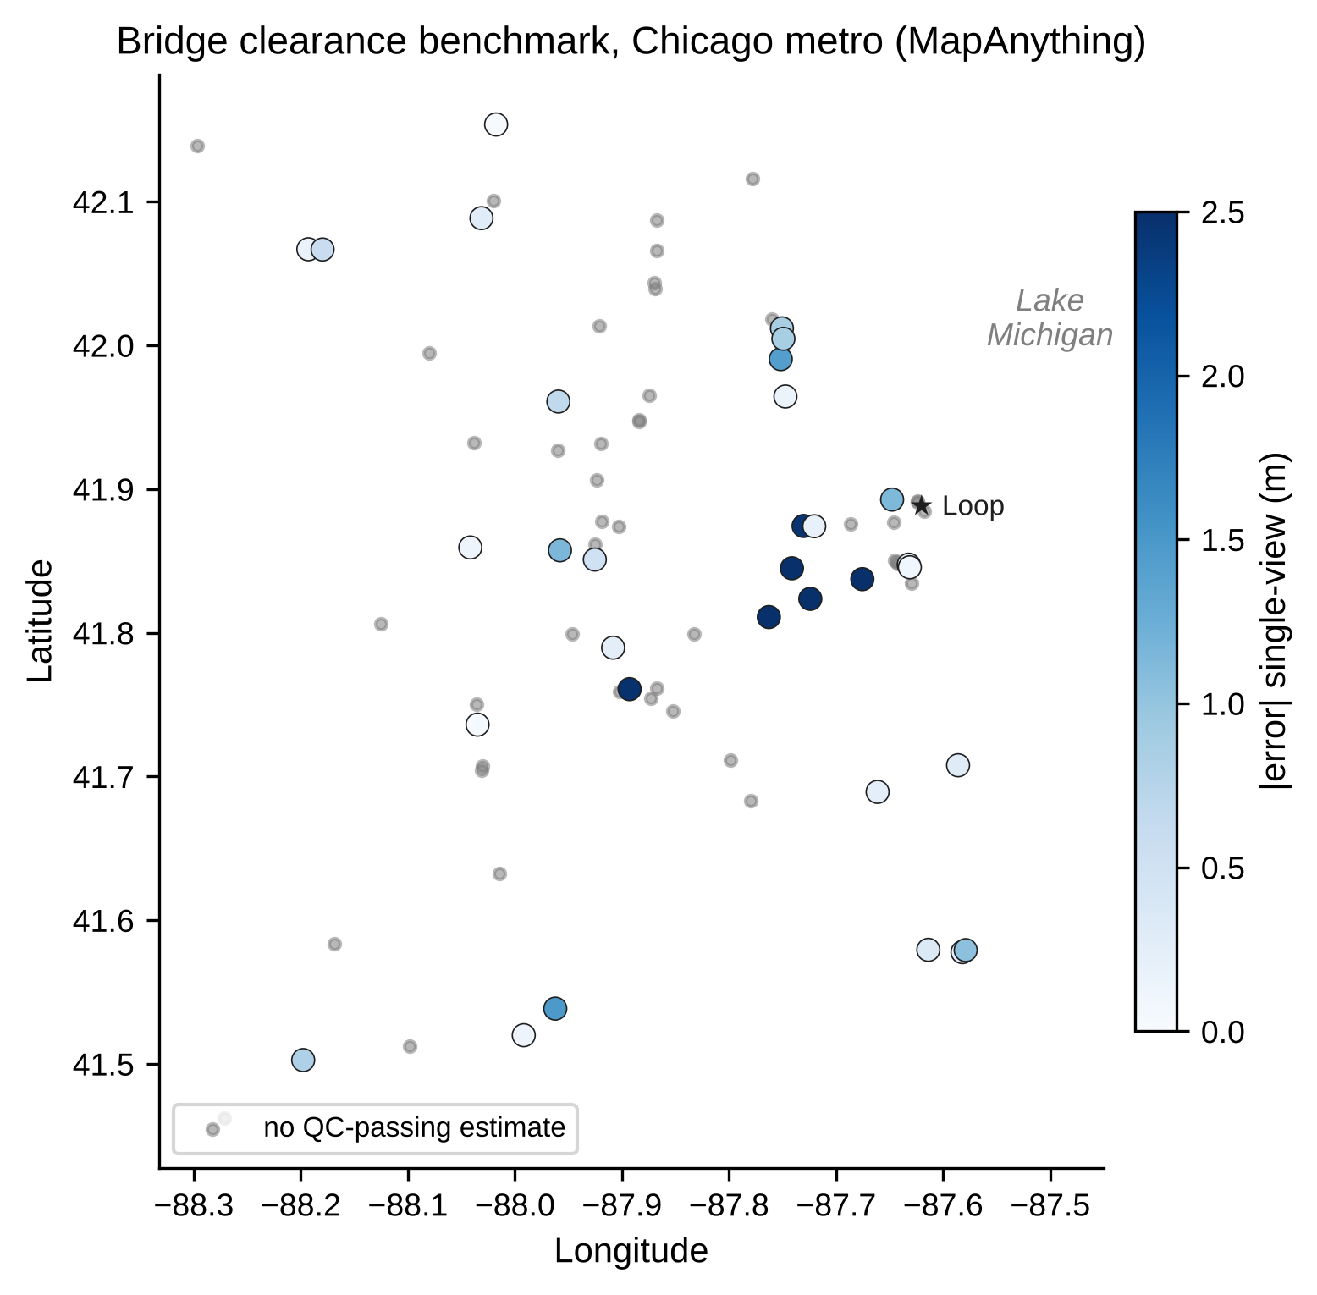
Figure 2. Benchmark bridges in the Chicago metro area. Coloured points passed the automatic quality check and are shaded by single-view absolute error; grey points had no quality-checked estimate. An interactive version is in the project repository.

Methodology
[Owner: Kely (intro, Feature Engineering, MapAnything, Evaluation) — update for the final draft by Tue Oct 27]
The pipeline is modular: image retrieval, frame selection, segmentation, metric 3D reconstruction, geometric measurement and quality control are separate steps. Only the 3D backbone changes between the methods compared in this paper; every backbone receives the same frames and the same masks and is scored with the same measurement code and metrics. Figure 1 summarises the pipeline.
[Figure 1 — pipeline diagram — Adaora inserts here]

Feature Engineering
For target segmentation, the main bridge benchmark used Mask2Former with a Swin-L backbone trained on Mapillary Vistas (Cheng et al., 2022; Neuhold et al., 2017). A separate DA3 experiment used SAM3 (Carion et al., 2025), as described below. The Mask2Former street-level label set includes Bridge, Road, lane-marking and crosswalk classes. Each connected Bridge component is a candidate structure; road, lane-marking, crosswalk, service-lane and manhole pixels form the road mask.
Structure and anchor-frame selection. A candidate structure must span at least 18% of the image width, start in the upper 55% of the image, have its lower edge above 65% of the image height, and have road visible directly beneath it in at least five sampled columns. Each frame is scored by the best candidate's width and the vertical position of its lower edge, and the highest-scoring frame becomes the anchor. The three frames closest to the anchor in distance form the multi-view set (four frames in total).
To estimate bridge clearance, the pipeline identified the lowest structure pixel with road beneath it in each image column and retrieved its corresponding three-dimensional point from the reconstruction. Points whose distance from the camera differed from the median by more than three scaled median absolute deviations were removed. A road plane was then fitted to points at a similar distance from the camera using RANSAC (Fischler & Bolles, 1981), with 400 iterations and a 0.12 m inlier threshold. Only underside points more than 0.3 m above the camera were retained to help exclude walls, abutments, and barriers also labeled as Bridge by the segmentation model. Clearance was calculated as the median perpendicular distance from the retained underside points to the fitted road plane. The distance from the camera centre to this plane was recorded as the recovered camera height.

Modeling Framework

MapAnything
[Owner: Kely — update for the final draft by Tue Oct 27]
MapAnything (Keetha et al., 2026) is a feed-forward model that predicts metric 3D points, confidences and camera poses from one or more images. It was run in two settings: single-view on the anchor frame, and multi-view on the four selected frames, reading the anchor frame's point map. Points were filtered by model confidence (50th percentile for road points, 15th percentile for structure points). Inference used bfloat16 on a single NVIDIA L4 GPU and took about six seconds per bridge, including segmentation of all candidate frames.

Depth Anything 3
The DA3 branch used DA3NESTED-GIANT-LARGE-1.1 to predict metric-scale depth, camera intrinsics, and camera poses (Lin et al., 2025). Single-view inference used the frozen anchor image; multi-view inference used the frozen ordered sequence and retained the anchor output for measurement. The adapter required a true is_metric flag and available camera parameters. This metric-depth configuration supplied the physical scale needed to express reconstructed coordinates in metres.
We converted image pixels into three-dimensional camera coordinates using back-projection under the standard pinhole camera model (Hartley & Zisserman, 2004, Section 6.1). For a pixel at coordinates (u, v), the corresponding three-dimensional point was computed as
$P_{c} = Z K^{−1}{[u, v, 1]}^{T}, Z = D(u, v)$
Here, D(u, v) is the predicted optical-axis depth and K is the camera intrinsic matrix. Assuming zero skew, this relationship expands to
$X_{c} = \frac{(u − c_{x})Z}{f_{x}}, Y_{c} = \frac{(v − c_{y})Z}{f_{y}}, Z_{c} = Z$
The focal lengths fx and fy are expressed in pixels, and (c_x, c_y) is the principal point. Because the normalized image coordinates are dimensionless and Z is expressed in metres, the resulting coordinates (Xc, Yc, Zc) are also expressed in metres. This calculation assumes a pinhole camera model; uncorrected lens distortion remains a potential source of error.
The predicted world-to-camera transformation was inverted to place the reconstructed points and camera centre in a common world coordinate system. Finite points with positive depth were retained, with confidence thresholds at the 50th percentile for road points and the 15th percentile for underside points. The resulting point map and anchor masks were passed to the clearance procedure described in Feature Engineering. Figure 3 illustrates the geometry and reference surface used by this procedure.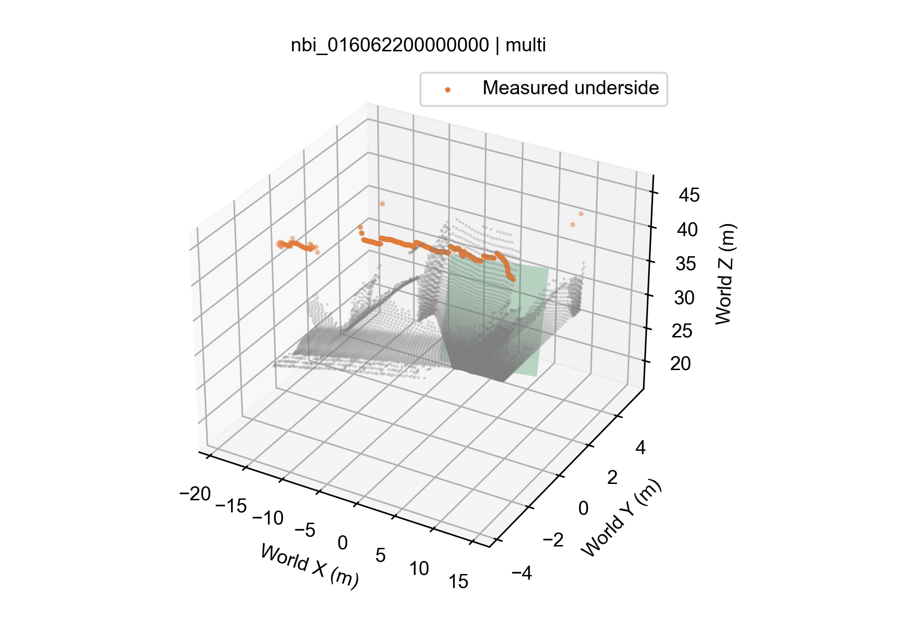

Figure 3. Example DA3 reconstruction with Mask2Former masks, showing scene points in grey, the fitted road plane in green, and the retained bridge-underside samples in orange. Clearance is estimated from the perpendicular distances between the underside samples and the road plane.
The main DA3 comparison used the shared Mask2Former masks. In the separate SAM3 configuration, the prompts bridge underside and road were applied with a confidence threshold of 0.5. The original candidate-selection gates were retained, and structure masks were rejected when more than 5% of their area overlapped the road mask.

VGGT
[Owner: Adaora — update for the final draft by Tue Oct 27]
[VGGT paragraph incl. GPS-based scale recovery — Adaora]

Building Height (Exploratory)
[Owner: Adaora — update for the final draft by Tue Oct 27]
[Building-height method — Adaora]

Evaluation Protocol
[Owner: Kely — update for the final draft by Tue Oct 27]
Automatic quality control (QC) uses no ground truth: an estimate passes if the recovered camera height is between 0.7 m and 3.5 m, at least 10 underside columns are measured, and the structure is within 90 m. Each backbone is reported on three subsets: S1, all cases that pass its own QC; S2, the S1 cases captured with phone or action cameras (EXIF make present); and S3, a common set of 32 cases that passed MapAnything QC, so that backbones can be compared on identical bridges. Metrics are the number of cases, mean absolute error (MAE) with a bootstrap 95% confidence interval (1,000 resamples, seed 42), median absolute error, mean signed error (bias), mean absolute percentage error (MAPE) and the share of estimates within 0.5 m. The camera split in S2 was identified after inspecting errors and is therefore reported as a diagnostic, not as the headline result.

Findings
Table 1 summarises the bridge-clearance results by reconstruction backbone, view setting, and evaluation subset.
[Owner: all — each person fills their own rows by Sun Oct 25]
Table 1. Bridge vertical under-clearance versus NBI Item 54B (metres).
Method | View | Subset | n | MAE (95% CI) | Median AE | Bias | MAPE % | ≤0.5 m %
MapAnything | single | S1 | 30 | 0.92 (0.54–1.45) | 0.43 | -0.69 | 16.8 | 50
MapAnything | single | S2 | 24 | 0.65 (0.40–1.00) | 0.32 | -0.43 | 12.4 | 54
MapAnything | single | S3 | 30 | 0.92 (0.54–1.45) | 0.43 | -0.69 | 16.8 | 50
MapAnything | multi | S1 | 32 | 1.09 (0.75–1.51) | 0.58 | -0.28 | 19.9 | 47
MapAnything | multi | S2 | 24 | 0.77 (0.50–1.12) | 0.47 | +0.28 | 14.6 | 54
MapAnything | multi | S3 | 32 | 1.09 (0.75–1.51) | 0.58 | -0.28 | 19.9 | 47
Depth Anything 3 | single | S1 | 35 | 1.207 (0.838–1.630) | 0.727 | -0.588 | 21.88 | 34
Depth Anything 3 | single | S2 | 26 | 0.860 (0.582–1.176) | 0.620 | -0.249 | 16.29 | 38
Depth Anything 3 | single | S3 | 31 | 1.220 (0.786–1.701) | 0.681 | -0.642 | 21.88 | 39
Depth Anything 3 | multi | S1 | 32 | 0.992 (0.629–1.431) | 0.548 | -0.202 | 17.49 | 44
Depth Anything 3 | multi | S2 | 25 | 0.680 (0.487–0.870) | 0.512 | +0.140 | 13.03 | 48
Depth Anything 3 | multi | S3 | 29 | 1.036 (0.634–1.563) | 0.544 | -0.248 | 18.22 | 45
VGGT (GPS-scaled) | multi | S1 | 35
VGGT (GPS-scaled) | multi | S2
VGGT (GPS-scaled) | multi | S3
VGGT | single | — | n/a
S1 = own QC-passing estimates; S2 = S1 with the EXIF-make-presence proxy; S3 = available successful estimates in the fixed 32-bridge list. The actual n can differ between methods. Bias = mean(estimate − reference). VGGT single-view: n/a — VGGT is not metric from one image.

MapAnything
[Owner: Kely — update for the final draft by Tue Oct 27]
Of the 80 benchmark bridges, 38 had an anchor frame with a detected overhead structure and visible road. Four of these failed during measurement because no underside points remained above the camera, leaving 34 estimates, of which 32 passed QC. The two QC failures were a reconstruction with a recovered camera height of 6.0 m and a structure placed 146 m from the camera. Recovered camera heights on QC-passing cases had a median of 1.29 m (multi-view) and 1.25 m (single-view), consistent with car- or handlebar-mounted cameras, which indicates that MapAnything's metric scale is broadly correct.
On S1, single-view estimates had an MAE of 0.92 m (95% CI 0.54–1.45 m), a median absolute error of 0.43 m and a MAPE of 16.8%; 50% of estimates were within 0.5 m. Multi-view estimates were slightly less accurate (MAE 1.09 m, median 0.58 m). The two settings differ in bias: single-view under-estimates on average (-0.69 m), while multi-view is close to unbiased overall (-0.28 m) but includes several over-estimates of 1.5 m or more (Figure 3).
Error depends strongly on the camera. On phone and action-camera imagery (S2, n = 24), single-view MAE fell to 0.65 m (median 0.32 m, MAPE 12.4%). The eight QC-passing cases without EXIF metadata, mostly wide-angle dashcams, were under-estimated by about 2 m on average (multi-view MAE 2.05 m, bias −1.94 m). MapAnything assumes near-pinhole input, and uncorrected lens distortion compresses the apparent height of the structure. Because this split was found after inspecting the errors, it is a diagnostic that motivates camera-aware filtering rather than a pre-registered result.
The road-plane measurement was essential. The earlier point-to-point measure produced 'clearances' of roughly 13–79 m (multi-view) on the same cases, with a single-view MAE of 25.8 m,, because its road point lay near the camera rather than beneath the structure.
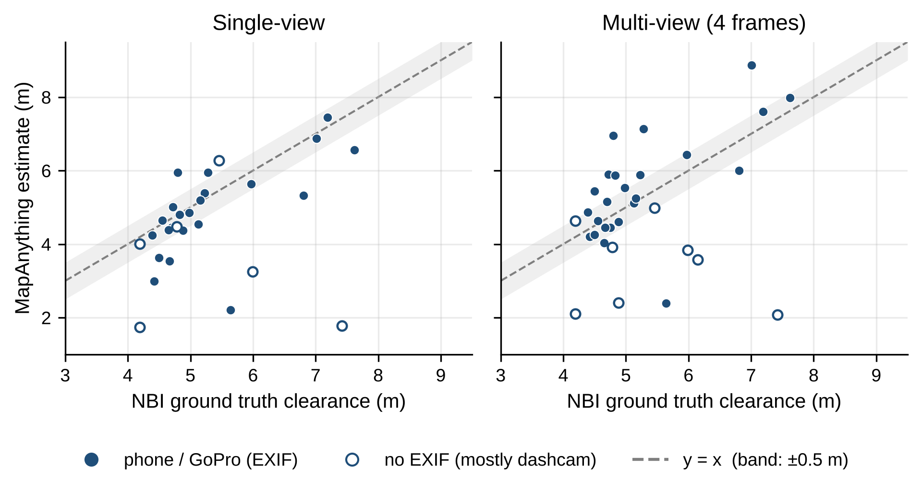
Figure 3. MapAnything estimates versus NBI ground truth on QC-passing bridges. Filled markers: phone or action cameras; hollow markers: no EXIF (mostly wide-angle dashcams). Dashed line: perfect agreement; band: ±0.5 m.

Depth Anything 3
All 80 bridges were represented in both DA3 view settings. The archived measurement check reproduced the stored measurement or failure status for all 76 available case-mode geometry files. With the shared Mask2Former masks, 35 single-view estimates passed QC (43.75% coverage), compared with 32 multi-view estimates (40.00%). S1 MAE was 1.207 m (95% CI 0.838–1.630 m) for single-view and 0.992 m (0.629–1.431 m) for multi-view. The corresponding median absolute errors were 0.727 m and 0.548 m, and 34.29% and 43.75% of retained estimates were within 0.5 m. Figure 5 shows the spread of these estimates. Because the two modes retained different bridges, these averages alone do not establish a paired benefit from adding views.
Most missing estimates arose before clearance measurement: in each mode, 41 anchors had no selected structure and one had no road mask. Single-view had three measurement failures; multi-view had five measurement failures and one additional QC rejection. On S2, MAE was 0.860 m for single-view (n = 26) and 0.680 m for multi-view (n = 25). On S3, 31 single-view and 29 multi-view estimates were available, with MAEs of 1.220 m and 1.036 m, respectively. The complete statistics and confidence intervals for all six subsets are reported in Table 1.
The separate SAM3 configuration processed all 319 frame instances and reused the 40 archived DA3 case-mode geometries required for its selected cases. It yielded 20 QC-passing single-view estimates (25.00% coverage), with MAE 0.543 m (95% CI 0.336–0.771 m), and 19 multi-view estimates (23.75%), with MAE 0.610 m (0.408–0.854 m). Its lower error on its own retained cases coincided with substantially fewer usable estimates than the Mask2Former configuration (Figure 6a).
On the identical QC intersections, Mask2Former and SAM3 had MAEs of 0.589 m and 0.543 m for 20 single-view bridges, and 0.626 m and 0.610 m for 19 multi-view bridges (Figure 6b). The paired MAE differences, Mask2Former minus SAM3, were 0.045 m (95% CI −0.050 to 0.141 m) and 0.017 m (−0.079 to 0.115 m). Neither interval excluded zero. Across all 80 bridges, estimates both passing QC and within 0.5 m numbered 12 versus 10 in single-view and 14 versus 10 in multi-view. Thus, the tested SAM3 configuration did not improve useful measurement coverage at this threshold.
An exploratory thumbnail review classified 40 anchors as lacking a clear visible overhead underside, 28 as showing an overhead region, five as distant structures, five as side or oblique views, and two as inverted images. This helped identify input limitations but did not independently verify bridge identity or explain every failure. One bridge had informed SAM3 prompt and overlap-gate development, and the benchmark had previously been inspected, so the results remain retrospective. Validation on an untouched, geographically separate sample is needed. Metric scale, segmentation boundaries, roadway correspondence, and the difference between inventory minimum clearance and the visible-column median remain sources of uncertainty.
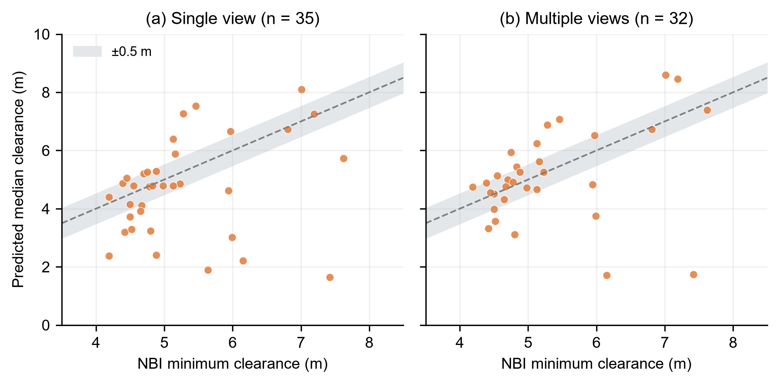
Figure 5. DA3 with Mask2Former: predicted visible-column median clearance versus NBI minimum underclearance for QC-passing (a) single-view and (b) multi-view estimates. Dashed lines indicate equality; grey bands show ±0.5 m. The two clearance definitions differ in spatial coverage.
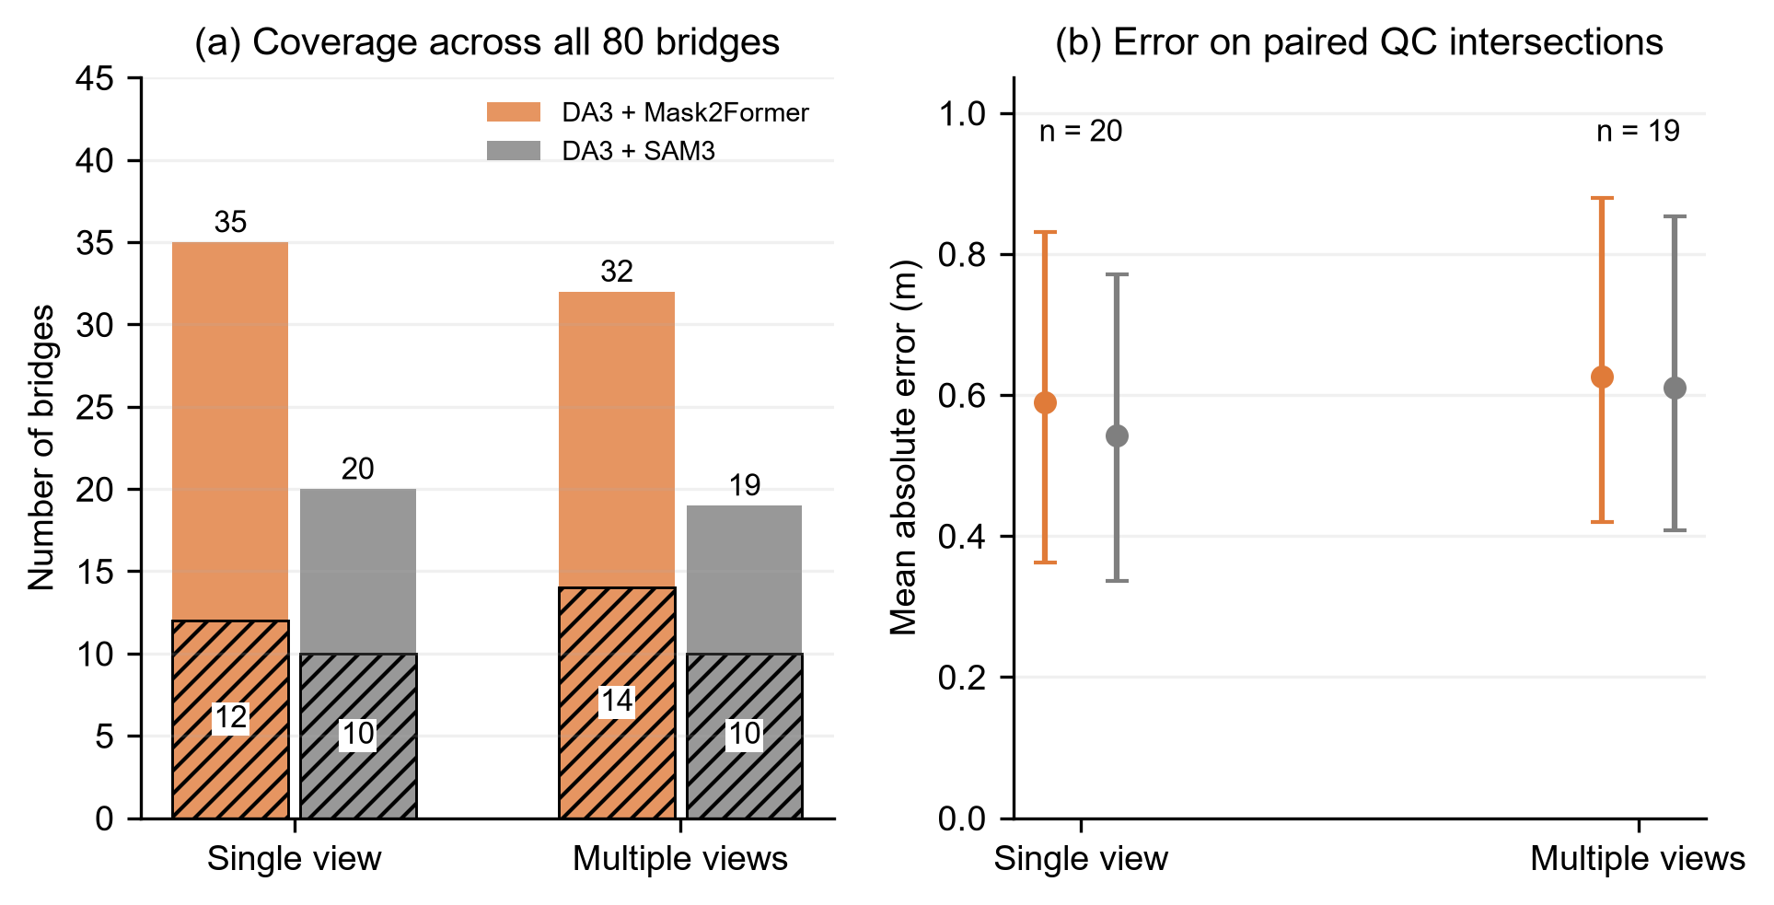
Figure 6. DA3 segmentation comparison. (a) QC-passing counts across all 80 bridges; hatched portions also fall within 0.5 m of the NBI reference. (b) MAE on identical QC intersections, with 95% bootstrap intervals for each configuration’s MAE. The paired difference intervals are reported in the text.

VGGT
[Owner: Adaora — update for the final draft by Tue Oct 27]
[VGGT findings — Adaora]

Stop-Sign Size
[Owner: Kely — update for the final draft by Tue Oct 27]
Of 25 sampled stop signs, 15 were segmented in at least one frame; the other ten were not detected by the combined red-colour and Vistas traffic-sign filter. Sign width was computed as the sign's pixel width multiplied by MapAnything depth and divided by the focal length.
Single-view estimates (n = 14) had a median of 0.88 m. Against the nearest standard size (0.762 m or 0.914 m) the MAE was 0.11 m, and 71% of estimates were within 15% of a standard size. Multi-view estimates (n = 15) had a median of 0.94 m and were biased high relative to the 30-inch standard (MAE vs. nearest standard 0.10 m; 67% within 15%). Because signs occupy only 50–150 pixels, a one- or two-pixel error at the mask edge changes the estimate by several percent, so mask quality rather than depth dominates the error (Figure 4).
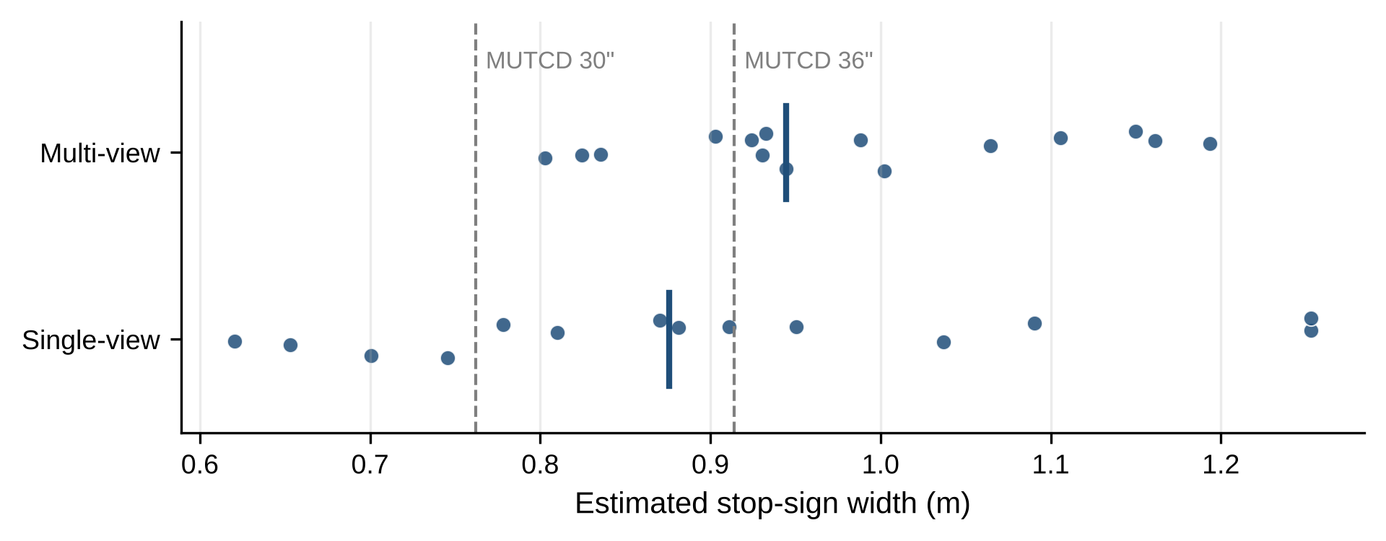
Figure 4. Estimated stop-sign widths. Vertical bars mark the median; dashed lines mark the MUTCD 30-inch and 36-inch standard sizes.

Building Height
[Owner: Adaora — update for the final draft by Tue Oct 27]
[Building-height findings or pointer to Future Work — Adaora]

Method Comparison
[Owner: Kely — write on Wed Oct 28 from the completed Table 1]
[Compare MapAnything, DA3 and VGGT on S3; name the recommended backbone and why.]

Discussion
[Owner: Adaora — spring text below; rewrite by Tue Oct 27]
The preliminary findings suggest that the project’s central idea is technically plausible. Image-based metric estimation from street-level imagery appears capable of producing measurements that are close to ground truth under favorable conditions. In particular, the improvement from the original single-image baseline to the multi-image configurations supports the hypothesis that additional spatial context reduces ambiguity and improves reconstruction quality.
The results also suggest that the most effective solution may not come from a single component in isolation, but rather from the interaction between segmentation quality, reconstruction quality, and the number of informative views. The strong performance of the Depth Anything v3 and SAM3 combination on the main benchmark case indicates that accurate measurements can emerge from a pipeline in which reliable target isolation is paired with strong depth reasoning. Likewise, the operational success of Adaora’s VGGT and SAM3 pipeline shows that a fully automated object-to-geometry workflow is achievable and can produce interpretable intermediate outputs rather than only a final number.
At the same time, the large error observed on one of the alternate image sets shows that the project’s objectives have only been partially achieved so far. The current workflow can produce highly accurate estimates in some cases, but it is not yet consistently reliable across diverse scenes. The available evidence suggests several possible reasons. Lighting conditions may degrade target visibility or depth prediction quality. Some sequences may not provide enough overlapping geometry for stable multi-view reconstruction. Perspective distortion, occlusion, and segmentation imperfections may also propagate through the pipeline and amplify final measurement error.
The results also imply that automated selection does not guarantee improvement in every case, even though it is highly valuable from a workflow perspective. Replacing manual point selection with SAM3 increases scalability and reduces the need for direct human intervention, but the quality of the final estimate still depends on whether the segmented pixels correspond cleanly to the physical boundaries needed for measurement. This means that segmentation quality must be evaluated not only visually, but also in terms of its downstream effect on reconstructed geometry and dimension estimates. The difference between the 19.048-foot five-image manual result and the 19.788-foot automated result on the same 18.08-foot benchmark illustrates this point. Automation makes the workflow more realistic for operational use, but the automation step itself becomes a source of measurement variance.
An additional limitation is the current size and structure of the benchmark set. The reported experiments provide a meaningful starting point, but they are not yet broad enough to characterize overall model performance across object types, weather conditions, scene clutter, or camera geometries. The present discussion must therefore remain within the limits of the tested work. The project can currently claim promising proof-of-concept evidence, but not yet a general-purpose and fully validated measurement system.

Business Value for HERE
[Owner: Adaora — update for the final draft by Tue Oct 27]
[New subsection — Adaora]

Conclusion
[Owner: Kely — draft; finalise after Table 1 and Discussion]
This project moved image-based dimension estimation from a handful of hand-picked examples to an automated benchmark against official ground truth. The pipeline retrieves Mapillary imagery for a target structure, isolates the structure and road automatically, reconstructs the scene in metres and measures clearance against a fitted road plane, with a quality check that requires no ground truth. On 32 quality-checked Chicago bridges, MapAnything single-view estimates were within 0.43 m of the NBI value at the median and within 0.65 m on average for phone and action-camera imagery. The same components sized stop signs to within 15% of a standard size in most measured cases.
The evidence also shows where the approach is not yet reliable: wide-angle dashcam imagery, structures far from the camera, and bridges whose inventory coordinates do not match the road crossing. These limits are identifiable in advance from metadata and from the recovered camera geometry, which makes the pipeline suitable as a screening layer in which confident estimates are accepted and flagged ones are reviewed.

Future Work
- Correct lens distortion using Mapillary camera parameters, or exclude uncalibrated wide-angle cameras before reconstruction.
- Replace NBI point coordinates with map-matched crossing locations (structure line geometry intersected with the road below) to raise the share of usable cases above the current 48%.
- Validate the SAM3 configuration on an untouched sample, and test whether revised prompts and mask-selection rules improve usable clearance coverage.
- Estimate the minimum rather than the median clearance (for example a low percentile over columns) to match the definition of NBI Item 54B, and calibrate it on a held-out set.
- Extend validation beyond Chicago and to additional feature types (overhead sign structures, lane width, building height), and use vision-language models for automatic frame selection and quality review.

References
Carion, N., Gustafson, L., Hu, Y.-T., Debnath, S., Hu, R., Suris, D., Ryali, C., Alwala, K. V., Khedr, H., Huang, A., Lei, J., Ma, T., Guo, B., Kalla, A., Marks, M., Greer, J., Wang, M., Sun, P., Rädle, R., ... Feichtenhofer, C. (2025). SAM 3: Segment anything with concepts. arXiv. https://doi.org/10.48550/arXiv.2511.16719
Cheng, B., Misra, I., Schwing, A. G., Kirillov, A., & Girdhar, R. (2022). Masked-attention mask transformer for universal image segmentation. In Proceedings of the IEEE/CVF Conference on Computer Vision and Pattern Recognition (pp. 1290–1299). https://openaccess.thecvf.com/content/CVPR2022/html/Cheng_Masked-Attention_Mask_Transformer_for_Universal_Image_Segmentation_CVPR_2022_paper.html
Federal Highway Administration. (1995). Recording and coding guide for the structure inventory and appraisal of the nation’s bridges (Report No. FHWA-PD-96-001). https://rosap.ntl.bts.gov/view/dot/38886
Federal Highway Administration. (2009). Manual on Uniform Traffic Control Devices for streets and highways (2009 ed., Part 2B, Table 2B-1). U.S. Department of Transportation. https://mutcd.fhwa.dot.gov/pdfs/2009/part2b.pdf
Federal Highway Administration. (2025). National Bridge Inventory 2025 Illinois data [Data set]. https://www.fhwa.dot.gov/bridge/nbi/2025/delimited/IL25.txt
Fischler, M. A., & Bolles, R. C. (1981). Random sample consensus: A paradigm for model fitting with applications to image analysis and automated cartography. Communications of the ACM, 24(6), 381–395. https://doi.org/10.1145/358669.358692
Hartley, R., & Zisserman, A. (2004). Multiple view geometry in computer vision (2nd ed.). Cambridge University Press. https://doi.org/10.1017/CBO9780511811685
Illinois Department of Transportation. (n.d.). Vertical clearance [Data set]. ArcGIS. Retrieved November 2, 2026, from https://gis1.dot.illinois.gov/arcgis/rest/services/Permits/TruckPermitRoutes/MapServer/15
Keetha, N., Müller, N., Schönberger, J., Porzi, L., Zhang, Y., Fischer, T., Knapitsch, A., Zauss, D., Weber, E., Antunes, N., Luiten, J., Lopez-Antequera, M., Rota Bulò, S., Richardt, C., Ramanan, D., Scherer, S., & Kontschieder, P. (2026). MapAnything: Universal feed-forward metric 3D reconstruction. In 2026 International Conference on 3D Vision (3DV) (pp. 499–509). IEEE. https://doi.org/10.1109/3DV69130.2026.00054
Lin, H., Chen, S., Liew, J., Chen, D. Y., Li, Z., Shi, G., Feng, J., & Kang, B. (2025). Depth Anything 3: Recovering the visual space from any views. arXiv. https://doi.org/10.48550/arXiv.2511.10647
Mapillary. (n.d.). mapillary.config.api.entities. In Mapillary Python SDK documentation. https://mapillary.github.io/mapillary-python-sdk/docs/mapillary.config.api/mapillary.config.api.entities/
Neuhold, G., Ollmann, T., Rota Bulò, S., & Kontschieder, P. (2017). The Mapillary Vistas dataset for semantic understanding of street scenes. In Proceedings of the IEEE International Conference on Computer Vision (pp. 4990–4999). https://openaccess.thecvf.com/content_iccv_2017/html/Neuhold_The_Mapillary_Vistas_ICCV_2017_paper.html
Wang, J., Chen, M., Karaev, N., Vedaldi, A., Rupprecht, C., & Novotny, D. (2025). VGGT: Visual geometry grounded transformer. In Proceedings of the IEEE/CVF Conference on Computer Vision and Pattern Recognition (pp. 5294–5306). https://openaccess.thecvf.com/content/CVPR2025/html/Wang_VGGT_Visual_Geometry_Grounded_Transformer_CVPR_2025_paper.html
Yang, L., Kang, B., Huang, Z., Xu, X., Feng, J., & Zhao, H. (2024). Depth Anything: Unleashing the power of large-scale unlabeled data. In Proceedings of the IEEE/CVF Conference on Computer Vision and Pattern Recognition (pp. 10371–10381). https://openaccess.thecvf.com/content/CVPR2024/html/Yang_Depth_Anything_Unleashing_the_Power_of_Large-Scale_Unlabeled_Data_CVPR_2024_paper.html
Yin, W., Zhang, C., Chen, H., Cai, Z., Yu, G., Wang, K., Chen, X., & Shen, C. (2023). Metric3D: Towards zero-shot metric 3D prediction from a single image. In Proceedings of the IEEE/CVF International Conference on Computer Vision (pp. 9043–9053). https://openaccess.thecvf.com/content/ICCV2023/html/Yin_Metric3D_Towards_Zero-shot_Metric_3D_Prediction_from_A_Single_Image_ICCV_2023_paper.html

Appendices

Appendix A. Implementation Details
[Owner: Adaora — spring text below; update Wed Oct 28]
Current implementation work includes Mapillary API-based image retrieval, single-image and multi-image experiment branches, SAM3-based automated sign, sign-truss, and road-surface selection, VGGT-generated depth maps and point clouds, and PCA-based plane fitting for sign measurement. Comparative reconstruction experimentation has also included Pi3 notebook-based testing for point-cloud generation and direct point-to-point distance measurement. In the notebook-based prototype, Mapillary imagery was retrieved through the API, stored locally, loaded into the candidate model pipeline, and measured either through manually specified image-plane points or automatically segmented target regions aligned to reconstructed 3D coordinates.

Appendix B. Benchmark Cases and Setup
[Owner: Adaora — spring text below; update Wed Oct 28]
The current benchmark set includes repeated evaluation on a baseline case with a ground-truth dimension of 18.08 feet and at least two additional image sequences with ground-truth values of 18.00 feet and 18.83 feet. These tests are useful for early comparative evaluation, but the sample remains too limited for a complete assessment of robustness or generalizability. Expanding the benchmark set remains a priority for the next stage of the project.

Appendix C. Early Experiments (Spring 2026)
[Owner: Kely — update for the final draft by Tue Oct 27]
Before the NBI benchmark, the team compared models on three manually selected Illinois Department of Transportation (IDOT) overhead sign structures with documented vertical clearance, measured point-to-point between selected image points. These experiments guided model selection but are too few to estimate accuracy, and they used a different measurement definition from the main results. Table C1 lists them for completeness.
Table C1. Early experiments on IDOT overhead sign structures (feet).
Experiment Configuration | Ground Truth (ft) | Estimate (ft) | Accuracy | Error
Single-image baseline | 18.08 | 15.604 | 86.31% | 13.69%
Five-image same-sequence input with manual selection | 18.08 | 19.048 | 94.65% | 5.35%
Five-image workflow with SAM3 automated selection | 18.08 | 19.788 | 90.55% | 9.45%
Depth Anything v3 + SAM3, baseline case | 18.08 | 17.39 | 96.18% | 3.82%
Depth Anything v3 + SAM3, image set 1 | 18.00 | 17.01 | 94.50% | 5.50%
Depth Anything v3 + SAM3, image set 2 | 18.83 | 25.60 | 64.05% | 35.95%

