**Task 1**

BACKGROUND: In all my projects, I’ve used Spring Boot 1.5.9 with Hibernate 5.0.12. All the tables in Mysql are mapped into a specific Spring Data JPA Object, as well as a Repository Class, aka Data Access Object (DAO) class. The DAO is using either hibernate (hql) transformation or manually written sql @Query to access the database.

* How did you use connection pooling?
  + In application.properties, I set as following, notice the mysql instance is on a RDS instance named “utilities-db”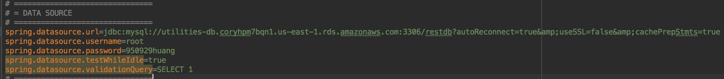
  + When launching from spring boot with command mvn spring-boot:run, the following log indicates the successful DataSource (pool) setting, by default it is using Hibernate built-in connection pool created by org.hibernate.connection.DriverManagerConnectionProvider
  + 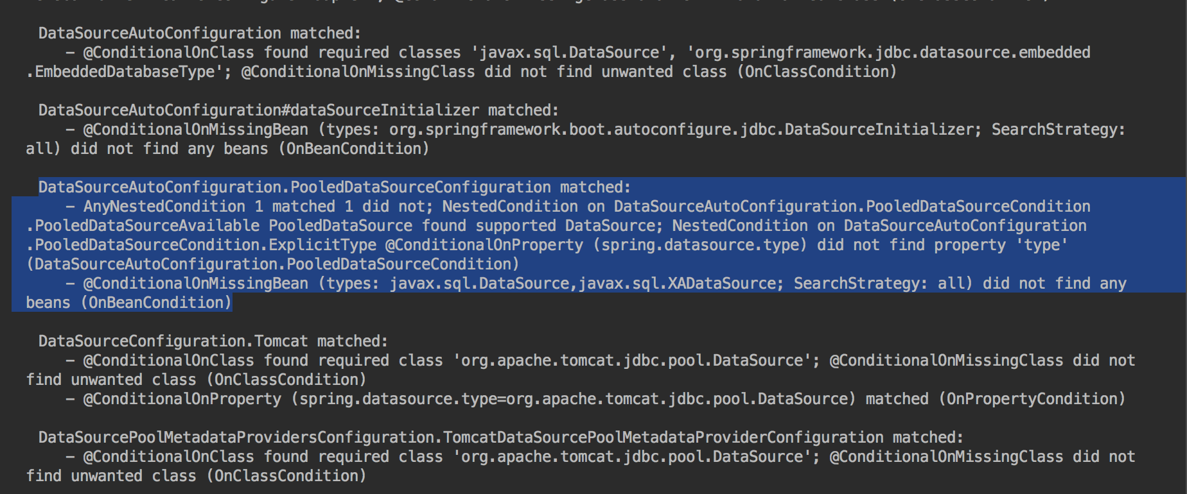

* File name, line numbers as in Github
  + - In pers.yicong.foodvenger.repository package, I’ve included all extended JpaRepository classes (DAO), listing as following:
      * CreditCardRepository
      * CuisineInRestRepository
      * CuisineRepository
      * DishInRestRepository
      * DishRepository
      * RatingRepository
      * RestaurantRepository
      * RoleRepository
      * SaleRepository
      * UserRepository

All the method (extended or Overrided) are using connection pooling.

* Snapshots

Here I am listing two example files:

* + RestaurantRepository: 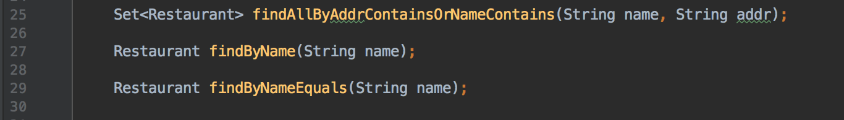

* + UserRepository: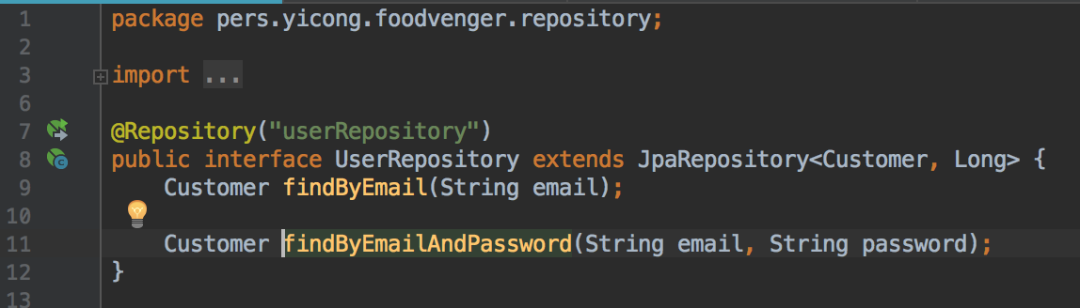
* How did you use Prepared Statements?

I used manually written native SQL Statements instead of JpaRepository methods.

The Syntax is using @Query annotation to define a method in JpaRepository in order to have some costume functionalities.

* File name, line numbers as in Github
  + - RestaurantRepository in pers.yicong.foodvenger.repository package: 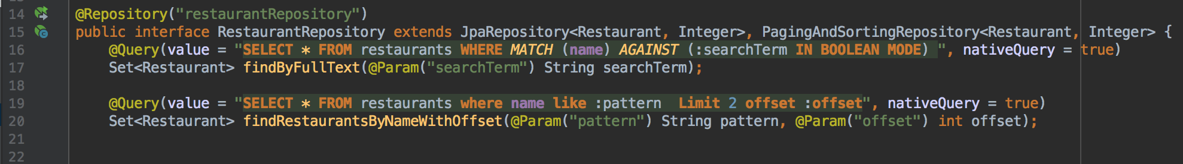
    - DishRepository in pers.yicong.foodvenger.repository package:

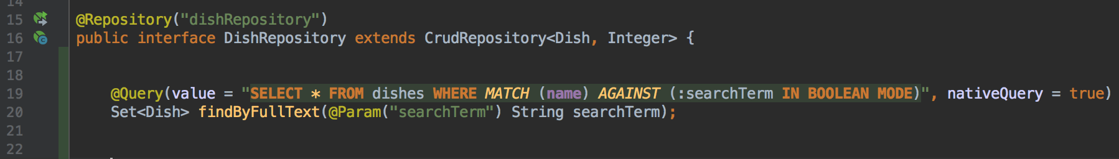

* Snapshots

**Task 2**

* Address of AWS and Google instances

(Might change)

AWS:

Master: 52.33.219.224

Slave: 34.218.79.185

* Have you verified that they are accessible? Does Fablix site get opened both on Google’s 80 port and AWS’ 8080 port?

Since I am using Spring boot, which contains a private tomcat within the framework itself, the global Tomcat server has to be shutdown before launch my instances. Note normally deploy the .war file in the target folder onto Tomcat will not work.

* 1. Make sure Tomcat is shut down, otherwise the port 8080 is occupied.
  2. Navigate to ~/cs122b-winter18-team-89
  3. Launch the sprint boot instance with command: mvn spring-boot:run
  4. Wait for about 30 seconds, until seen following lines:
     + 2018-03-15 00:56:06.341 INFO 2382 --- [ main] o.s.j.e.a.AnnotationMBeanExporter : Registering beans for JMX exposure on startup
     + 2018-03-15 00:56:07.208 INFO 2382 --- [ main] s.b.c.e.t.TomcatEmbeddedServletContainer : Tomcat started on port(s): 8443 (https) 8080 (http)
     + 2018-03-15 00:56:07.219 INFO 2382 --- [ main] p.y.foodvenger.FoodVengerApplication : Started FoodVengerApplication in 25.977 seconds (JVM running for 52.257)

Please do the same for both Master and Slave

* How connection pooling works with two backend SQL?
  + File name, line numbers as in Github

I’ve simply changed the setting in /src/main/resources/application.properties to be localhost mysql, so master instance would use master mysql while slave instance would use slave mysql.

Snapshot:

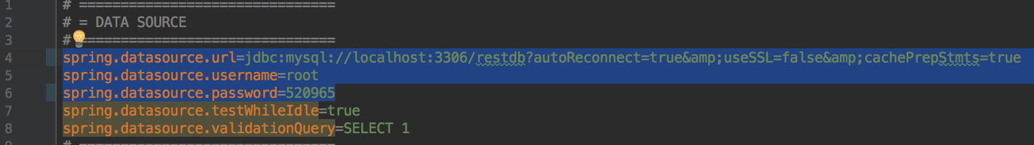

* How read/write requests were routed?
  + File name, line numbers as in Github
    - All read are distributed into two instances, writes are only direct to master instance, even if randomly access the slave instance.
    - In pers.yicong.foodvenger.controller package, there are Controller Objects, in which I mapped all the url. For example in AdminController, there is method mapping “/add” which writes to database.
* Snapshots
* 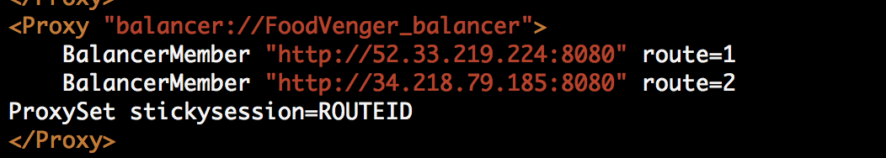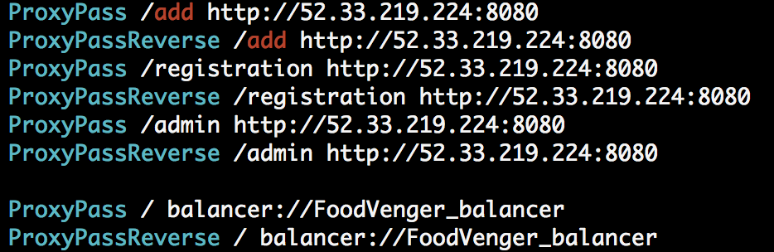

**Task 3**

As I am using my own domain Restaurant, I have 1000 records in the database, and generated a 1000 line query csv based on the records.

* Have you uploaded the log file to Github? Where is it located?

They are in /data/log

* Have you uploaded the HTML file to Github? Where is it located?

Its in /report, as well as all the .png files

* Have you uploaded the script  to Github? Where is it located?

The average_time.py script is located in /src/python

* Have you uploaded the WAR file and README  to Github? Where is it located?

The WAR and README are in the root folder.