DXB-111

Introduction to Web Design

Assignment - 2

Rationale

Yicong Li

N10149899

**Target audience**

A group of 10-year-old children decides to visit Brisbane when they are on summer vacation. My target audience is from 4-5 children and is adventurous, outgoing, social. They love to go to watch several sceneries and take some images. If there’s an exciting and funny spot in Brisbane, they would like to have fun. In addition, they also want to go to one area where has dessert, classic food, and fast food would be better. They love to eat Nugget. This is one of the foods they dream it. Therefore, I strongly recommend my local living area where is in the Southbank.

图示

**Mood board**

手机屏幕截图

**Screenshot annotation**

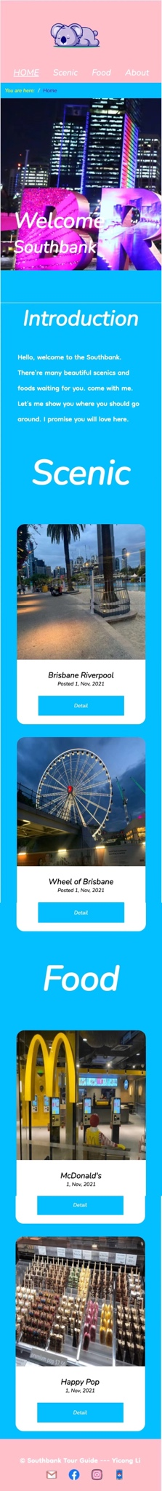

Added footer background color is same with header color. It would be more consistent for my whole website style.



My card layout is a simple design, included two main colours white and blue. Change the border radius to make them more rounded. It’s better for my target to view and use. Added blue colour for the button interacts with my background colour.



I used another font family for the paragraph element, which is Dongle: wght. The reason why I chose it is that it's similar to the word my target audience wrote it. In addition, I keep my introduction simple and short. For the children. They probably do not want to read too many words.



Font-family selection --- Nunito : ital. this is a good font family for heading. It’s a clear and highly legible font which increases readability for my target. In addition, the font size would be 60px, making my target audience easily to see, because they probably don't want to see a smaller heading.



Logo selection – considering my target audience is a group of 10 yead old children. I’m thinking they would like attractive and representive logo.

Therefore, I find this koala logo for them. Because koala is the symbol of Brisbane and is anomie style of koala, which adapted my target audience age.



Pink color words are the reference heading, white color words are the reference. That would be better for my target audience to read.



Icons that I selected are rounded and adorable design, which is more conformable for my target audience to read.



Added breadcrumb for my target audience, it’s better for users to use and know which page they are in. for this page is in the about page.

It includes my contact information and reference.



Added relative images for my content. I was supposed to share images that I took, but images that I took are dark and pale. Therefore, I added these images from Pexel and reference on the about page. Because these images clearer and more readable.

Added several sentences as description for this location. Just try to keep it short.

