- 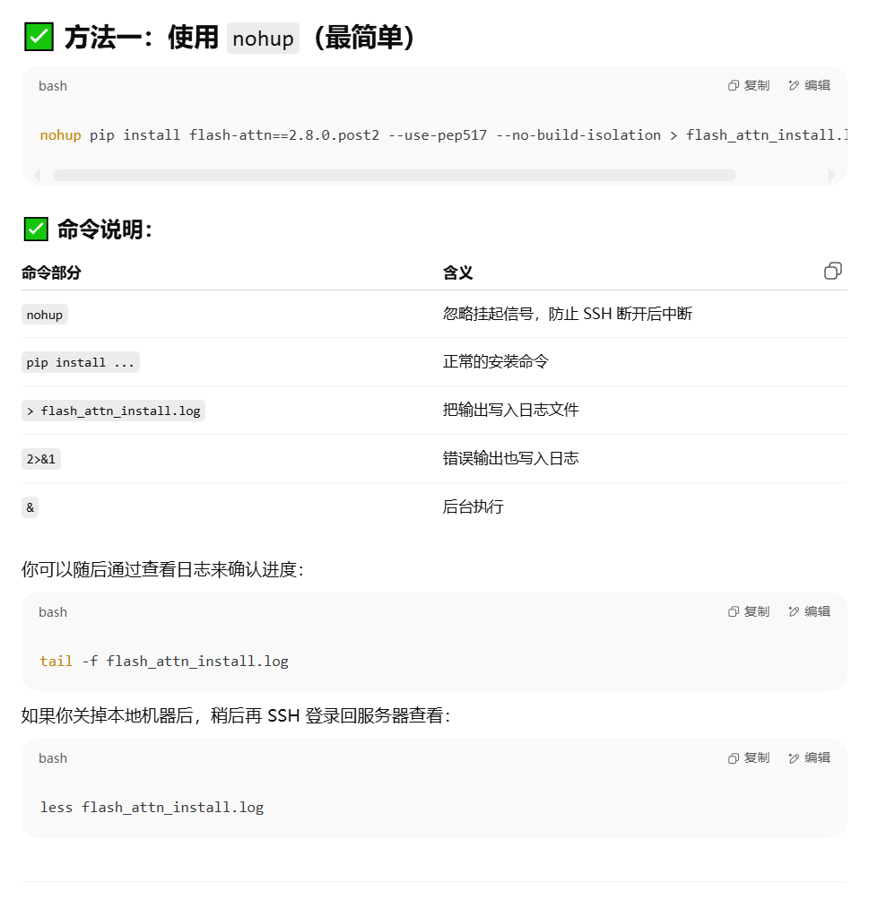
- 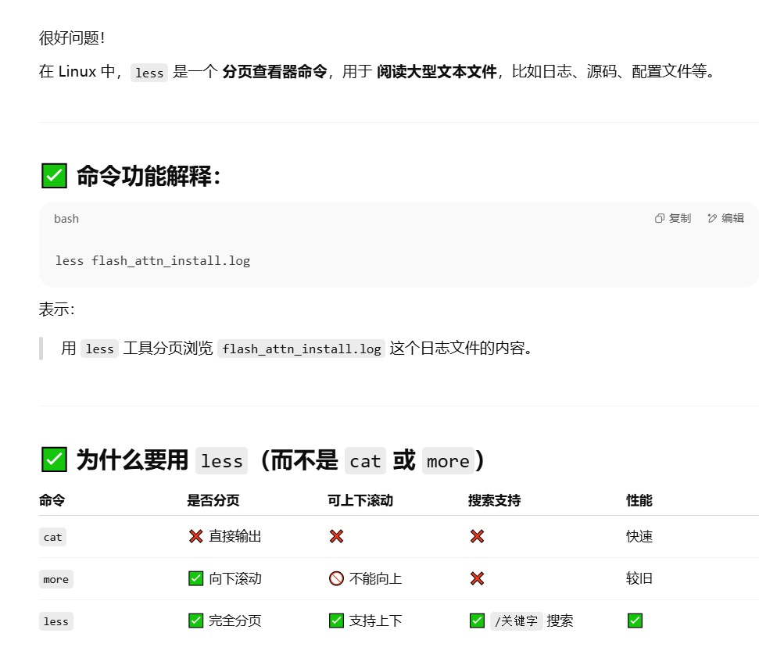
- 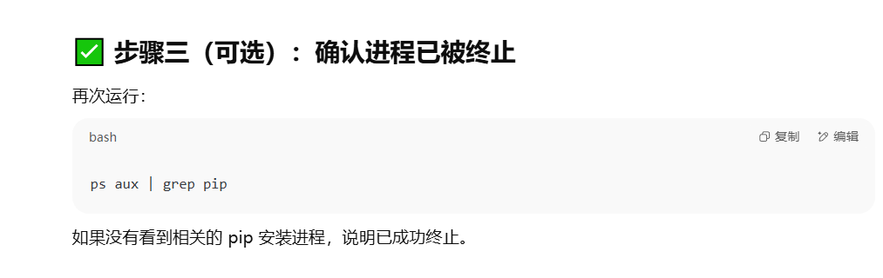
- 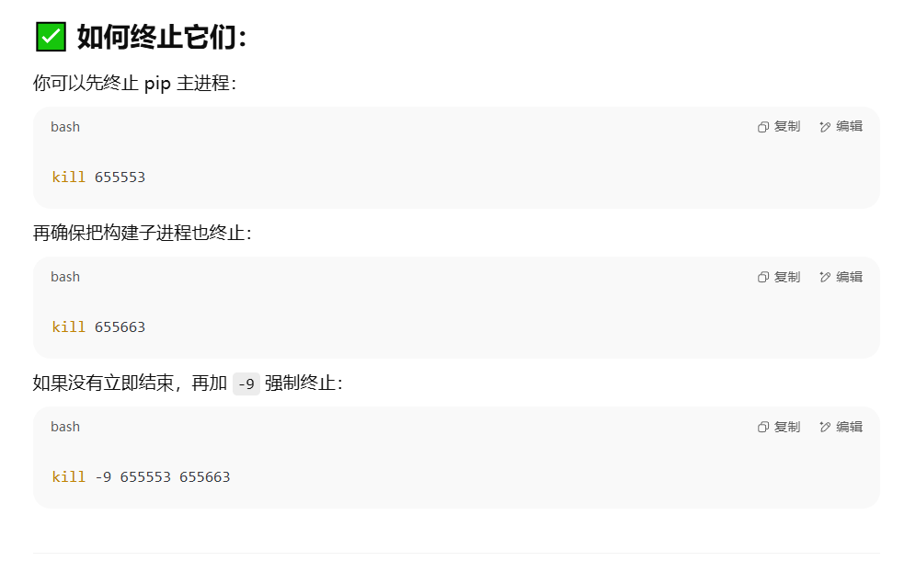
- python -c "import flash_attn; print(flash_attn.__version__)"
- 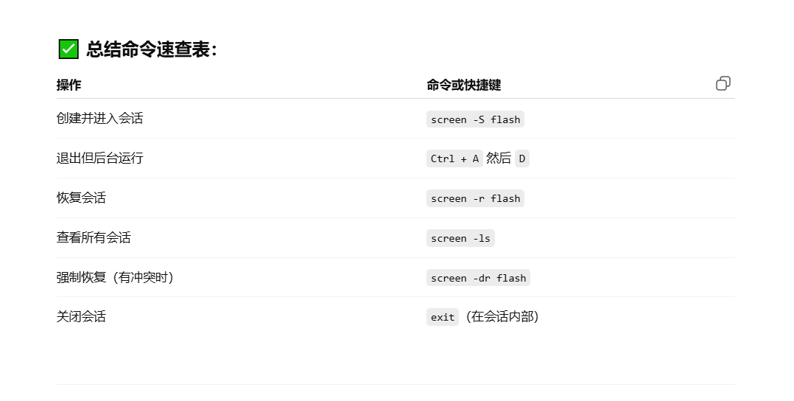
- tensorboard --logdir=./local_output/__b4ep100adamlr0.0003wd0.005

