**CS566 Assignment 2**

Yiduo Feng

09/22/2022

Tasks

1. Strassen’s algorithm (3 points): Use Strassen’s algorithm to compute the following matrix product. Show your work in different computation steps.

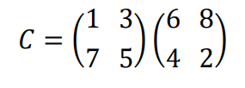

Let’s define the following:

A11 = 1, A12 = 3, A21 = 7, A22 = 5; B11 = 6, B12 = 8, B21 = 4, B22 = 2.

And the 10 helper matrices:

S1 = B12-B22 = 8-2 = 6

S2 = A11 + A12 = 1+3 = 4

S3 = A21+A22 = 7+5 = 12

S4 = B21 – B11 = 4-6 = -2

S5 = A11+A22 = 1+5 =6

S6 = B11+B22 = 6+2 = 8

S7 = A12 – A22 = 3-5 = -2

S8 = B21+B22 = 4+2 = 6

S9 = A11 – A21 = 1-7 = -6

S10 = B11+B12 = 6+8 = 14

Then the 7 matrices:

P1 = A11*S1 = A11*B12-A11*B22 = 1*6 = 6

P2 = S2*B22 = A11*B22+A12*B22 = 4*2=8

P3 = S3*B11 = A21*B11 + A22*B11 = 12*6 = 72

P4 = A22*S4 = A22*B21-A22*B11 = 5*(-2) = -10

P5 = S5*S6 = A11*B11+A11*B22+A22*B11+A22*B22 = 6*8 = 48

P6 = S7*S8 = A12*B21+A12*B22-A22*B21-A22*B22 = -2*6 = -12

P7 = S9*S10 = A11*B11+A11*B12-A21*B11-A21*B12 = -6*14 = -84

So we can get C matrix is :

C11 = P5+P4-P2+P6 = 48-10-8-12 = 18

C12 = P1+P2 = 6+8 = 14

C21 = P3+P4 = 72-10 = 62

C22 = P5+P1-P3-P7 = 48+6-72+84 = 66

Thus the results is

()

2. Strassen’s algorithm (3 points)

Write pseudocode for Strassen’s Algorithm (assume the input is the power of 2). You can use similar pseudocode syntax similar to the CLRS book or our lecture slides.

Def Strassen(A, B):

Divide the input A, B and put into A11….A22, B11…B22 and create C

Define the S1…S10 and P1…P7.

#And the 10 helper matrices:

S1 = B12-B22 = 8-2 = 6

S2 = A11 + A12 = 1+3 = 4

S3 = A21+A22 = 7+5 = 12

S4 = B21 – B11 = 4-6 = -2

S5 = A11+A22 = 1+5 =6

S6 = B11+B22 = 6+2 = 8

S7 = A12 – A22 = 3-5 = -2

S8 = B21+B22 = 4+2 = 6

S9 = A11 – A21 = 1-7 = -6

S10 = B11+B12 = 6+8 = 14

#Then the 7 matrices:

P1 = A11*S1

P2 = S2*B22

P3 = S3*B11

P4 = A22*S4

P5 = S5*S6

P6 = S7*S8

P7 = S9*S10

#So we can get C matrix is :

C11 = P5+P4-P2+P6

C12 = P1+P2

C21 = P3+P4

C22 = P5+P1-P3-P7

Combine C11…C22 into matrix C

return C

3. Strassen’s algorithm (4 points)

Is it possible to use Strassen’s Algorithm to compute the following matrix multiplication?

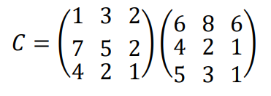

• Describe how would you compute it.

• You do not need to calculate it with exact results, just describe how would you do it and describe your steps. (2 points)

• Is it possible to use Strassen’s Algorithm for any matrix multiplication? What is the resulting algorithm run time in Q notation? Describe your answers. (2 points)

It is possible.

Let’s say the left matrix is A, and the right one is B. First, we need to convert these two 3x3 matrices into two 4x4 matrices. According to the Strassen’s Algorithm, we need to divide each of them into 4 small part which are A11…A22, B11..B22. (shown the picture below.)

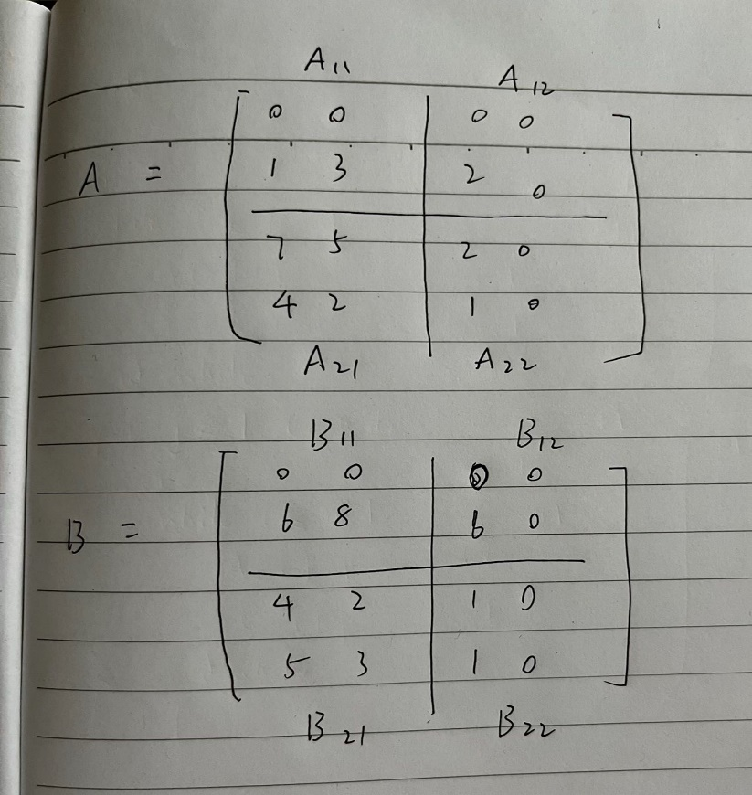

Then follow the Strassen’s Algorithm

Create the 10 helper matrices:

S1 = B12-B22 = 8-2 = 6

S2 = A11 + A12 = 1+3 = 4

S3 = A21+A22 = 7+5 = 12

S4 = B21 – B11 = 4-6 = -2

S5 = A11+A22 = 1+5 =6

S6 = B11+B22 = 6+2 = 8

S7 = A12 – A22 = 3-5 = -2

S8 = B21+B22 = 4+2 = 6

S9 = A11 – A21 = 1-7 = -6

S10 = B11+B12 = 6+8 = 14

Then the 7 matrices:

P1 = A11*S1

P2 = S2*B22

P3 = S3*B11

P4 = A22*S4

P5 = S5*S6

P6 = S7*S8

P7 = S9*S10

So we can get C matrix is :

C11 = P5+P4-P2+P6

C12 = P1+P2

C21 = P3+P4

C22 = P5+P1-P3-P7

This example tells us that it is possible to use Strassen’s Algorithm for any matrix multiplication because we can change the matrix into suitable size by adding zero raw and column.

In the class slide, we can know that the runtime is T(n) = 7T(n/2)+theta(n^2)

By using Master Method:

a = 7, b = 2, d = 2.

a > b^d, so we choose case 3.

Thus, T(n) = theta(n^(log(7)))

4. Solving the following recurrences (4 points)

Use the Substitution Method for solving the following recurrences.

1. Show that the solution of 

T(n-1)<=c*(n-1)^2+n

<= c(n^2-2n+1)+n

<= cn^2 – c2n + c + n

<=cn^2 holds as long as c >= 1

Thus T(n) = O(n^2)

2. Show that the solution of 

T(n/2)<=c*(log(n/2))+1

<= clog(n) – clog(2) +1

<= clog(n) – 1 +1

<= clog(n) holds as long as c >= 1

Thus T(n) = O(log(n))

5. Solving the following recurrences (6 points)

Use the Master Method for solving the following recurrences:

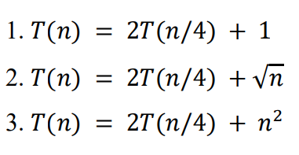

According to the course slide, the formular of Master Method is:

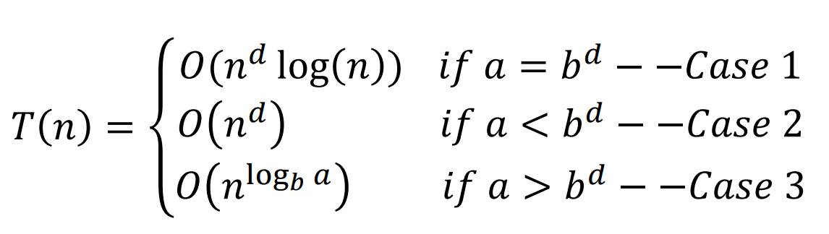

1. a = 2, b = 4, d = 0

2 > 4^0 = 1

So a > b^d and we choose case 3:

So that T(n) = O(n^(log4(2)))

1. a = 2, b = 4, d = 1/2

2 = 4^(1/2) = 2

So a = b^d and we choose case 1:

So that T(n) = O(sqrt(n)*log(n))

1. a = 2, b = 4, d = 2

2 < 4^2 = 16

So a < b^d and we choose case 2:

So that T(n) = O(n^2)