**CS566 Assignment 5**

Yiduo Feng

11/21/2022

**Tasks**

**1. Dynamic Programming Tables (10 points):** An investor wants to invest 10 million dollars in

real estate. He can select properties from a list of 4 houses in 4 different cities in Massachusetts.

He wants to purchase as much as possible, and he wants to maximize the expected profits that

he can get when he is going to sell the houses in the next year.

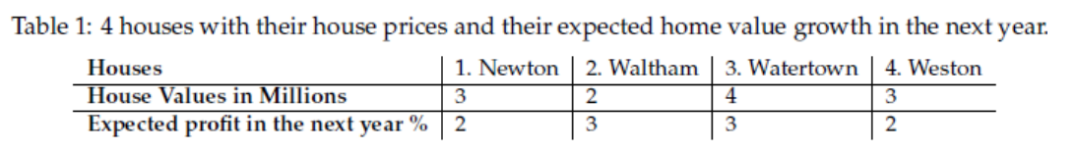

Tasks:

• Task 1.1. Describe what are the sub-problems here and what is the size/count of the subproblems

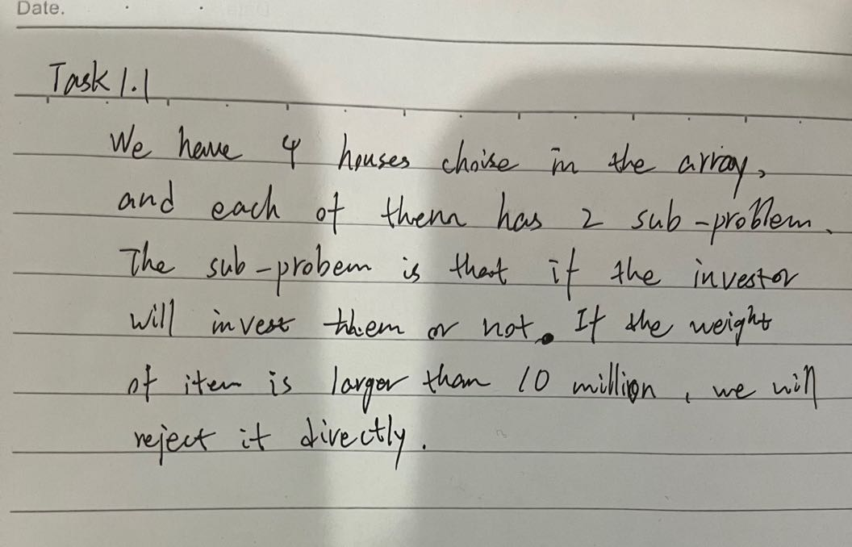

• Task 1.2. Describe which inputs to the knapsack problem (value and size) correspond to the

inputs in the home purchasing problem.

Value is Expected profit, and size is house value.

• Task 1.3. Fill up the following dynamic programming table and check the maximum possible

profits.

Calculate the profit for each item.

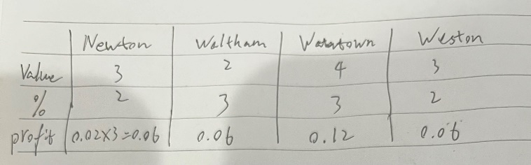

Then fill the table.

|  |  |  |  |  |  |  |  |  |  |  |  |
| --- | --- | --- | --- | --- | --- | --- | --- | --- | --- | --- | --- |
| V[i,w] | 0 | 1 | 2 | 3 | 4 | 5 | 6 | 7 | 8 | 9 | 10 |
| I = 0 | 0 | 0 | 0 | 0 | 0 | 0 | 0 | 0 | 0 | 0 | 0 |
| I = 1 | 0 | 0 | 0 | 0.06 | 0.06 | 0.06 | 0.06 | 0.06 | 0.06 | 0.06 | 0.06 |
| I = 2 | 0 | 0 | 0.06 | 0.06 | 0.06 | 0.12 | 0.12 | 0.12 | 0.12 | 0.12 | 0.12 |
| I = 3 | 0 | 0 | 0.06 | 0.06 | 0.12 | 0.12 | 0.18 | 0.18 | 0.18 | 0.24 | 0.24 |
| I = 4 | 0 | 0 | 0.06 | 0.06 | 0.12 | 0.12 | 0.18 | 0.18 | 0.18 | 0.24 | 0.24 |

The max possible profit is 0.24 million

• Task 1.4. What is the optimal set of houses to buy and invest the money in?

[Newton, Waltham, Watertown]

Or [Weston, Waltham, Watertown]

**2. Dynamic Programming - City Planning. (10 points):** A city planner is asked to organize grocery shops in a new city. The city has a straight-line main street that goes throughout the city. The city planner is asked where the city should provide permits to build new grocery shops so that people of the new city can have the shortest distance to their grocery markets. The population density is not constant along both sides of the main street. A higher density is around multiple city centers or crossroads alongside the main street.

Your task is to develop an algorithm, given the positions of the city centers and the number of

grocery shops compute the least possible sum of all distances between each city center and

its nearest grocery shops.

Input to your Algorithm:

1. List of city centers coordinate positions along the main street (each an integer number

between 1 and 1000). This is a sequence of numbers.

2. The number of city centers is an integer between 2 and 100.

3. The number of grocery shops (an integer number between 2 and 30).

4. The number of shops is smaller than the number of city centers.

The output of your algorithm: A single integer, which is the sum of all distances between each city

center and its nearest grocery market.

Sample Input:

5

[1 2 3 6 7 9 11 21 40 50]

Sample Output:

9

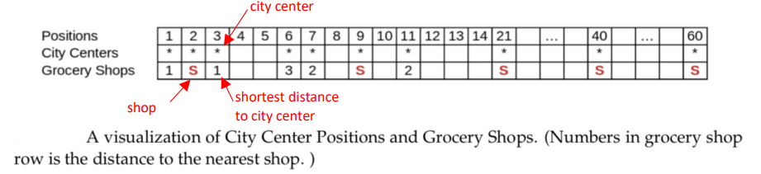

Tasks:

• Task 2.1. What are the sub-problems in this case? What are the counts of sub-problems? Provide

a brief description of your solution.

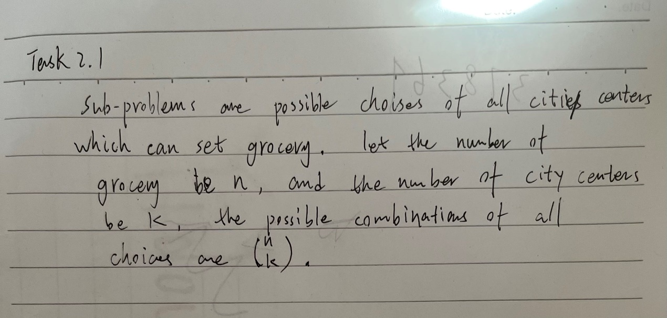

• Task 2.2. Write up your algorithm in Pseudocode or python implementation.

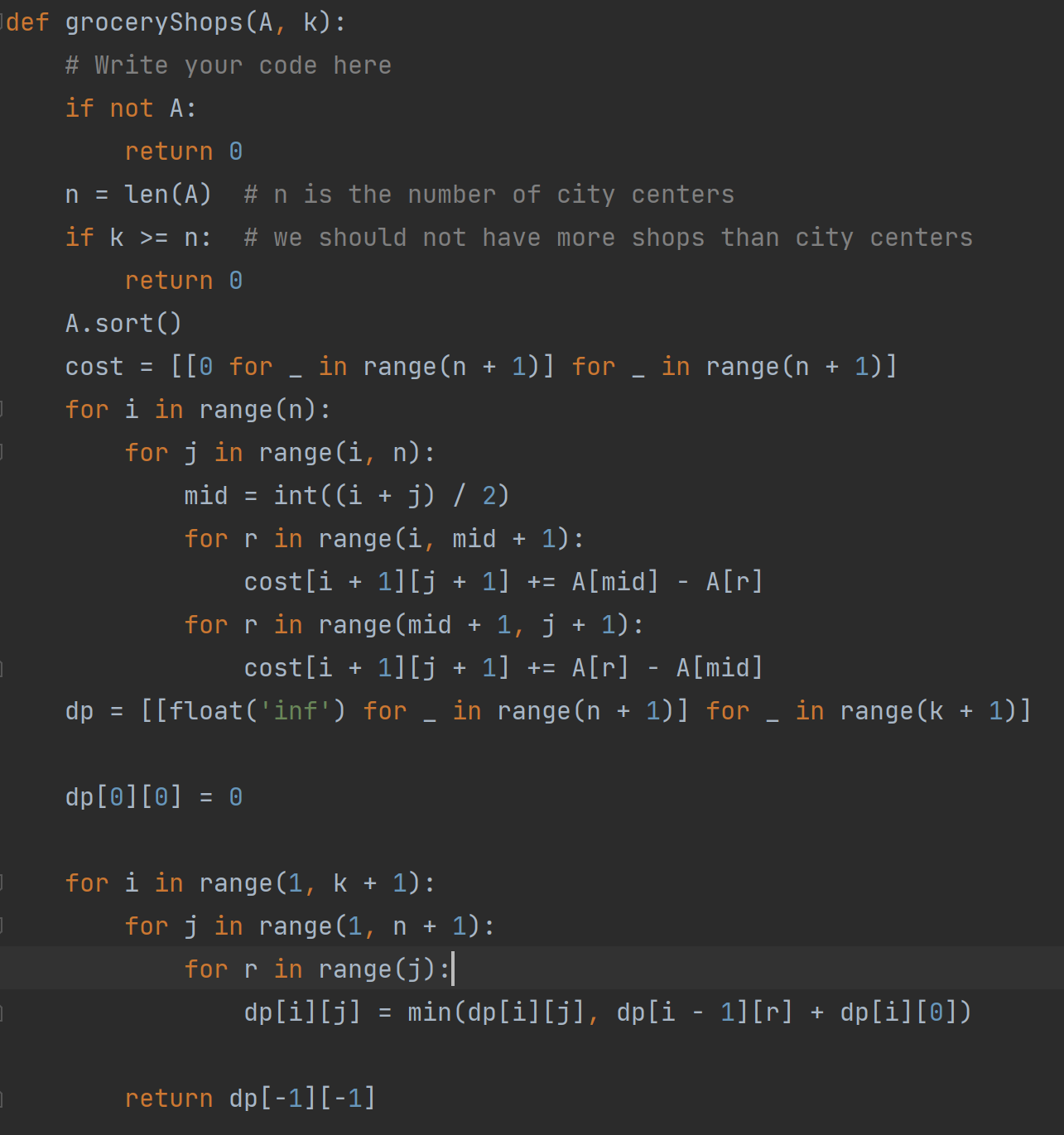

• Task 2.3. What is the run time complexity of your algorithm?

O(n*W)