Yiduo Feng

Class: CS 677

Date: 03/21/2022

Homework 1

##### Question 1:

1. for each of the 5 years, compute the mean and standard

deviation for the sets R, R− and R+ of daily returns for

your stock for each day of the week

2. summarize your results in the table as shown below (5 tables

total).

1. are there more days with negative or non-negative returns?

4. does your stock lose more on a ”down” day than it gains

on an ”up” days.

**The results for part 1 - part 4 shown in tables below:**

The tables below are for part 1-2, and the summary following the tables are results for part 3-4.

I used python to compute the result for part 3- 4, and give a sentence for each year output.

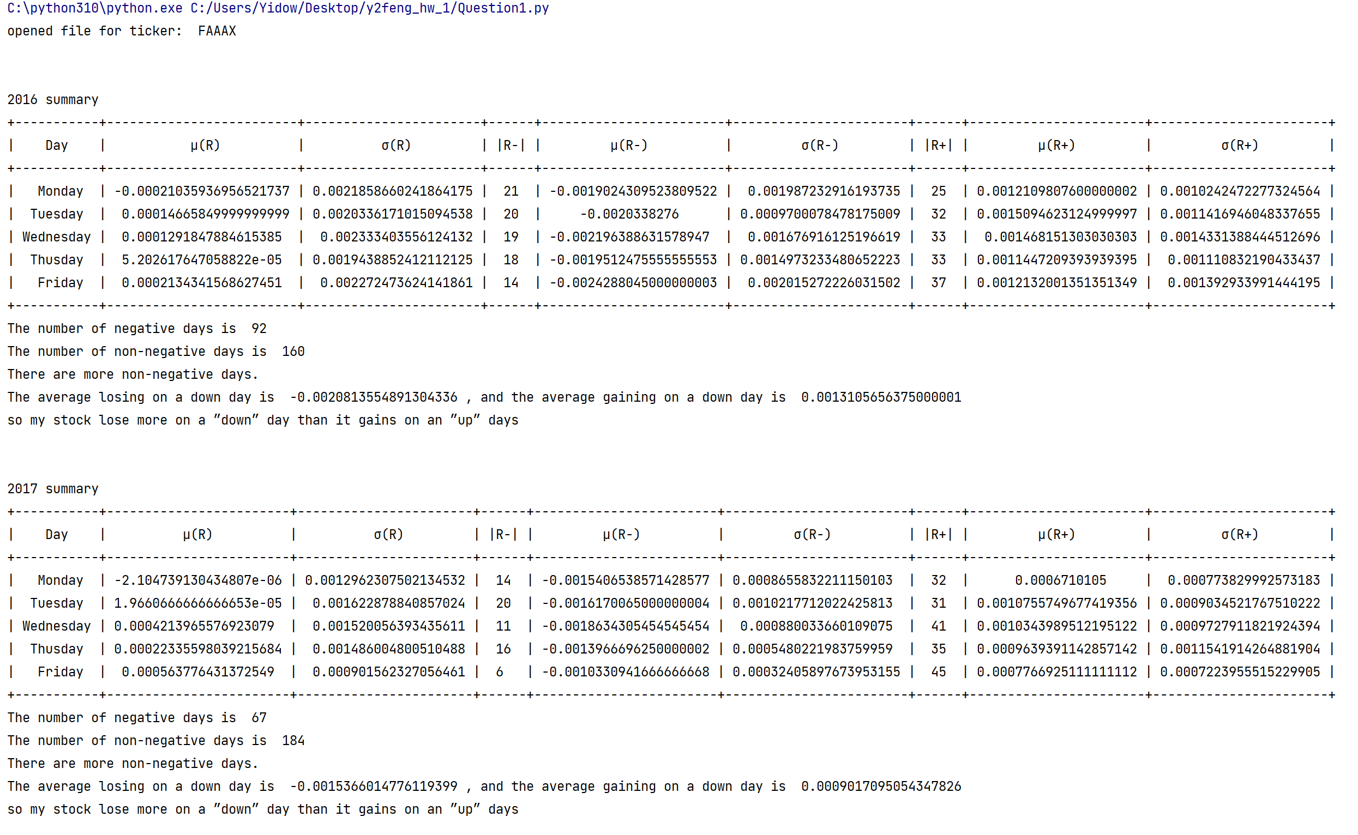

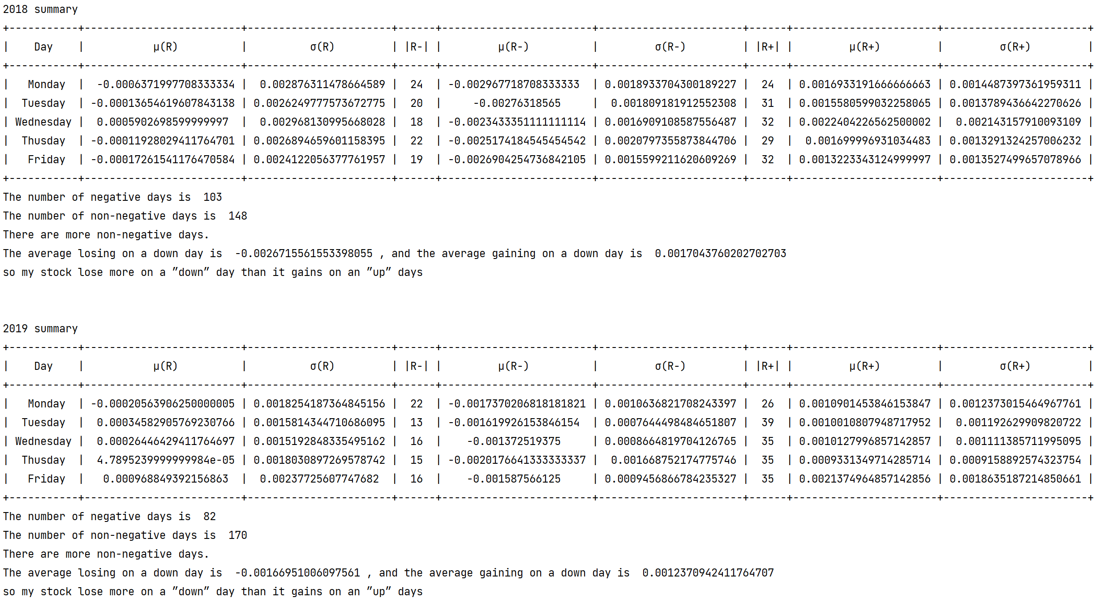

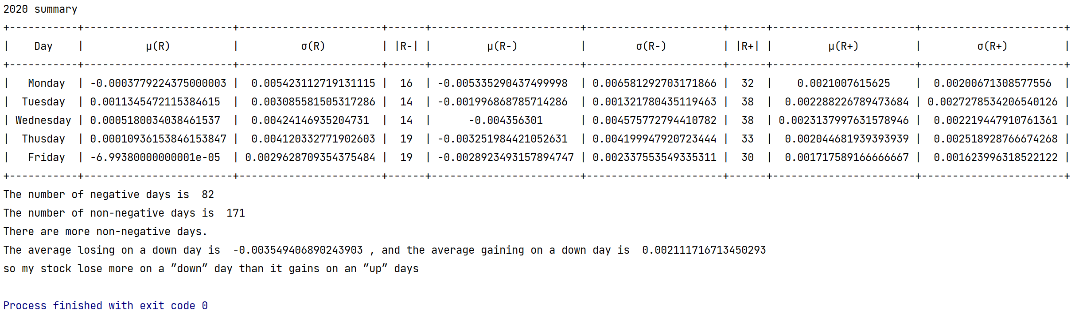

1. are these results the same across days of the week?

**Solution:**

Even though for this 5 years, my stock lose more on a ”down” day than it gains

on an ”up” days every year, but the accurate data for each year are different. Because of Covid-19, in 2020, the average of losing on a down day is largest for these 5 years.

##### Question 2: Examine your 5 tables.

1. are there any patterns across days of the week?

**Solution:**

There is no patterns across days, but for each day of week, according to the table in Question 1, in a year from each day of week, the number of non-negative returns is always larger than the number of negative returns.

2. are there any patterns across different years for the same

day of the week?

**Solution:**

Yes. According to the table in Question 1, Monday is always the day which makes the lowest return and the mean of Monday returns is always negative.

3. what are the best and worst days of the week to be invested

for each year.

**Solution:**

2016:

Best: Friday, Worst: Monday;

2017:

Best: Friday, Worst: Monday;

2018:

Best: Wednesday, Worst: Monday;

2019:

Best: Friday, Worst: Monday;

2020:

Best: Tuesday, Worst: Monday;

1. do these days change from year to year for your stock?

**Solution:**

For the best days, yes, the best days of each year are different; for the worst day, no, they are all Monday.

##### Question 3: Compute the aggregate table across all 5 years,one table for both your stock and one table for S&P-500 (using data for ”spy”).

1. what is the best and worst days of the week for each?

Page 3

2. are these days the same for your stock as they are for S&P-

500?

**The results for 1 - 2 shown below:**

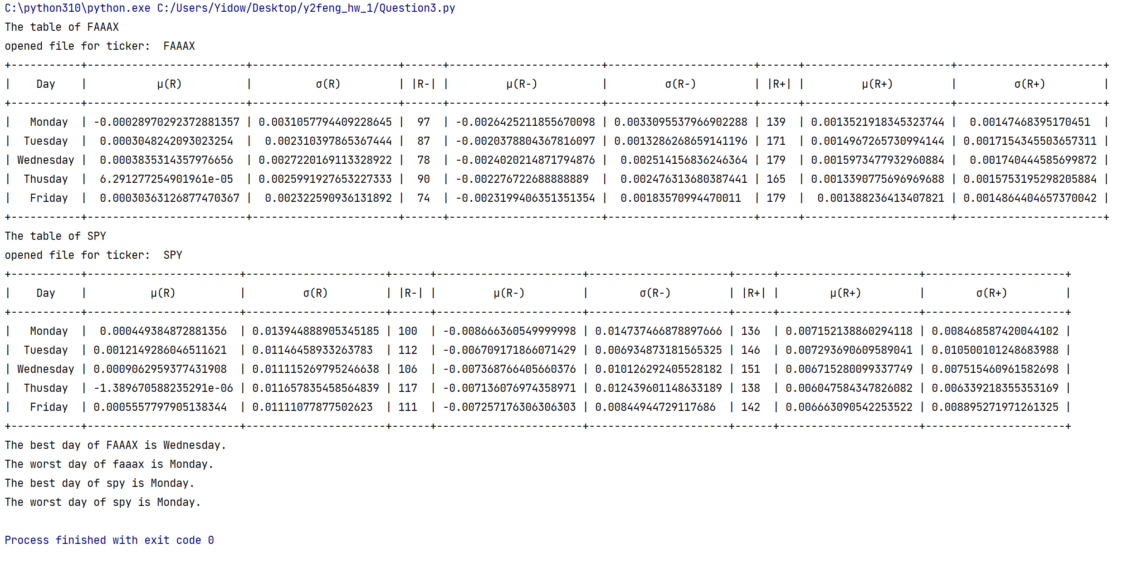

For the next questions, suppose that you have an ”oracle”.

On any day, this oracle could tell you whether price of any

stock would increase or decrease the next day. Assume that

you have no transaction costs. You start with $100 on the first

trading day of 2016 to trade your stock and another $100 to

trade ”spy”.

##### Question 4: You listen to the oracle and follow its advice.How much much money will you have on the last trading day of 2020:

1. your stock?

2. S&P-500 stock?

**The results shown below:**

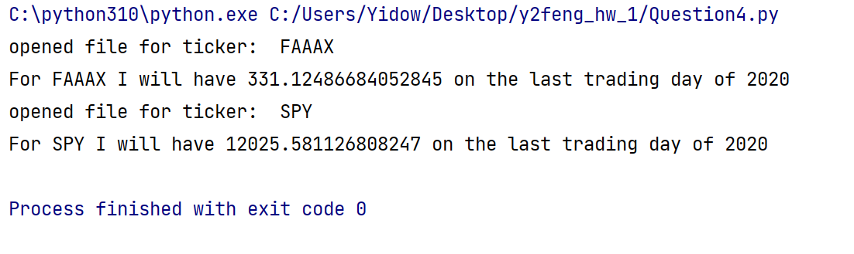

##### Question 5: Consider ”buy-and-hold” strategy: you buy on the first trading day and sell on the last day. So you do not listen to your oracle at all. As before, assume that you start with $100 for both your stock and ”spy”.

1. how much money will you have on the last trading day of

2020?

**Solution:**

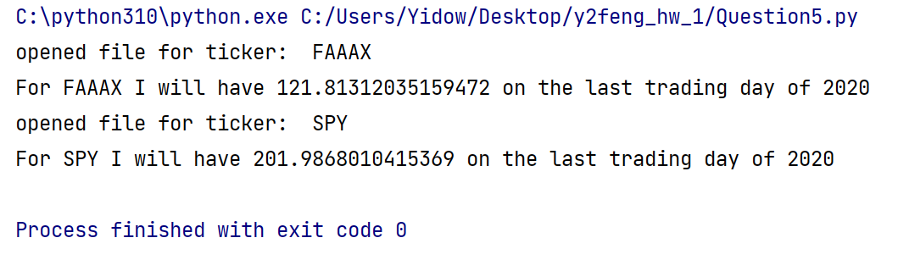

1. how do these results compare with results obtained in question 4?

**Solution:**

According to the data from Question 4, the gaining for both of my stock and SPY in question 5 is less then that in question 4. However, for my stock, it is not much less than that in question 4, but for SPY, the money is much less than that in question 4.

##### Question 6: Your oracle got very upset that you did not follow its advice. It decided to take revenge by giving you wrong advice from time to time. Specifically, let us consider the following three scenarios:

(a) Oracle gave you wrong results for the best 10 trading days.

In other words, you missed the best 10 days and your overall

profit will be lower.

(b) Oracle gave you wrong results for worst 10 trading days. In

other words, you missed the worst 10 days and your overall

profit will be higher.

(c) Oracle gave you wrong results for best 5 days and for the

worst 5 days.

Please answer the following:

1. for each of the scenarios above (a,b and c), compute the

final amount that you will have for both your stock and ”spy”

**Solution：**

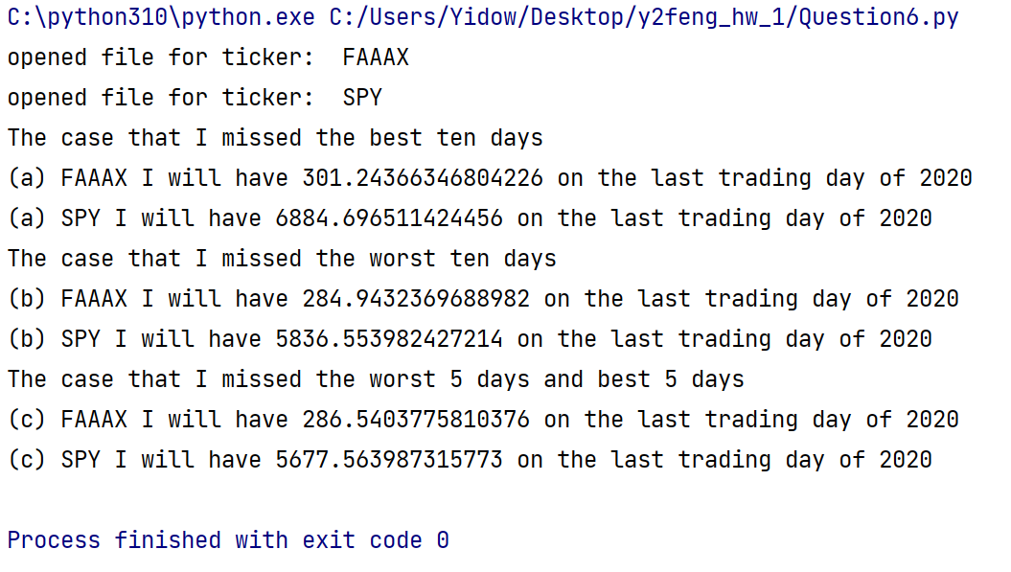

2. do you gain more by missing the worst days or by missing

the best days?

**Solution：**

I gain more by missing the best day.

3. are the results in part (c) different from results that you

obtained in question 4.

**Solution：**

Yes, the result is part(c) is less than results that I obtained in question 4.