CS688 G-Trends Lab Project

Yiduo Feng

10/04/2022

– Q1: Which are the states where GG is smaller than 1? Find those and replace them with zero.

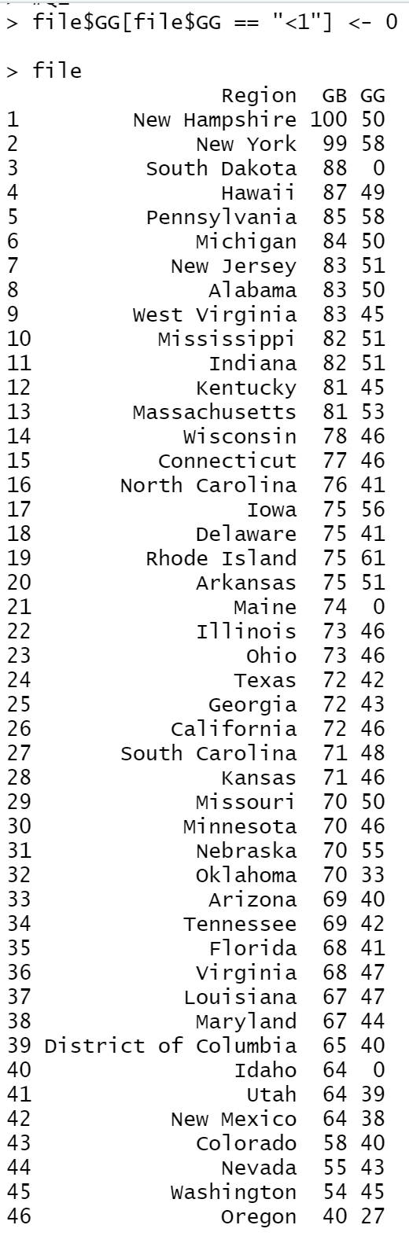

– Q2: For How Many States GB > GG?

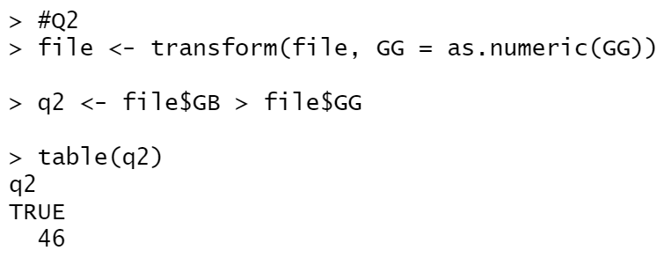

– Q3: Find any states where GG+10 > GB

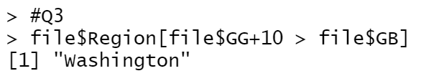

– Q4: What is the % of states for which GG+10 > GB?

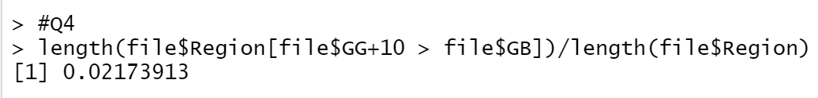

– Q5: What is the ratio GG/GB for the state of New Hampshire?



– Q6: Create a Bar Plot of GG & GB values for each state.

