**JMP Pro Installation (for homework 1)**

JMP Pro is available from the following BU’s website:

<http://www.bu.edu/tech/services/cccs/desktop/distribution/statistics/>

Go to the above web site and scroll down to the “Getting Started” section, shown below:

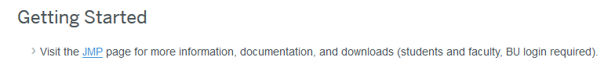

Click the “JMP” link and log in with your BU credential. You will see the following screen (only a part of the screen is shown):

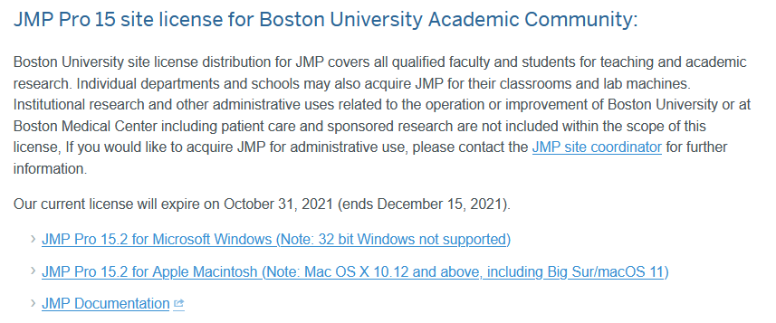

Download JMP Pro 15.2 for your OS and install it.

You may also want to download JMP Pro documentation from this website:

<https://www.jmp.com/en_us/support/jmp-documentation.html>

Then, start JMP Pro 15 by double clicking the shortcut.

1. Select Help > Sample Data Library and open Big Class.jmp. You will see the following screen:

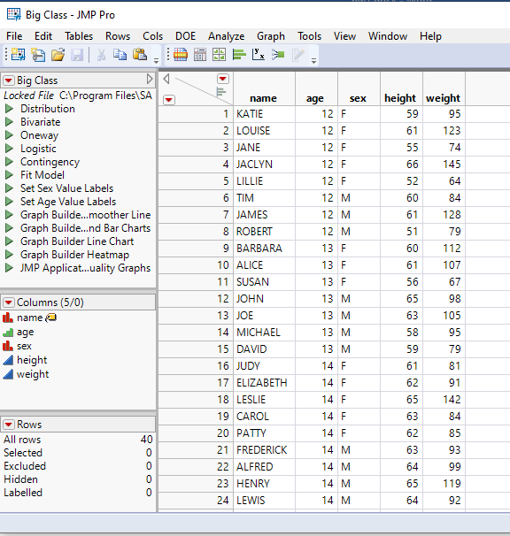

2. Select Analyze > Distribution. The following screen will pop up.

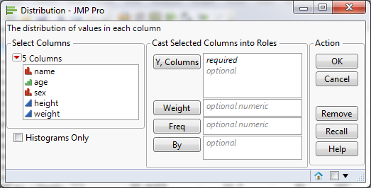

3. Select age and height and click Y, Columns, as shown below:

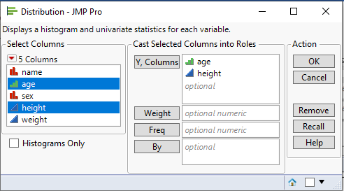

4. Click OK. You will see the following screen:

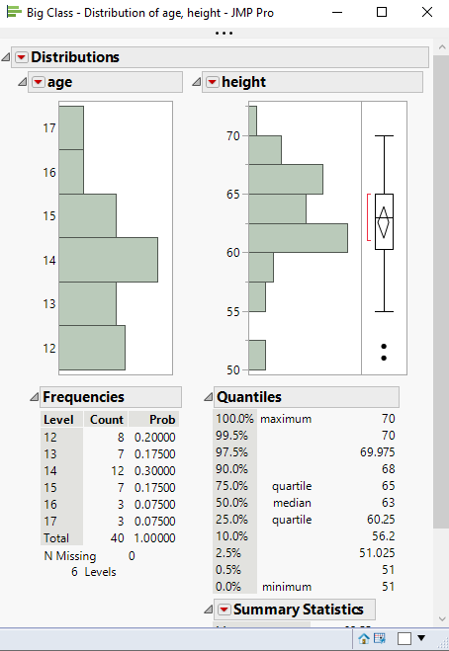

Capture this screen and include it in your submission file.