Screenshot:

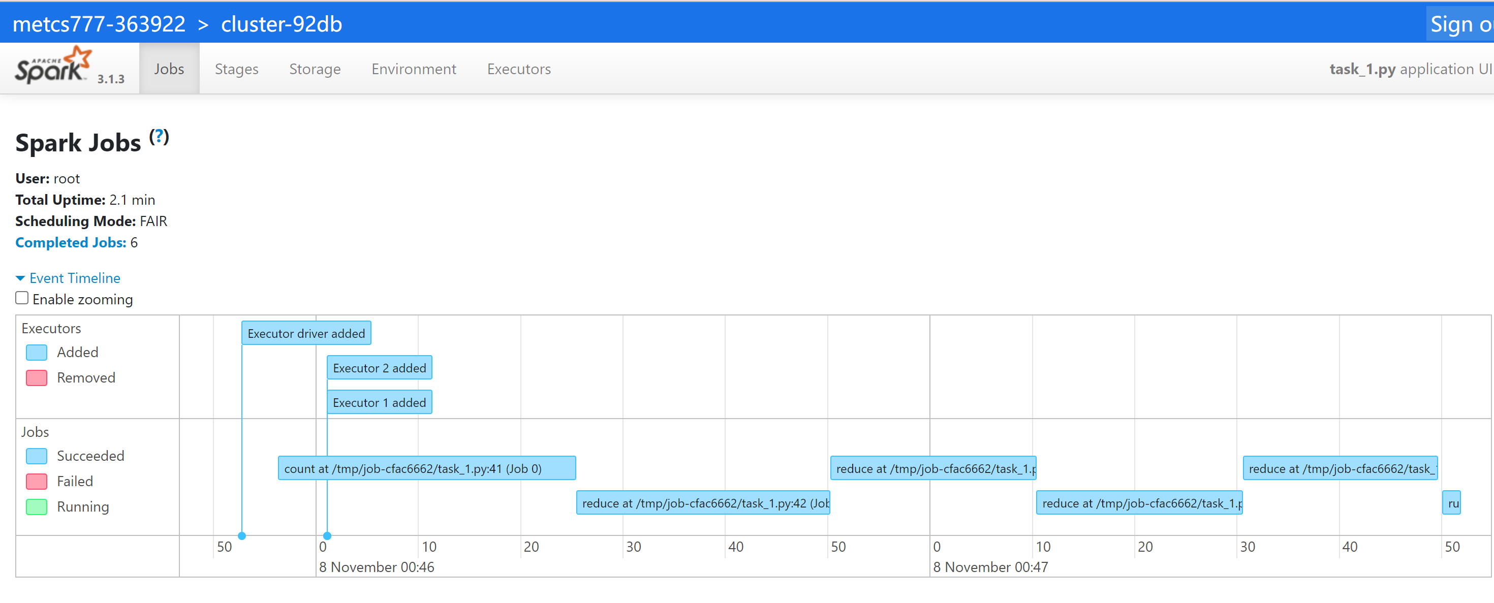

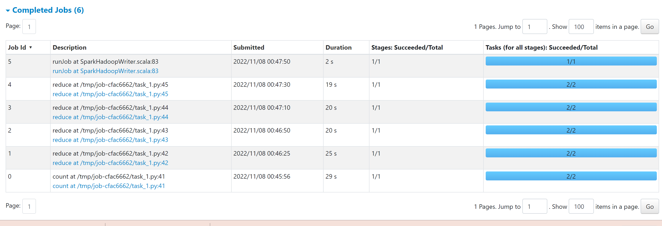

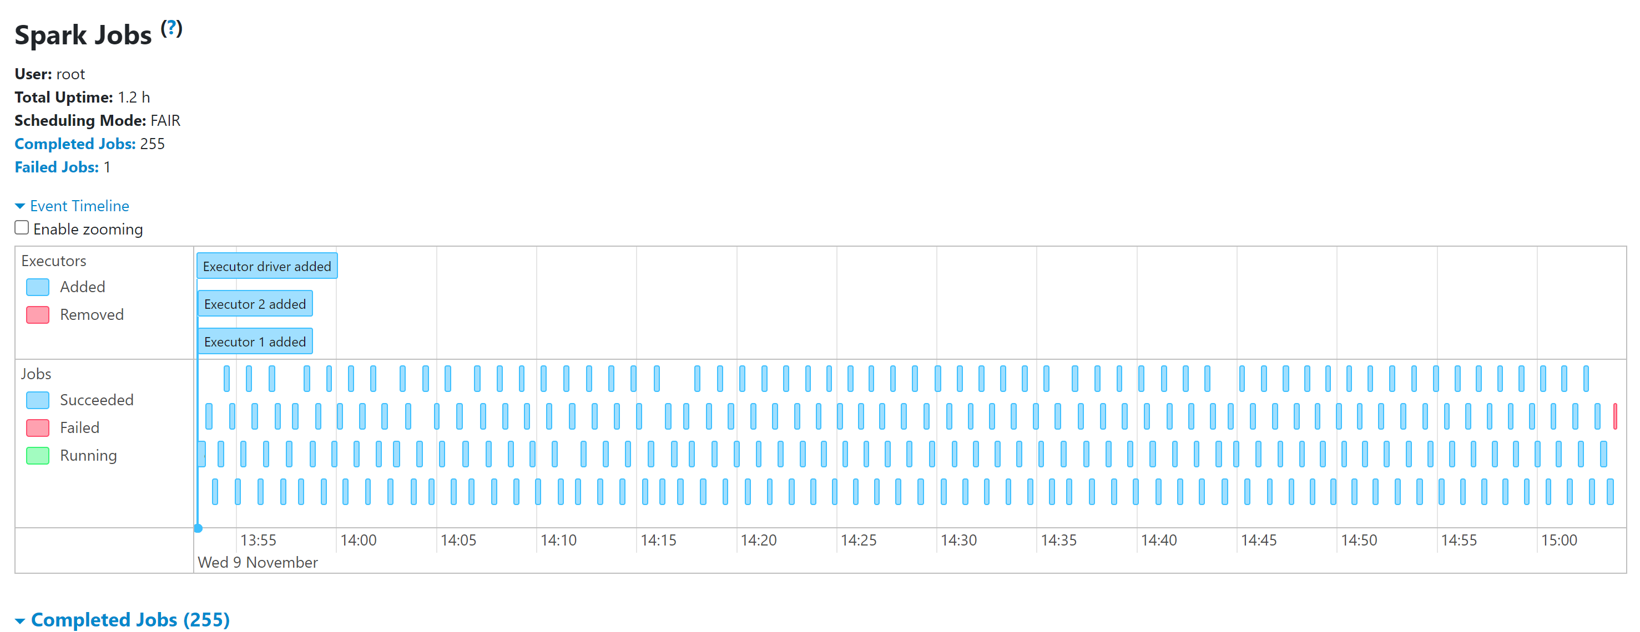

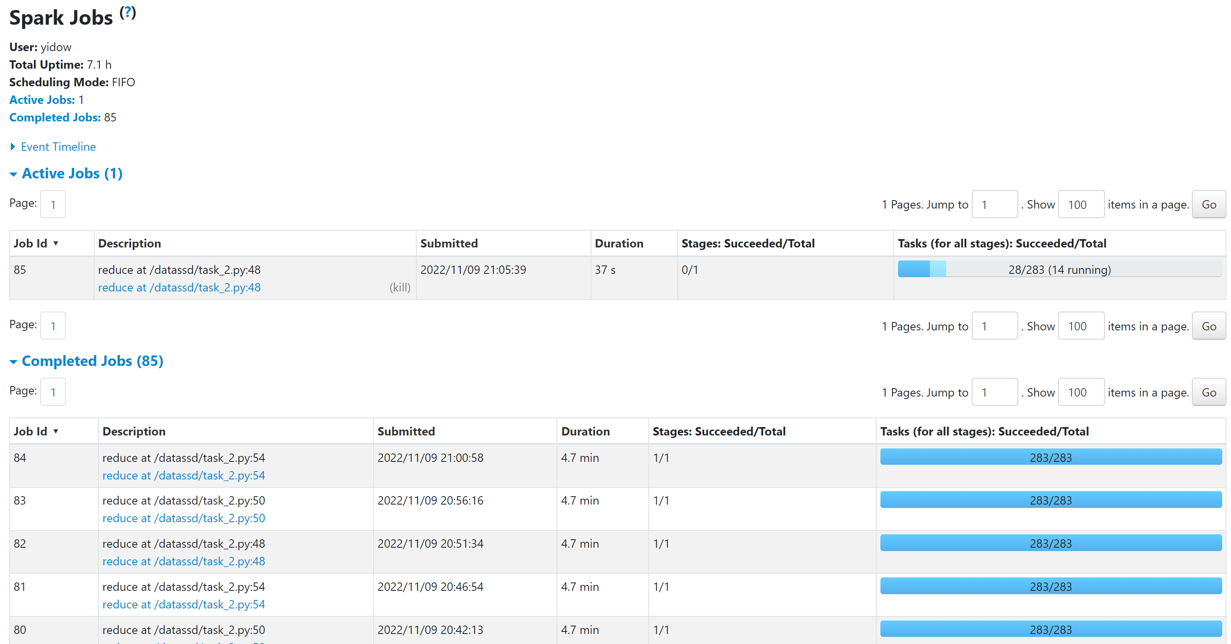



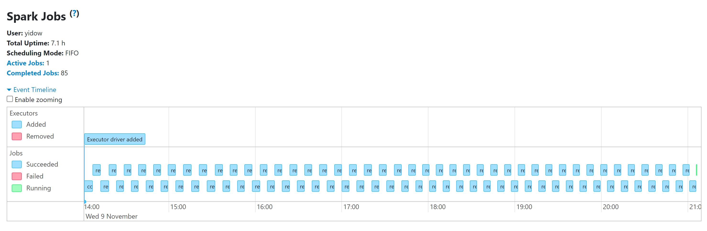

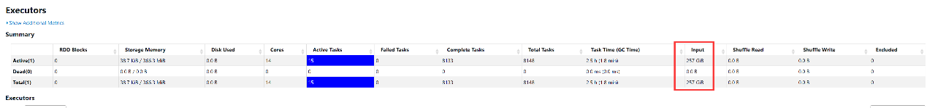

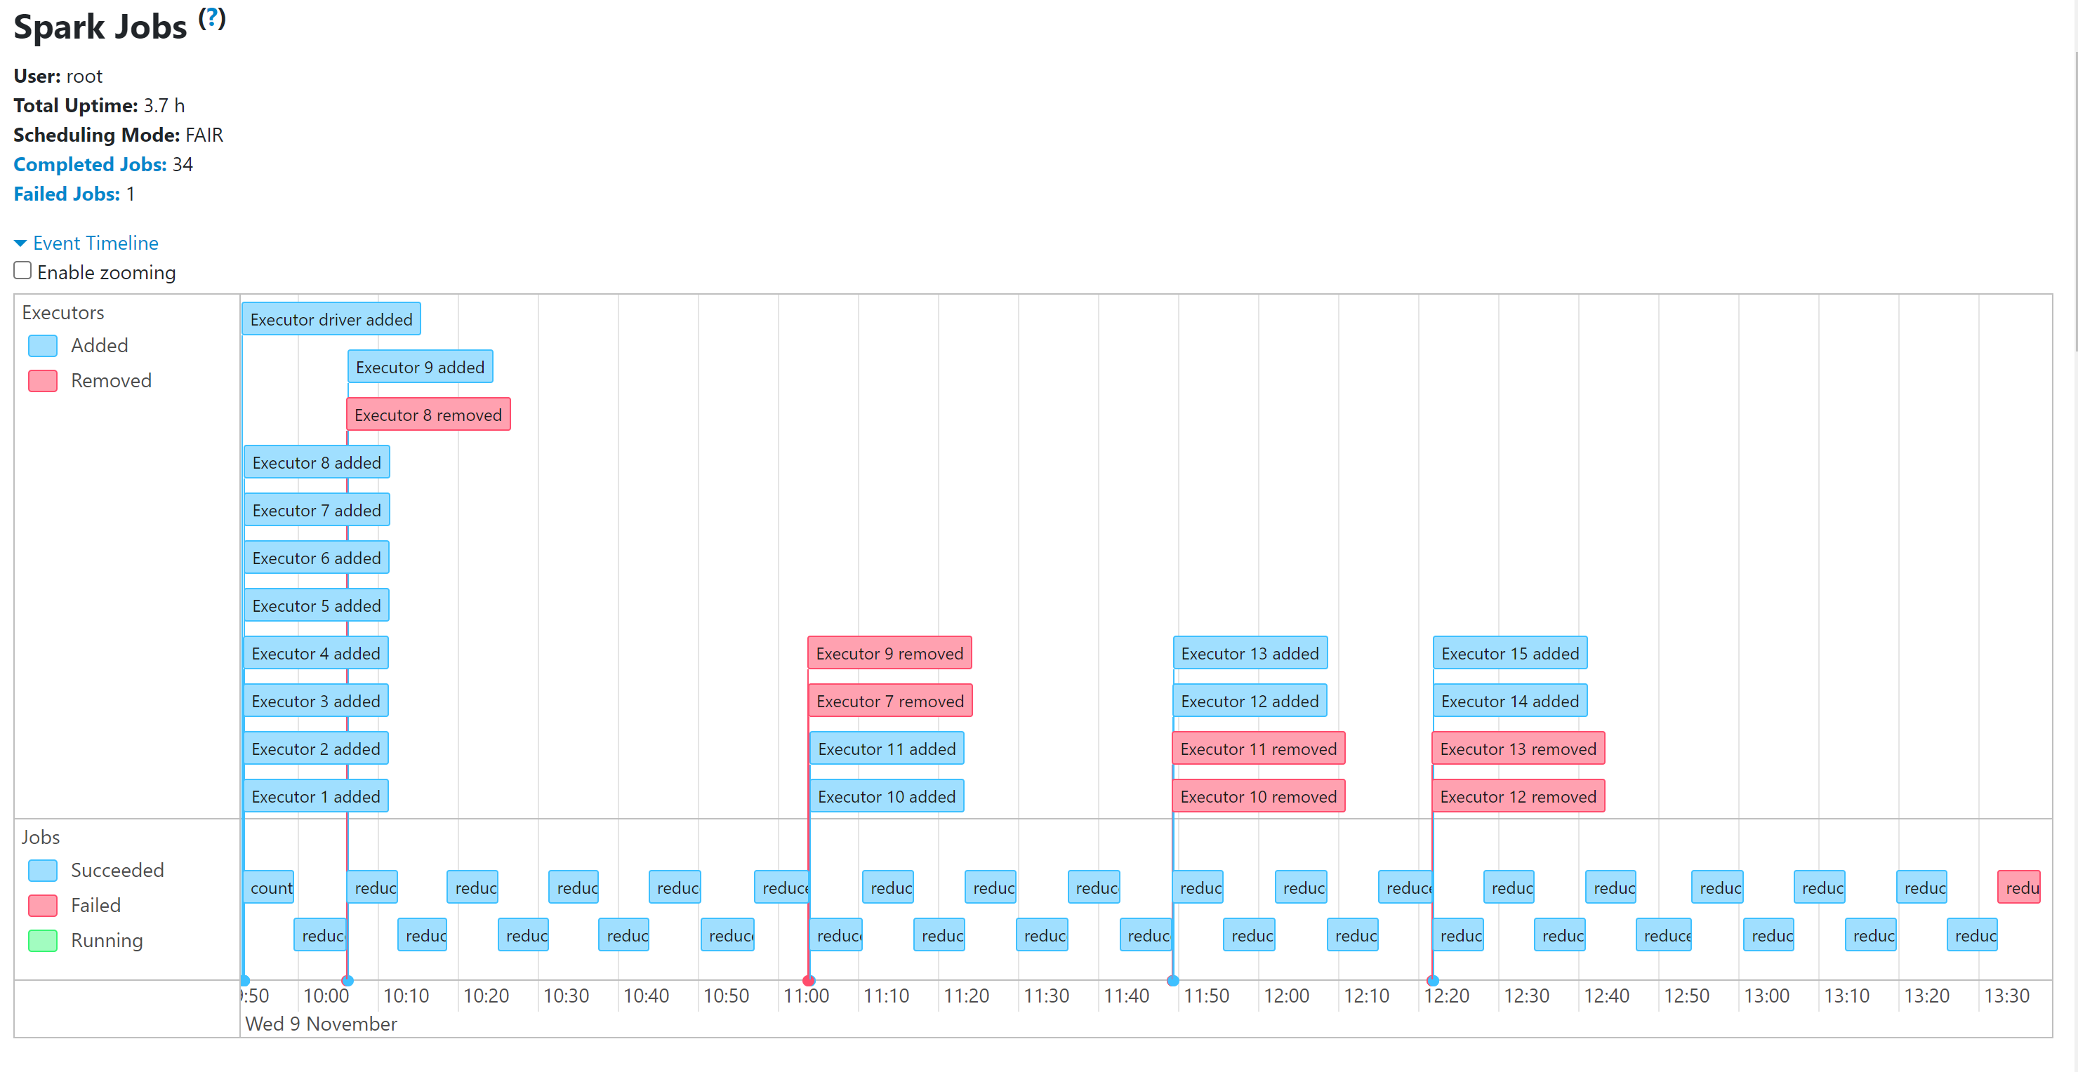

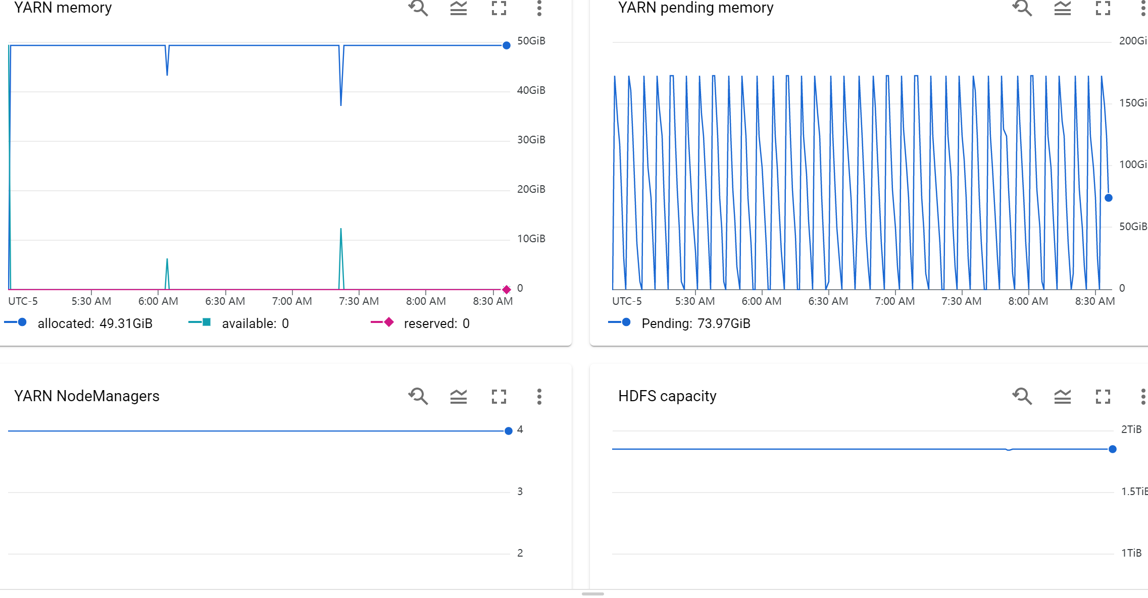

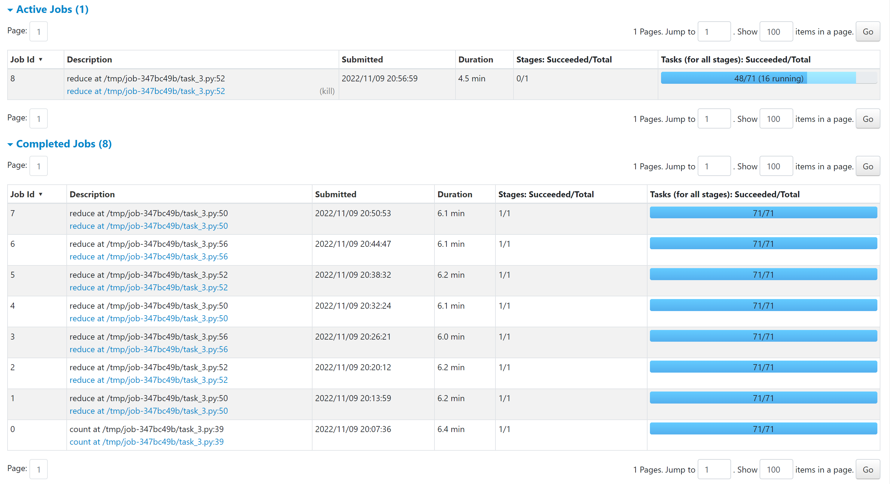

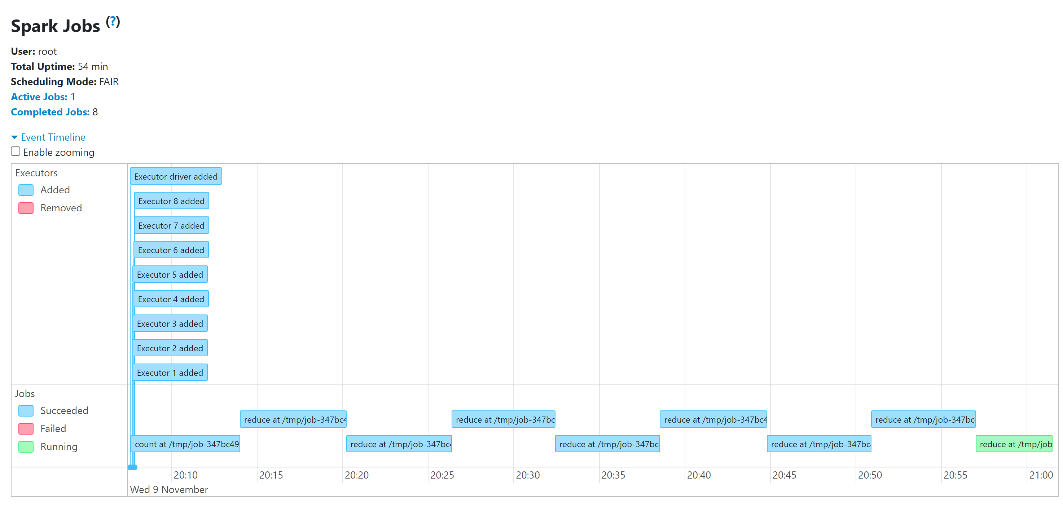

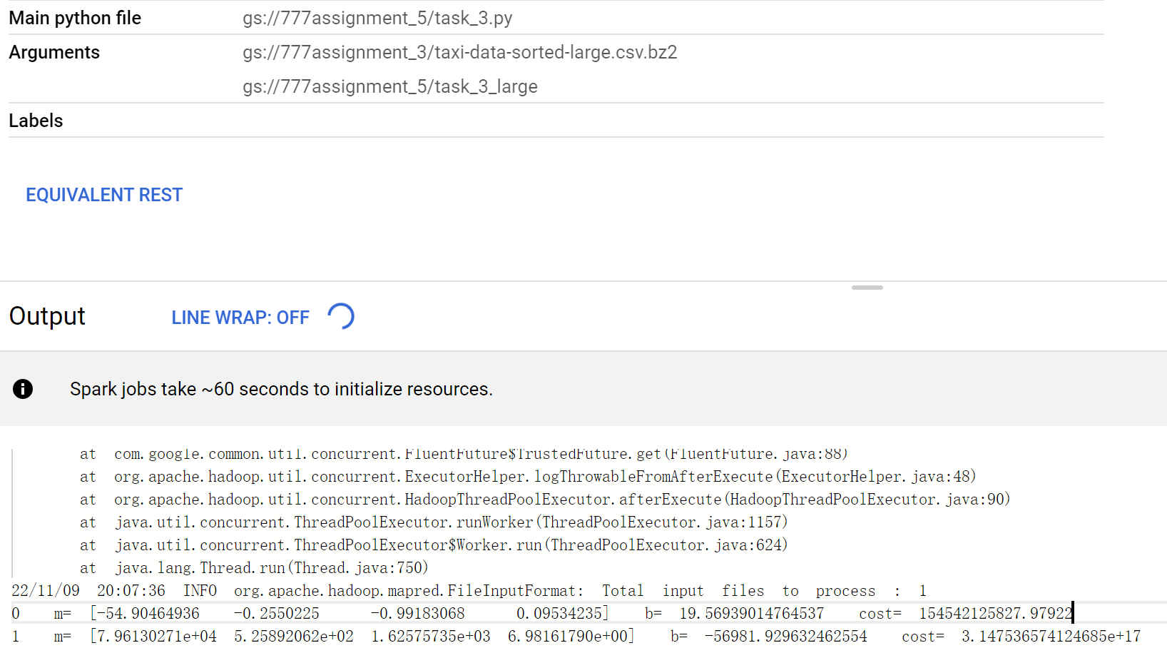

Results:

Task_1 small:

m =

2.3692447119544813

b =

8.645236596568909

Runtime: 2.1min

Task_1 large:

m =

2.374374858012113

b =

8.989846634766463

Runtime: 44.7 min

Task_2 small:

[0, ' m=', 0.20536152604199218, ' b=', 0.10719357367389828, ' cost=', 134144661.26735897]

[1, ' m=', 0.2989812125353237, ' b=', 0.11336981067040641, ' cost=', 107026925.21349806]

[2, ' m=', 0.3743533076289615, ' b=', 0.11819035010425294, ' cost=', 71261577.42093691]

[3, ' m=', 0.42724115795157486, ' b=', 0.12149936768392007, ' cost=', 37824410.26705322]

[4, ' m=', 0.45622084314149797, ' b=', 0.12333104690908928, ' cost=', 15129291.648445794]

[5, ' m=', 0.4626835820475304, ' b=', 0.12388116252318215, ' cost=', 5864812.612826786]

[6, ' m=', 0.45031655198905707, ' b=', 0.12345201894118614, ' cost=', 7129533.854564019]

[7, ' m=', 0.4372677155912491, ' b=', 0.12278674433225936, ' cost=', 13222190.90498144]

[8, ' m=', 0.4275973684600049, ' b=', 0.12222617304187097, ' cost=', 22637830.318454005]

[9, ' m=', 0.42115385534908134, ' b=', 0.12182782927518096, ' cost=', 36056352.602405064]

[10, ' m=', 0.4170905595610283, ' b=', 0.12156751263816891, ' cost=', 54203286.74880185]

[11, ' m=', 0.4146199941139638, ' b=', 0.12140590587935596, ' cost=', 77606275.77523111]

[12, ' m=', 0.4131579683053687, ' b=', 0.12130905215118992, ' cost=', 106583556.81966807]

[13, ' m=', 0.41231092576205186, ' b=', 0.12125248654820459, ' cost=', 141288669.95919916]

[14, ' m=', 0.4118284772205387, ' b=', 0.12122009666048422, ' cost=', 181767523.57237324]

[15, ' m=', 0.4115574895656022, ' b=', 0.12120183608706159, ' cost=', 228007463.24287227]

[16, ' m=', 0.41140701882090425, ' b=', 0.12119166921942966, ' cost=', 279971281.5180688]

[17, ' m=', 0.41132426552789836, ' b=', 0.12118606634773445, ' cost=', 337616990.41533804]

[18, ' m=', 0.4112791209981741, ' b=', 0.12118300484974563, ' cost=', 400907271.99336725]

[19, ' m=', 0.41125466213627737, ' b=', 0.12118134396858632, ' cost=', 469812675.8575632]

[20, ' m=', 0.4112414886280358, ' b=', 0.12118044843252745, ' cost=', 544311614.6970688]

[21, ' m=', 0.41123442960967477, ' b=', 0.12117996810830386, ' cost=', 624389056.0653825]

[22, ' m=', 0.4112306639037112, ' b=', 0.12117971166568642, ' cost=', 710034923.4521294]

[23, ' m=', 0.4112286629339716, ' b=', 0.12117957530344436, ' cost=', 801242659.5066]

[24, ' m=', 0.4112276033855476, ' b=', 0.12117950305166579, ' cost=', 898008097.2533118]

[25, ' m=', 0.4112270440781104, ' b=', 0.12117946489039454, ' cost=', 1000328640.024383]

[26, ' m=', 0.4112267496573765, ' b=', 0.12117944479205318, ' cost=', 1108202696.0462835]

[27, ' m=', 0.41122659506339054, ' b=', 0.12117943423402558, ' cost=', 1221629303.1174097]

[28, ' m=', 0.4112265140745574, ' b=', 0.1211794287005822, ' cost=', 1340607886.5956125]

[29, ' m=', 0.4112264717342124, ' b=', 0.12117942580664541, ' cost=', 1465138106.9036117]

[30, ' m=', 0.41122644964107335, ' b=', 0.12117942429606939, ' cost=', 1595219765.234921]

[31, ' m=', 0.41122643813301996, ' b=', 0.12117942350897754, ' cost=', 1730852746.1589756]

[32, ' m=', 0.41122643214825116, ' b=', 0.12117942309952968, ' cost=', 1872036983.1508758]

[33, ' m=', 0.41122642904049567, ' b=', 0.12117942288685479, ' cost=', 2018772438.1269598]

[34, ' m=', 0.41122642742893234, ' b=', 0.12117942277654187, ' cost=', 2171059089.417418]

[35, ' m=', 0.4112264265943079, ' b=', 0.12117942271939766, ' cost=', 2328896924.760046]

[36, ' m=', 0.4112264261625743, ' b=', 0.12117942268983169, ' cost=', 2492285937.2511463]

[37, ' m=', 0.4112264259394968, ' b=', 0.12117942267455177, ' cost=', 2661226123.0219574]

[38, ' m=', 0.4112264258243527, ' b=', 0.12117942266666334, ' cost=', 2835717479.913741]

[39, ' m=', 0.411226425764978, ' b=', 0.12117942266259489, ' cost=', 3015760006.7267475]

[40, ' m=', 0.4112264257343893, ' b=', 0.12117942266049855, ' cost=', 3201353702.7965918]

[41, ' m=', 0.41122642571864426, ' b=', 0.12117942265941932, ' cost=', 3392498567.7567]

[42, ' m=', 0.4112264257105464, ' b=', 0.12117942265886418, ' cost=', 3589194601.405401]

[43, ' m=', 0.4112264257063848, ' b=', 0.12117942265857884, ' cost=', 3791441803.63212]

[44, ' m=', 0.41122642570424767, ' b=', 0.12117942265843229, ' cost=', 3999240174.376348]

[45, ' m=', 0.41122642570315093, ' b=', 0.12117942265835707, ' cost=', 4212589713.6051283]

[46, ' m=', 0.4112264257025885, ' b=', 0.12117942265831849, ' cost=', 4431490421.300503]

[47, ' m=', 0.4112264257023002, ' b=', 0.12117942265829872, ' cost=', 4655942297.452744]

[48, ' m=', 0.41122642570215256, ' b=', 0.12117942265828859, ' cost=', 4885945342.056527]

[49, ' m=', 0.41122642570207696, ' b=', 0.1211794226582834, ' cost=', 5121499555.109083]

[50, ' m=', 0.41122642570203827, ' b=', 0.12117942265828074, ' cost=', 5362604936.608791]

[51, ' m=', 0.4112264257020185, ' b=', 0.12117942265827938, ' cost=', 5609261486.554837]

[52, ' m=', 0.4112264257020084, ' b=', 0.12117942265827869, ' cost=', 5861469204.946859]

[53, ' m=', 0.41122642570200324, ' b=', 0.12117942265827833, ' cost=', 6119228091.784512]

[54, ' m=', 0.4112264257020006, ' b=', 0.12117942265827815, ' cost=', 6382538147.067732]

[55, ' m=', 0.41122642570199924, ' b=', 0.12117942265827805, ' cost=', 6651399370.796419]

[56, ' m=', 0.4112264257019986, ' b=', 0.12117942265827801, ' cost=', 6925811762.970563]

[57, ' m=', 0.41122642570199824, ' b=', 0.12117942265827798, ' cost=', 7205775323.59011]

[58, ' m=', 0.4112264257019981, ' b=', 0.12117942265827797, ' cost=', 7491290052.655087]

[59, ' m=', 0.41122642570199797, ' b=', 0.12117942265827797, ' cost=', 7782355950.165481]

[60, ' m=', 0.4112264257019979, ' b=', 0.12117942265827797, ' cost=', 8078973016.1212635]

[61, ' m=', 0.4112264257019979, ' b=', 0.12117942265827797, ' cost=', 8381141250.522432]

[62, ' m=', 0.4112264257019979, ' b=', 0.12117942265827797, ' cost=', 8688860653.369024]

[63, ' m=', 0.4112264257019979, ' b=', 0.12117942265827797, ' cost=', 9002131224.661022]

[64, ' m=', 0.4112264257019979, ' b=', 0.12117942265827797, ' cost=', 9320952964.398434]

[65, ' m=', 0.4112264257019979, ' b=', 0.12117942265827797, ' cost=', 9645325872.581211]

[66, ' m=', 0.4112264257019979, ' b=', 0.12117942265827797, ' cost=', 9975249949.209387]

[67, ' m=', 0.4112264257019979, ' b=', 0.12117942265827797, ' cost=', 10310725194.282974]

[68, ' m=', 0.4112264257019979, ' b=', 0.12117942265827797, ' cost=', 10651751607.801983]

[69, ' m=', 0.4112264257019979, ' b=', 0.12117942265827797, ' cost=', 10998329189.766344]

[70, ' m=', 0.4112264257019979, ' b=', 0.12117942265827797, ' cost=', 11350457940.176191]

[71, ' m=', 0.4112264257019979, ' b=', 0.12117942265827797, ' cost=', 11708137859.031404]

[72, ' m=', 0.4112264257019979, ' b=', 0.12117942265827797, ' cost=', 12071368946.331978]

[73, ' m=', 0.4112264257019979, ' b=', 0.12117942265827797, ' cost=', 12440151202.078005]

[74, ' m=', 0.4112264257019979, ' b=', 0.12117942265827797, ' cost=', 12814484626.269396]

[75, ' m=', 0.4112264257019979, ' b=', 0.12117942265827797, ' cost=', 13194369218.906212]

[76, ' m=', 0.4112264257019979, ' b=', 0.12117942265827797, ' cost=', 13579804979.9884]

[77, ' m=', 0.4112264257019979, ' b=', 0.12117942265827797, ' cost=', 13970791909.51601]

[78, ' m=', 0.4112264257019979, ' b=', 0.12117942265827797, ' cost=', 14367330007.48903]

[79, ' m=', 0.4112264257019979, ' b=', 0.12117942265827797, ' cost=', 14769419273.907415]

[80, ' m=', 0.4112264257019979, ' b=', 0.12117942265827797, ' cost=', 15177059708.771265]

[81, ' m=', 0.4112264257019979, ' b=', 0.12117942265827797, ' cost=', 15590251312.080462]

[82, ' m=', 0.4112264257019979, ' b=', 0.12117942265827797, ' cost=', 16008994083.835068]

[83, ' m=', 0.4112264257019979, ' b=', 0.12117942265827797, ' cost=', 16433288024.035093]

[84, ' m=', 0.4112264257019979, ' b=', 0.12117942265827797, ' cost=', 16863133132.680477]

[85, ' m=', 0.4112264257019979, ' b=', 0.12117942265827797, ' cost=', 17298529409.77127]

[86, ' m=', 0.4112264257019979, ' b=', 0.12117942265827797, ' cost=', 17739476855.30753]

[87, ' m=', 0.4112264257019979, ' b=', 0.12117942265827797, ' cost=', 18185975469.289146]

[88, ' m=', 0.4112264257019979, ' b=', 0.12117942265827797, ' cost=', 18638025251.71615]

[89, ' m=', 0.4112264257019979, ' b=', 0.12117942265827797, ' cost=', 19095626202.58864]

[90, ' m=', 0.4112264257019979, ' b=', 0.12117942265827797, ' cost=', 19558778321.906418]

[91, ' m=', 0.4112264257019979, ' b=', 0.12117942265827797, ' cost=', 20027481609.669598]

[92, ' m=', 0.4112264257019979, ' b=', 0.12117942265827797, ' cost=', 20501736065.878292]

[93, ' m=', 0.4112264257019979, ' b=', 0.12117942265827797, ' cost=', 20981541690.53229]

[94, ' m=', 0.4112264257019979, ' b=', 0.12117942265827797, ' cost=', 21466898483.63175]

[95, ' m=', 0.4112264257019979, ' b=', 0.12117942265827797, ' cost=', 21957806445.1766]

[96, ' m=', 0.4112264257019979, ' b=', 0.12117942265827797, ' cost=', 22454265575.16669]

[97, ' m=', 0.4112264257019979, ' b=', 0.12117942265827797, ' cost=', 22956275873.602406]

[98, ' m=', 0.4112264257019979, ' b=', 0.12117942265827797, ' cost=', 23463837340.483437]

[99, ' m=', 0.4112264257019979, ' b=', 0.12117942265827797, ' cost=', 23976949975.80992]

Runtime: 1.2hr

Task_2 large:

[0, ' m=', 0.41536152604199218, ' b=', 0.10719357367389828, ' cost=', 134144661.26735897]

[1, ' m=', 0.4189812125353237, ' b=', 0.11336981067040641, ' cost=', 107026925.21349806]

[2, ' m=', 0.4243533076289615, ' b=', 0.11819035010425294, ' cost=', 71261577.42093691]

[3, ' m=', 0.42724115795157486, ' b=', 0.12149936768392007, ' cost=', 37824410.26705322]

[4, ' m=', 0.45622084314149797, ' b=', 0.12333104690908928, ' cost=', 15129291.648445794]

[5, ' m=', 0.4626835820475304, ' b=', 0.12388116252318215, ' cost=', 5864812.612826786]

[6, ' m=', 0.45031655198905707, ' b=', 0.12345201894118614, ' cost=', 7129533.854564019]

[7, ' m=', 0.4372677155912491, ' b=', 0.12278674433225936, ' cost=', 13222190.90498144]

[8, ' m=', 0.4275973684600049, ' b=', 0.12222617304187097, ' cost=', 22637830.318454005]

[9, ' m=', 0.42115385534908134, ' b=', 0.12182782927518096, ' cost=', 36056352.602405064]

[10, ' m=', 0.4170905595610283, ' b=', 0.12156751263816891, ' cost=', 54203286.74880185]

[11, ' m=', 0.4146199941139638, ' b=', 0.12140590587935596, ' cost=', 77606275.77523111]

[12, ' m=', 0.4131579683053687, ' b=', 0.12130905215118992, ' cost=', 106583556.81966807]

[13, ' m=', 0.41231092576205186, ' b=', 0.12125248654820459, ' cost=', 141288669.95919916]

[14, ' m=', 0.4118284772205387, ' b=', 0.12122009666048422, ' cost=', 181767523.57237324]

[15, ' m=', 0.4115574895656022, ' b=', 0.12120183608706159, ' cost=', 228007463.24287227]

[16, ' m=', 0.41140701882090425, ' b=', 0.12119166921942966, ' cost=', 279971281.5180688]

[17, ' m=', 0.41132426552789836, ' b=', 0.12118606634773445, ' cost=', 337616990.41533804]

[18, ' m=', 0.4112791209981741, ' b=', 0.12118300484974563, ' cost=', 400907271.99336725]

[19, ' m=', 0.41125466213627737, ' b=', 0.12118134396858632, ' cost=', 469812675.8575632]

[20, ' m=', 0.4112414886280358, ' b=', 0.12118044843252745, ' cost=', 544311614.6970688]

[21, ' m=', 0.41123442960967477, ' b=', 0.12117996810830386, ' cost=', 624389056.0653825]

[22, ' m=', 0.4112306639037112, ' b=', 0.12117971166568642, ' cost=', 710034923.4521294]

[23, ' m=', 0.4112286629339716, ' b=', 0.12117957530344436, ' cost=', 801242659.5066]

[24, ' m=', 0.4112276033855476, ' b=', 0.12117950305166579, ' cost=', 898008097.2533118]

[25, ' m=', 0.4112270440781104, ' b=', 0.12117946489039454, ' cost=', 1000328640.024383]

[26, ' m=', 0.4112267496573765, ' b=', 0.12117944479205318, ' cost=', 1108202696.0462835]

[27, ' m=', 0.41122659506339054, ' b=', 0.12117943423402558, ' cost=', 1221629303.1174097]

[28, ' m=', 0.4112265140745574, ' b=', 0.1211794287005822, ' cost=', 1340607886.5956125]

[29, ' m=', 0.4112264717342124, ' b=', 0.12117942580664541, ' cost=', 1465138106.9036117]

[30, ' m=', 0.41122644964107335, ' b=', 0.12117942429606939, ' cost=', 1595219765.234921]

[31, ' m=', 0.41122643813301996, ' b=', 0.12117942350897754, ' cost=', 1730852746.1589756]

[32, ' m=', 0.41122643214825116, ' b=', 0.12117942309952968, ' cost=', 1872036983.1508758]

[33, ' m=', 0.41122642904049567, ' b=', 0.12117942288685479, ' cost=', 2018772438.1269598]

[34, ' m=', 0.41122642742893234, ' b=', 0.12117942277654187, ' cost=', 2171059089.417418]

[35, ' m=', 0.4112264265943079, ' b=', 0.12117942271939766, ' cost=', 2328896924.760046]

[36, ' m=', 0.4112264261625743, ' b=', 0.12117942268983169, ' cost=', 2492285937.2511463]

[37, ' m=', 0.4112264259394968, ' b=', 0.12117942267455177, ' cost=', 2661226123.0219574]

[38, ' m=', 0.4112264258243527, ' b=', 0.12117942266666334, ' cost=', 2835717479.913741]

[39, ' m=', 0.411226425764978, ' b=', 0.12117942266259489, ' cost=', 3015760006.7267475]

[40, ' m=', 0.4112264257343893, ' b=', 0.12117942266049855, ' cost=', 3201353702.7965918]

[41, ' m=', 0.41122642571864426, ' b=', 0.12117942265941932, ' cost=', 3392498567.7567]

[42, ' m=', 0.4112264257105464, ' b=', 0.12117942265886418, ' cost=', 3589194601.405401]

[43, ' m=', 0.4112264257063848, ' b=', 0.12117942265857884, ' cost=', 3791441803.63212]

[44, ' m=', 0.41122642570424767, ' b=', 0.12117942265843229, ' cost=', 3999240174.376348]

[45, ' m=', 0.41122642570315093, ' b=', 0.12117942265835707, ' cost=', 4212589713.6051283]

[46, ' m=', 0.4112264257025885, ' b=', 0.12117942265831849, ' cost=', 4431490421.300503]

[47, ' m=', 0.4112264257023002, ' b=', 0.12117942265829872, ' cost=', 4655942297.452744]

[48, ' m=', 0.41122642570215256, ' b=', 0.12117942265828859, ' cost=', 4885945342.056527]

[49, ' m=', 0.41122642570207696, ' b=', 0.1211794226582834, ' cost=', 5121499555.109083]

[50, ' m=', 0.41122642570203827, ' b=', 0.12117942265828074, ' cost=', 5362604936.608791]

[51, ' m=', 0.4112264257020185, ' b=', 0.12117942265827938, ' cost=', 5609261486.554837]

[52, ' m=', 0.4112264257020084, ' b=', 0.12117942265827869, ' cost=', 5861469204.946859]

[53, ' m=', 0.41122642570200324, ' b=', 0.12117942265827833, ' cost=', 6119228091.784512]

[54, ' m=', 0.4112264257020006, ' b=', 0.12117942265827815, ' cost=', 6382538147.067732]

[55, ' m=', 0.41122642570199924, ' b=', 0.12117942265827805, ' cost=', 6651399370.796419]

[56, ' m=', 0.4112264257019986, ' b=', 0.12117942265827801, ' cost=', 6925811762.970563]

[57, ' m=', 0.41122642570199824, ' b=', 0.12117942265827798, ' cost=', 7205775323.59011]

[58, ' m=', 0.4112264257019981, ' b=', 0.12117942265827797, ' cost=', 7491290052.655087]

[59, ' m=', 0.41122642570199797, ' b=', 0.12117942265827797, ' cost=', 7782355950.165481]

[60, ' m=', 0.4112264257019979, ' b=', 0.12117942265827797, ' cost=', 8078973016.1212635]

[61, ' m=', 0.4112264257019979, ' b=', 0.12117942265827797, ' cost=', 8381141250.522432]

[62, ' m=', 0.4112264257019979, ' b=', 0.12117942265827797, ' cost=', 8688860653.369024]

[63, ' m=', 0.4112264257019979, ' b=', 0.12117942265827797, ' cost=', 9002131224.661022]

[64, ' m=', 0.4112264257019979, ' b=', 0.12117942265827797, ' cost=', 9320952964.398434]

[65, ' m=', 0.4112264257019979, ' b=', 0.12117942265827797, ' cost=', 9645325872.581211]

[66, ' m=', 0.4112264257019979, ' b=', 0.12117942265827797, ' cost=', 9975249949.209387]

[67, ' m=', 0.4112264257019979, ' b=', 0.12117942265827797, ' cost=', 10310725194.282974]

[68, ' m=', 0.4112264257019979, ' b=', 0.12117942265827797, ' cost=', 10651751607.801983]

[69, ' m=', 0.4112264257019979, ' b=', 0.12117942265827797, ' cost=', 10998329189.766344]

[70, ' m=', 0.4112264257019979, ' b=', 0.12117942265827797, ' cost=', 11350457940.176191]

[71, ' m=', 0.4112264257019979, ' b=', 0.12117942265827797, ' cost=', 11708137859.031404]

[72, ' m=', 0.4112264257019979, ' b=', 0.12117942265827797, ' cost=', 12071368946.331978]

[73, ' m=', 0.4112264257019979, ' b=', 0.12117942265827797, ' cost=', 12440151202.078005]

[74, ' m=', 0.4112264257019979, ' b=', 0.12117942265827797, ' cost=', 12814484626.269396]

[75, ' m=', 0.4112264257019979, ' b=', 0.12117942265827797, ' cost=', 13194369218.906212]

[76, ' m=', 0.4112264257019979, ' b=', 0.12117942265827797, ' cost=', 13579804979.9884]

[77, ' m=', 0.4112264257019979, ' b=', 0.12117942265827797, ' cost=', 13970791909.51601]

[78, ' m=', 0.4112264257019979, ' b=', 0.12117942265827797, ' cost=', 14367330007.48903]

[79, ' m=', 0.4112264257019979, ' b=', 0.12117942265827797, ' cost=', 14769419273.907415]

[80, ' m=', 0.4112264257019979, ' b=', 0.12117942265827797, ' cost=', 15177059708.771265]

[81, ' m=', 0.4112264257019979, ' b=', 0.12117942265827797, ' cost=', 15590251312.080462]

[82, ' m=', 0.4112264257019979, ' b=', 0.12117942265827797, ' cost=', 16008994083.835068]

[83, ' m=', 0.4112264257019979, ' b=', 0.12117942265827797, ' cost=', 16433288024.035093]

[84, ' m=', 0.4112264257019979, ' b=', 0.12117942265827797, ' cost=', 16863133132.680477]

[85, ' m=', 0.4112264257019979, ' b=', 0.12117942265827797, ' cost=', 17298529409.77127]

[86, ' m=', 0.4112264257019979, ' b=', 0.12117942265827797, ' cost=', 17739476855.30753]

[87, ' m=', 0.4112264257019979, ' b=', 0.12117942265827797, ' cost=', 18185975469.289146]

[88, ' m=', 0.4112264257019979, ' b=', 0.12117942265827797, ' cost=', 18638025251.71615]

[89, ' m=', 0.4112264257019979, ' b=', 0.12117942265827797, ' cost=', 19095626202.58864]

[90, ' m=', 0.4112264257019979, ' b=', 0.12117942265827797, ' cost=', 19558778321.906418]

[91, ' m=', 0.4112264257019979, ' b=', 0.12117942265827797, ' cost=', 20027481609.669598]

[92, ' m=', 0.4112264257019979, ' b=', 0.12117942265827797, ' cost=', 20501736065.878292]

[93, ' m=', 0.4112264257019979, ' b=', 0.12117942265827797, ' cost=', 20981541690.53229]

[94, ' m=', 0.4112264257019979, ' b=', 0.12117942265827797, ' cost=', 21466898483.63175]

[95, ' m=', 0.4112264257019979, ' b=', 0.12117942265827797, ' cost=', 21957806445.1766]

[96, ' m=', 0.4112264257019979, ' b=', 0.12117942265827797, ' cost=', 22454265575.16669]

[97, ' m=', 0.4112264257019979, ' b=', 0.12117942265827797, ' cost=', 22956275873.602406]

[98, ' m=', 0.4112264257019979, ' b=', 0.12117942265827797, ' cost=', 23463837340.483437]

[99, ' m=', 0.4112264257019979, ' b=', 0.12117942265827797, ' cost=', 23976949975.80992]

Runtime: 7.1hr

Task_3 small:

[0, ' m=', array([-46.19917931, -0.23630394, -0.91024924, 0.09638327]), ' b=', 15.336228094143735, ' cost=', 1498217756.5280325]

[1, ' m=', array([5.76642420e+04, 4.27529530e+02, 1.29381775e+03, 4.71258782e+00]), ' b=', -38378.13567484535, ' cost=', 2258168924561527.5]

[2, ' m=', array([-5.39446858e+07, -3.99844953e+05, -1.21021103e+06, -4.31452197e+03]), ' b=', 26899347.485329345, ' cost=', 7.909206986300859e+21]

[3, ' m=', array([3.36283866e+10, 2.49258846e+08, 7.54432399e+08, 2.68976516e+06]), ' b=', -11168176842.506943, ' cost=', 1.230755818555737e+28]

[4, ' m=', array([-1.30907295e+13, -9.70308564e+10, -2.93683767e+11, -1.04709553e+09]), ' b=', 2712567142880.6924, ' cost=', 7.474527255402163e+33]

[5, ' m=', array([3.05251310e+15, 2.26258370e+13, 6.84817699e+13, 2.44169039e+11]), ' b=', -378361900944753.6, ' cost=', 1.6312467344035116e+39]

[6, ' m=', array([-4.13956824e+17, -3.06833586e+15, -9.28695588e+15, -3.31127438e+13]), ' b=', 2.9767254083659332e+16, ' cost=', 1.207366563713517e+44]

[7, ' m=', array([3.19020195e+19, 2.36464791e+17, 7.15709980e+17, 2.55189450e+15]), ' b=', -1.2977777385319158e+18, ' cost=', 2.9002947746351947e+48]

[8, ' m=', array([-1.36900775e+21, -1.01473932e+19, -3.07132051e+19, -1.09509828e+17]), ' b=', 3.0747165734243123e+19, ' cost=', 2.1801576343105638e+52]

[9, ' m=', array([3.20296954e+22, 2.37411391e+20, 7.18575223e+20, 2.56213228e+18]), ' b=', -3.8577096502477606e+20, ' cost=', 4.956633054750905e+55]

[10, ' m=', array([-3.97745757e+23, -2.94818269e+21, -8.92329185e+21, -3.18167035e+19]), ' b=', 2.459013379619383e+21, ' cost=', 3.2829991039306544e+58]

[11, ' m=', array([2.51333514e+24, 1.86294181e+22, 5.63858340e+22, 2.01048356e+20]), ' b=', -7.346103260327925e+21, ' cost=', 6.0249866830960984e+60]

[12, ' m=', array([-7.45062511e+24, -5.52257508e+22, -1.67152298e+23, -5.95995684e+20]), ' b=', 8.398335566293802e+21, ' cost=', 2.8233941286759808e+62]

[13, ' m=', array([8.45421832e+24, 6.26646173e+22, 1.89667587e+23, 6.76276063e+20]), ' b=', -1.2213886729213402e+21, ' cost=', 2.8775728201505846e+63]

[14, ' m=', array([-1.21393659e+24, -8.99797835e+21, -2.72342659e+22, -9.71061301e+19]), ' b=', -4.814113734513193e+20, ' cost=', 4.2531893576563156e+63]

[15, ' m=', array([-4.73539000e+23, -3.50998047e+21, -1.06236910e+22, -3.78796926e+19]), ' b=', -3.2746237138658296e+20, ' cost=', 9.977402729328096e+61]

[16, ' m=', array([-1.63600784e+23, -1.21264684e+21, -3.67032965e+21, -1.30868817e+19]), ' b=', -2.703859048170807e+20, ' cost=', 1.713937642981215e+61]

[17, ' m=', array([-4.90890647e+22, -3.63859513e+20, -1.10129704e+21, -3.92677240e+18]), ' b=', -2.5207109823631173e+20, ' cost=', 2.29351660143294e+60]

[18, ' m=', array([-1.24577430e+22, -9.23396729e+19, -2.79485362e+20, -9.96529629e+17]), ' b=', -2.471158741580677e+20, ' cost=', 2.300723572925766e+59]

[19, ' m=', array([-2.57429760e+21, -1.90812645e+19, -5.77534271e+19, -2.05922673e+17]), ' b=', -2.4602719373444088e+20, ' cost=', 1.6418491690500467e+58]

[20, ' m=', array([-4.08310102e+20, -3.02643408e+18, -9.16009968e+18, -3.26561627e+16]), ' b=', -2.4584401463767224e+20, ' cost=', 7.730109850528249e+56]

[21, ' m=', array([-4.47056086e+19, -3.31280788e+17, -1.00263164e+18, -3.56702503e+15]), ' b=', -2.4582273028410973e+20, ' cost=', 2.1354505520547124e+55]

[22, ' m=', array([-2.55939039e+18, -1.88485936e+16, -5.69667694e+16, -1.92025273e+14]), ' b=', -2.4582137317924582e+20, ' cost=', 2.812587730029969e+53]

[23, ' m=', array([1.05855093e+17, 9.43386876e+14, 2.96247492e+15, 2.49777615e+13]), ' b=', -2.4582135031998743e+20, ' cost=', 1.1029708516522028e+51]

[24, ' m=', array([1.31999826e+17, 1.17564623e+15, 3.69141067e+15, 3.10699526e+13]), ' b=', -2.4582134079721498e+20, ' cost=', 4.98026256769448e+47]

[25, ' m=', array([1.30835106e+17, 1.20741859e+15, 3.81483729e+15, 3.51792272e+13]), ' b=', -2.4582133011704018e+20, ' cost=', 4.263326517873004e+47]

[26, ' m=', array([1.30946718e+17, 1.25062303e+15, 3.97419559e+15, 3.95958733e+13]), ' b=', -2.4582131898595013e+20, ' cost=', 4.595347521187376e+47]

[27, ' m=', array([1.30935852e+17, 1.27251471e+15, 4.05527953e+15, 4.18804880e+13]), ' b=', -2.458213132114868e+20, ' cost=', 4.941931020709418e+47]

[28, ' m=', array([1.30932962e+17, 1.28387147e+15, 4.09732971e+15, 4.30638112e+13]), ' b=', -2.458213102208421e+20, ' cost=', 5.301175911116608e+47]

[29, ' m=', array([1.30931763e+17, 1.28974777e+15, 4.11908616e+15, 4.36758986e+13]), ' b=', -2.458213086739025e+20, ' cost=', 5.673048113831525e+47]

[30, ' m=', array([1.30931199e+17, 1.29278425e+15, 4.13032814e+15, 4.39921482e+13]), ' b=', -2.4582130787463827e+20, ' cost=', 6.057538397039895e+47]

[31, ' m=', array([1.30930920e+17, 1.29435154e+15, 4.13613071e+15, 4.41553748e+13]), ' b=', -2.4582130746211185e+20, ' cost=', 6.454641717785478e+47]

[32, ' m=', array([1.30930779e+17, 1.29515970e+15, 4.13912272e+15, 4.42395387e+13]), ' b=', -2.4582130724940215e+20, ' cost=', 6.864355258738915e+47]

[33, ' m=', array([1.30930707e+17, 1.29557603e+15, 4.14066407e+15, 4.42828960e+13]), ' b=', -2.4582130713982425e+20, ' cost=', 7.286677449170178e+47]

[34, ' m=', array([1.30930671e+17, 1.29579032e+15, 4.14145742e+15, 4.43052122e+13]), ' b=', -2.458213070834238e+20, ' cost=', 7.721607416384948e+47]

[35, ' m=', array([1.30930652e+17, 1.29590053e+15, 4.14186543e+15, 4.43166892e+13]), ' b=', -2.4582130705441784e+20, ' cost=', 8.169144677211077e+47]

[36, ' m=', array([1.30930642e+17, 1.29595716e+15, 4.14207510e+15, 4.43225870e+13]), ' b=', -2.45821307039512e+20, ' cost=', 8.629288965030931e+47]

[37, ' m=', array([1.30930637e+17, 1.29598624e+15, 4.14218277e+15, 4.43256157e+13]), ' b=', -2.4582130703185766e+20, ' cost=', 9.102040133186509e+47]

[38, ' m=', array([1.30930635e+17, 1.29600117e+15, 4.14223802e+15, 4.43271698e+13]), ' b=', -2.4582130702792976e+20, ' cost=', 9.587398101244996e+47]

[39, ' m=', array([1.30930633e+17, 1.29600882e+15, 4.14226636e+15, 4.43279668e+13]), ' b=', -2.4582130702591545e+20, ' cost=', 1.0085362825216923e+48]

[40, ' m=', array([1.30930633e+17, 1.29601274e+15, 4.14228088e+15, 4.43283753e+13]), ' b=', -2.4582130702488312e+20, ' cost=', 1.0595934281107236e+48]

[41, ' m=', array([1.30930632e+17, 1.29601475e+15, 4.14228832e+15, 4.43285845e+13]), ' b=', -2.4582130702435438e+20, ' cost=', 1.1119112455859689e+48]

[42, ' m=', array([1.30930632e+17, 1.29601578e+15, 4.14229212e+15, 4.43286916e+13]), ' b=', -2.458213070240837e+20, ' cost=', 1.1654897342386627e+48]

[43, ' m=', array([1.30930632e+17, 1.29601631e+15, 4.14229407e+15, 4.43287464e+13]), ' b=', -2.4582130702394524e+20, ' cost=', 1.22032889368491e+48]

[44, ' m=', array([1.30930632e+17, 1.29601658e+15, 4.14229507e+15, 4.43287744e+13]), ' b=', -2.4582130702387442e+20, ' cost=', 1.2764287237172054e+48]

[45, ' m=', array([1.30930632e+17, 1.29601671e+15, 4.14229558e+15, 4.43287887e+13]), ' b=', -2.458213070238382e+20, ' cost=', 1.3337892242236117e+48]

[46, ' m=', array([1.30930632e+17, 1.29601678e+15, 4.14229584e+15, 4.43287961e+13]), ' b=', -2.4582130702381974e+20, ' cost=', 1.3924103951438582e+48]

[47, ' m=', array([1.30930632e+17, 1.29601682e+15, 4.14229597e+15, 4.43287998e+13]), ' b=', -2.458213070238103e+20, ' cost=', 1.4522922364455594e+48]

[48, ' m=', array([1.30930632e+17, 1.29601684e+15, 4.14229604e+15, 4.43288017e+13]), ' b=', -2.4582130702380548e+20, ' cost=', 1.5134347481113305e+48]

[49, ' m=', array([1.30930632e+17, 1.29601685e+15, 4.14229607e+15, 4.43288027e+13]), ' b=', -2.4582130702380302e+20, ' cost=', 1.5758379301318568e+48]

[50, ' m=', array([1.30930632e+17, 1.29601685e+15, 4.14229609e+15, 4.43288032e+13]), ' b=', -2.4582130702380178e+20, ' cost=', 1.6395017825021712e+48]

[51, ' m=', array([1.30930632e+17, 1.29601685e+15, 4.14229610e+15, 4.43288034e+13]), ' b=', -2.4582130702380112e+20, ' cost=', 1.7044263052196075e+48]

[52, ' m=', array([1.30930632e+17, 1.29601686e+15, 4.14229610e+15, 4.43288036e+13]), ' b=', -2.458213070238008e+20, ' cost=', 1.770611498282749e+48]

[53, ' m=', array([1.30930632e+17, 1.29601686e+15, 4.14229611e+15, 4.43288036e+13]), ' b=', -2.4582130702380063e+20, ' cost=', 1.8380573616908412e+48]

[54, ' m=', array([1.30930632e+17, 1.29601686e+15, 4.14229611e+15, 4.43288037e+13]), ' b=', -2.4582130702380053e+20, ' cost=', 1.906763895443479e+48]

[55, ' m=', array([1.30930632e+17, 1.29601686e+15, 4.14229611e+15, 4.43288037e+13]), ' b=', -2.458213070238005e+20, ' cost=', 1.9767310995404524e+48]

[56, ' m=', array([1.30930632e+17, 1.29601686e+15, 4.14229611e+15, 4.43288037e+13]), ' b=', -2.4582130702380047e+20, ' cost=', 2.0479589739816485e+48]

[57, ' m=', array([1.30930632e+17, 1.29601686e+15, 4.14229611e+15, 4.43288037e+13]), ' b=', -2.4582130702380047e+20, ' cost=', 2.1204475187670072e+48]

[58, ' m=', array([1.30930632e+17, 1.29601686e+15, 4.14229611e+15, 4.43288037e+13]), ' b=', -2.4582130702380047e+20, ' cost=', 2.1941967338964967e+48]

[59, ' m=', array([1.30930632e+17, 1.29601686e+15, 4.14229611e+15, 4.43288037e+13]), ' b=', -2.4582130702380047e+20, ' cost=', 2.2692066193700952e+48]

[60, ' m=', array([1.30930632e+17, 1.29601686e+15, 4.14229611e+15, 4.43288037e+13]), ' b=', -2.4582130702380047e+20, ' cost=', 2.3454771751877996e+48]

[61, ' m=', array([1.30930632e+17, 1.29601686e+15, 4.14229611e+15, 4.43288037e+13]), ' b=', -2.4582130702380047e+20, ' cost=', 2.423008401349604e+48]

[62, ' m=', array([1.30930632e+17, 1.29601686e+15, 4.14229611e+15, 4.43288037e+13]), ' b=', -2.4582130702380047e+20, ' cost=', 2.501800297855513e+48]

[63, ' m=', array([1.30930632e+17, 1.29601686e+15, 4.14229611e+15, 4.43288037e+13]), ' b=', -2.4582130702380047e+20, ' cost=', 2.5818528647055082e+48]

[64, ' m=', array([1.30930632e+17, 1.29601686e+15, 4.14229611e+15, 4.43288037e+13]), ' b=', -2.4582130702380047e+20, ' cost=', 2.6631661018996e+48]

[65, ' m=', array([1.30930632e+17, 1.29601686e+15, 4.14229611e+15, 4.43288037e+13]), ' b=', -2.4582130702380047e+20, ' cost=', 2.745740009437788e+48]

[66, ' m=', array([1.30930632e+17, 1.29601686e+15, 4.14229611e+15, 4.43288037e+13]), ' b=', -2.4582130702380047e+20, ' cost=', 2.8295745873200716e+48]

[67, ' m=', array([1.30930632e+17, 1.29601686e+15, 4.14229611e+15, 4.43288037e+13]), ' b=', -2.4582130702380047e+20, ' cost=', 2.914669835546445e+48]

[68, ' m=', array([1.30930632e+17, 1.29601686e+15, 4.14229611e+15, 4.43288037e+13]), ' b=', -2.4582130702380047e+20, ' cost=', 3.001025754116923e+48]

[69, ' m=', array([1.30930632e+17, 1.29601686e+15, 4.14229611e+15, 4.43288037e+13]), ' b=', -2.4582130702380047e+20, ' cost=', 3.0886423430314916e+48]

[70, ' m=', array([1.30930632e+17, 1.29601686e+15, 4.14229611e+15, 4.43288037e+13]), ' b=', -2.4582130702380047e+20, ' cost=', 3.177519602290145e+48]

[71, ' m=', array([1.30930632e+17, 1.29601686e+15, 4.14229611e+15, 4.43288037e+13]), ' b=', -2.4582130702380047e+20, ' cost=', 3.2676575318929005e+48]

[72, ' m=', array([1.30930632e+17, 1.29601686e+15, 4.14229611e+15, 4.43288037e+13]), ' b=', -2.4582130702380047e+20, ' cost=', 3.359056131839756e+48]

[73, ' m=', array([1.30930632e+17, 1.29601686e+15, 4.14229611e+15, 4.43288037e+13]), ' b=', -2.4582130702380047e+20, ' cost=', 3.4517154021307016e+48]

[74, ' m=', array([1.30930632e+17, 1.29601686e+15, 4.14229611e+15, 4.43288037e+13]), ' b=', -2.4582130702380047e+20, ' cost=', 3.5456353427657435e+48]

[75, ' m=', array([1.30930632e+17, 1.29601686e+15, 4.14229611e+15, 4.43288037e+13]), ' b=', -2.4582130702380047e+20, ' cost=', 3.6408159537448766e+48]

[76, ' m=', array([1.30930632e+17, 1.29601686e+15, 4.14229611e+15, 4.43288037e+13]), ' b=', -2.4582130702380047e+20, ' cost=', 3.737257235068104e+48]

[77, ' m=', array([1.30930632e+17, 1.29601686e+15, 4.14229611e+15, 4.43288037e+13]), ' b=', -2.4582130702380047e+20, ' cost=', 3.8349591867354204e+48]

[78, ' m=', array([1.30930632e+17, 1.29601686e+15, 4.14229611e+15, 4.43288037e+13]), ' b=', -2.4582130702380047e+20, ' cost=', 3.9339218087468415e+48]

[79, ' m=', array([1.30930632e+17, 1.29601686e+15, 4.14229611e+15, 4.43288037e+13]), ' b=', -2.4582130702380047e+20, ' cost=', 4.034145101102351e+48]

[80, ' m=', array([1.30930632e+17, 1.29601686e+15, 4.14229611e+15, 4.43288037e+13]), ' b=', -2.4582130702380047e+20, ' cost=', 4.1356290638019625e+48]

[81, ' m=', array([1.30930632e+17, 1.29601686e+15, 4.14229611e+15, 4.43288037e+13]), ' b=', -2.4582130702380047e+20, ' cost=', 4.238373696845663e+48]

[82, ' m=', array([1.30930632e+17, 1.29601686e+15, 4.14229611e+15, 4.43288037e+13]), ' b=', -2.4582130702380047e+20, ' cost=', 4.3423790002334485e+48]

[83, ' m=', array([1.30930632e+17, 1.29601686e+15, 4.14229611e+15, 4.43288037e+13]), ' b=', -2.4582130702380047e+20, ' cost=', 4.447644973965342e+48]

[84, ' m=', array([1.30930632e+17, 1.29601686e+15, 4.14229611e+15, 4.43288037e+13]), ' b=', -2.4582130702380047e+20, ' cost=', 4.5541716180413305e+48]

[85, ' m=', array([1.30930632e+17, 1.29601686e+15, 4.14229611e+15, 4.43288037e+13]), ' b=', -2.4582130702380047e+20, ' cost=', 4.661958932461405e+48]

[86, ' m=', array([1.30930632e+17, 1.29601686e+15, 4.14229611e+15, 4.43288037e+13]), ' b=', -2.4582130702380047e+20, ' cost=', 4.771006917225578e+48]

[87, ' m=', array([1.30930632e+17, 1.29601686e+15, 4.14229611e+15, 4.43288037e+13]), ' b=', -2.4582130702380047e+20, ' cost=', 4.8813155723338506e+48]

[88, ' m=', array([1.30930632e+17, 1.29601686e+15, 4.14229611e+15, 4.43288037e+13]), ' b=', -2.4582130702380047e+20, ' cost=', 4.992884897786211e+48]

[89, ' m=', array([1.30930632e+17, 1.29601686e+15, 4.14229611e+15, 4.43288037e+13]), ' b=', -2.4582130702380047e+20, ' cost=', 5.1057148935826604e+48]

[90, ' m=', array([1.30930632e+17, 1.29601686e+15, 4.14229611e+15, 4.43288037e+13]), ' b=', -2.4582130702380047e+20, ' cost=', 5.2198055597232184e+48]

[91, ' m=', array([1.30930632e+17, 1.29601686e+15, 4.14229611e+15, 4.43288037e+13]), ' b=', -2.4582130702380047e+20, ' cost=', 5.335156896207865e+48]

[92, ' m=', array([1.30930632e+17, 1.29601686e+15, 4.14229611e+15, 4.43288037e+13]), ' b=', -2.4582130702380047e+20, ' cost=', 5.451768903036599e+48]

[93, ' m=', array([1.30930632e+17, 1.29601686e+15, 4.14229611e+15, 4.43288037e+13]), ' b=', -2.4582130702380047e+20, ' cost=', 5.569641580209432e+48]

[94, ' m=', array([1.30930632e+17, 1.29601686e+15, 4.14229611e+15, 4.43288037e+13]), ' b=', -2.4582130702380047e+20, ' cost=', 5.6887749277263645e+48]

[95, ' m=', array([1.30930632e+17, 1.29601686e+15, 4.14229611e+15, 4.43288037e+13]), ' b=', -2.4582130702380047e+20, ' cost=', 5.809168945587389e+48]

[96, ' m=', array([1.30930632e+17, 1.29601686e+15, 4.14229611e+15, 4.43288037e+13]), ' b=', -2.4582130702380047e+20, ' cost=', 5.930823633792507e+48]

[97, ' m=', array([1.30930632e+17, 1.29601686e+15, 4.14229611e+15, 4.43288037e+13]), ' b=', -2.4582130702380047e+20, ' cost=', 6.053738992341721e+48]

[98, ' m=', array([1.30930632e+17, 1.29601686e+15, 4.14229611e+15, 4.43288037e+13]), ' b=', -2.4582130702380047e+20, ' cost=', 6.177915021235017e+48]

[99, ' m=', array([1.30930632e+17, 1.29601686e+15, 4.14229611e+15, 4.43288037e+13]), ' b=', -2.4582130702380047e+20, ' cost=', 6.303351720472422e+48]

Runtime: 55min

Task_3_large:

[0, ' m=', array([-54.90464936 -0.2550225 -0.99183068 0.09534235]), ' b=', 19.56939014764537, ' cost=', 154542125827.97922]

[1, ' m=', array([7.96130271e+04 5.25892062e+02 1.62575735e+03 6.98161790e+00]), ' b=', -56981.929632462554, ' cost=', 3.147536574124685e+17]

[2, ' m=', array([-8.65299757e+07 -5.71453295e+05 -1.76682022e+06 -7.47879144e+03]), ' b=', 46408466.96871032 , ' cost=', 1.48797501751444e+24]

[3, ' m=', array([3.36283866e+10, 2.49258846e+08, 7.54432399e+08, 2.68976516e+06]), ' b=', -11168176842.506943, ' cost=', 1.230755818555737e+28]

[4, ' m=', array([-1.30907295e+13, -9.70308564e+10, -2.93683767e+11, -1.04709553e+09]), ' b=', 2712567142880.6924, ' cost=', 7.474527255402163e+33]

[5, ' m=', array([3.05251310e+15, 2.26258370e+13, 6.84817699e+13, 2.44169039e+11]), ' b=', -378361900944753.6, ' cost=', 1.6312467344035116e+39]

[6, ' m=', array([-4.13956824e+17, -3.06833586e+15, -9.28695588e+15, -3.31127438e+13]), ' b=', 2.9767254083659332e+16, ' cost=', 1.207366563713517e+44]

[7, ' m=', array([3.19020195e+19, 2.36464791e+17, 7.15709980e+17, 2.55189450e+15]), ' b=', -1.2977777385319158e+18, ' cost=', 2.9002947746351947e+48]

[8, ' m=', array([-1.36900775e+21, -1.01473932e+19, -3.07132051e+19, -1.09509828e+17]), ' b=', 3.0747165734243123e+19, ' cost=', 2.1801576343105638e+52]

[9, ' m=', array([3.20296954e+22, 2.37411391e+20, 7.18575223e+20, 2.56213228e+18]), ' b=', -3.8577096502477606e+20, ' cost=', 4.956633054750905e+55]

[10, ' m=', array([-3.97745757e+23, -2.94818269e+21, -8.92329185e+21, -3.18167035e+19]), ' b=', 2.459013379619383e+21, ' cost=', 3.2829991039306544e+58]

[11, ' m=', array([2.51333514e+24, 1.86294181e+22, 5.63858340e+22, 2.01048356e+20]), ' b=', -7.346103260327925e+21, ' cost=', 6.0249866830960984e+60]

[12, ' m=', array([-7.45062511e+24, -5.52257508e+22, -1.67152298e+23, -5.95995684e+20]), ' b=', 8.398335566293802e+21, ' cost=', 2.8233941286759808e+62]

[13, ' m=', array([8.45421832e+24, 6.26646173e+22, 1.89667587e+23, 6.76276063e+20]), ' b=', -1.2213886729213402e+21, ' cost=', 2.8775728201505846e+63]

[14, ' m=', array([-1.21393659e+24, -8.99797835e+21, -2.72342659e+22, -9.71061301e+19]), ' b=', -4.814113734513193e+20, ' cost=', 4.2531893576563156e+63]

[15, ' m=', array([-4.73539000e+23, -3.50998047e+21, -1.06236910e+22, -3.78796926e+19]), ' b=', -3.2746237138658296e+20, ' cost=', 9.977402729328096e+61]

[16, ' m=', array([-1.63600784e+23, -1.21264684e+21, -3.67032965e+21, -1.30868817e+19]), ' b=', -2.703859048170807e+20, ' cost=', 1.713937642981215e+61]

[17, ' m=', array([-4.90890647e+22, -3.63859513e+20, -1.10129704e+21, -3.92677240e+18]), ' b=', -2.5207109823631173e+20, ' cost=', 2.29351660143294e+60]

[18, ' m=', array([-1.24577430e+22, -9.23396729e+19, -2.79485362e+20, -9.96529629e+17]), ' b=', -2.471158741580677e+20, ' cost=', 2.300723572925766e+59]

[19, ' m=', array([-2.57429760e+21, -1.90812645e+19, -5.77534271e+19, -2.05922673e+17]), ' b=', -2.4602719373444088e+20, ' cost=', 1.6418491690500467e+58]

[20, ' m=', array([-4.08310102e+20, -3.02643408e+18, -9.16009968e+18, -3.26561627e+16]), ' b=', -2.4584401463767224e+20, ' cost=', 7.730109850528249e+56]

[21, ' m=', array([-4.47056086e+19, -3.31280788e+17, -1.00263164e+18, -3.56702503e+15]), ' b=', -2.4582273028410973e+20, ' cost=', 2.1354505520547124e+55]

[22, ' m=', array([-2.55939039e+18, -1.88485936e+16, -5.69667694e+16, -1.92025273e+14]), ' b=', -2.4582137317924582e+20, ' cost=', 2.812587730029969e+53]

[23, ' m=', array([1.05855093e+17, 9.43386876e+14, 2.96247492e+15, 2.49777615e+13]), ' b=', -2.4582135031998743e+20, ' cost=', 1.1029708516522028e+51]

[24, ' m=', array([1.31999826e+17, 1.17564623e+15, 3.69141067e+15, 3.10699526e+13]), ' b=', -2.4582134079721498e+20, ' cost=', 4.98026256769448e+47]

[25, ' m=', array([1.30835106e+17, 1.20741859e+15, 3.81483729e+15, 3.51792272e+13]), ' b=', -2.4582133011704018e+20, ' cost=', 4.263326517873004e+47]

[26, ' m=', array([1.30946718e+17, 1.25062303e+15, 3.97419559e+15, 3.95958733e+13]), ' b=', -2.4582131898595013e+20, ' cost=', 4.595347521187376e+47]

[27, ' m=', array([1.30935852e+17, 1.27251471e+15, 4.05527953e+15, 4.18804880e+13]), ' b=', -2.458213132114868e+20, ' cost=', 4.941931020709418e+47]

[28, ' m=', array([1.30932962e+17, 1.28387147e+15, 4.09732971e+15, 4.30638112e+13]), ' b=', -2.458213102208421e+20, ' cost=', 5.301175911116608e+47]

[29, ' m=', array([1.30931763e+17, 1.28974777e+15, 4.11908616e+15, 4.36758986e+13]), ' b=', -2.458213086739025e+20, ' cost=', 5.673048113831525e+47]

[30, ' m=', array([1.30931199e+17, 1.29278425e+15, 4.13032814e+15, 4.39921482e+13]), ' b=', -2.4582130787463827e+20, ' cost=', 6.057538397039895e+47]

[31, ' m=', array([1.30930920e+17, 1.29435154e+15, 4.13613071e+15, 4.41553748e+13]), ' b=', -2.4582130746211185e+20, ' cost=', 6.454641717785478e+47]

[32, ' m=', array([1.30930779e+17, 1.29515970e+15, 4.13912272e+15, 4.42395387e+13]), ' b=', -2.4582130724940215e+20, ' cost=', 6.864355258738915e+47]

[33, ' m=', array([1.30930707e+17, 1.29557603e+15, 4.14066407e+15, 4.42828960e+13]), ' b=', -2.4582130713982425e+20, ' cost=', 7.286677449170178e+47]

[34, ' m=', array([1.30930671e+17, 1.29579032e+15, 4.14145742e+15, 4.43052122e+13]), ' b=', -2.458213070834238e+20, ' cost=', 7.721607416384948e+47]

[35, ' m=', array([1.30930652e+17, 1.29590053e+15, 4.14186543e+15, 4.43166892e+13]), ' b=', -2.4582130705441784e+20, ' cost=', 8.169144677211077e+47]

[36, ' m=', array([1.30930642e+17, 1.29595716e+15, 4.14207510e+15, 4.43225870e+13]), ' b=', -2.45821307039512e+20, ' cost=', 8.629288965030931e+47]

[37, ' m=', array([1.30930637e+17, 1.29598624e+15, 4.14218277e+15, 4.43256157e+13]), ' b=', -2.4582130703185766e+20, ' cost=', 9.102040133186509e+47]

[38, ' m=', array([1.30930635e+17, 1.29600117e+15, 4.14223802e+15, 4.43271698e+13]), ' b=', -2.4582130702792976e+20, ' cost=', 9.587398101244996e+47]

[39, ' m=', array([1.30930633e+17, 1.29600882e+15, 4.14226636e+15, 4.43279668e+13]), ' b=', -2.4582130702591545e+20, ' cost=', 1.0085362825216923e+48]

[40, ' m=', array([1.30930633e+17, 1.29601274e+15, 4.14228088e+15, 4.43283753e+13]), ' b=', -2.4582130702488312e+20, ' cost=', 1.0595934281107236e+48]

[41, ' m=', array([1.30930632e+17, 1.29601475e+15, 4.14228832e+15, 4.43285845e+13]), ' b=', -2.4582130702435438e+20, ' cost=', 1.1119112455859689e+48]

[42, ' m=', array([1.30930632e+17, 1.29601578e+15, 4.14229212e+15, 4.43286916e+13]), ' b=', -2.458213070240837e+20, ' cost=', 1.1654897342386627e+48]

[43, ' m=', array([1.30930632e+17, 1.29601631e+15, 4.14229407e+15, 4.43287464e+13]), ' b=', -2.4582130702394524e+20, ' cost=', 1.22032889368491e+48]

[44, ' m=', array([1.30930632e+17, 1.29601658e+15, 4.14229507e+15, 4.43287744e+13]), ' b=', -2.4582130702387442e+20, ' cost=', 1.2764287237172054e+48]

[45, ' m=', array([1.30930632e+17, 1.29601671e+15, 4.14229558e+15, 4.43287887e+13]), ' b=', -2.458213070238382e+20, ' cost=', 1.3337892242236117e+48]

[46, ' m=', array([1.30930632e+17, 1.29601678e+15, 4.14229584e+15, 4.43287961e+13]), ' b=', -2.4582130702381974e+20, ' cost=', 1.3924103951438582e+48]

[47, ' m=', array([1.30930632e+17, 1.29601682e+15, 4.14229597e+15, 4.43287998e+13]), ' b=', -2.458213070238103e+20, ' cost=', 1.4522922364455594e+48]

[48, ' m=', array([1.30930632e+17, 1.29601684e+15, 4.14229604e+15, 4.43288017e+13]), ' b=', -2.4582130702380548e+20, ' cost=', 1.5134347481113305e+48]

[49, ' m=', array([1.30930632e+17, 1.29601685e+15, 4.14229607e+15, 4.43288027e+13]), ' b=', -2.4582130702380302e+20, ' cost=', 1.5758379301318568e+48]

[50, ' m=', array([1.30930632e+17, 1.29601685e+15, 4.14229609e+15, 4.43288032e+13]), ' b=', -2.4582130702380178e+20, ' cost=', 1.6395017825021712e+48]

[51, ' m=', array([1.30930632e+17, 1.29601685e+15, 4.14229610e+15, 4.43288034e+13]), ' b=', -2.4582130702380112e+20, ' cost=', 1.7044263052196075e+48]

[52, ' m=', array([1.30930632e+17, 1.29601686e+15, 4.14229610e+15, 4.43288036e+13]), ' b=', -2.458213070238008e+20, ' cost=', 1.770611498282749e+48]

[53, ' m=', array([1.30930632e+17, 1.29601686e+15, 4.14229611e+15, 4.43288036e+13]), ' b=', -2.4582130702380063e+20, ' cost=', 1.8380573616908412e+48]

[54, ' m=', array([1.30930632e+17, 1.29601686e+15, 4.14229611e+15, 4.43288037e+13]), ' b=', -2.4582130702380053e+20, ' cost=', 1.906763895443479e+48]

[55, ' m=', array([1.30930632e+17, 1.29601686e+15, 4.14229611e+15, 4.43288037e+13]), ' b=', -2.458213070238005e+20, ' cost=', 1.9767310995404524e+48]

[56, ' m=', array([1.30930632e+17, 1.29601686e+15, 4.14229611e+15, 4.43288037e+13]), ' b=', -2.4582130702380047e+20, ' cost=', 2.0479589739816485e+48]

[57, ' m=', array([1.30930632e+17, 1.29601686e+15, 4.14229611e+15, 4.43288037e+13]), ' b=', -2.4582130702380047e+20, ' cost=', 2.1204475187670072e+48]

[58, ' m=', array([1.30930632e+17, 1.29601686e+15, 4.14229611e+15, 4.43288037e+13]), ' b=', -2.4582130702380047e+20, ' cost=', 2.1941967338964967e+48]

[59, ' m=', array([1.30930632e+17, 1.29601686e+15, 4.14229611e+15, 4.43288037e+13]), ' b=', -2.4582130702380047e+20, ' cost=', 2.2692066193700952e+48]

[60, ' m=', array([1.30930632e+17, 1.29601686e+15, 4.14229611e+15, 4.43288037e+13]), ' b=', -2.4582130702380047e+20, ' cost=', 2.3454771751877996e+48]

[61, ' m=', array([1.30930632e+17, 1.29601686e+15, 4.14229611e+15, 4.43288037e+13]), ' b=', -2.4582130702380047e+20, ' cost=', 2.423008401349604e+48]

[62, ' m=', array([1.30930632e+17, 1.29601686e+15, 4.14229611e+15, 4.43288037e+13]), ' b=', -2.4582130702380047e+20, ' cost=', 2.501800297855513e+48]

[63, ' m=', array([1.30930632e+17, 1.29601686e+15, 4.14229611e+15, 4.43288037e+13]), ' b=', -2.4582130702380047e+20, ' cost=', 2.5818528647055082e+48]

[64, ' m=', array([1.30930632e+17, 1.29601686e+15, 4.14229611e+15, 4.43288037e+13]), ' b=', -2.4582130702380047e+20, ' cost=', 2.6631661018996e+48]

[65, ' m=', array([1.30930632e+17, 1.29601686e+15, 4.14229611e+15, 4.43288037e+13]), ' b=', -2.4582130702380047e+20, ' cost=', 2.745740009437788e+48]

[66, ' m=', array([1.30930632e+17, 1.29601686e+15, 4.14229611e+15, 4.43288037e+13]), ' b=', -2.4582130702380047e+20, ' cost=', 2.8295745873200716e+48]

[67, ' m=', array([1.30930632e+17, 1.29601686e+15, 4.14229611e+15, 4.43288037e+13]), ' b=', -2.4582130702380047e+20, ' cost=', 2.914669835546445e+48]

[68, ' m=', array([1.30930632e+17, 1.29601686e+15, 4.14229611e+15, 4.43288037e+13]), ' b=', -2.4582130702380047e+20, ' cost=', 3.001025754116923e+48]

[69, ' m=', array([1.30930632e+17, 1.29601686e+15, 4.14229611e+15, 4.43288037e+13]), ' b=', -2.4582130702380047e+20, ' cost=', 3.0886423430314916e+48]

[70, ' m=', array([1.30930632e+17, 1.29601686e+15, 4.14229611e+15, 4.43288037e+13]), ' b=', -2.4582130702380047e+20, ' cost=', 3.177519602290145e+48]

[71, ' m=', array([1.30930632e+17, 1.29601686e+15, 4.14229611e+15, 4.43288037e+13]), ' b=', -2.4582130702380047e+20, ' cost=', 3.2676575318929005e+48]

[72, ' m=', array([1.30930632e+17, 1.29601686e+15, 4.14229611e+15, 4.43288037e+13]), ' b=', -2.4582130702380047e+20, ' cost=', 3.359056131839756e+48]

[73, ' m=', array([1.30930632e+17, 1.29601686e+15, 4.14229611e+15, 4.43288037e+13]), ' b=', -2.4582130702380047e+20, ' cost=', 3.4517154021307016e+48]

[74, ' m=', array([1.30930632e+17, 1.29601686e+15, 4.14229611e+15, 4.43288037e+13]), ' b=', -2.4582130702380047e+20, ' cost=', 3.5456353427657435e+48]

[75, ' m=', array([1.30930632e+17, 1.29601686e+15, 4.14229611e+15, 4.43288037e+13]), ' b=', -2.4582130702380047e+20, ' cost=', 3.6408159537448766e+48]

[76, ' m=', array([1.30930632e+17, 1.29601686e+15, 4.14229611e+15, 4.43288037e+13]), ' b=', -2.4582130702380047e+20, ' cost=', 3.737257235068104e+48]

[77, ' m=', array([1.30930632e+17, 1.29601686e+15, 4.14229611e+15, 4.43288037e+13]), ' b=', -2.4582130702380047e+20, ' cost=', 3.8349591867354204e+48]

[78, ' m=', array([1.30930632e+17, 1.29601686e+15, 4.14229611e+15, 4.43288037e+13]), ' b=', -2.4582130702380047e+20, ' cost=', 3.9339218087468415e+48]

[79, ' m=', array([1.30930632e+17, 1.29601686e+15, 4.14229611e+15, 4.43288037e+13]), ' b=', -2.4582130702380047e+20, ' cost=', 4.034145101102351e+48]

[80, ' m=', array([1.30930632e+17, 1.29601686e+15, 4.14229611e+15, 4.43288037e+13]), ' b=', -2.4582130702380047e+20, ' cost=', 4.1356290638019625e+48]

[81, ' m=', array([1.30930632e+17, 1.29601686e+15, 4.14229611e+15, 4.43288037e+13]), ' b=', -2.4582130702380047e+20, ' cost=', 4.238373696845663e+48]

[82, ' m=', array([1.30930632e+17, 1.29601686e+15, 4.14229611e+15, 4.43288037e+13]), ' b=', -2.4582130702380047e+20, ' cost=', 4.3423790002334485e+48]

[83, ' m=', array([1.30930632e+17, 1.29601686e+15, 4.14229611e+15, 4.43288037e+13]), ' b=', -2.4582130702380047e+20, ' cost=', 4.447644973965342e+48]

[84, ' m=', array([1.30930632e+17, 1.29601686e+15, 4.14229611e+15, 4.43288037e+13]), ' b=', -2.4582130702380047e+20, ' cost=', 4.5541716180413305e+48]

[85, ' m=', array([1.30930632e+17, 1.29601686e+15, 4.14229611e+15, 4.43288037e+13]), ' b=', -2.4582130702380047e+20, ' cost=', 4.661958932461405e+48]

[86, ' m=', array([1.30930632e+17, 1.29601686e+15, 4.14229611e+15, 4.43288037e+13]), ' b=', -2.4582130702380047e+20, ' cost=', 4.771006917225578e+48]

[87, ' m=', array([1.30930632e+17, 1.29601686e+15, 4.14229611e+15, 4.43288037e+13]), ' b=', -2.4582130702380047e+20, ' cost=', 4.8813155723338506e+48]

[88, ' m=', array([1.30930632e+17, 1.29601686e+15, 4.14229611e+15, 4.43288037e+13]), ' b=', -2.4582130702380047e+20, ' cost=', 4.992884897786211e+48]

[89, ' m=', array([1.30930632e+17, 1.29601686e+15, 4.14229611e+15, 4.43288037e+13]), ' b=', -2.4582130702380047e+20, ' cost=', 5.1057148935826604e+48]

[90, ' m=', array([1.30930632e+17, 1.29601686e+15, 4.14229611e+15, 4.43288037e+13]), ' b=', -2.4582130702380047e+20, ' cost=', 5.2198055597232184e+48]

[91, ' m=', array([1.30930632e+17, 1.29601686e+15, 4.14229611e+15, 4.43288037e+13]), ' b=', -2.4582130702380047e+20, ' cost=', 5.335156896207865e+48]

[92, ' m=', array([1.30930632e+17, 1.29601686e+15, 4.14229611e+15, 4.43288037e+13]), ' b=', -2.4582130702380047e+20, ' cost=', 5.451768903036599e+48]

[93, ' m=', array([1.30930632e+17, 1.29601686e+15, 4.14229611e+15, 4.43288037e+13]), ' b=', -2.4582130702380047e+20, ' cost=', 5.569641580209432e+48]

[94, ' m=', array([1.30930632e+17, 1.29601686e+15, 4.14229611e+15, 4.43288037e+13]), ' b=', -2.4582130702380047e+20, ' cost=', 5.6887749277263645e+48]

[95, ' m=', array([1.30930632e+17, 1.29601686e+15, 4.14229611e+15, 4.43288037e+13]), ' b=', -2.4582130702380047e+20, ' cost=', 5.809168945587389e+48]

[96, ' m=', array([1.30930632e+17, 1.29601686e+15, 4.14229611e+15, 4.43288037e+13]), ' b=', -2.4582130702380047e+20, ' cost=', 5.930823633792507e+48]

[97, ' m=', array([1.30930632e+17, 1.29601686e+15, 4.14229611e+15, 4.43288037e+13]), ' b=', -2.4582130702380047e+20, ' cost=', 6.053738992341721e+48]

[98, ' m=', array([1.30930632e+17, 1.29601686e+15, 4.14229611e+15, 4.43288037e+13]), ' b=', -2.4582130702380047e+20, ' cost=', 6.177915021235017e+48]

[99, ' m=', array([1.30930632e+17, 1.29601686e+15, 4.14229611e+15, 4.43288037e+13]), ' b=', -2.4582130702380047e+20, ' cost=', 6.303351720472422e+48]

Runtime:3.7hr