CS767

SPR23

Assignment 2

Yiduo Feng

02/07/2023

**Problem 1(90 points)**

Building a simple neural network using ONLY Numpy and Pandas.

A single Perceptron neural network is basically a linear regression model.

Using single layer Perceptron neural network to Predict median house value of California houses using (i)batch gradient descent and (ii) Stochastic gradient descent to adjust the weights.

1. Use Batch Gradient Descent to adjust the weights. (Write batch gradient descent code.)
   1. Plot the MSE (Mean Square Error) of training set as a function of iteration

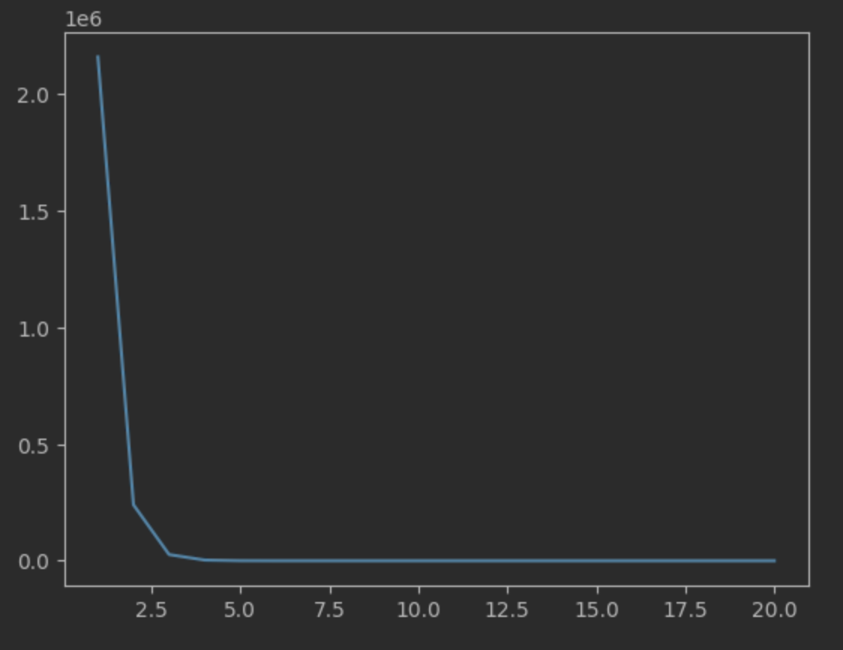

Prediction：

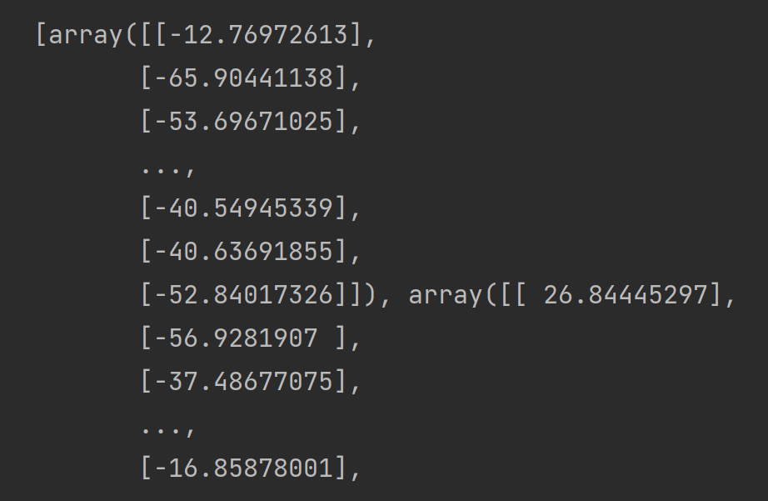

* 1. Plot the MSE (Mean Square Error) of testing set as a function of iteration

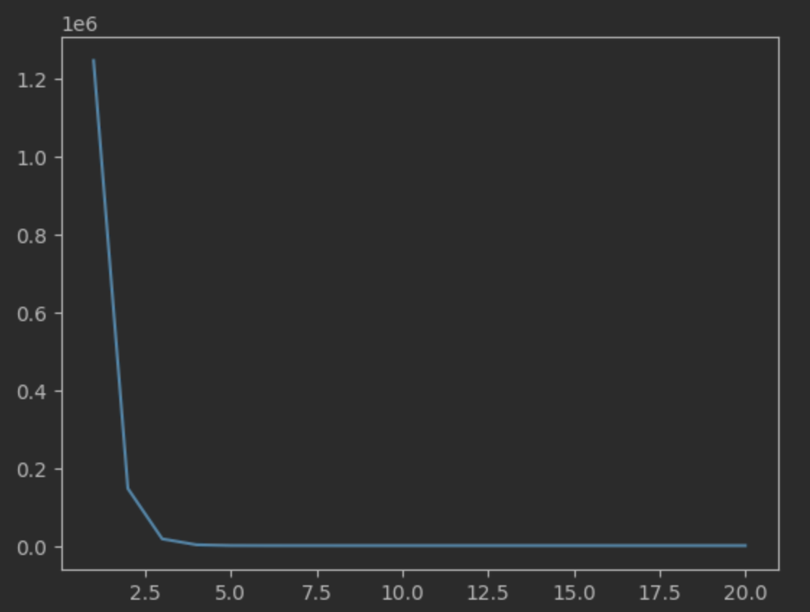

Prediction：

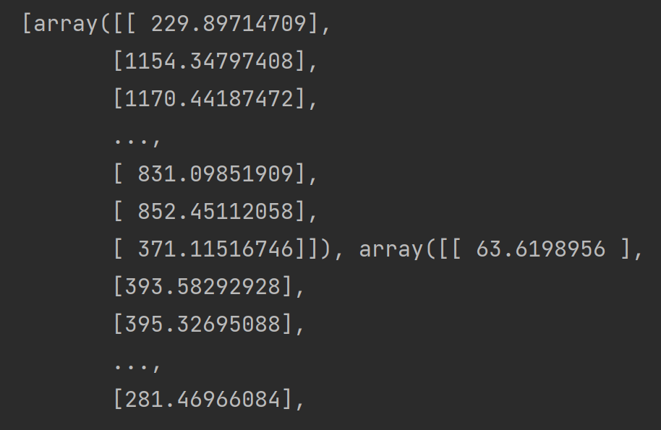

1. Use Stochastic Gradient Descent to adjust the weights (Write stochastic gradient descent code.)
   1. Plot the MSE (Mean Square Error) of training set as a function of iteration per epoch

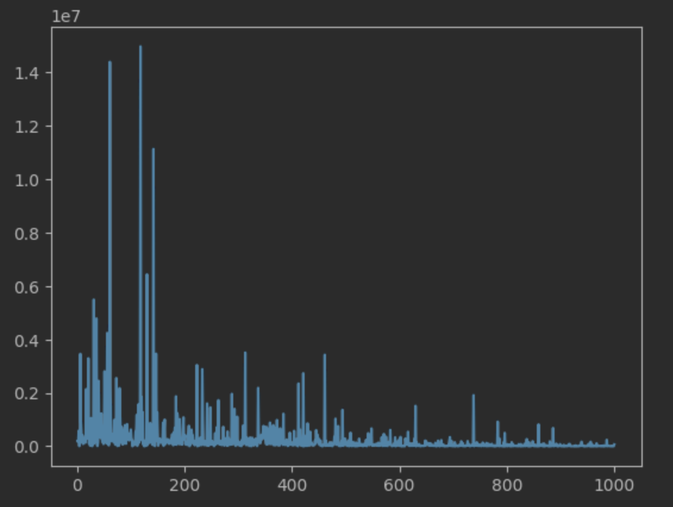

Prediction:

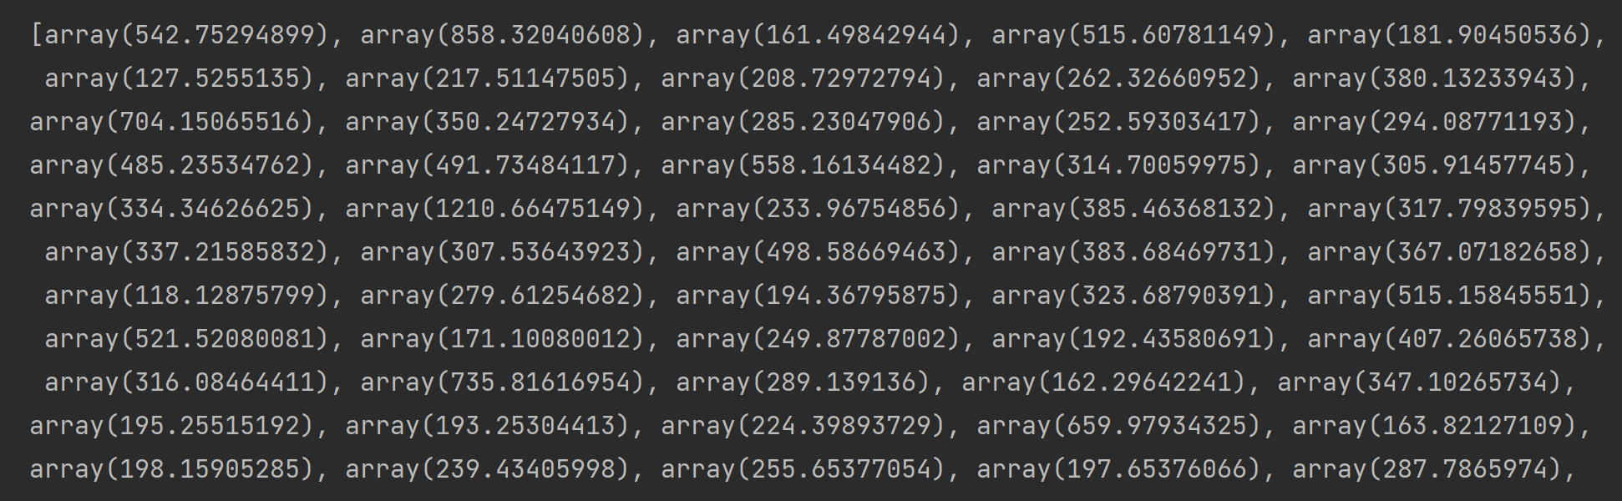

* 1. Plot the MSE (Mean Square Error) of testing set as a function of iteration per epoch

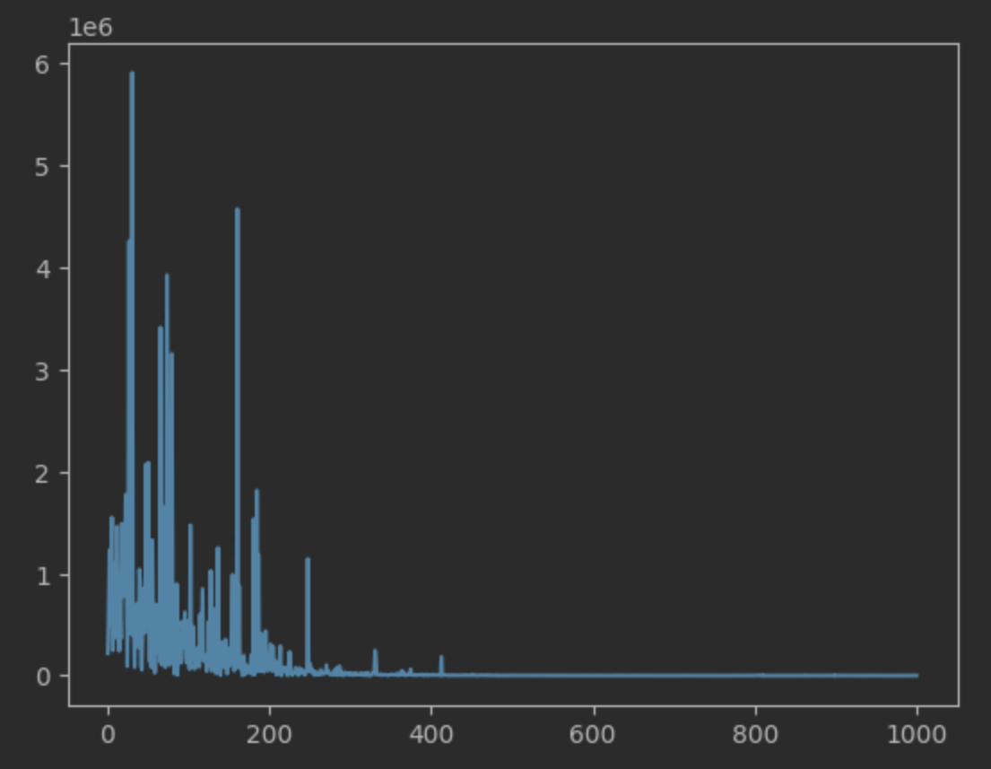

Prediction:

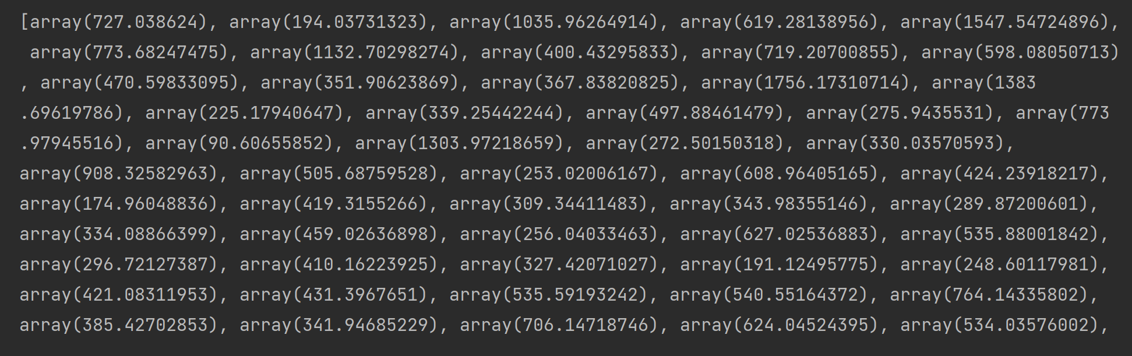

1. Use minibatch with size 12 to adjust the weights.
   1. Plot the MSE (Mean Square Error) of training set as a function of iteration per epoch

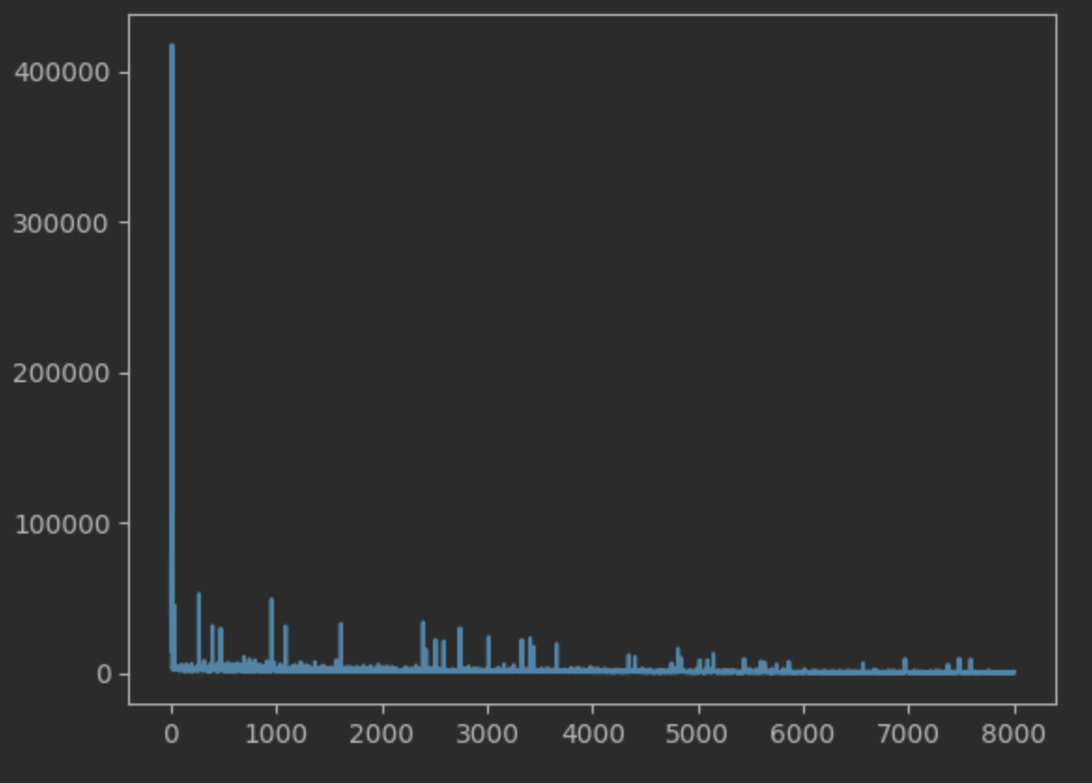

* 1. Plot the MSE (Mean Square Error) of testing set as a function of iteration per epoch

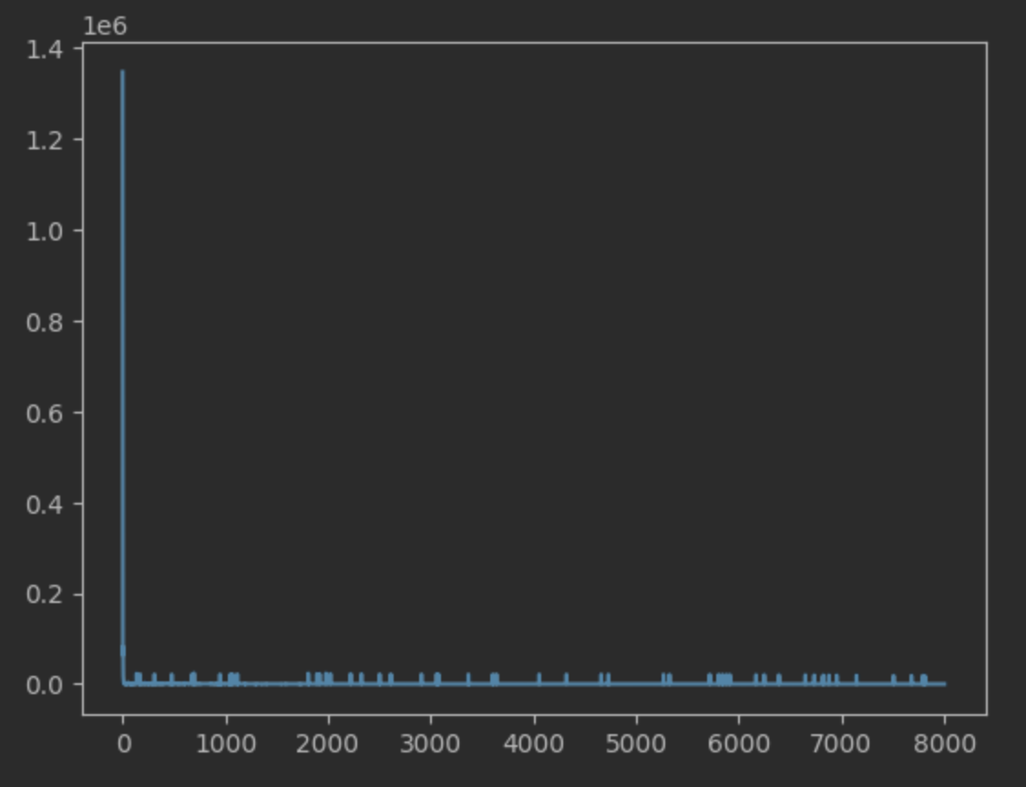

**Problem 2 (10 points)**

Stochastic gradient descent (SGD): name pros and cons of stochastics gradient descent.

Pros:

1. single training sample, easy to fit.
2. Fast
3. Converge fast

Cons:

1. Update too frequently
2. Don’t have vectorized operations
3. expensive