CS767

SPR23

Assignment 4

Yiduo Feng

02/28/2023

**Question 1 – Backpropagation**

1. Calculate entropy based cost function after setting the initial weights, and after one round of training.

Initial： 13.270972614548725

one round： 11.52633604329897

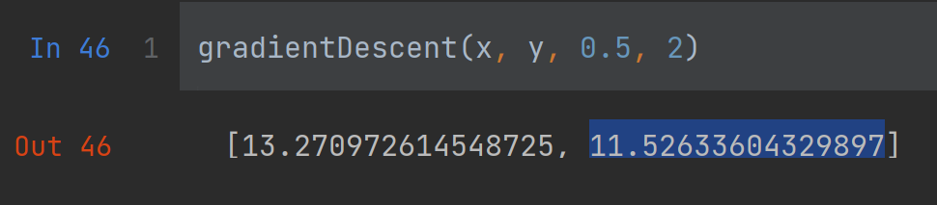

1. Use gradient descent with the step size of 0.5 and update weights from the hidden layer to the output layer.
2. Use gradient descent with step size of 0.5 and update wights from the input neurons to the hidden layer.

Code for ii and iii

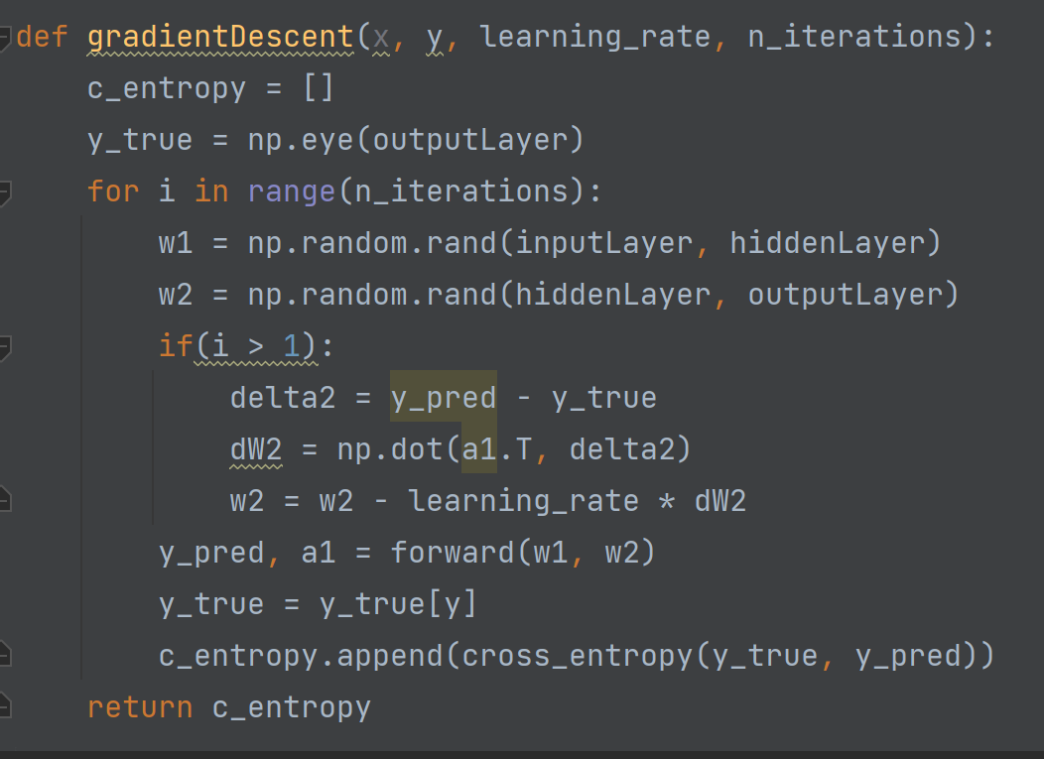

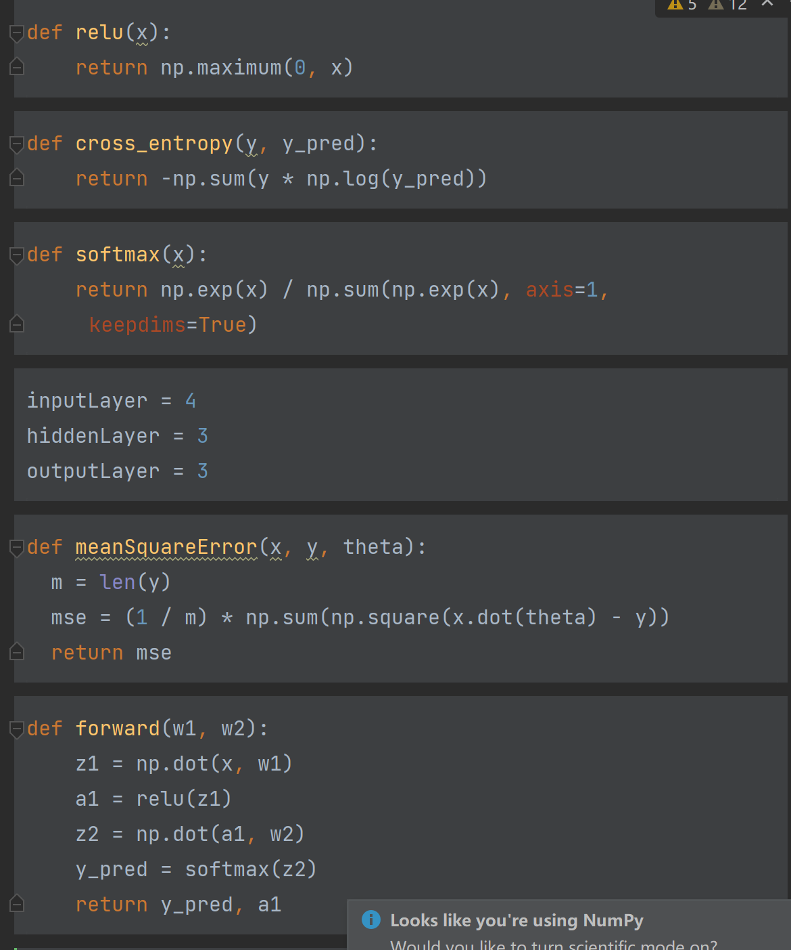

1. Bonus: Run your code to classify three types of flowers using all four parameters as an input.

Use Sigmoid activation function.

Use cross validation with CV = 5.

Choose five neurons in the hidden layer. Train your neural network model.

Show the result of your trained network and also calculate accuracy of your model.

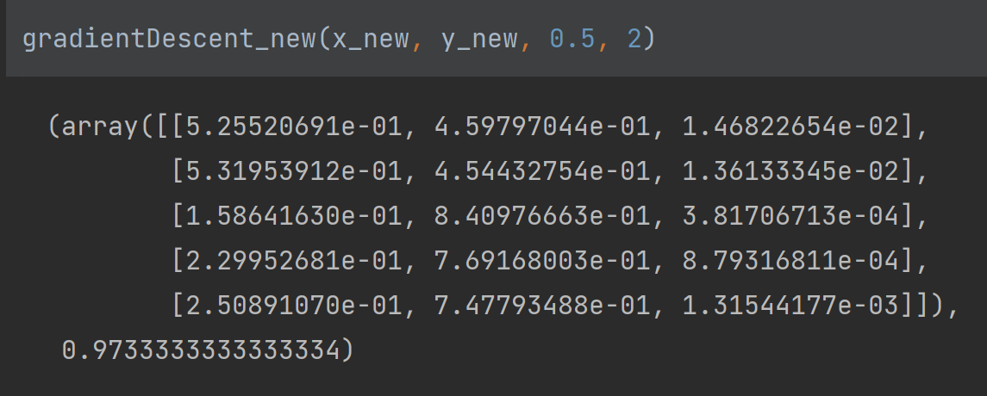

According to the results, the accuracy is 97.333%.