CS767

SPR23

Assignment 6

Yiduo Feng

03/28/2023

- Build a Multi-layer perceptron network (MLP), which classifies the data to 10 classes

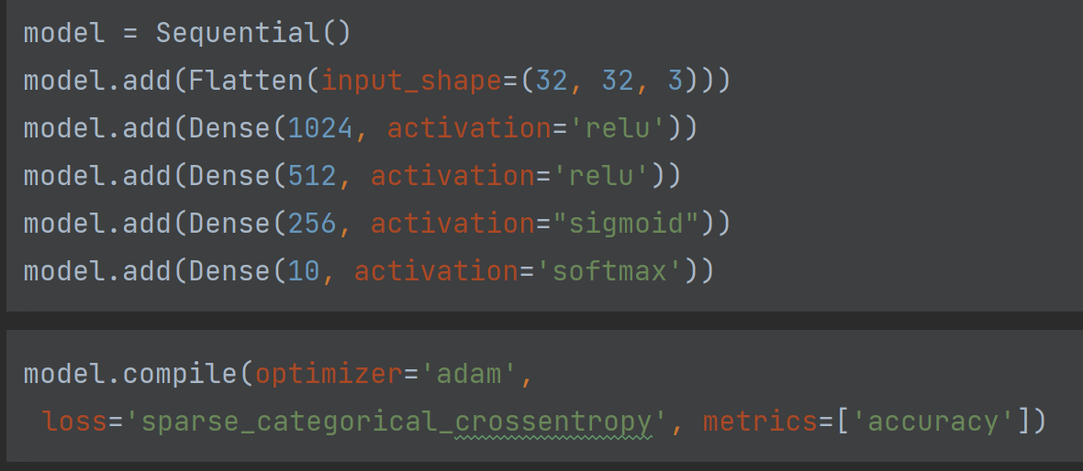

- Add a learning rate scheduler to your design. You can decide which scheduler provides you with the best performance

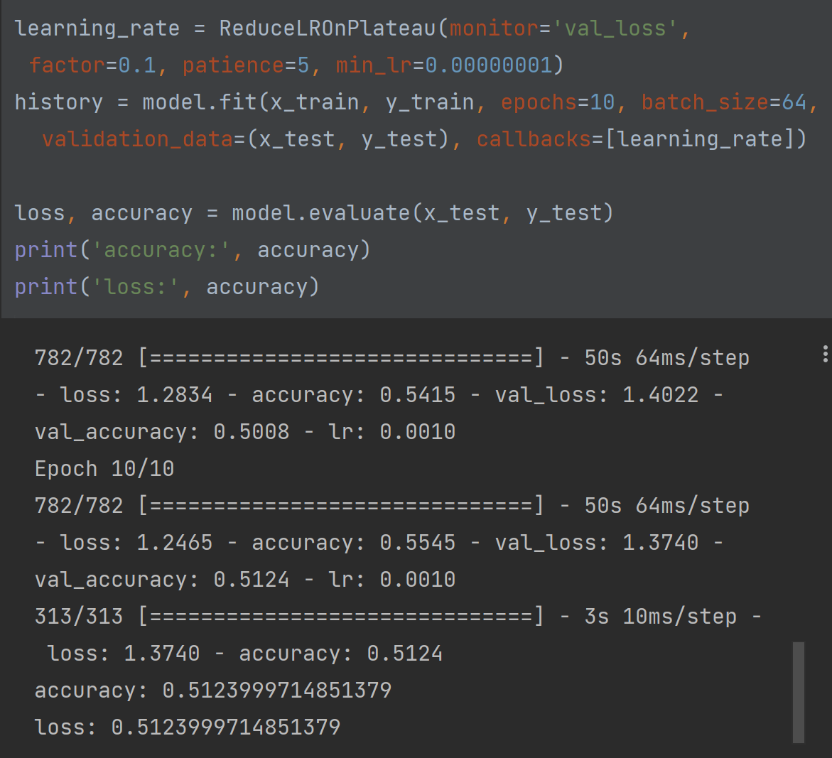

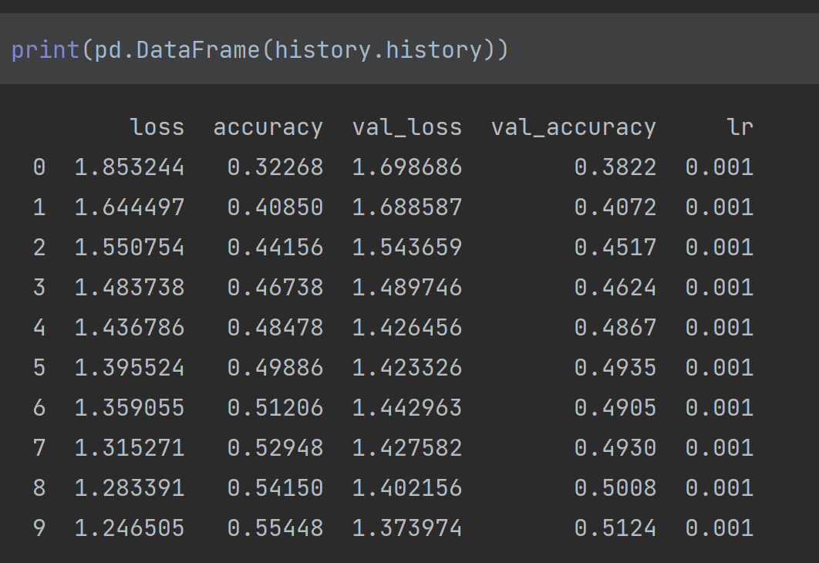

- Add a Batch Normalization to your design and report the performance of your network with and without batch normalization

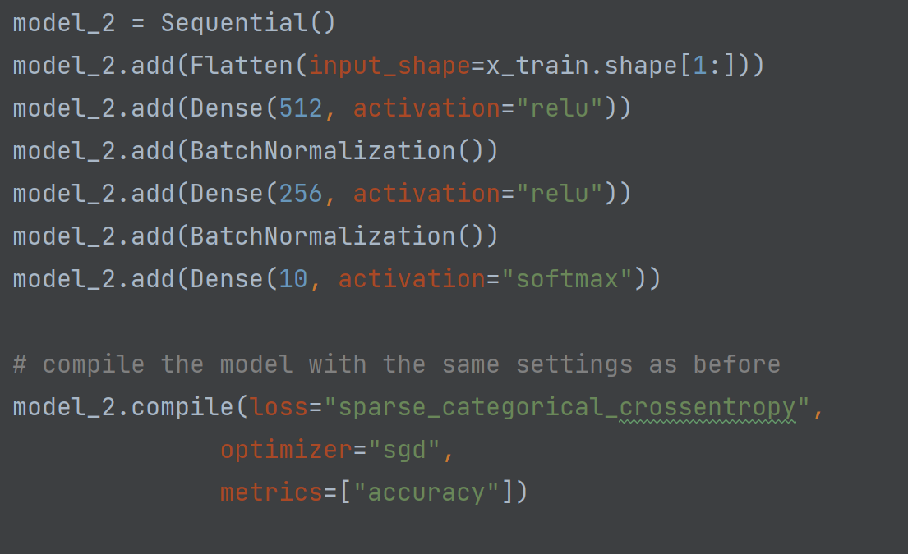

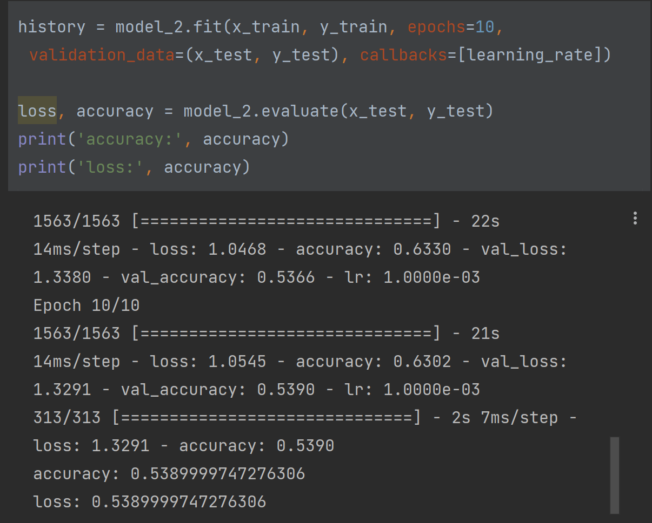

- Try different activation functions and report your observation

