CS767

SPR23

Assignment 7

Yiduo Feng

04/04/2023

**Question 1 – Computing CNN Memory Usage**

1. What is the total number of parameters in the CNN?

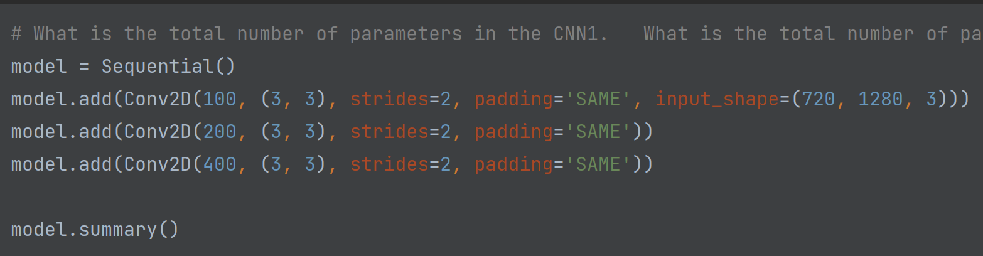

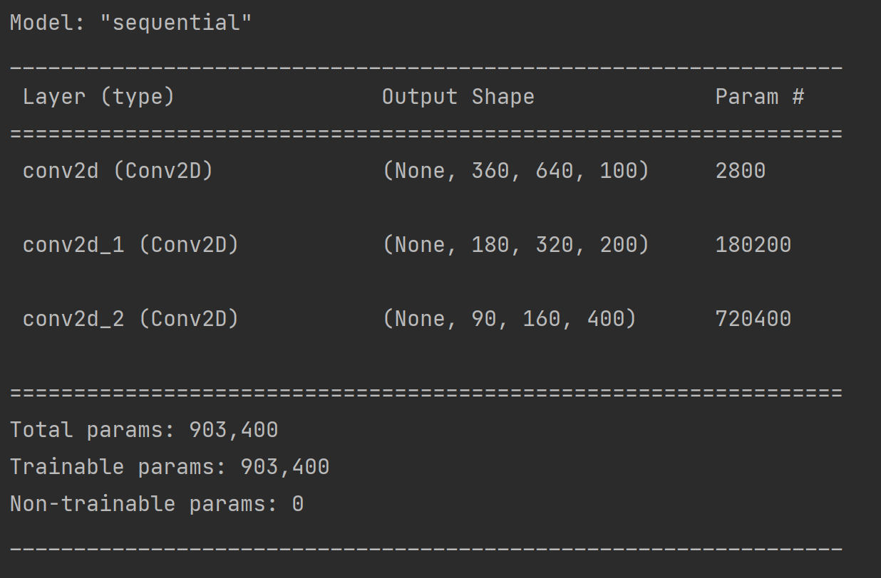

1. What is the minimum total RAM needed, if parameters are stored in 32-bit floats. Assume making prediction for a single image. (4 points)

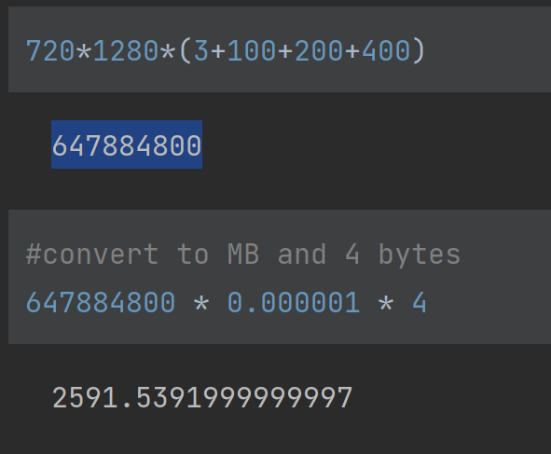

Minimum needed is 2591.5391999999997 MB.

1. How answer to question 2 change if everything is stored in 8-bit floats. Assume making prediction for a single image. (2 points)

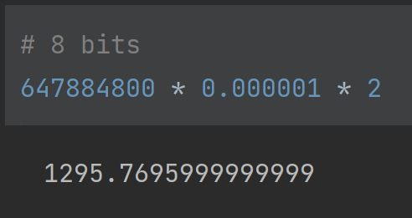

1295.7695999999999MB

1. How answer to question 2 change when training on a mini-batch of 20 images? (2 points)

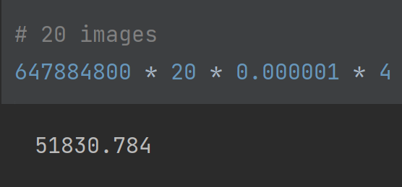

51830.784MB

**Question 2 – CNN Design**

Build a CNN and try to achieve the highest possible accuracy on Fashion_MNIST.

1. Model details:

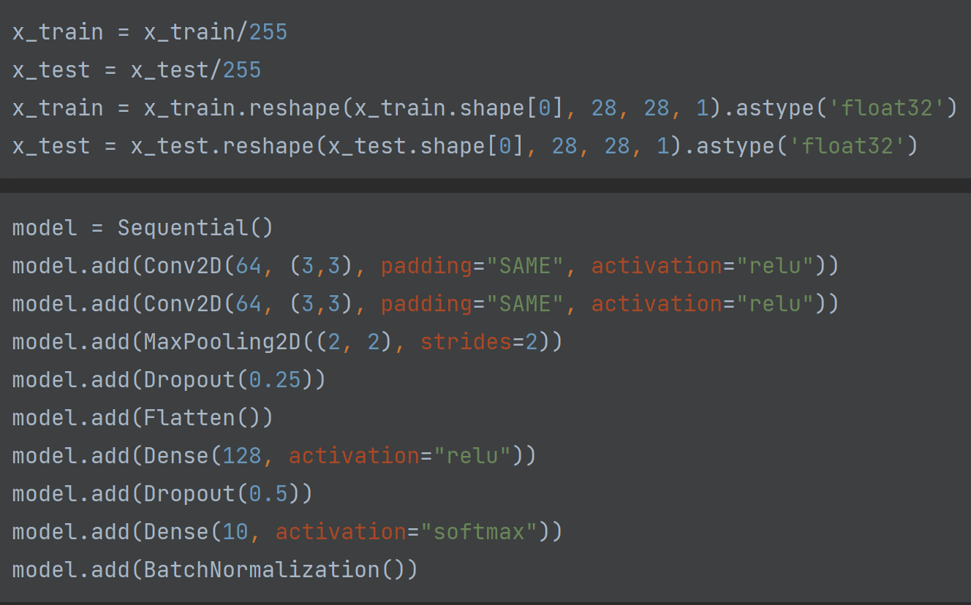

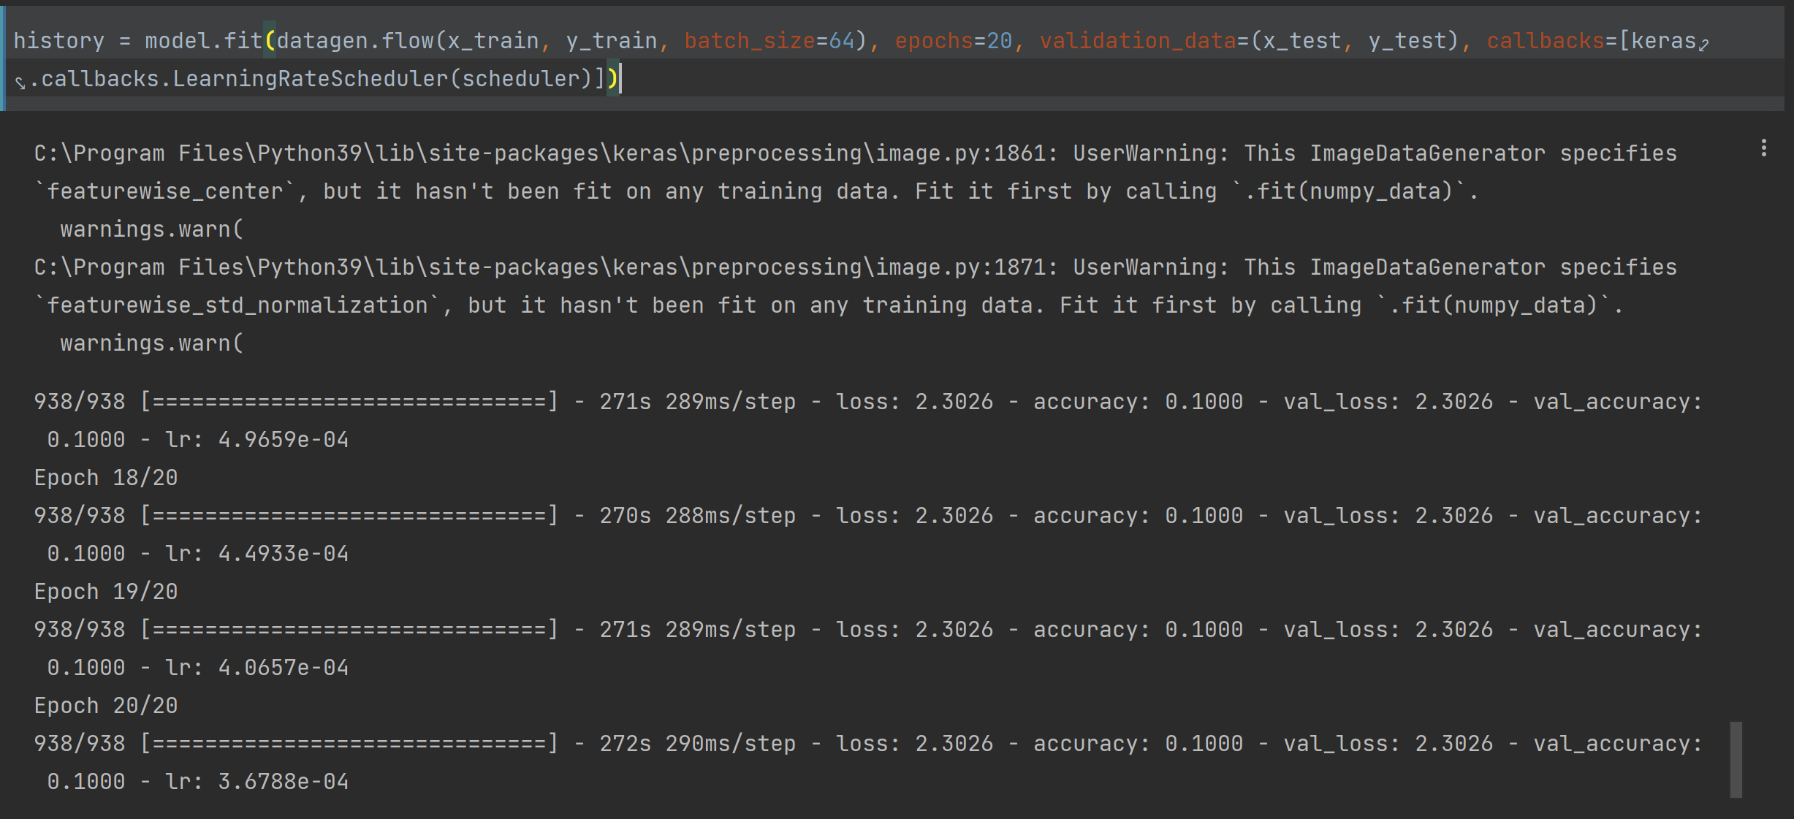

1. Add image augmentation. (3 points)

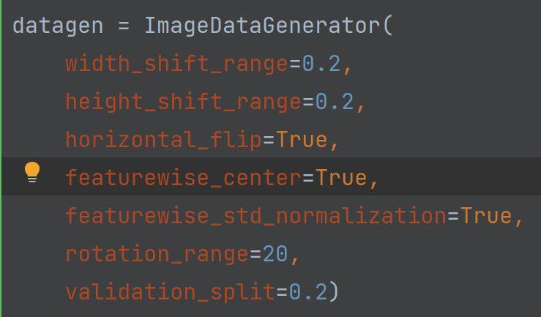

1. Add batch norm. (2 points)

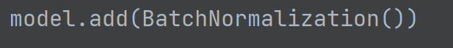

1. Use a learning rate scheduler. (3 points)

