CS767

SPR23

Assignment 8

Yiduo Feng

04/11/2023

1. (15 point) Build a ResidualUnit layer.

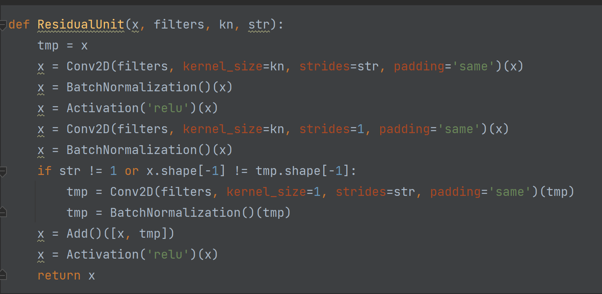

1. (20 point) Build the entire network.

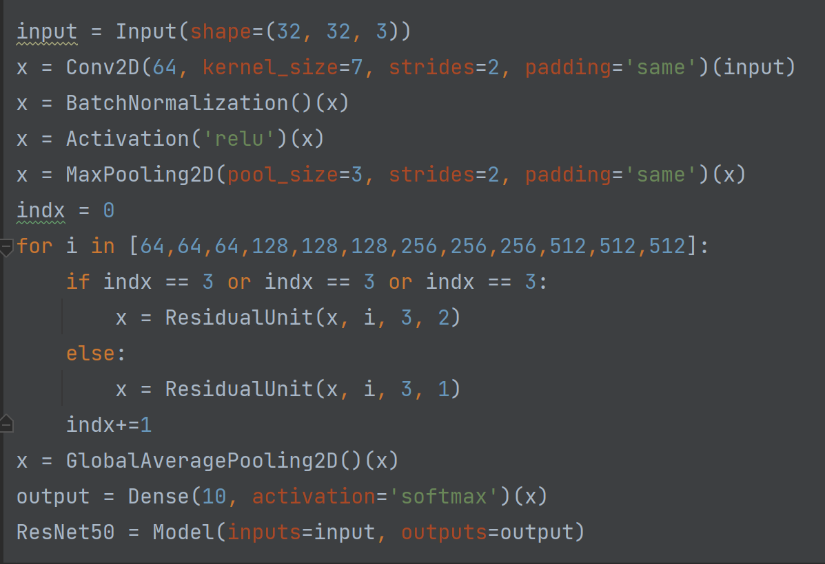

1. (5 points) Transfer learning – The ResNet50 model which won Imagenet2015 is available on Keras. Transfer the weights from the Keras pretrained model to your model.

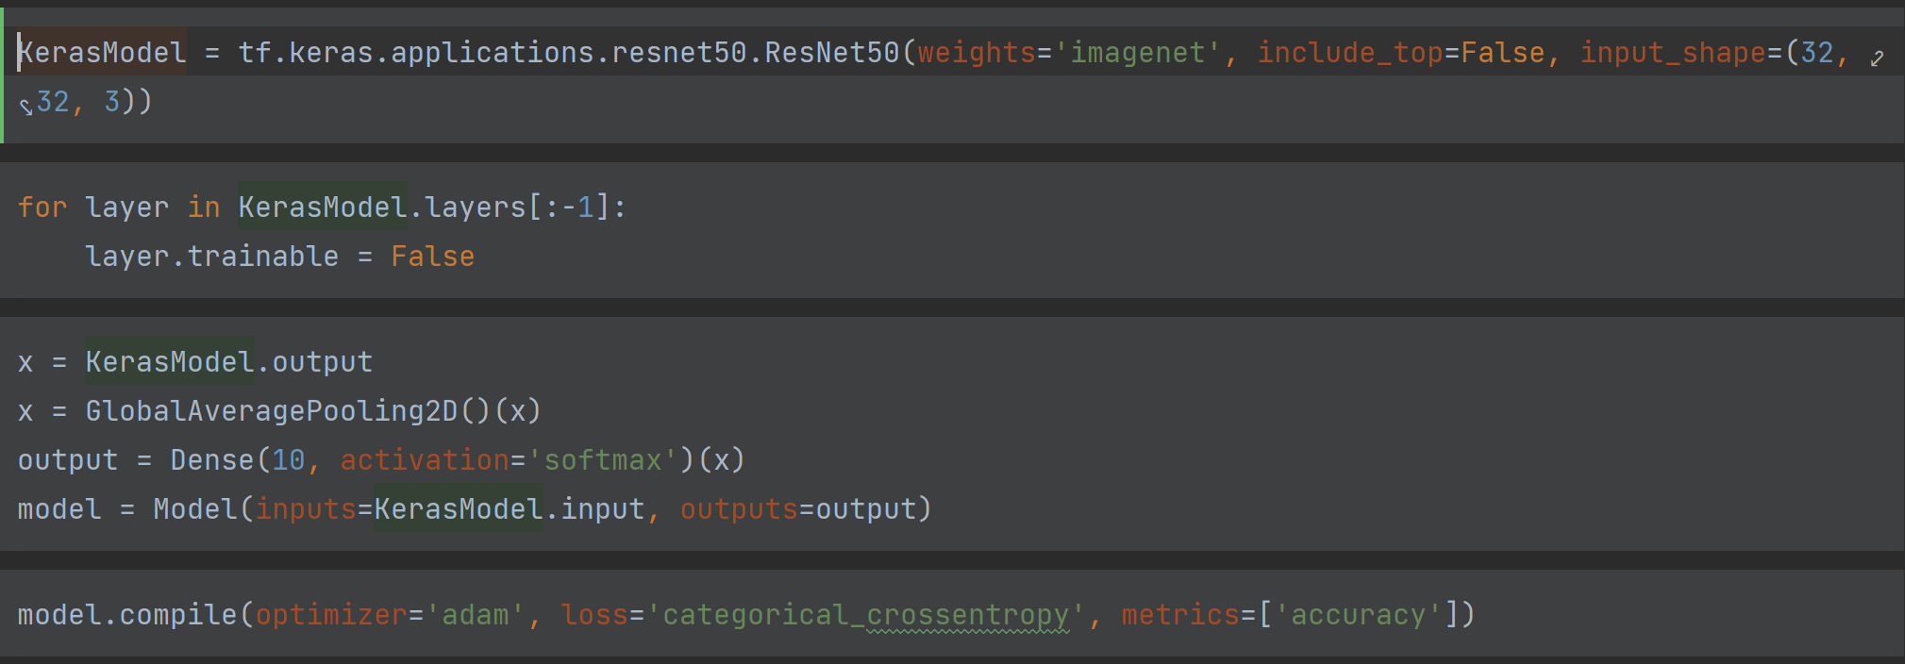

1. (10 points) Train your model, run the classifier, show the results and report the accuracy.

