**Facial Age and Gender Recognition**

***CS767 (Prof. Farshid Alizadeh-Shabdiz) Final Project Report***

Yiduo Feng 04/25/2023

**1. Data Description**

This dataset contains 23705 face images, and corresponding age, gender, race and pixels. Read image information by pixel and use it for the following analysis. The following is the source of the dataset:

https://www.kaggle.com/datasets/nipunarora8/age-gender-and-ethnicity-face-data-csv

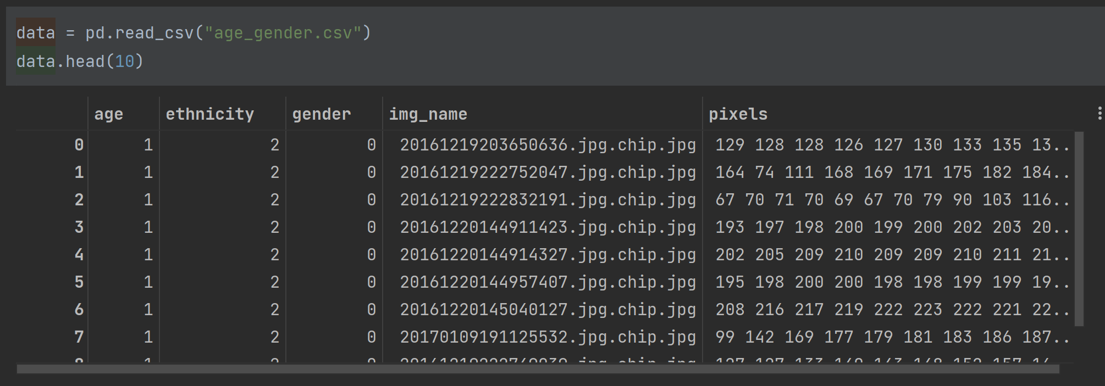

**2. Objective**

1. Definite Requirements
   1. Read data and plot the distribution of information
   2. Clean and reshape the data
2. Requirements Not Classified Yet
   1. Build CNN model
   2. Train and fit the data correctly
3. Nice-to-do Requirements
   1. Give an accuracy higher than 80%
   2. Predict age and gender, and show the results

**3. Data Processing**

**3.1 Data Import**

Use Pandas to read raw data and perform subsequent data cleansing

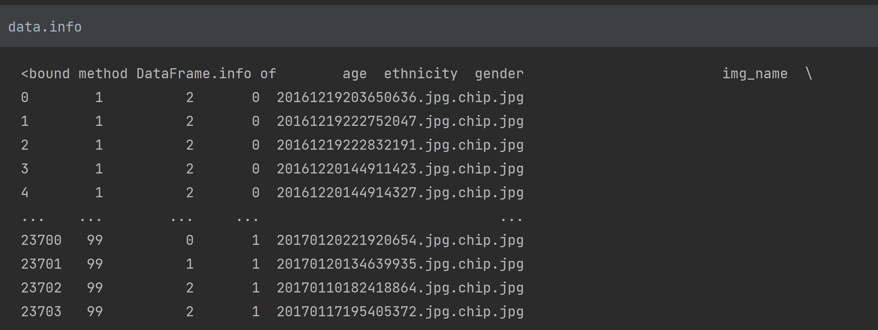

**3.2 Data Cleansing**

* **Removing null values**

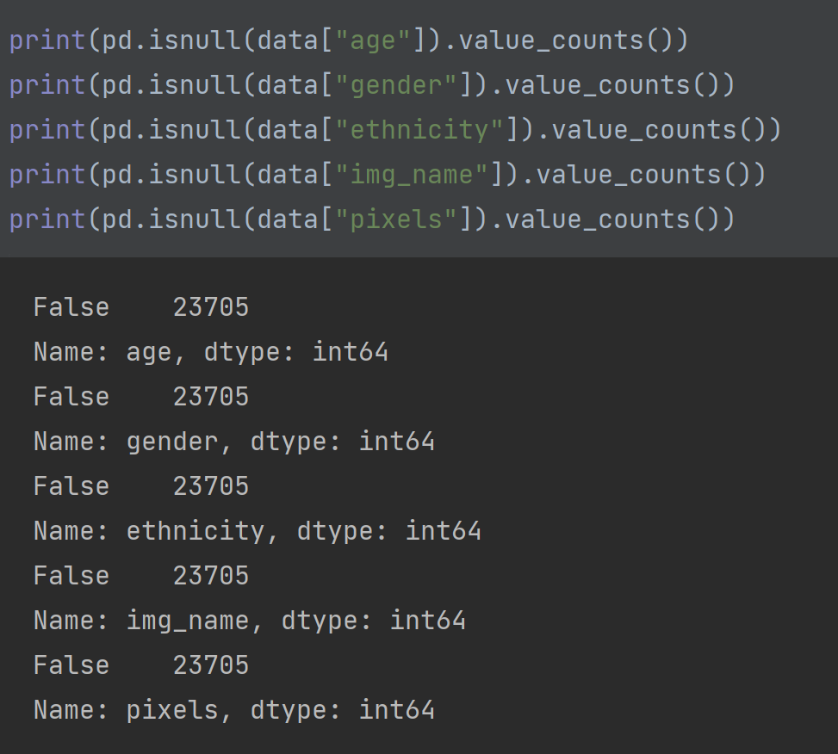

* **Check for abnormal values**

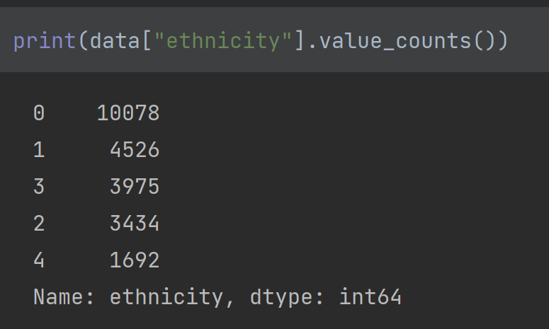

* **Reshape Data**

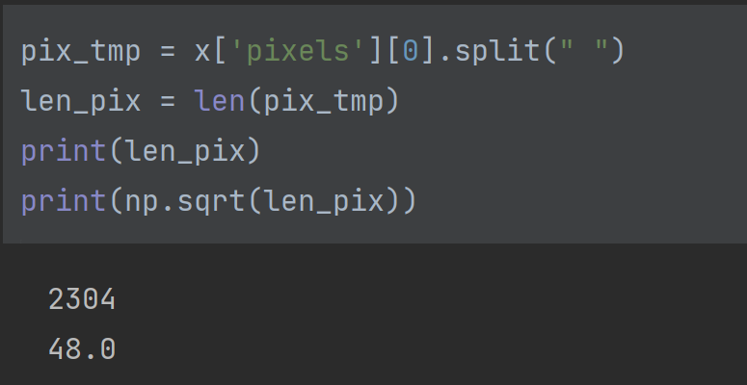

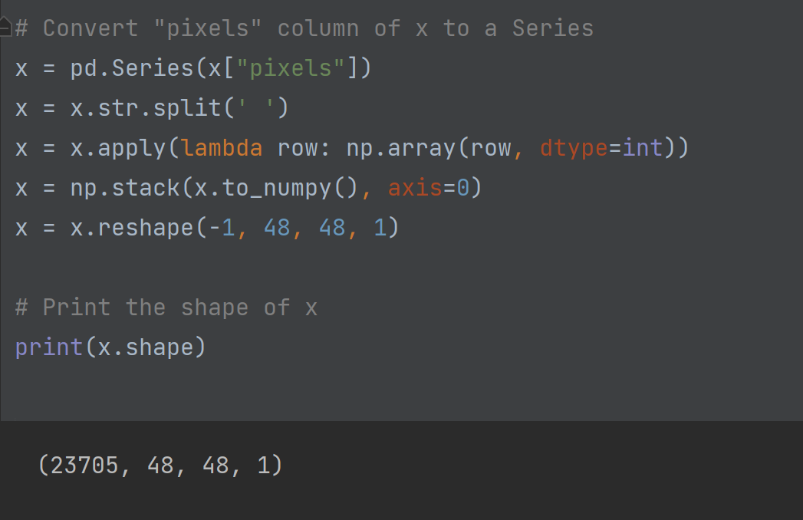

* **Prepare the train data**

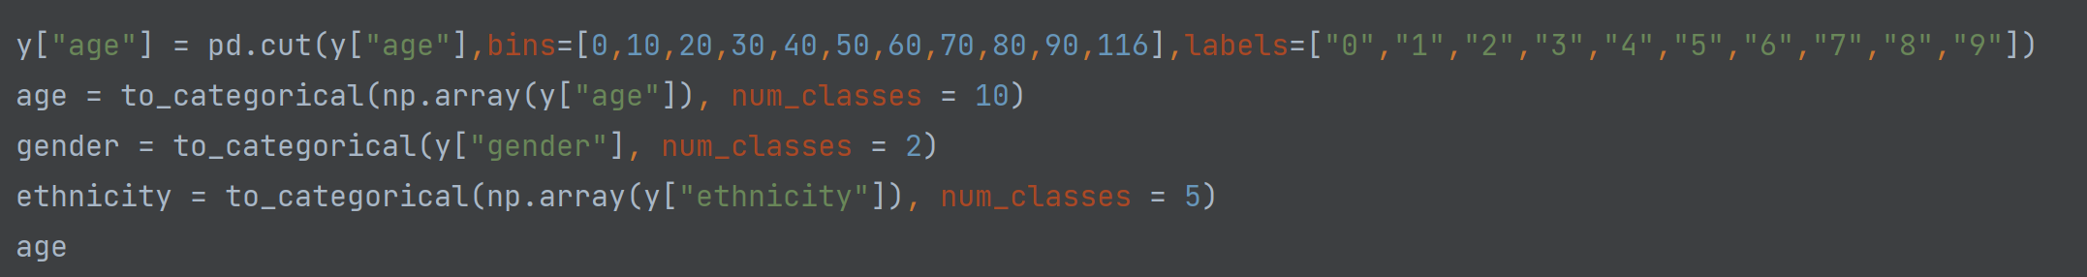

**4. Data Analysis Visualization**

**4.1 Plot Data**

The graph below shows the distribution of people’s age

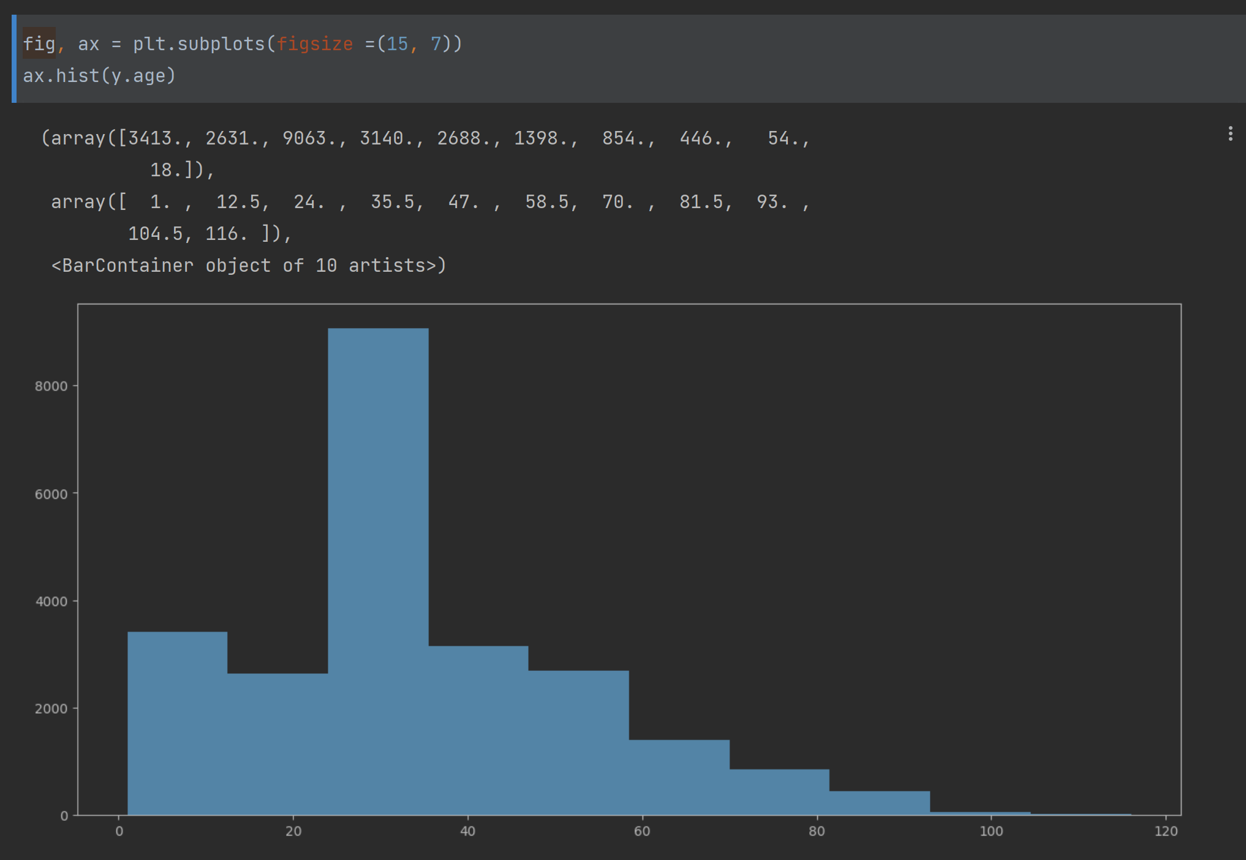

The graph below shows the distribution of people’s gender.

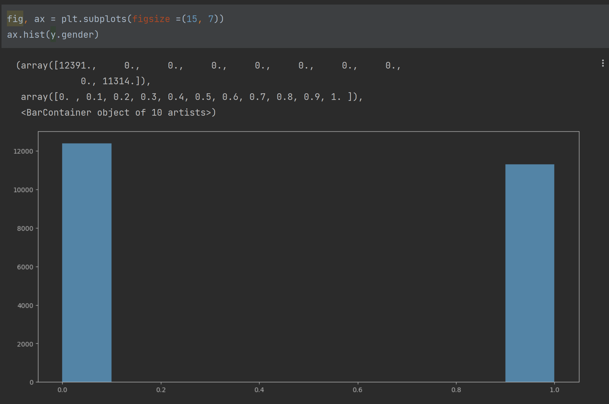

**4.2 Data pictures**

Use the pixel data to draw the pictures.

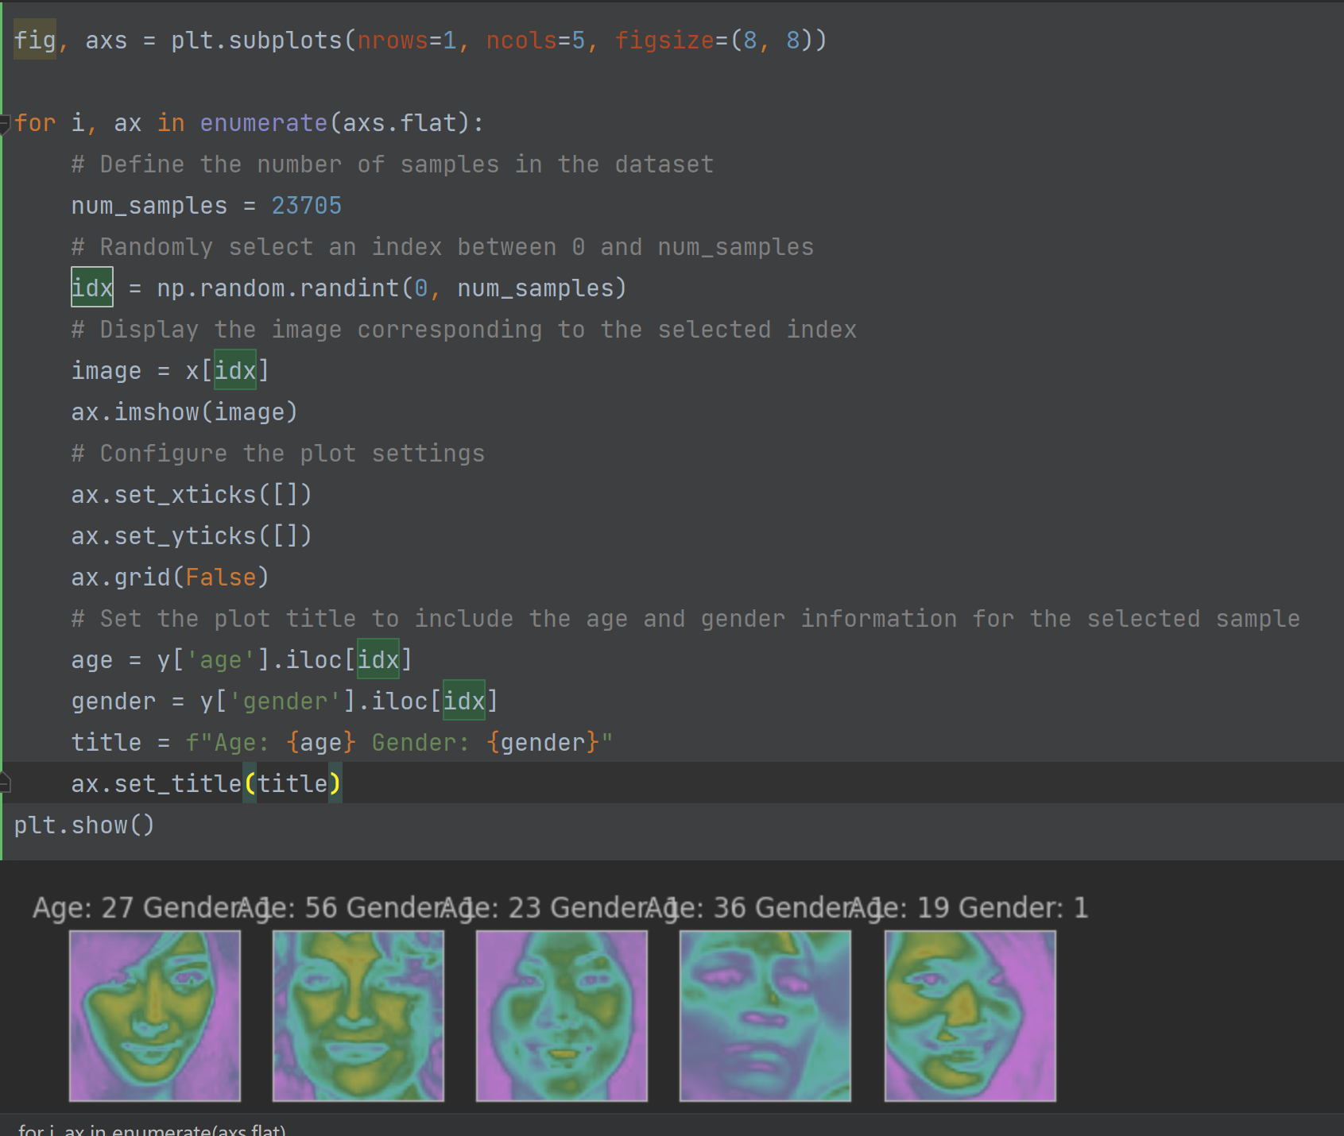

**5. CNN Model**

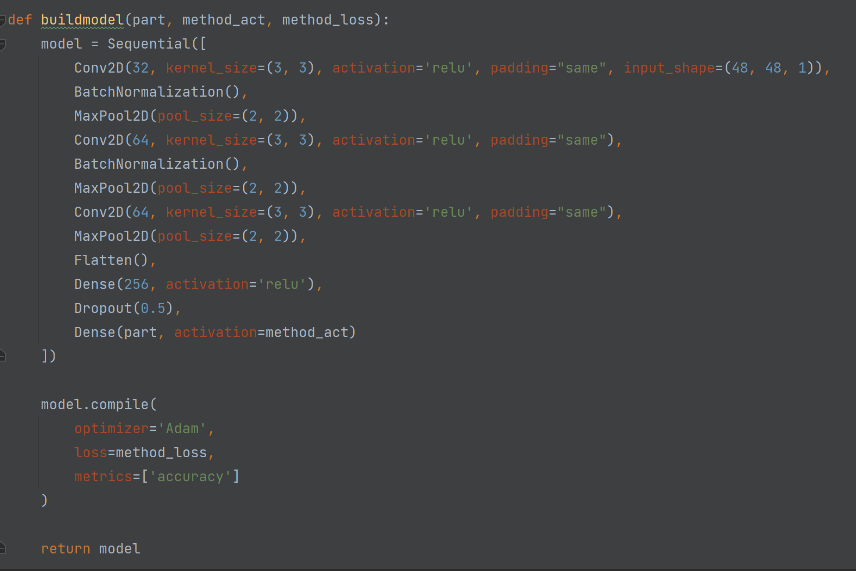

**5.1 Age**

**5.1.1 part=10, method_act='sigmoid', method_loss='mse'**

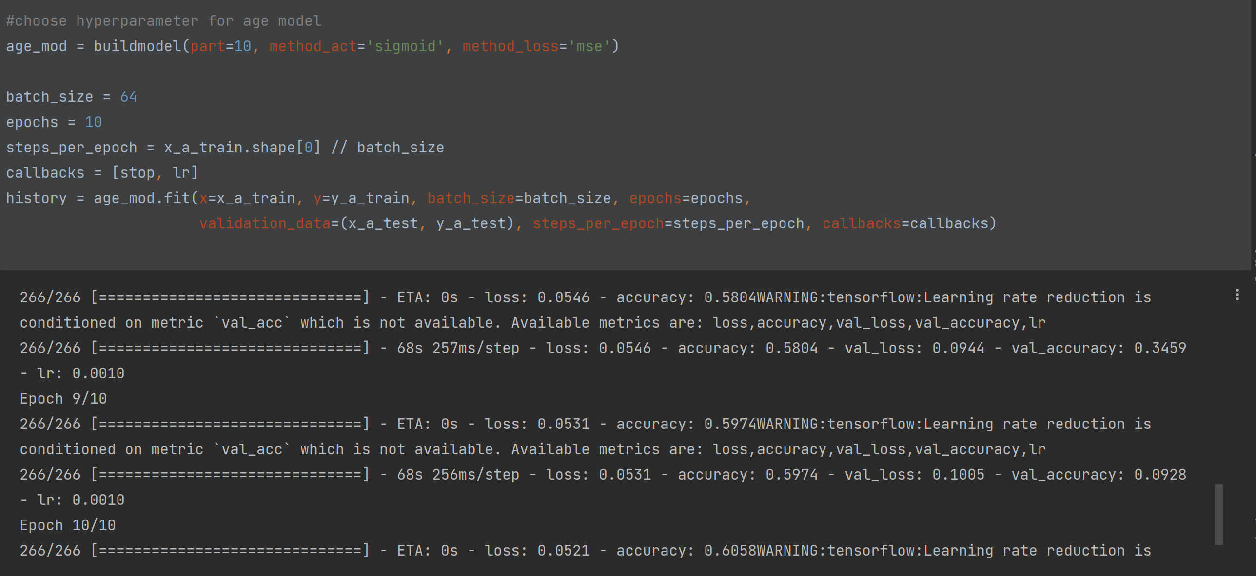

**5.1.2 part=10, method_act=softmax, method_loss='categorical_crossentropy'**

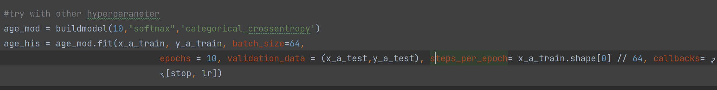

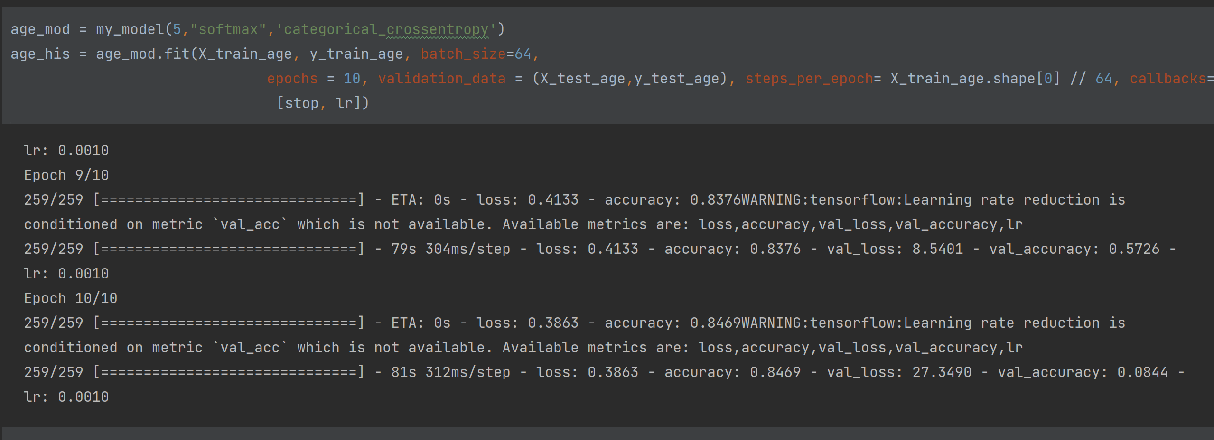

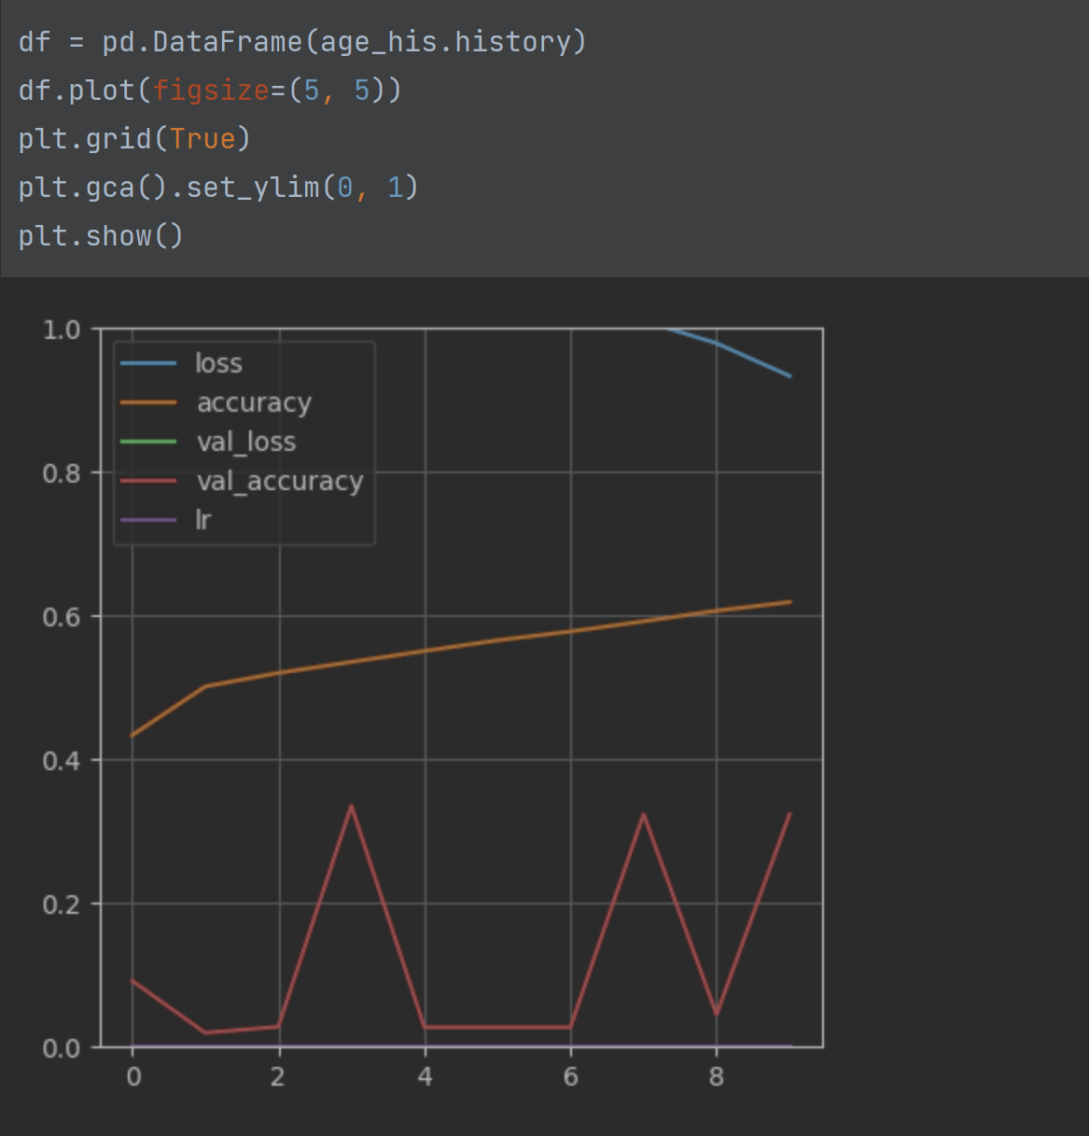

Based on the results obtained from the code above, the accuracy achieved after 10 epochs for predicting age is approximately 84%. To achieve higher accuracy, the age values were separated into 5 categories. However, when the number of categories was increased to 10, the accuracy of the age predictions decreased significantly to around 51%. This suggests that the age categories used in the 5-part separation provide a better balance between granularity and accuracy for this particular task. It is worth noting that the optimal number of categories for age separation may vary depending on the specific problem, dataset, and model architecture used, and therefore, may require experimentation and tuning to achieve the best results.

**5.2 Gender**

**5.2.1 part=2, method_act= softmax, method_loss='mse'**

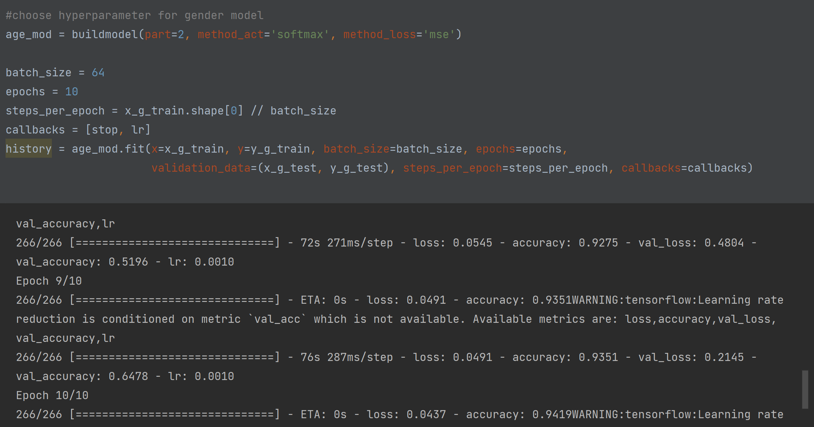

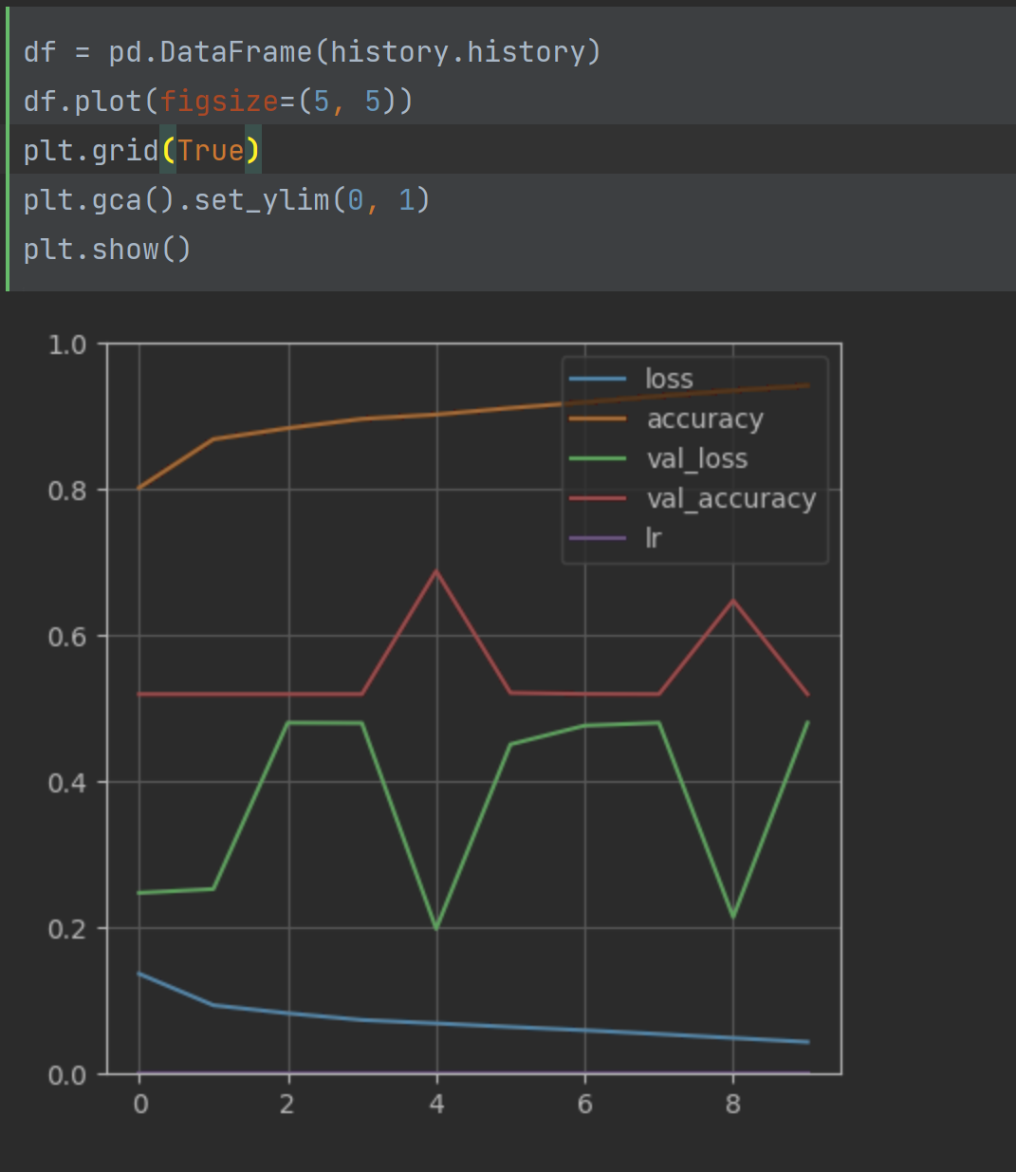

**5.2.2 part=2, method_act='sigmoid', method_loss='categorical_crossentropy'**

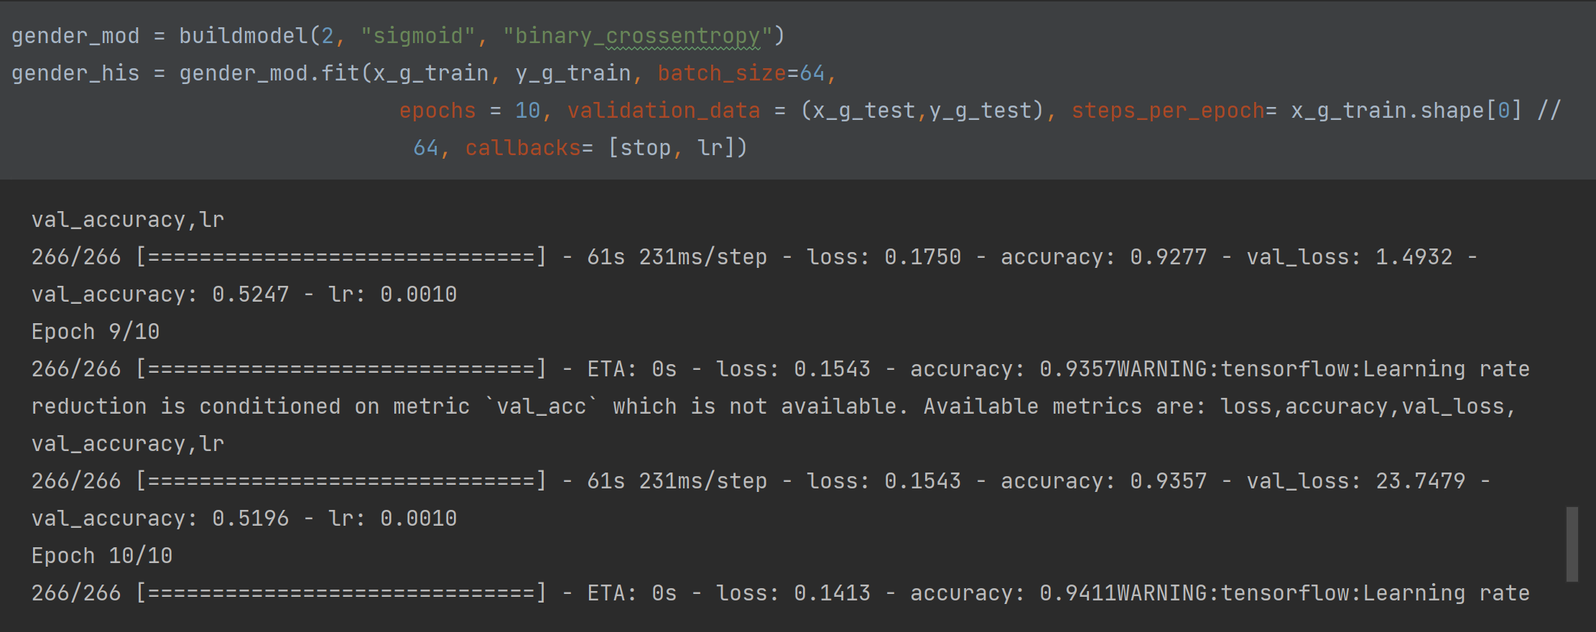

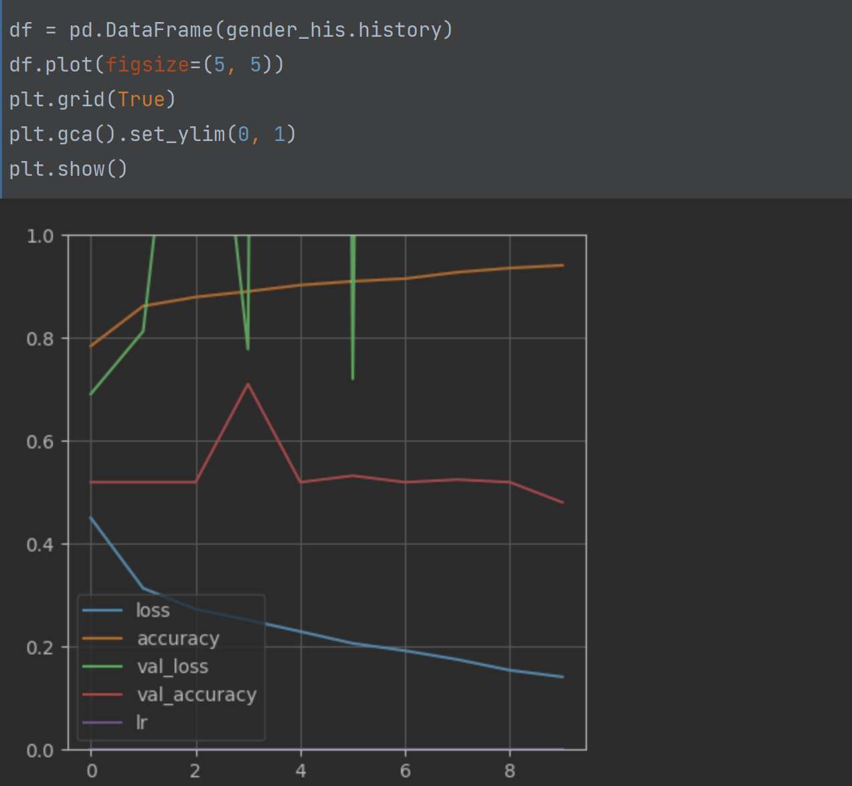

After training the gender classification model for 10 epochs, the accuracy of the model was evaluated and found to be approximately 94%. This means that the model correctly predicted the gender of new, unseen data with an accuracy of 94% after being trained on a dataset of labeled examples. It is important to note that the accuracy may vary depending on the specific dataset being used, the complexity of the model architecture, and the quality and quantity of the training data.

**6. Conclusion**

This project involves using a deep learning model to predict the age of individuals based on their face images. The model architecture consists of several convolutional and dense layers, with a softmax activation function and categorical cross-entropy loss function used for training. The dataset used in this project contains over 23,000 face images, each with corresponding information on age, gender, race, and pixel values. The pixel values column is used to train the model, and the images are preprocessed and normalized before being fed into the model. Overall, this project has the potential to provide valuable insights into the relationship between age and facial features, and to develop a useful tool for age prediction based on face images.

**7. References**

<https://blog.csdn.net/woshicver/article/details/120192357>

https://www.[kaggle](https://so.csdn.net/so/search?q=kaggle&spm=1001.2101.3001.7020).com/nipunarora8/age-gender-and-ethnicity-face-data-csv