Testing Stored Procedure PROC_CANCEL_THE_PROGRESSING_PO_G4We use POs where poNo = 2 to test there will be 5 scenarios as bellow:

Scenario 1: “ordered” to “canceled”

Scenario 2: “Client paid. Preparing for shipment” to “canceled”

Scenario 3: “On the way” to “canceled”

Scenario 4: “Received” to “canceled”

Scenario 5: “canceled” to “canceled” – error handling

Scenario 6: the PO somehow has a invalid stateNo – error handling

In Scenario 1: “ordered” to “canceled”

1. get PO 2 using postman to check its state as “ordered “

URL: <http://localhost:8000/pos/>2

1. Check the stored procedure is already in database by using workbench

1. Cancel the PO order by using postman

URL: <http://localhost:8000/cancelPo/2>

1. Check the consequence of the cancelation:
   1. If there is a record in HistoryG4 by using workbench

* 1. If the status of the purchase order has been update as canceled by using postman

URL: <http://localhost:8000/pos/>2

In Scenario 2: “Client paid. Preparing for shipment” to “canceled”

1. Set the status for “Client paid. Preparing for shipment”

UPDATE POsG4

SET statusG4 = 2

WHERE poNoG4 = 2 ;

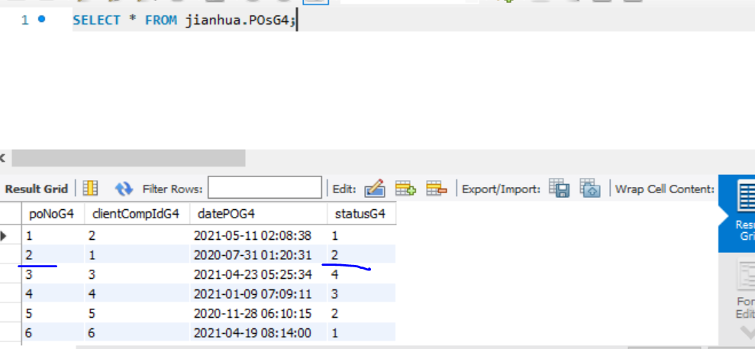

1. Check how much many owned (moneyOwedG4) for this client, how many parts in this PO, what qty is currently stored in company by using workbench

SELECT lineNoG4, POsG4.poNoG4, ClientG4.clientCompIdG4, PartsG4.partNoG4, statusG4, moneyOwedG4, PartsG4.qtyG4 as 'stored qty', POLinesG4.qtyG4 as 'PO line qty'

FROM POsG4 JOIN POLinesG4 ON POsG4.poNoG4 = POLinesG4.poNoG4 JOIN PartsG4 ON PartsG4.partNoG4 = POLinesG4.partNoG4 JOIN ClientG4 ON ClientG4.clientCompIdG4 = POsG4.clientCompIdG4

WHERE POsG4.poNoG4 = 2;

1. Cancel the PO order by using postman

URL: <http://localhost:8000/cancelPo/2>

1. Check the consequence of the cancelation:
2. If there is a record in HistoryG4 by using workbench

1. if the status of the purchase order has been update as canceled, the client owned money has been decrease, if the PartsG4 ‘s qty has been increased by using workbench

SELECT lineNoG4, POsG4.poNoG4, ClientG4.clientCompIdG4, PartsG4.partNoG4, statusG4, moneyOwedG4, PartsG4.qtyG4 as 'stored qty', POLinesG4.qtyG4 as 'PO line qty'

FROM POsG4 JOIN POLinesG4 ON POsG4.poNoG4 = POLinesG4.poNoG4 JOIN PartsG4 ON PartsG4.partNoG4 = POLinesG4.partNoG4 JOIN ClientG4 ON ClientG4.clientCompIdG4 = POsG4.clientCompIdG4

WHERE POsG4.poNoG4 = 2;

In Scenario 3: “On the way” to “canceled”

1. Set the status for “On the way”
2. Check if its state as “On the way “, how the qty of PartsG4, Check how much many owned (moneyOwedG4) for this client

SELECT lineNoG4, POsG4.poNoG4, ClientG4.clientCompIdG4, PartsG4.partNoG4, statusG4, moneyOwedG4, PartsG4.qtyG4 as 'stored qty', POLinesG4.qtyG4 as 'PO line qty'

FROM POsG4 JOIN POLinesG4 ON POsG4.poNoG4 = POLinesG4.poNoG4 JOIN PartsG4 ON PartsG4.partNoG4 = POLinesG4.partNoG4 JOIN ClientG4 ON ClientG4.clientCompIdG4 = POsG4.clientCompIdG4

WHERE POsG4.poNoG4 = 2;

1. Cancel the PO order by using postman

URL: <http://localhost:8000/cancelPo/2>

1. Check the consequence of the cancelation:
   1. If there is a record in HistoryG4 by using workbench
   2. if the status of the purchase order has been update as canceled, the client owned money has been decrease, if the PartsG4 ‘s qty has been increased by using workbench

SELECT lineNoG4, POsG4.poNoG4, ClientG4.clientCompIdG4, PartsG4.partNoG4, statusG4, moneyOwedG4, PartsG4.qtyG4 as 'stored qty', POLinesG4.qtyG4 as 'PO line qty'

FROM POsG4 JOIN POLinesG4 ON POsG4.poNoG4 = POLinesG4.poNoG4 JOIN PartsG4 ON PartsG4.partNoG4 = POLinesG4.partNoG4 JOIN ClientG4 ON ClientG4.clientCompIdG4 = POsG4.clientCompIdG4

WHERE POsG4.poNoG4 = 2;

In Scenario 4: “Received” to “canceled”

1. Set the status for “Received”
2. Check if its state as “Received“, how the qty of PartsG4, Check how much many owned (moneyOwedG4) for this client

SELECT lineNoG4, POsG4.poNoG4, ClientG4.clientCompIdG4, PartsG4.partNoG4, statusG4, moneyOwedG4, PartsG4.qtyG4 as 'stored qty', POLinesG4.qtyG4 as 'PO line qty'

FROM POsG4 JOIN POLinesG4 ON POsG4.poNoG4 = POLinesG4.poNoG4 JOIN PartsG4 ON PartsG4.partNoG4 = POLinesG4.partNoG4 JOIN ClientG4 ON ClientG4.clientCompIdG4 = POsG4.clientCompIdG4

WHERE POsG4.poNoG4 = 2;

1. Cancel the PO order by using postman

URL: <http://localhost:8000/cancelPo/2>

1. Check the consequence of the cancelation:
2. If there is a record in HistoryG4 by using workbench
3. if the status of the purchase order has been update as canceled, the client owned money has been decrease, if the PartsG4 ‘s qty has been increased by using workbench

SELECT lineNoG4, POsG4.poNoG4, ClientG4.clientCompIdG4, PartsG4.partNoG4, statusG4, moneyOwedG4, PartsG4.qtyG4 as 'stored qty', POLinesG4.qtyG4 as 'PO line qty'

FROM POsG4 JOIN POLinesG4 ON POsG4.poNoG4 = POLinesG4.poNoG4 JOIN PartsG4 ON PartsG4.partNoG4 = POLinesG4.partNoG4 JOIN ClientG4 ON ClientG4.clientCompIdG4 = POsG4.clientCompIdG4

WHERE POsG4.poNoG4 = 2;

In Scenario 5: “canceled” to “canceled” – error handling

1. Set the status for : “canceled”
2. get PO 2 using postman to check its state as : “canceled”

URL: <http://localhost:8000/pos/2>

1. Cancel the PO order by using postman

URL: <http://localhost:8000/cancelPo/2>

1. Check the consequence of the cancelation:
2. If there is no record in HistoryG4 for the unsuccessful cancelation by using workbench
3. If there is an error message in postman

UPDATE POsG4

SET statusG4 = 5

WHERE poNoG4 = 2 ;