**Tips for** : **What should I do if I can’t connect to server?**

<http://47.91.41.87:8000/carRental/homepage>

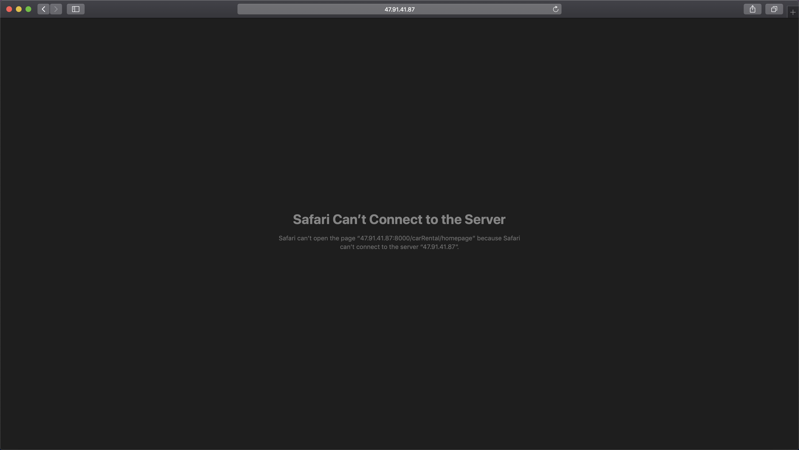

**Solution:**

This is due to CPU performance on the server is not very good, so we couldn’t run server for very long time on the back end yet (But We will try to run server in the daytime from 8AM-4PM everyday) very sorry about that. You need to start server by yourself but don’t worry it is quite simple (2 minutes prox.). Just follow following steps:

1. Open your terminal on the computer
2. Copy -> ssh [root@47.91.41.87](mailto:root@47.91.41.87) <-into terminal

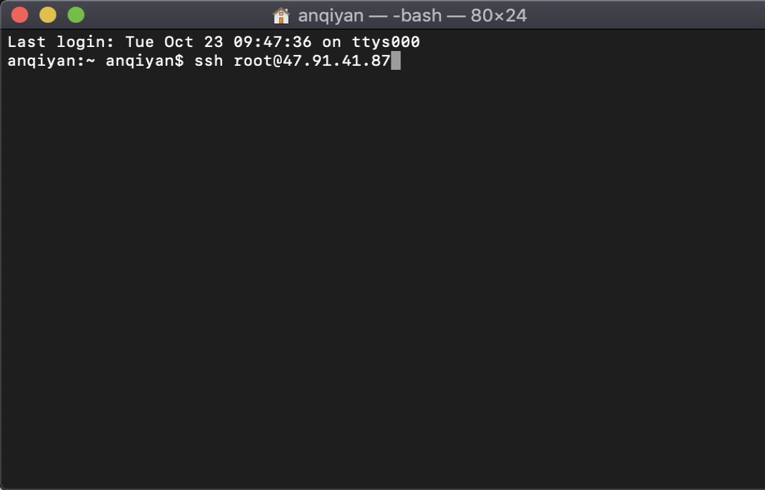

1. Enter password:-> Hahaha123$ <-Into terminal

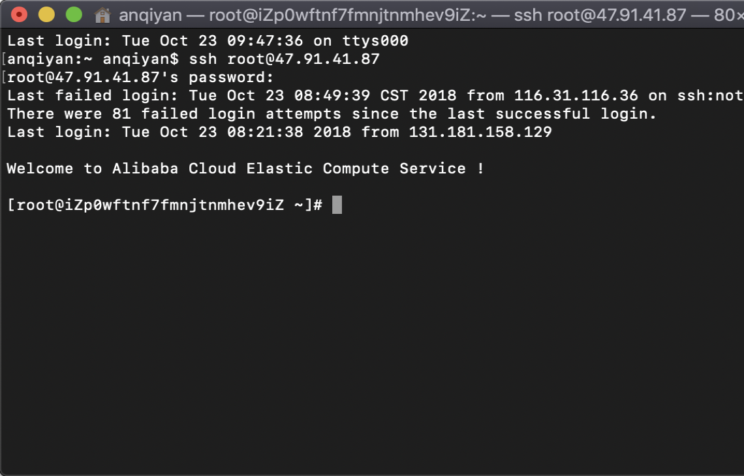

1. Copy -> cd /data/ifb299carrental <- into terminal

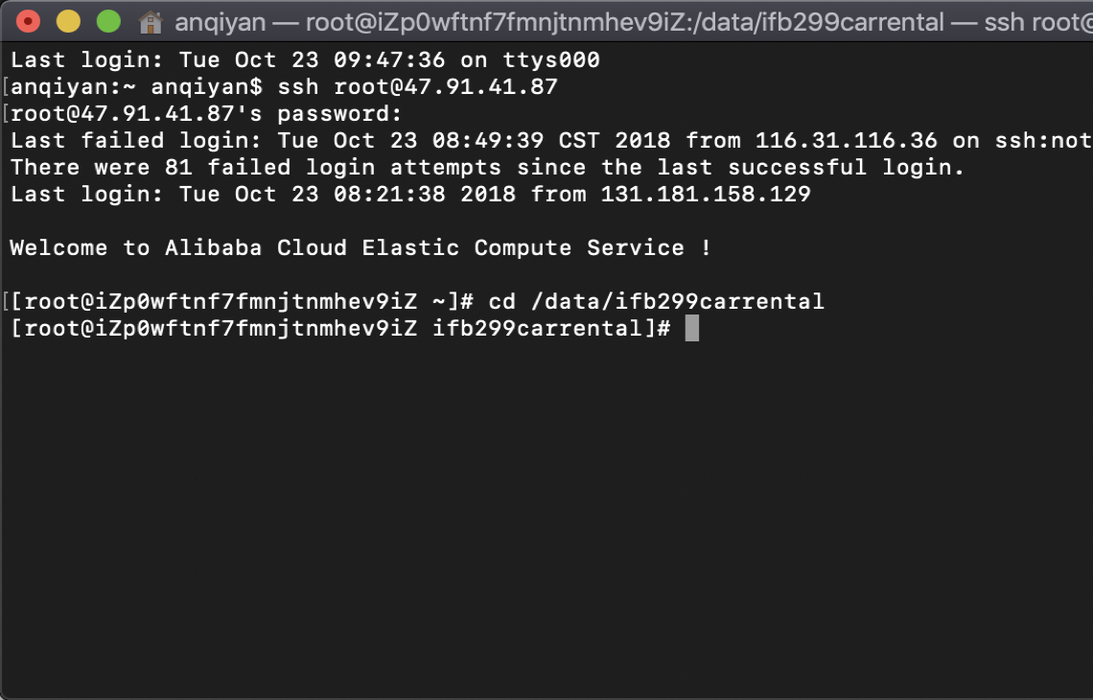

1. Copy-> python manage.py runserver 0.0.0.0:8000 -> into terminal

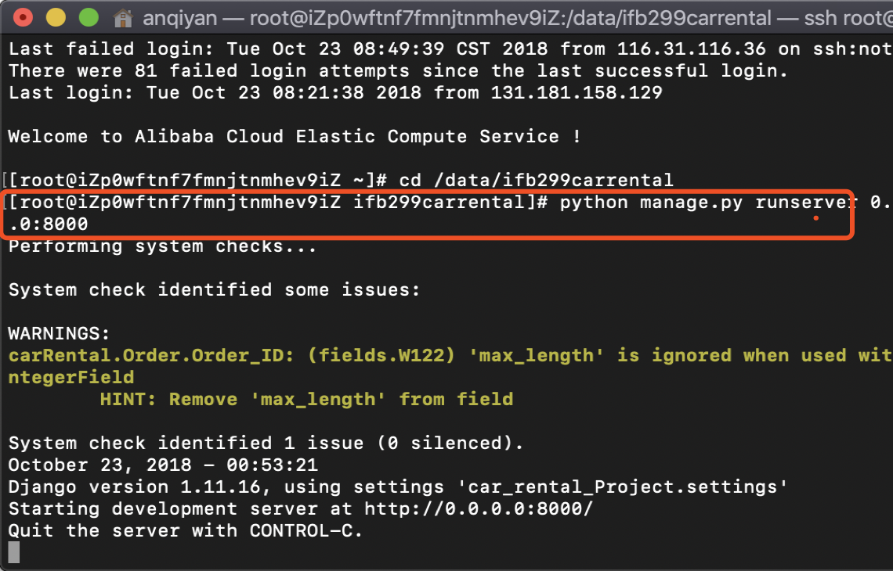

1. If below shows correctly. Congratulations! You are now able to use project on server

<http://47.91.41.87:8000/carRental/homepage>

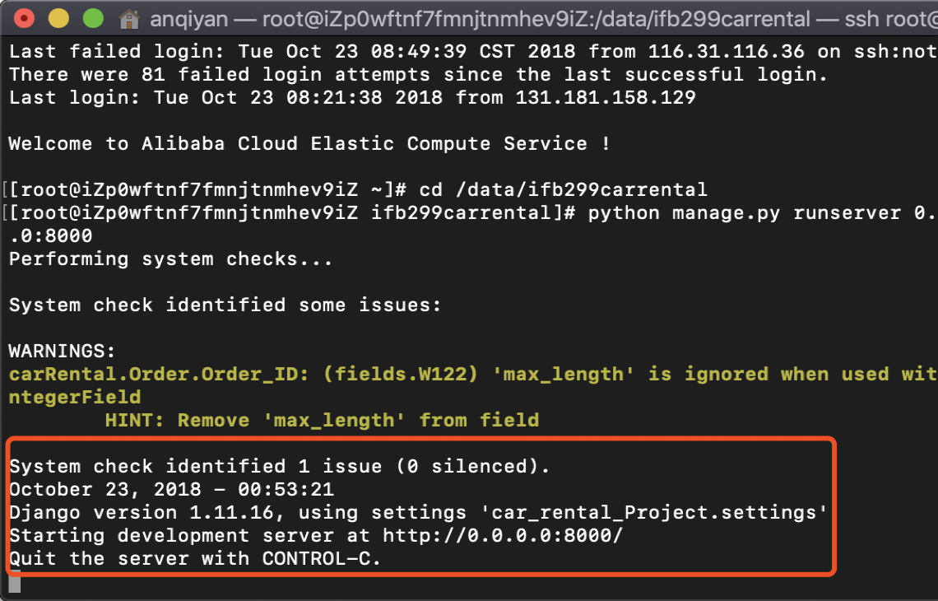

**2. What can I do if above solution doesn’t work?**

**Solution:**

Feel free to contact me: [anqi.yan@connect.qut.edu.au](mailto:anqi.yan@connect.qut.edu.au)

N9919180 Anqi Yan

Really sorry about that, we will try to run server as long as we can.