# Results

We compared the first five modes of simulation result with the theory result [1] as below:

For all TE modes, we compare the dashed line (magnetic field line) in theory with our result plot of Hz. For all TM modes, we compare the solid line (electric field line) in theory with our result plot of Ez.

Rectangular waveguide:

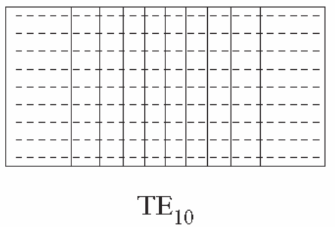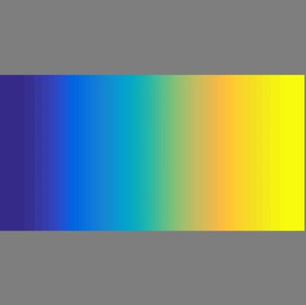

Figure 1. TE10

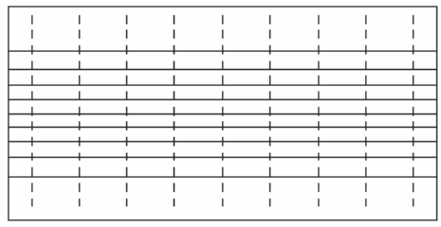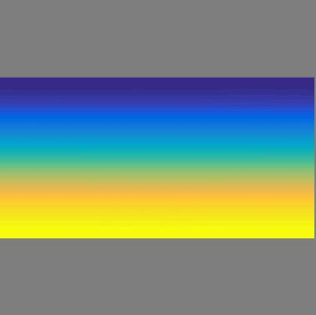

Figure 2. TE01

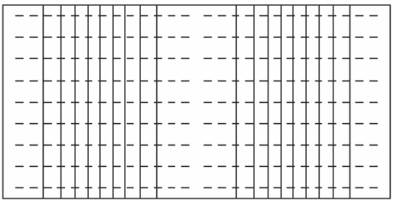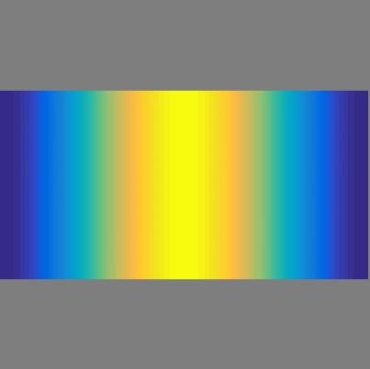

Figure 3. TE20

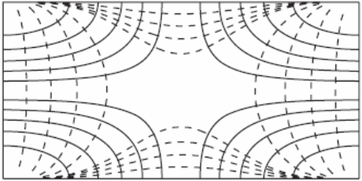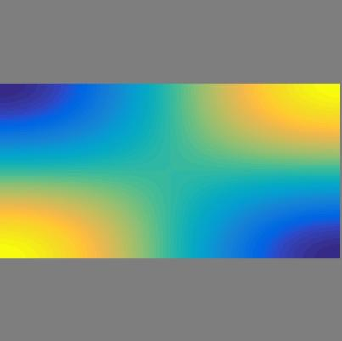

Figure 4. TE11

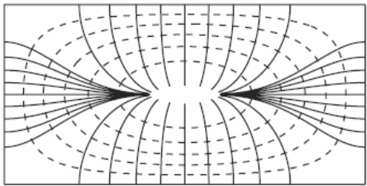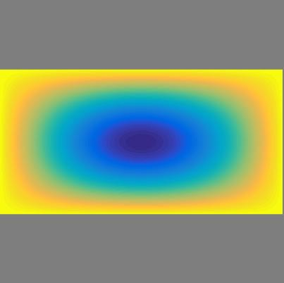

Figure 5. TM11

Circular Waveguide:

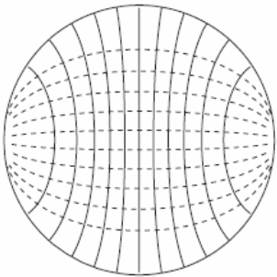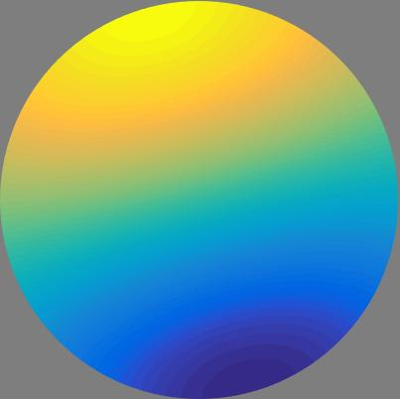

Figure 6. TE11

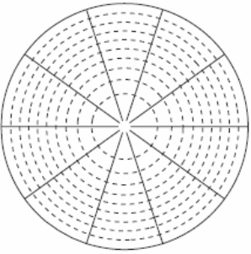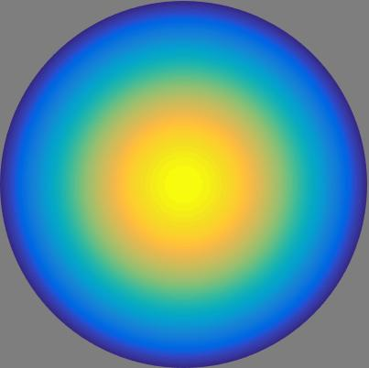

Figure 7. TM01

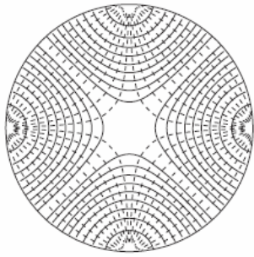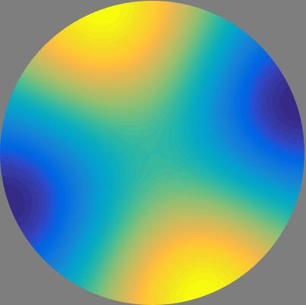

Figure 8. TE21

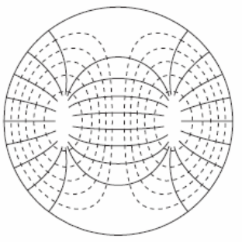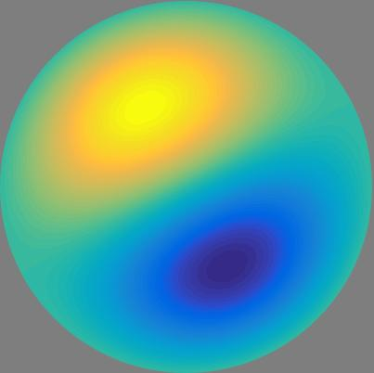

Figure 9. TM11

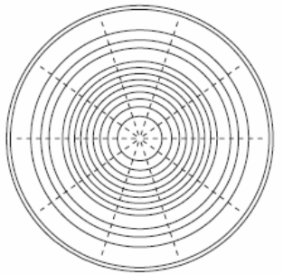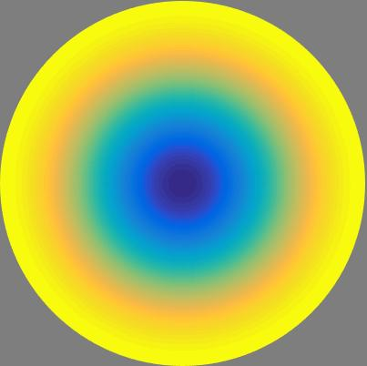

Figure 10. TE01

We also compared $k_{c}$ of the first 20 modes with theory result as below:

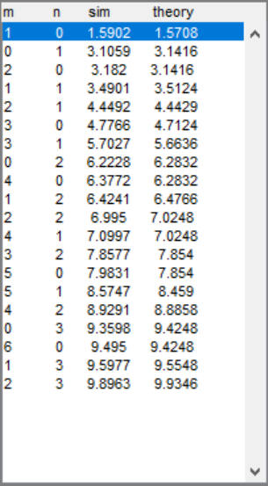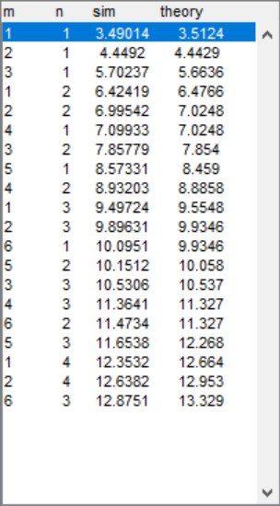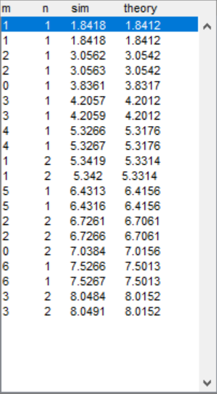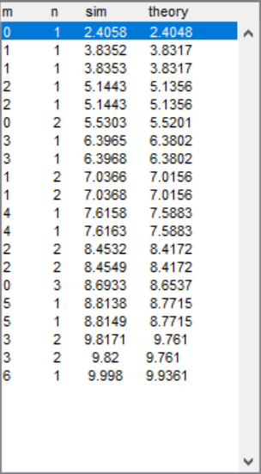

Figure 11. Rectangular TE Figure 12. Rectangular TM Figure 13. Circular TE Figure 14. Circular TM

From the result figures and $k_{c}$, the simulation matches the theory.

# References

[1] Jian-Ming Jin. *Theory and Computation of Electromagnetic Fields*. Wiley-IEEE Press, 2015