ECE 618 Project II: FEM Implementation of rectangular and circular waveguide

Bowen Wei

# Abstract

# In this project, we developed a Finite Element Method (FEM) solver to compute the TE/TM modes in a 2:1 rectangular waveguide or circular waveguide. The GUI can calculate the first 20 TE/TM modes and show the result in a list. The GUI can eventually generate a transverse field distribution of the selected mode.

# Implementation

## *Computation Domain*

The commonly used subdomains are triangular elements in two dimensions. We generate computation domain by the MATLAB built-in app ‘PDE’.

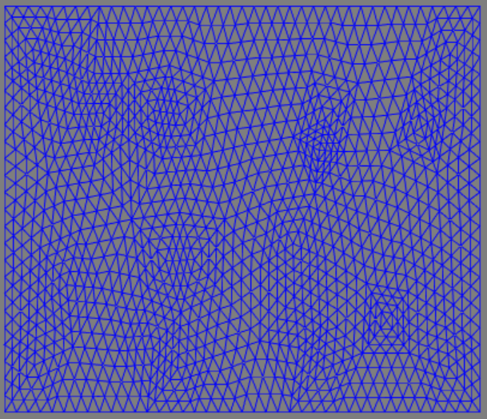 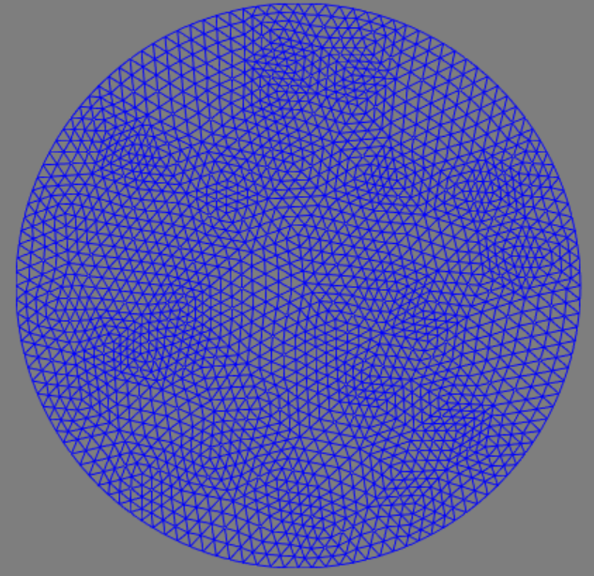

Figure . geometry of rectangular waveguide Figure . geometry of circular waveguide

The generated data is stored in mat file. Illustration of the variable can be found at <https://www.mathworks.com/help/pde/ug/mesh-data.html>

## *Algorithm*

For the TM modes, analysis can be done by considering only the z-component of the electric field, , since all other field components can be derived from .

For the TE modes, analysis can be done by considering only the z-component of the magnetic field, , since all other field components can be derived from .

Applying the finite element formulation described in the boundary-value problem [1], we obtain the matrix equation.

Where,

We define a function get_AB(p) to calculate A and B matrix, where p is the 3 nodes of a subdomain. We then solve the eigenvectors and eigenvalues using the MATLAB built-in function ‘eigs’ to get and .

The difference between TE and TM modes in this algorithm is that TE and TM have different boundary condition.

For TM,

For TE,

So we only solve the eigenvalues of the matrix of the interior subdomain for TM.

# Results

We compared the first five modes of simulation result with the theory result [1] as below:

Rectangular waveguide:

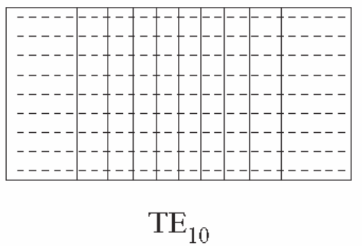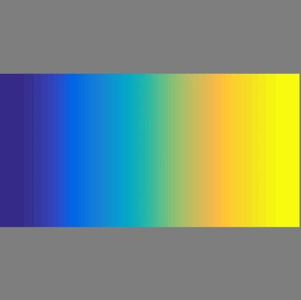

Figure 3. TE10

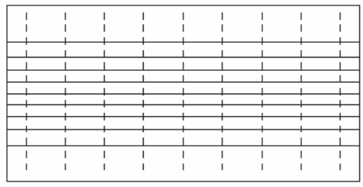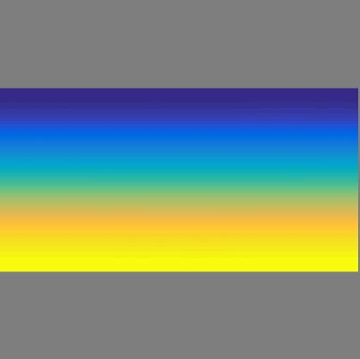

Figure 4. TE01

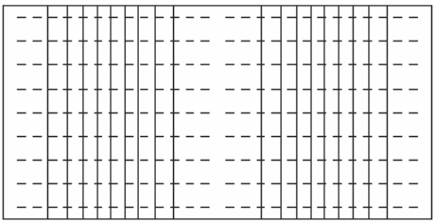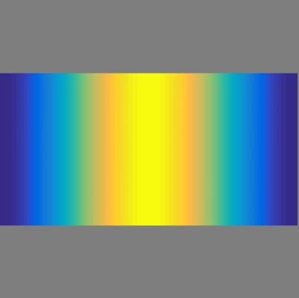

Figure 5. TE20

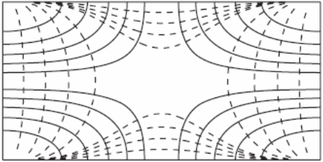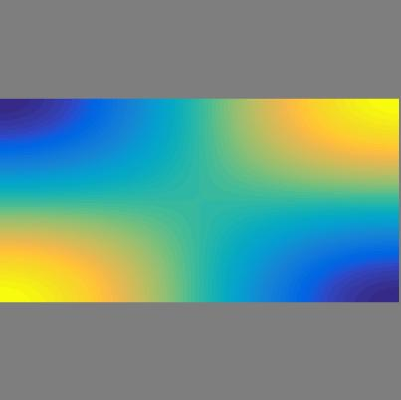

Figure 6. TE11

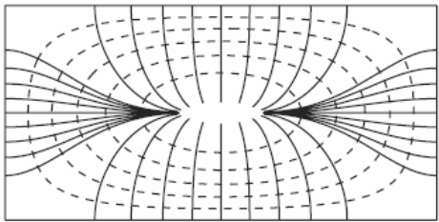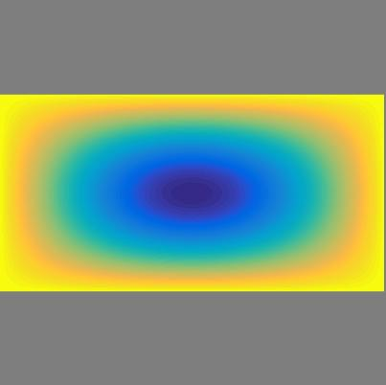

Figure 7. TM11

Circular Waveguide:

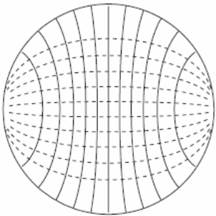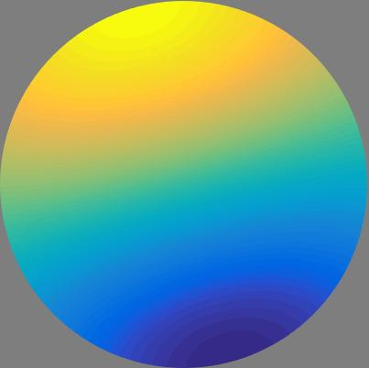

Figure 8. TE11

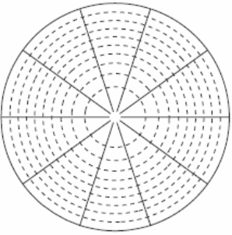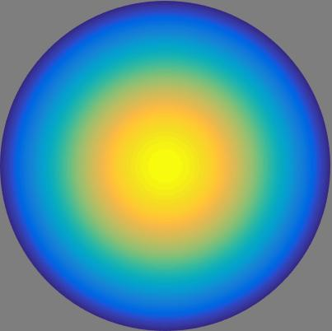

Figure 9. TM01

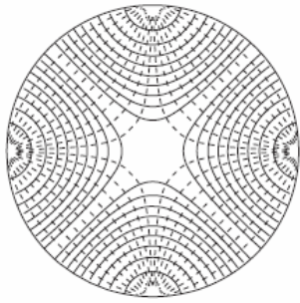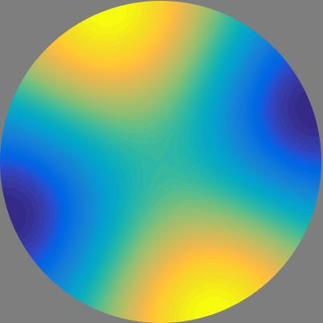

Figure 10. TE21

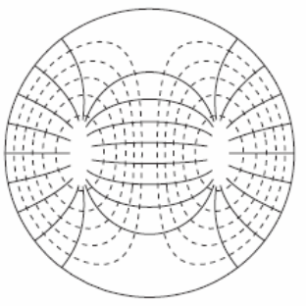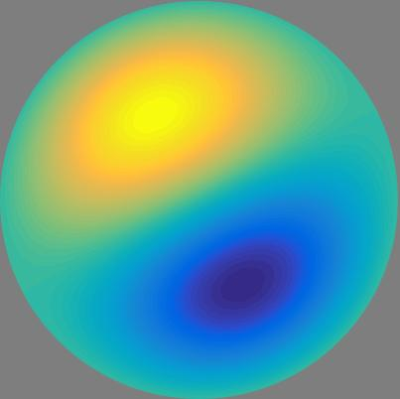

Figure 11. TM11

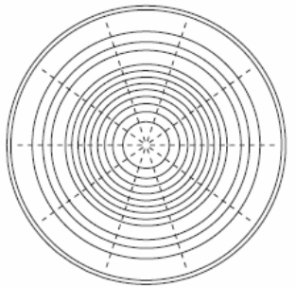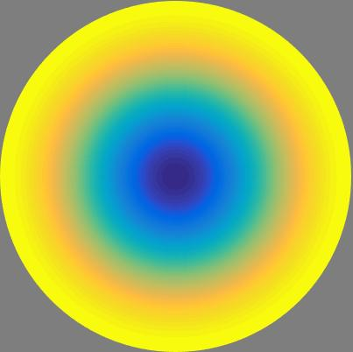

Figure 12. TE01

We also compared  of the first 20 modes with theory result [1] as below:

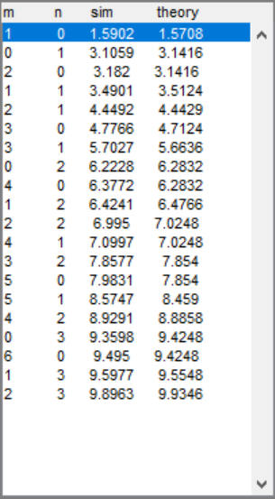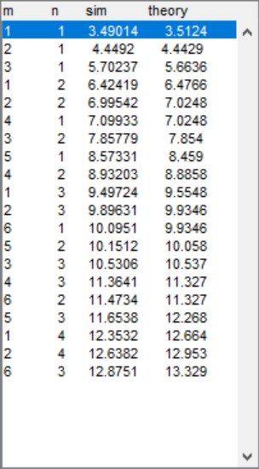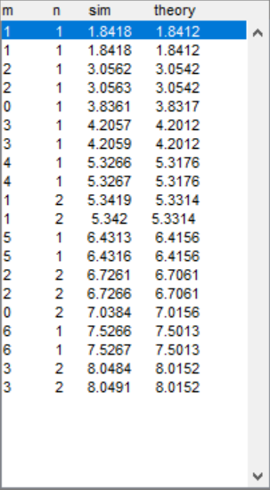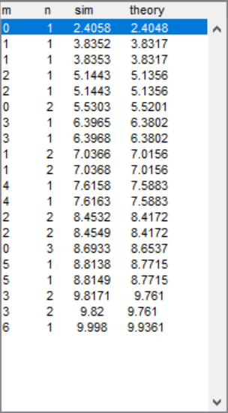

Figure . Rectangular TE Figure . Rectangular TM Figure . Circular TE Figure . Circular TM

From the result figures and , the simulation matches the theory.

# References

[1] Jin, Jian-Ming. Theory and computation of electromagnetic fields. John Wiley & Sons, 2011.