Pie chart code:

Mean and medium value code:

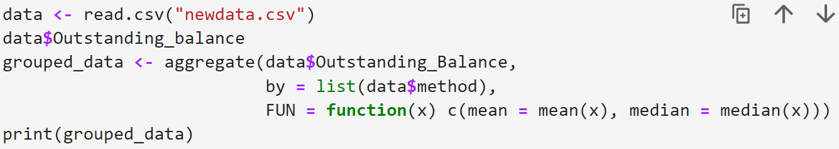

calculate correlation coefficients and regression coefficients code:

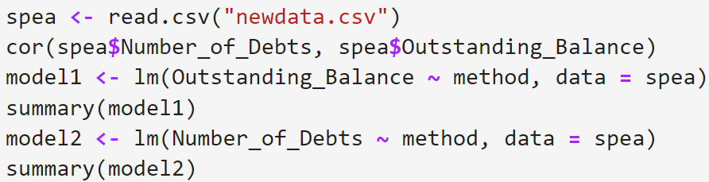

visualize changes in the number of offenses and debts over time code:

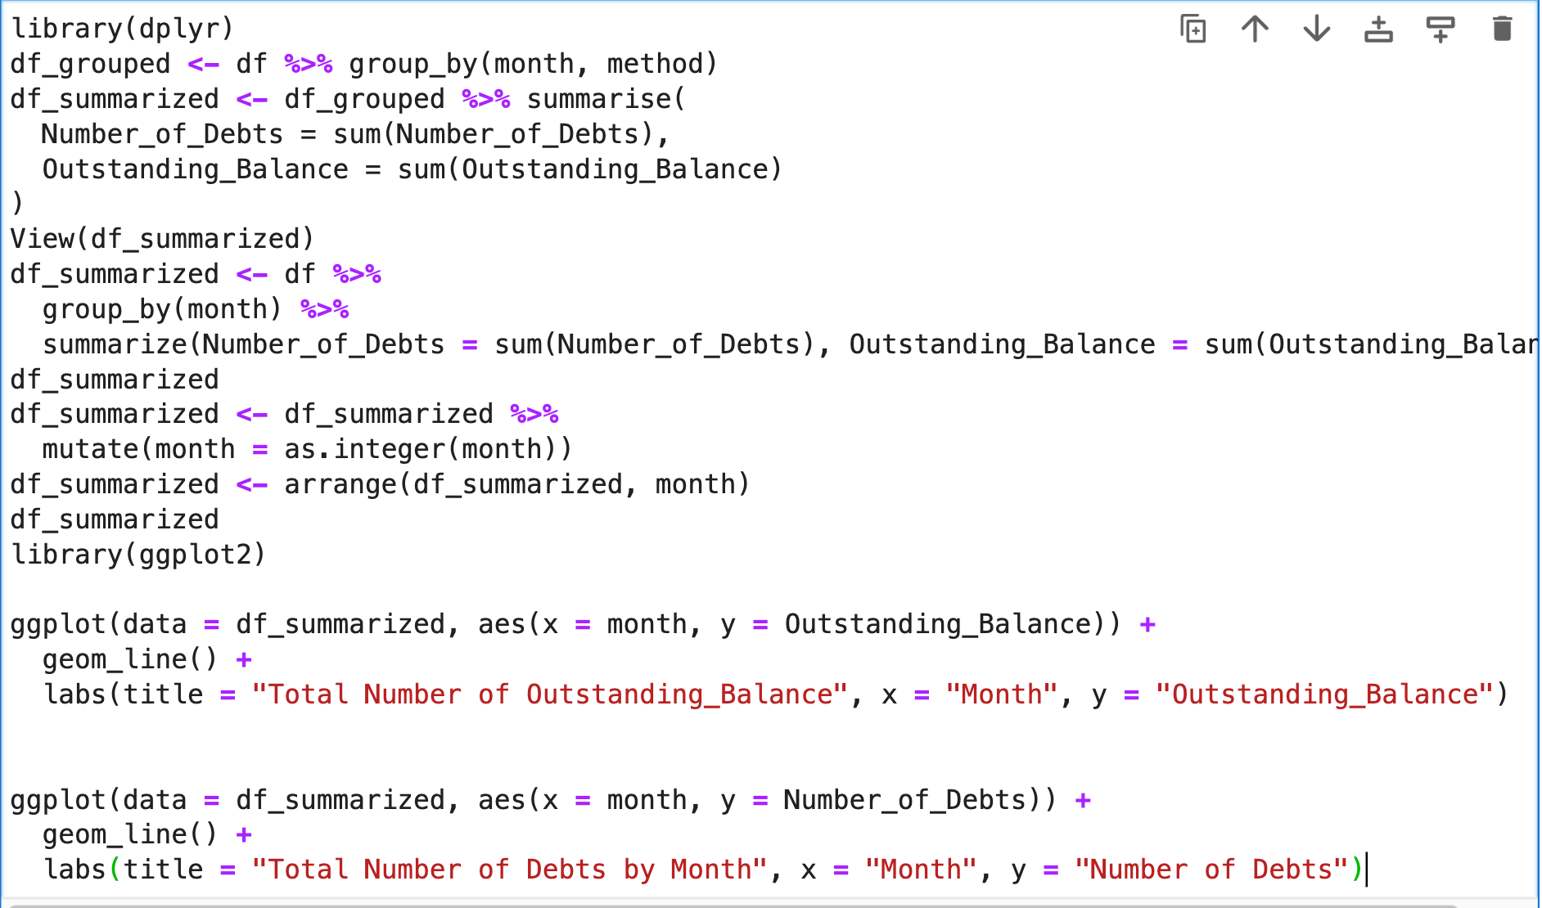

forecasting models code:

