**1.examine the number of debts and outstanding balance for each offense category in each local area.**

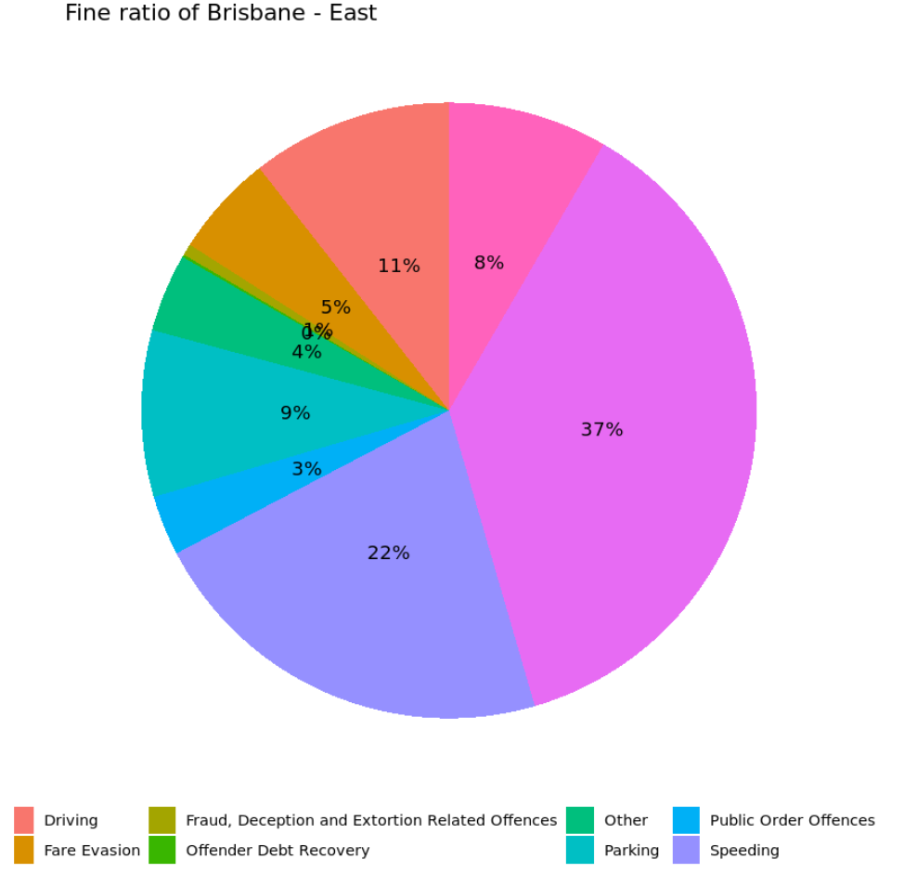

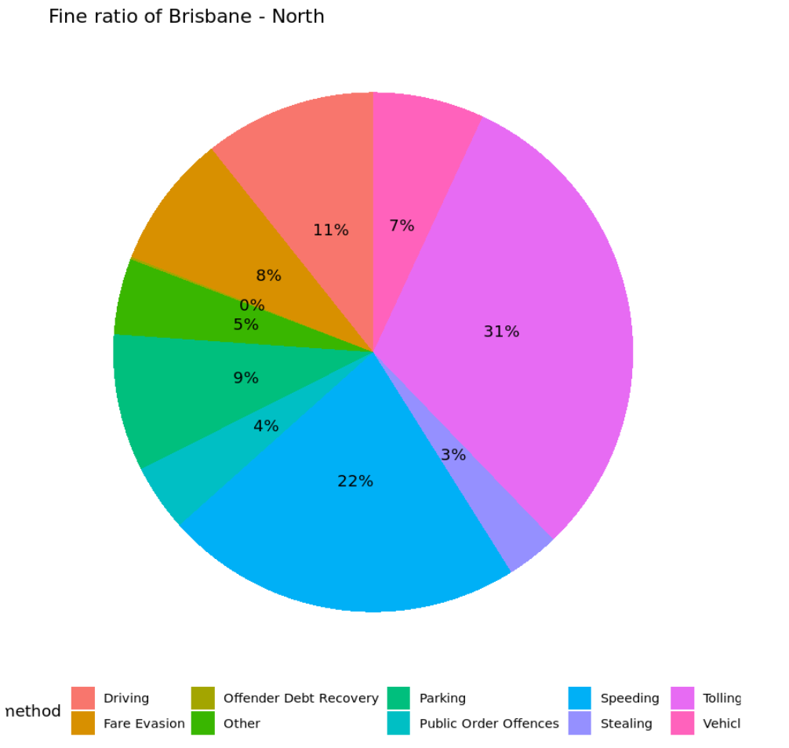

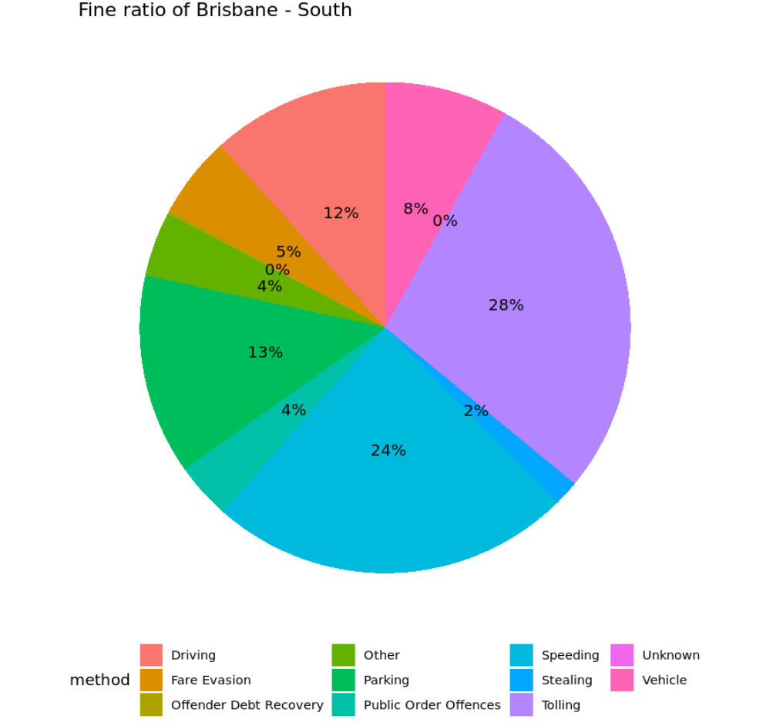

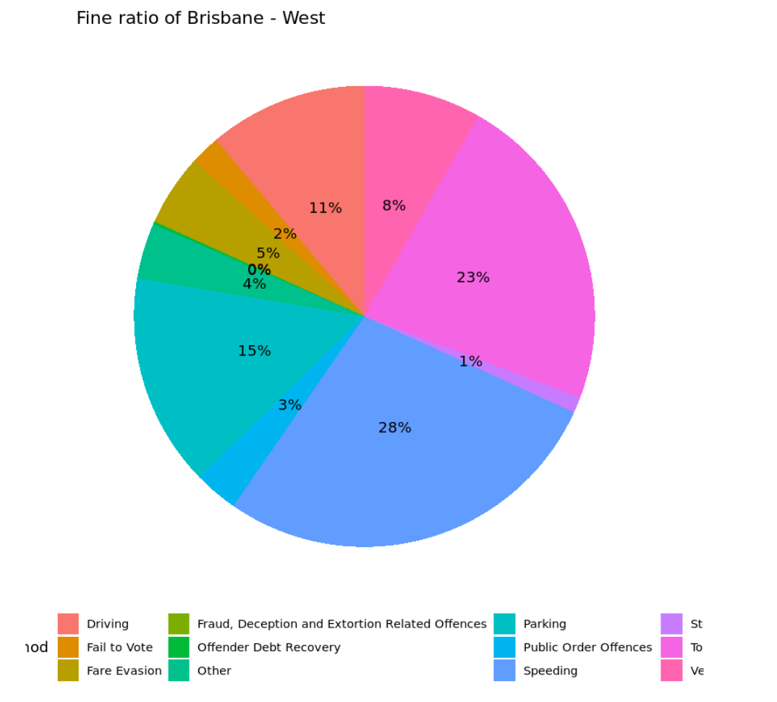

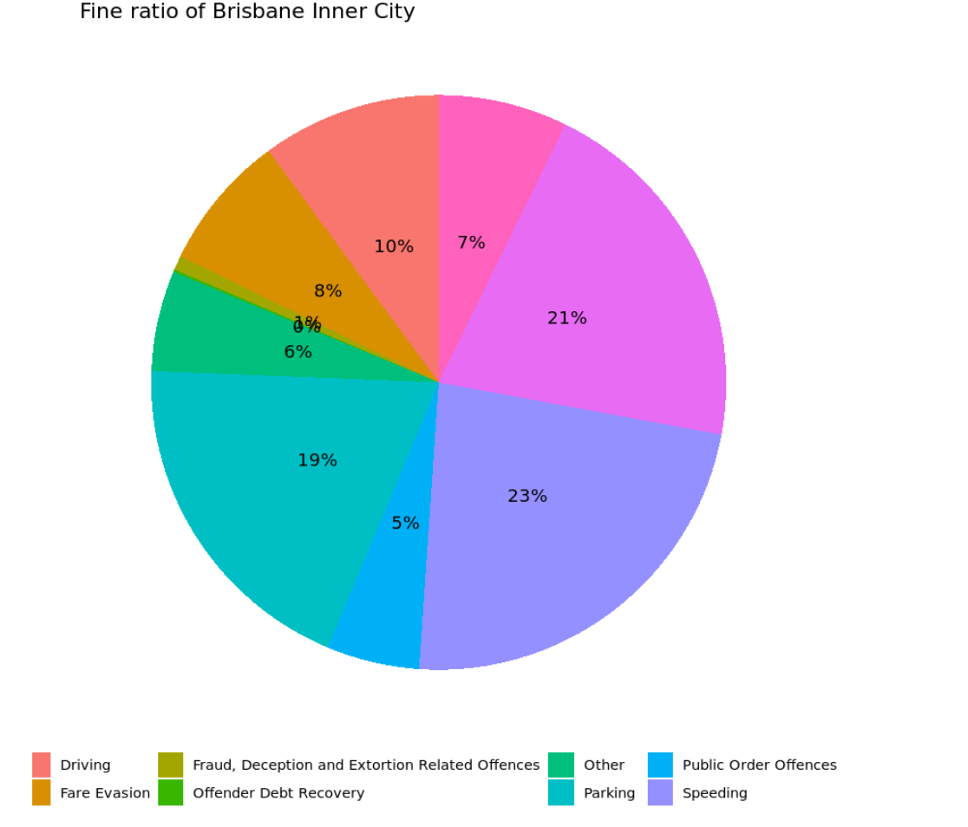

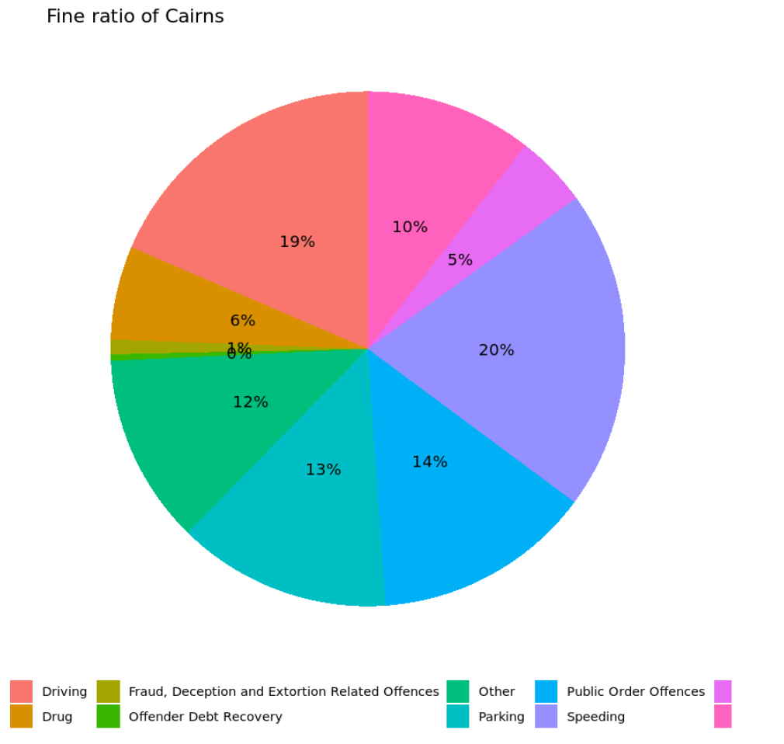

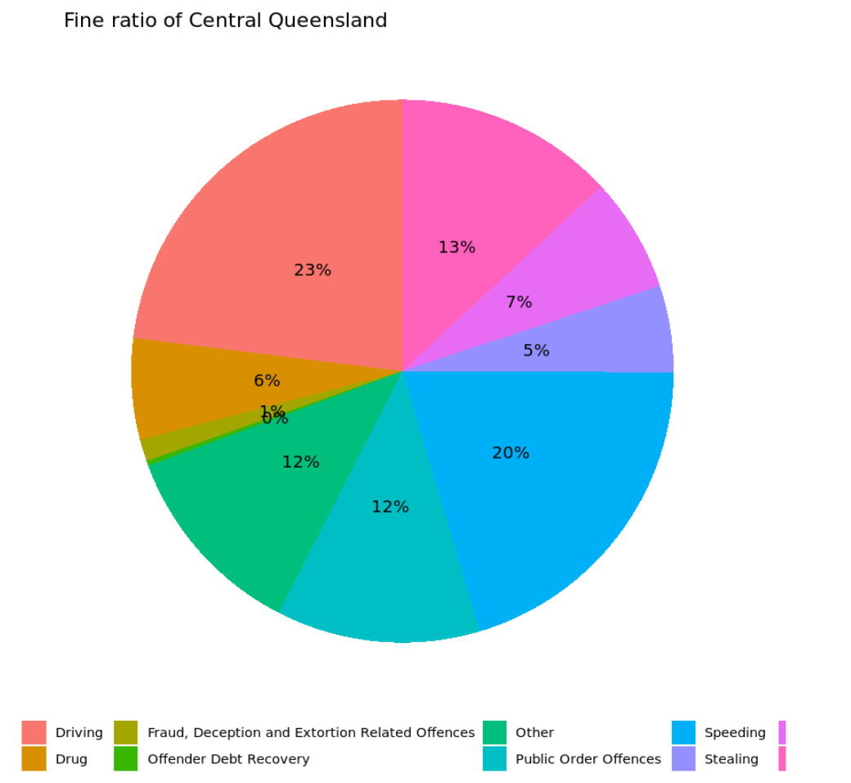

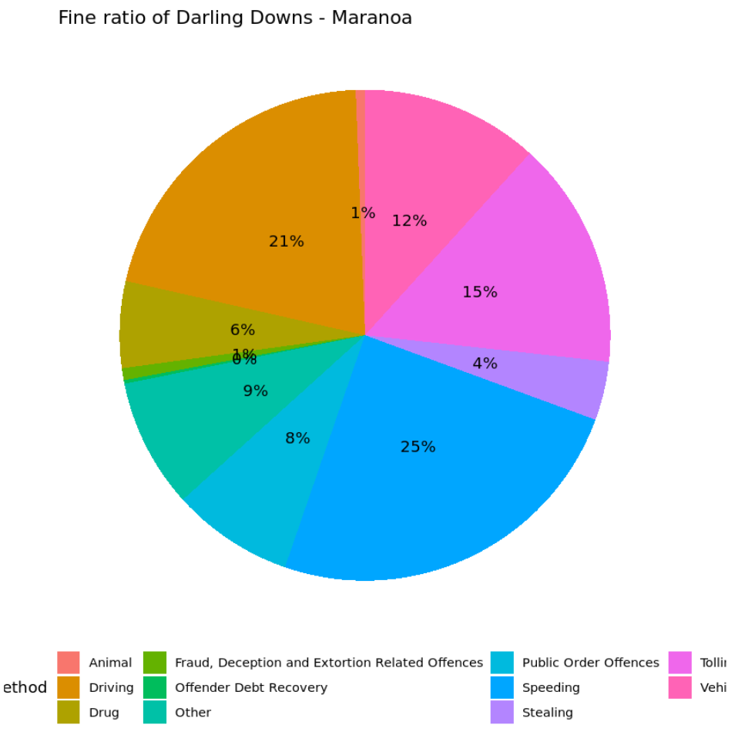

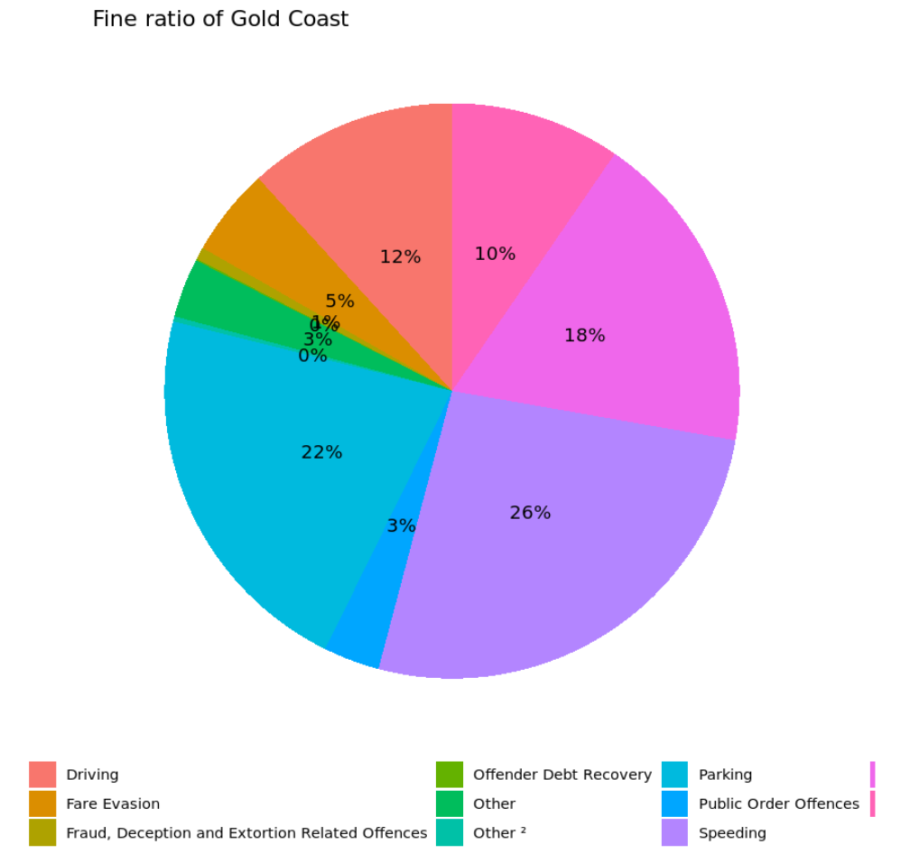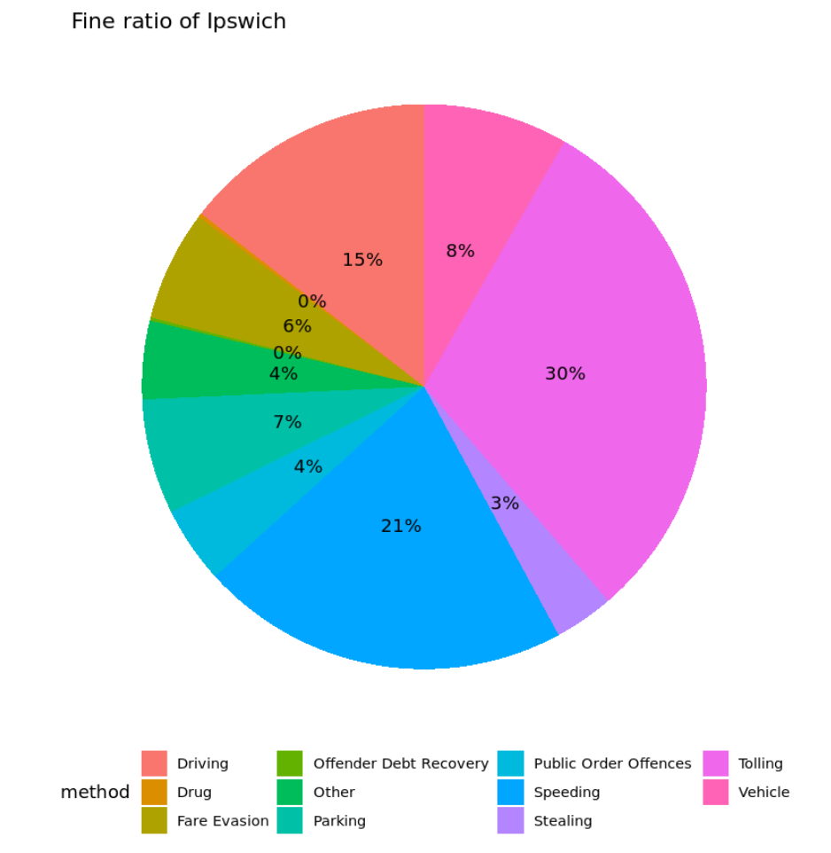

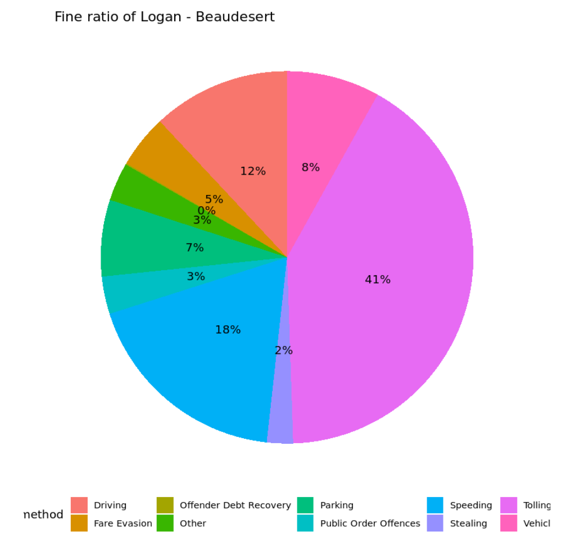

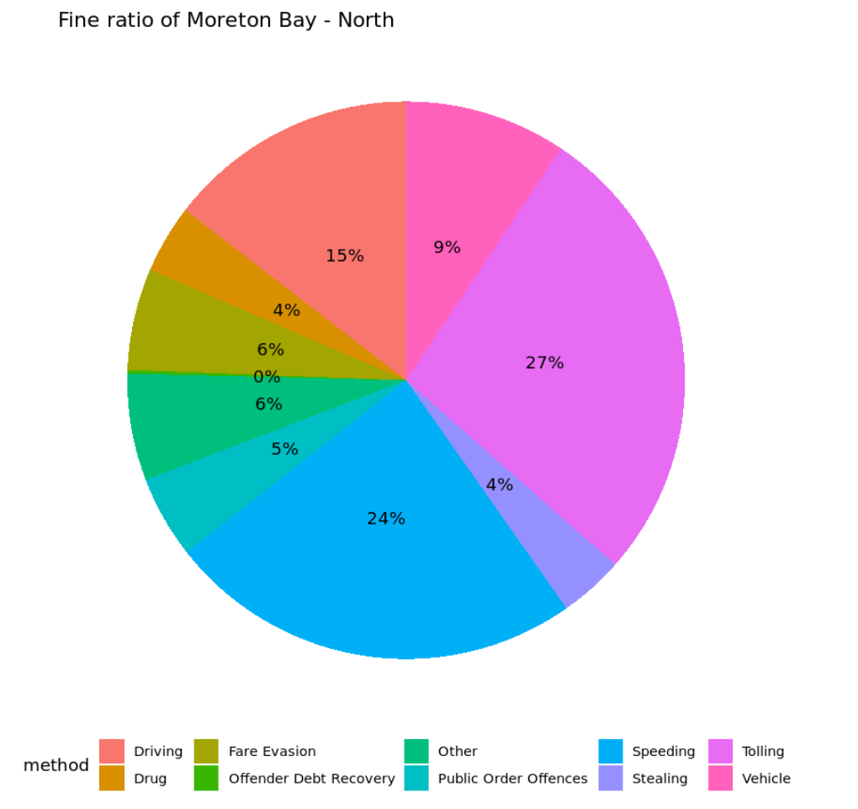

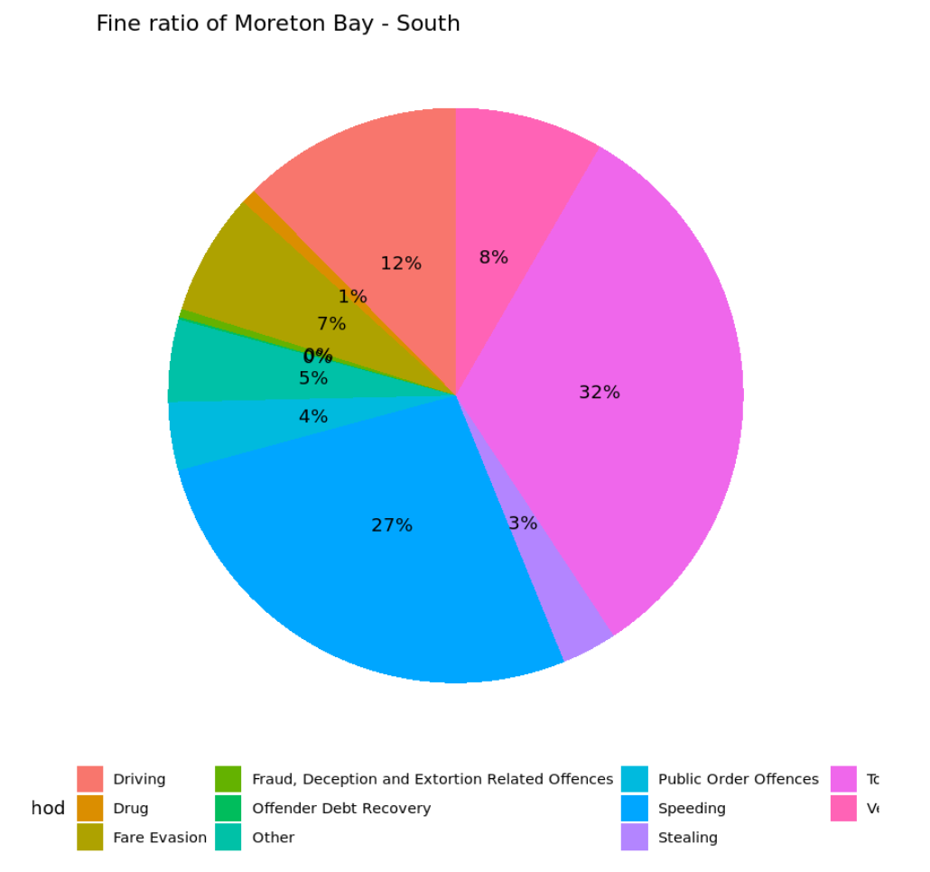

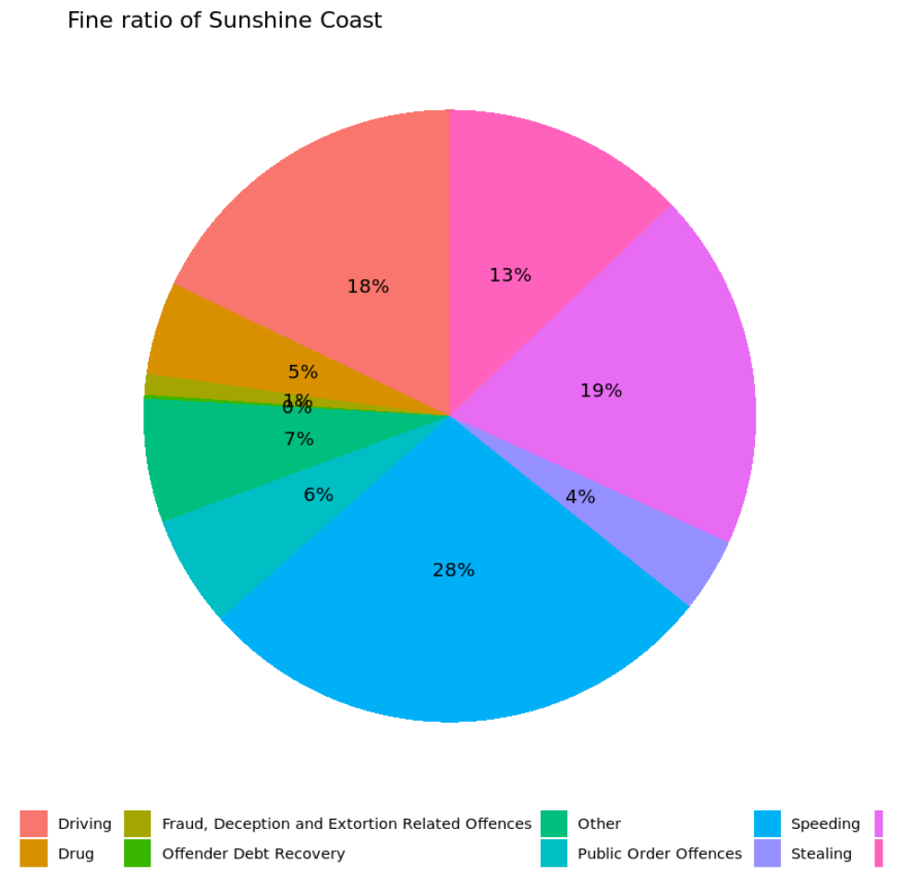

**2.calculate summary statistics such as mean and median outstanding balance for each offense category**

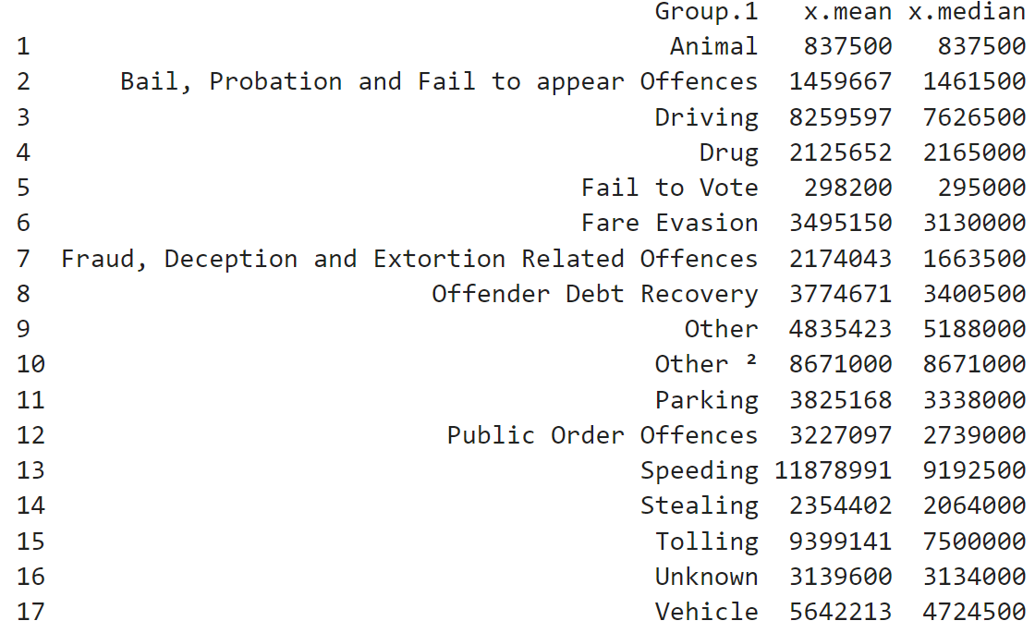

**3. calculate correlation coefficients or regression coefficients to identify which offense categories have the strongest relationship with debt accumulation and outstanding balance.**

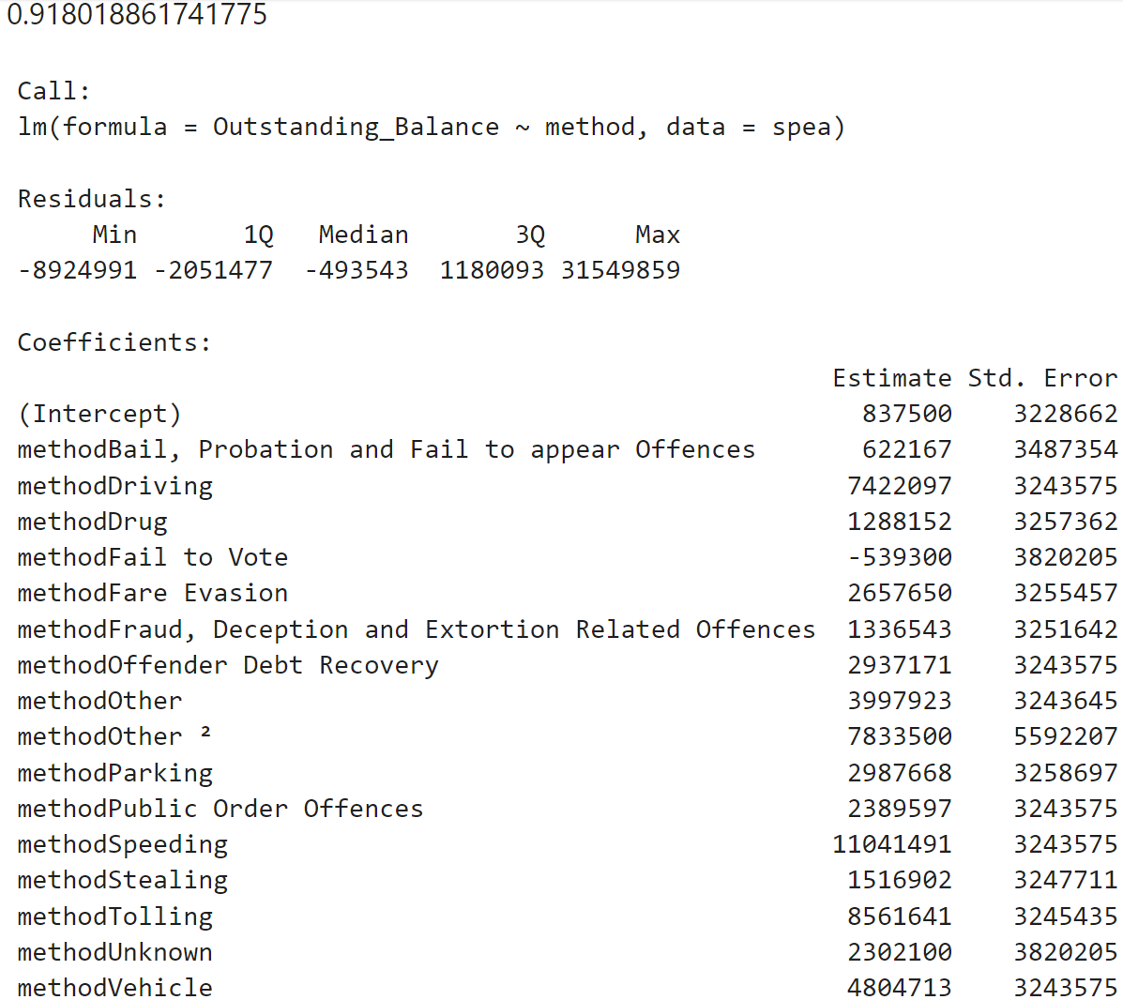

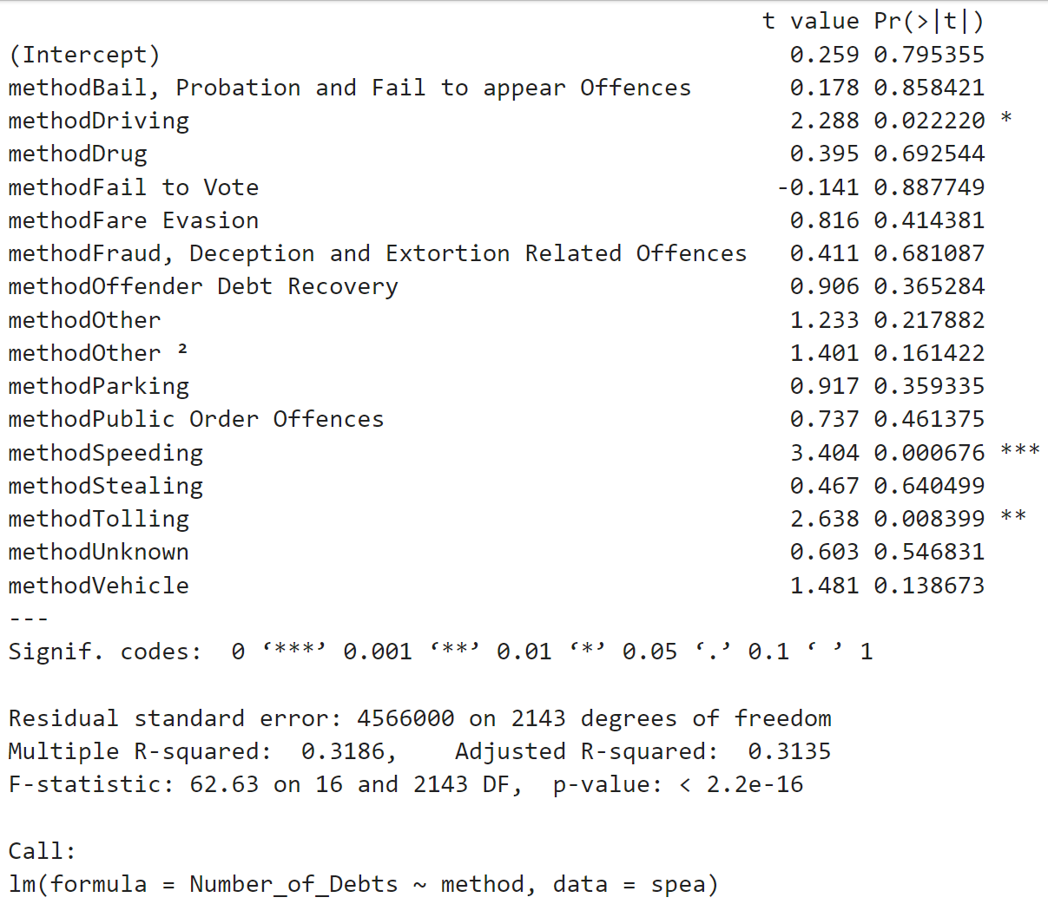

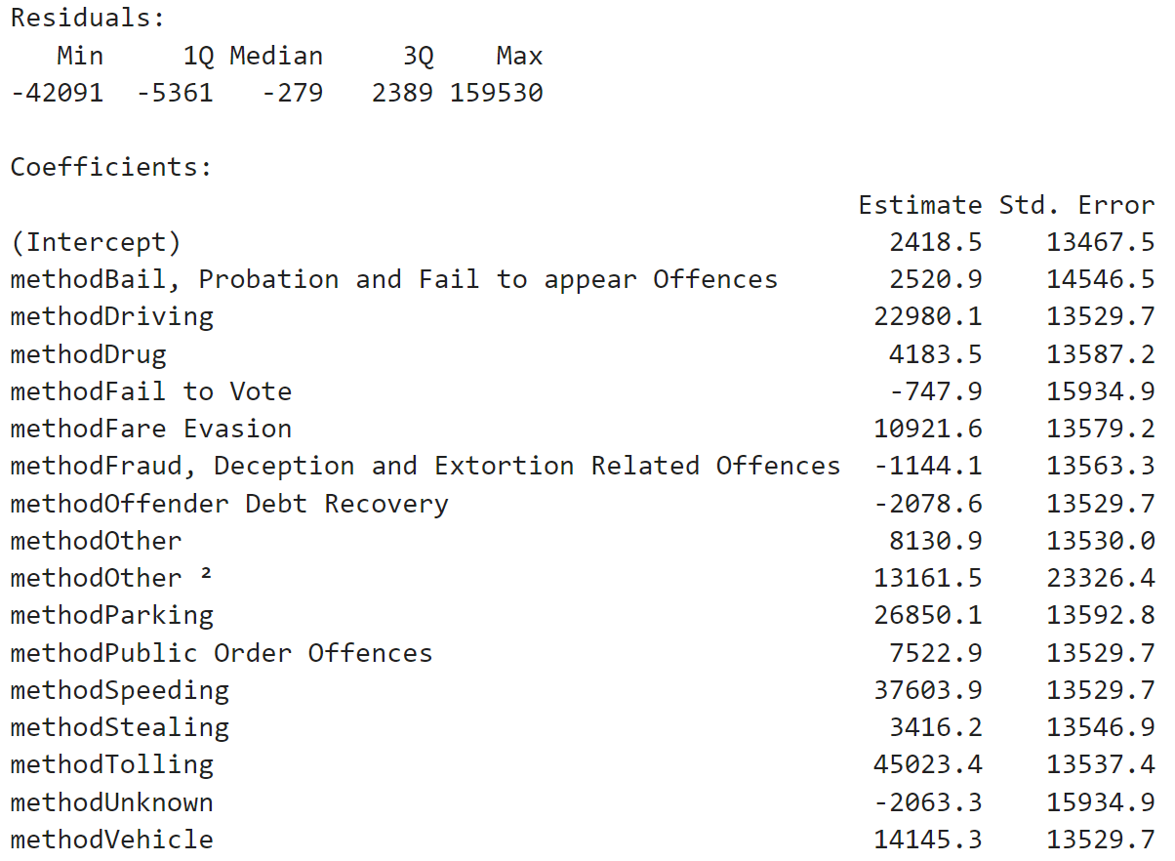

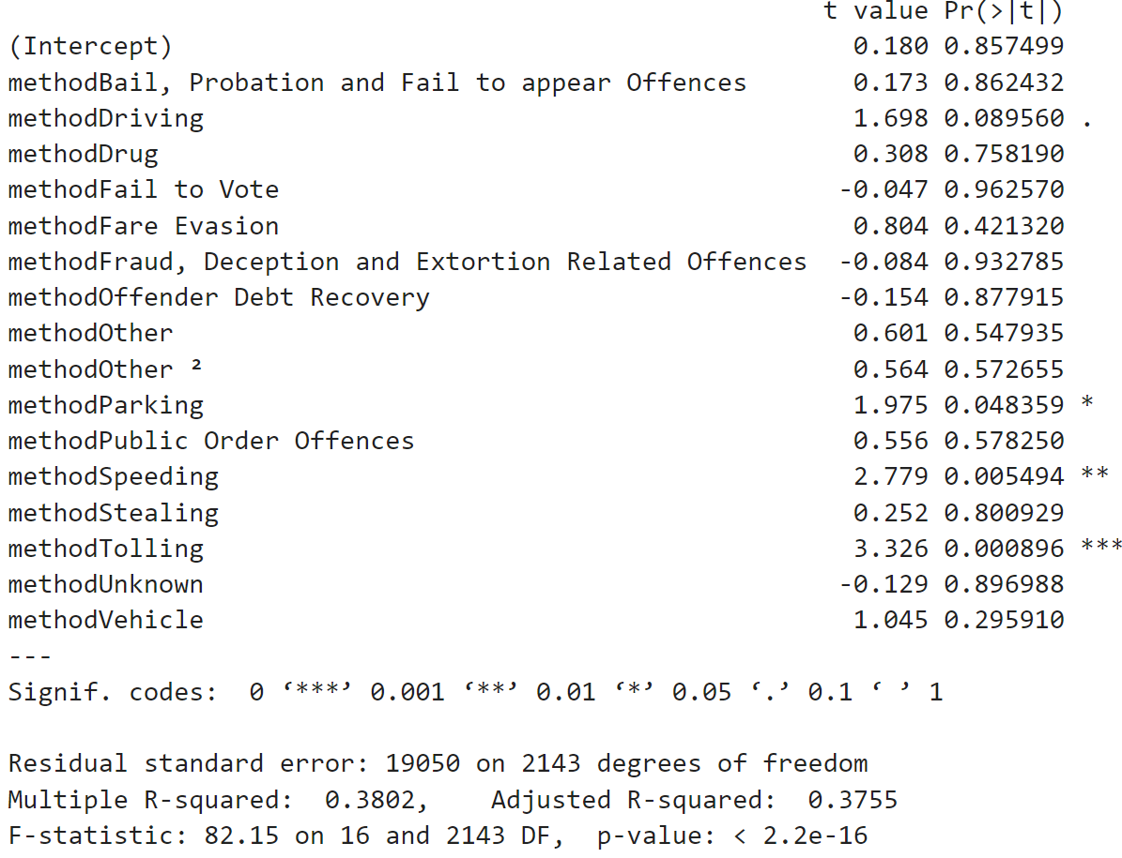

**Based on the output, we can see that the regression model has a multiple R-squared of 0.3186, indicating that the model explains approximately 31.86% of the variance in the outstanding balance variable. The adjusted R-squared of 0.3135 is slightly lower than the multiple R-squared, indicating that adding more predictors did not increase the explanatory power of the model. The F-statistic has a value of 62.63 and a p-value of less than 2.2e-16, indicating that at least one of the predictors is significantly related to the outcome.**

**Looking at the coefficients, we can see that the method "Speeding" has a significantly positive relationship with the outstanding balance, as it has the highest coefficient value and a low p-value (0.000676). This suggests that individuals with outstanding balances resulting from speeding offenses tend to have higher outstanding balances than those with other offenses.**

**Regarding the number of debts, the model has a multiple R-squared of 0.2336, indicating that the model explains approximately 23.36% of the variance in the number of debts variable. The adjusted R-squared of 0.2279 is slightly lower than the multiple R-squared, indicating that adding more predictors did not increase the explanatory power of the model. The F-statistic has a value of 40.09 and a p-value of less than 2.2e-16, indicating that at least one of the predictors is significantly related to the outcome.**

**Looking at the coefficients, we can see that the method "Tolling" has a significantly positive relationship with the number of debts, as it has the highest coefficient value and a low p-value (0.0000000001642). This suggests that individuals with outstanding balances resulting from tolling offenses tend to have more debts than those with other offenses.**

**4. use line charts or bar charts to visualize changes in the number of offenses and debts over time**

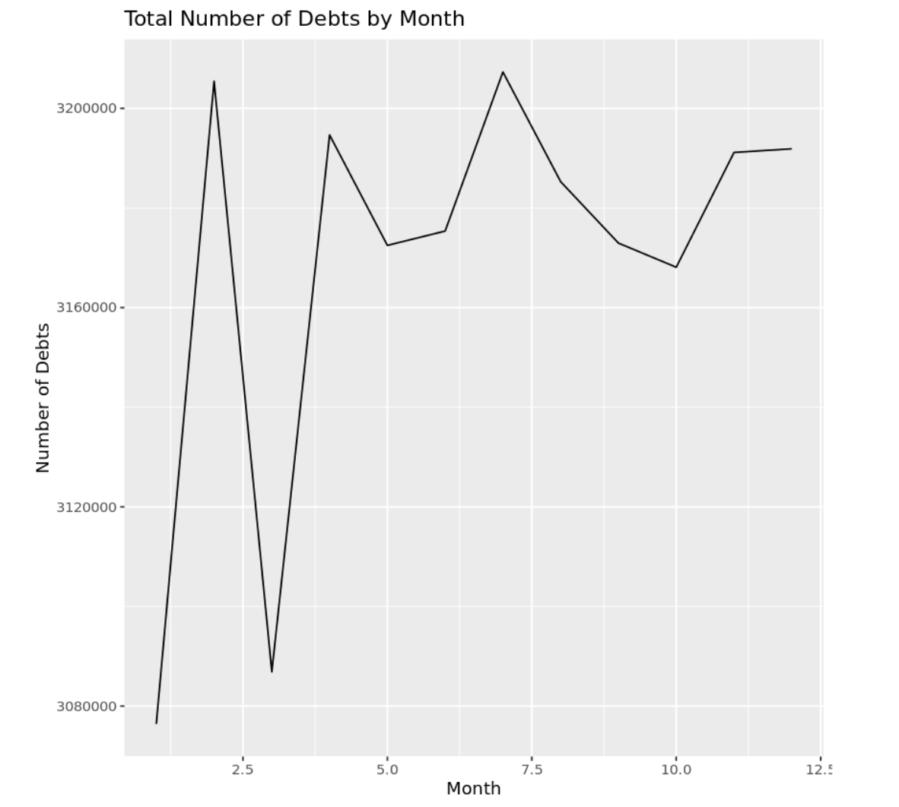

**5. use time series forecasting models to make predictions about future trends(this part is not very clear)**

