Development of a novel T2* mapping model for N-periodic ka-SPGR sequence for Parkinson’s Disease biomarker recognition.

Development of MRI T2* Mapping Model for N-Periodic ka-SPGR Sequence: A Promising Technique for Parkinson’s Disease Biomarker Recognition.

**METHOD**

1. Theory

In MRI, a train of radiofrequency (RF) pulse sequences excite the magnetised spins to generate the MRI signal. By excitation, the magnetisation initially aligned with the main magnetic field in the longitudinal direction is tipped towards the transverse plane with a longitudinal flip of α° and a transverse phase shift φ. After the excitation, the magnetisation relaxes with a longitudinal regrow with the time constant T1 and a transverse decay. The transverse component of magnetisation is measured to form an MR image and the signal will decay with a time constant T2 or T2* depending on the MRI pulse sequence used. The time between excitation and acquisition of the signal is known as echo time (TE), and the time between adjacent excitations is repetition time (TR). The MRI signal is acquired in Fourier space, known as k-space, and the resulting image is reconstructed by performing the inverse Fourier transform of the acquired k-space. [Method2]

* Multi-echo GRE

Using a gradient echo (GRE) based pulse sequence, the acquired MR signal decay with the time constant T2* [Method1]. The gold-standard T2* measuring method – multi-echo GRE is performed by measuring the MR signal at multiple TEs in one TR with GRE sequence and fitting monoexponential decay to get the time constant T2* voxel by voxel as shown in Figure X.

* N-periodic ka-SPGR

The N-periodic ka-SPGR sequence is based on short TR fast GRE [Method4] with TE = TR/2, which yields a steady-state behaviour of the signal. Additionally, quadratic radiofrequency-spoiling (RF-spoiling) and gradient-spoiling are required for the N-periodic ka-SPGR sequence. RF-spoiling is applied by constantly exciting the spins with a quadratic phase cycling given by the function [Method4] [Intro10],

  (for n = 0,1,2….) (1)

By adding RF-spoiling, N different and periodically repeating steady-state signals S(n) are yielded, each signal is the summation of the T2* related decay signals at certain times weighted by corresponding phase modulation, which is shown by the analytical solution below [Intro10],

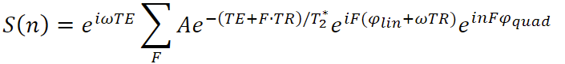 (2)

The T2* related component in the equation, , is known as the configuration state or F-state signal and is denoted as F0 if F in the equation equals 0. Furthermore, gradient spoiling is added to shift and split the F-states away from the centre of the k-space by different amounts, as shown in Figure X.

The k-space of each F-state can be reconstructed by summing up N-acquired signals with corresponding phase modulation followed by shifting the k-space back to the centre. An inverse Fourier transform is then performed to generate the F-states images, which is used to fit T2*. An illustration of the procedure is shown in Figure X.

1. Model Simulation and analysis

Based on the understanding of the N-periodic ka-SPGR sequence, a Python-based simulation is built to analyse its T2* mapping performance when different TR and periods are used.

* 1. Simulation setup

As shown in Figure X, the computer simulation can be described in 2 sections - signal formation modelling, where the ideal Bloch simulation is first performed followed by adding the magnetic field inhomogeneous effects; and acquisition modelling, where the noise is considered and T2* fitting is performed.

* + 1. Bloch simulation

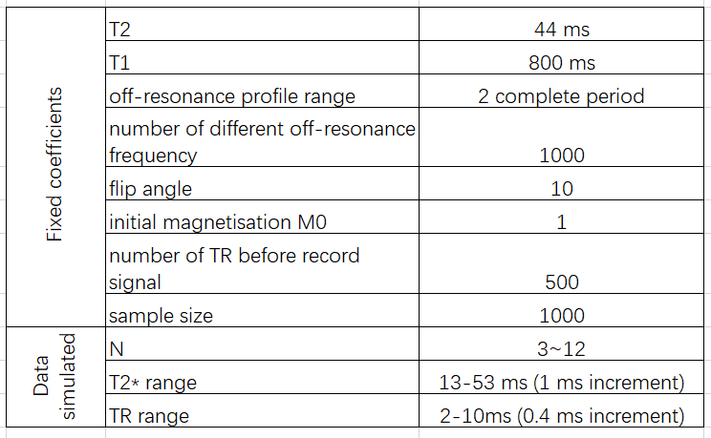

Using the well know Bloch equation [Method2], the performance of the spin with certain tissue properties (T1, T2) under different applied pulse sequences can be modelled by applying different α, φ, TR and TE. As the project focused on SN region T2* mapping, SN’s T1 (800ms) and T2 (44ms) are used in the computer simulation model, suggested by previous research on SN [Method7] [Intro5]. A 10°optimal flip angle calculated from the Ernst equation is used [Method3], and RF-spoiling is applied by implementing phase shiftφ based on equation (1). Additionally, to ensure the steady state is fully reached, the spin is repeatedly excited 500 times before the acquisition of the signal. The pulse sequence structure is shown in the left first figure in Figure X, and the parameters used are listed in Table X. An off-resonance profile is then generated, which models the performance of spins under external disturbances by simulating spins with different extra phase shifts, and the Fourier transform of the off-resonance profile is equal to the configuration F-states [Method8].

* + 1. Magnetic field inhomogeneity modelling

The field inhomogeneous effect caused by iron overload in the tissue can be modelled by convolving the Lorentzian distributed field inhomogeneous with the off-resonance profile [Method10]. With a selected ground truth T2* and the known SN T2, the inhomogeneous effect related to the ground truth T2* can be calculated using the relationship [Method1],

 (3)

and applied to the Bloch simulation model. However, as shown in Figure X, in this computer simulation, multiplying the F-states signal with the Fourier transform of Lorentzian - an exponential curve with the time constant 1/T2’ = 1/γΔBinhomo is performed instead of the complicated convolution, as it is an equivalent operation supported by the property of Fourier transforms.

* + 1. Noise Modelling

In reality, an MRI scanner introduces noise while acquiring the signal [Method9]. For ka-SPGR with different periods and TR, the acquisition noise is modelled using zero-mean Gaussian with standard deviation equals F0/sqr(N)*5%. The F0 is the F-state magnitude simulated when T2* = 33ms, the PD and healthy SN T2*mean. Then the generated Gaussian noises are added to the imaginary and real parts of the simulated F-states signal. Figure X shows 3 times of F-state acquisition modelling, each different colour indicates one sample acquisition. While in the data simulation, 1000 acquisitions are made to perform the Monte Carlo experiment and analyse the performance.

* + 1. T2* measurement modelling

To model the T2* calculation of N-periodic ka-SPGR, the exponential fit should only use the first N F-state magnitude F_0…F_N-1, because only these F-states can be reconstructed from the acquired signal using N-periodic ka-SPGR. For example, in Figure 3, only the first 5 F-states are used to fit the exponential for 5-periodic ka-SPGR.

* 1. Data Simulation

The data is simulated for spins with ground truth T2* of 13-53ms when applying 3 ~ 12 periodic ka-SPGR sequences with different TRs from 2ms to 10ms. Table X summarised the conditions covered by the data simulation. On top of the selected range, Monte Carlo experiments are performed and by fitting each group of acquired F-states, 1000 measured T2* can be obtained for each ground truth T2* value for different periodic ka-SPGR with different TR.

The range of ground truth T2* is selected specifically for analysing PD biomarker detection accuracy, which is between the PD patients’ (13ms) and healthy SN T2* (53ms) [Intro5]. The above periodicity and TR ranges are selected for the simulation because a periodicity less than 3 is not able to provide enough data points for fitting the exponential curve, and a TR smaller than 2ms can’t be achieved by a scanner, also, periodicity greater than 12 or TR greater than 10ms both resulting in an unacceptable long acquisition time.



* 1. Simulation result analysis

The simulated data are then used to compute bias and variation of the T2* measurement when different scan parameters are used. Percentage bias, mean and standard deviation are calculated for the measured T2* and used to analyse the performance.

* + 1. Average percentage bias

As shown in Figure X, the x-coordinate of points used for exponential fit is TE+F*TR, F = 0…(N-1), by using different periods and TRs, a different part and range of the exponential curve is sampled, which will affect the efficiency and accuracy of the exponential fit. So, the aim of the average percentage bias analysis is to find the period and TR combination for ka-SPGR to maximise T2* measurement accuracy.

The percentage bias is calculated using the equation Mean (T2* measured)-T2* GT/T2* GT *100%. The average T2* percentage error in the PD biomarker range will then be calculated for each periodic ka-SPGR pulse sequence for different TR. By plotting the average percentage error against TR for each periodic ka-SPGR, the optimal TR and Period can be found and will be used in the MRI phantom scan experiment.

* + 1. Standard deviation

The standard deviation of the measured T2* is used to visualise the variation of the measurement, and to specifically verify the reliability of the method when using the optimised parameters. Therefore, the mean of measured T2* is plotted against T2* ground truth with the error bar for the data simulated using optimised parameters.

1. MRI data acquisition and analysis

MRI scan using ka-SPGR sequence with optimised scan parameter is performed on a phantom. The T2* values are calculated and compared with the ground truth T2* value obtained using the gold-standard Multi-echo GRE method. Followed by a comparison between the ka-SPGR and the Multi-echo GRE with controlled variables.

* 1. MRI scan setup
     1. Phantom

(LHS: picture of NIST/ISMRM Premium System Phantom Model (SN:130-102), RHS: MnCl2-containing fiducial spheres layer being scanned)

NIST/ISMRM Premium System Phantom Model (SN:130-102) is used as the scanning object, and a slice acquisition is performed at the MnCl2-containing fiducial spheres layer (Figure X), where fiducial spheres have different T2* values. Multi-echo FLASH (Siemens, 3T), one commonly used multi-echo GRE sequence, is used as the gold standard T2* measuring method to obtain the ground truth T2* value for each voxel inside the fiducial sphere. Each fiducial sphere can be visualised as groups of voxels with approximately the same ground truth T2* value, and the voxels inside the same sphere can be treated as test samples for the T2* measurement of known ground truth T2*.

* + 1. Scan parameters

MRI signals are acquired from a phantom using 7 and 12-periodic ka-SPGR sequences with TR = 6ms and 10° flip angle, which are the optimised results from the computer simulation. The middle F-state and amount of gradient spoiler shift are carefully selected (Table X) to make sure the required N F-states are within the k-space acquisition range.

MRI signals are also acquired using Muti-echo FLASH with parameters chosen to match with ka-SPGR. In order to minimise the influence of the exponential fitting efficiency, the number and position of data points used to fit the exponential curve should be consistent for the two methods. Therefore, to achieve the match shown in Figure X, the multi-echo FLASH TEs start with ka-SPGR’s TE and following by an increment equal to ka-SPGR’s TR as shown in Table X. Additionally, the number is kept consistent by using the first N acquisition of multi-echo FLASH to fit exponential fit when compare with N-periodic ka-SPGR. Also, the image and voxel sizes are matched for all scanning performed, as shown in Table X.

A 90° flip angle FLASH is used to obtain an accurate T2* ground truth value for evaluating ka-SPGR T2* accuracy, and a 20° flip angle FLASH is used to match with ka-SPGR’s low flip angle aiming at comparing the 2 methods’ efficiency under similar environment.

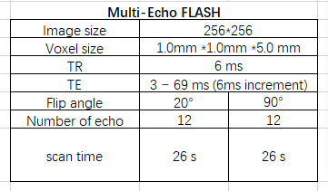 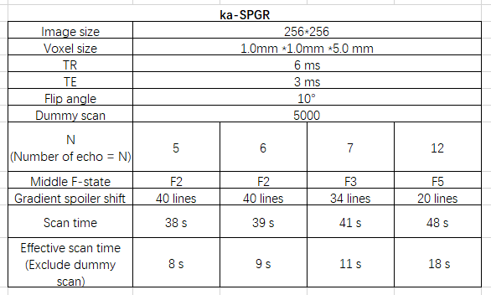

* 1. Image processing

The F-states images of ka-SPGR are reconstructed from raw data as described in theory and Figure X using MATLAB and transfer to Python for further processing [Intro10]. For consistency, the multi-echo FLASH images are also reconstructed from raw data using MATLAB, instead of directly using the default DICOM file from the scanner.

A mask shown in Figure X is extracted from the phantom MR image and used to exclude areas outside the fiducial spheres. The decay time-related images (multi-echo FLASH), or F-states (ka-SPGR) are masked, and then fitting is performed as shown in Figure X to compute T2* values for each pixel. As the range of interest for T2* is around 13ms - 53ms, the phantom spheres with T2* largely outside this range are excluded for further analysis.

* 1. Result analysis

The data acquired from the MRI phantom scanning is further processed to obtain T2* mapping images. The ka-SPGR T2* measuring percentage error and effective T2* signal-to-noise ratio in actual MRI scanning can be computed and used to evaluate its performance in reality.

* + 1. T2* mapping

The quantitative T2* mapping images for both methods are generated by colour-coding the T2* values obtained on top of a greyscale averaged image of the multiple acquisitions. It is used to prove the ability to distinguish PD and healthy biomarkers using a quantitative T2* map.

* + 1. Percentage error

T2* obtained using 90° flip angle multi-echo FLASH is defined as the ground truth T2* in each voxel. The percentage error of ka-SPGR T2* results are computed for each voxel, and a dot plot of percentage error in different spheres (different T2*) is used to visualise the distribution and variation of T2* percentage errors. Therefore, analyse the periodic ka-SPGR sequences’ PD biomarker measurement accuracy.

* + 1. Effective T2* Signal-to-Noise ratio

The Effective T2* SNR can be computed using the equation,

It includes factors that affect the scan’s efficiency - the effective acquisition time, the number of acquisitions required and the T2* measurement variation. In order to match the environment, 20 low flip angle Multi-echo GRE is used for the comparison. The ka-SPGR and Multi-echo FLASH sequences’ effective T2* SNR at different fiducial spheres (different T2*) will be compared using a bar plot. It can then be used to compare the T2* mapping efficiency of ka-SPGR and Multi-echo FLASH.

**RESULT**

The computer simulation and MRI phantom scanning experiment results are presented below. All results show the N-periodic ka-SPGR is able to achieve T2* measurement with small bias and an acceptable variation.

1. Model Simulation
   1. Averaged percentage bias

Each line plot in Figure X shows the changing of the averaged T2* percentage bias with TR for a specific periodic ka-SPGR sequence, and the plots for 5-12 periodic ka-SPGR are shown in the graph using different colours. The mean T2* percentage bias first decreases with TR and starts to raise when TR continuously increase. This trend is observed in all different periodic ka-SPGR and is expected behaviour due to the exponential fit efficiency. And the optimal parameter for ka-SPGR can be determined by finding the minimum point in the figure.

The optimal point is around TR = 3.5 ms on the 12-periodic ka-SPGR line plot, however, due to the limitation of the MRI scanner used for this project, the minimum TR able to achieve is 6ms. Therefore, 7-periodic and 12-periodic ka-SPGR with TR = 6ms is chosen based on the simulation.

* 1. Standard deviation of the optimal coefficient

The figure above shows the variation of measured T2* at different ground truth values using 7-periodic ka-SPGR (left) and 12-periodic ka-SPGR (right). A green line is drawn to show where the measured T2* should lay for an accurate measure, and the blue points show the mean of measurements with an error bar showing the standard deviation. Both plots show the ka-SPGR T2* measurement varying in an acceptable range with the optimised parameters used.

Both plots show the ka-SPGR is more stable and performs better when measuring small T2* values, this is because the exponential fit is more sensitive to sampling in a specific region. With larger T2*, the sampling is not at the sensitive region of the relatively slowly decayed exponential curve, so it is less tolerant to noise. The 12-periodic measurement is shown to be more stable than the 7-periodic, which could be explained by the 5 additional F-states 12-periodic can reconstruct compared with 7-periodic, as more data points are used to perform the exponential fit, the measurement variation decrease.

1. MRI data acquisition and analysis
   1. Quantitative T2* mapping image

Figure X shows the quantitative T2* mapping images generated for the phantom using the same colourmap and only the fiducial spheres with PD biomarker-related T2* are mapped on top of the greyscale image. As shown by the figure, the colours of each sphere are approximately the same in all 3 figures, which shows the ka-SPGR T2* mapping result (b,c) aligns with the gold standard (a).

The blue and red colours in the colourmap can approximately indicate PD and healthy SN T2* value respectively. As the blue and red coloured fiducial sphere are homogenous and does not have voxels containing extremely out-of-range colour, it proves the measurement variation will not affect the identification of the PD biomarker and ka-SPGR T2* mapping image can be potentially used for PD biomarker detection.

图形用户界面

* 1. Performance analysis
     1. Percentage error

The T2* percentage bias is computed for each voxel and plotted in Figure X, each group of points are voxels from the same fiducial sphere, and they distribute along the x-axis according to the voxel’s ground truth T2* value. The mean and standard deviation of each group are calculated and plotted as a red error bar on top of the scattered points.

As shown in the Figures, the 12-periodic ka-SPGR (b) has a more stable performance compared with the 7-periodic (a), especially at a higher T2* value, which aligns with the computer simulation result. However, the mean bias of each fiducial sphere (red dot) stays within +-5% bias, and all the error bars lay inside +-10% bias for both plots. It again proves the accuracy and stability of the T2* measurement using 7 or 12-periodic ka-SPGR within the PD biomarker T2* detection range.

Caption:

A horizontal green dotted line is used to show the zero bias, with two red dotted lines showing the +_10% bias. The percentage bias calculated for each voxel is scattered as blue dots, and the mean is plotted in red with an error bar for each fiducial sphere.

* + 1. Effective T2* Signal-to-Noise ratio

In Figure X, the bar charts show the effective T2* SNR when using the ka-SPGR (orange) and the Multi-echo GRE (blue) for each fiducial sphere and the bars are arranged according to increasing T2* order, with the mean ground truth T2* for each sphere labelled on the x-axis. Both 7-periodic and 12-periodic ka-SPGR have a higher SNR than the Multi-echo GRE for measuring a small T2* value of around 5-15ms. Moreover, the 7-periodic ka-SPGR exhibits a significantly high-efficiency improvement at this range. At higher T2* values, both ka-SPGR sequences have similar effective T2* SNR as the Multi-echo GRE, with no improvement observed. The results indicate the ka-SPGR efficiency aligns with the gold-standard method, suggesting that it can be considered as an alternative T2* measuring method to the traditional method. Additionally, the 7-periodic ka-SPGR will be a promising technique for detecting T2* PD biomarkers, given its high efficiency in detecting low T2* values.

Discussion

Improvement:

Phantom

1. Proved the method is able to detect T2* in this range. But T1 and T2 of the phantom are not specifically aligned with SN tissue property, it is not a highly accurate prediction of what will happen for in vivo test. But it still proves the performance of measuring T2* of these values. Limitations of the phantom we have. The scanning layer is build for T2 mapping, they have different T2 value.
2. The gold-standard method also has variation, not 100% accurate.
3. In order to prove the accuracy and actually used for PD detection, in vivo tests are required.
4. Only show the T2* mapping accuracy and variability, need further in vivo test for the motion robust assumption.

Method Reference:

1. Principles, techniques, and applications of T2*-based MR imaging and its special
2. Principle of MR imaging (that book)
3. Principles of nuclear magnetic resonance in one and two dimensions (check for Ernst angle)
4. Steady state effects in fast gradient echo magnetic resonance imaging
5. Steady state of echo-shifted sequences with radiofrequency phase cycling
6. A motion-robust, short-TR alternative to multi-echo SPGR (Intro10)
7. MRI characteristics of the substantia nigra in Parkinson's disease: A combined quantitative T1 and DTI study
8. Extended phase graphs: Dephasing, RF pulses, and echoes - Pure and simple
9. The rician distribution of noisy mri data
10. Theory of NMR signal behavior in magnetically inhomogeneous tissues: The static dephasing