**METHOD**

1. Model Simulation and analysis

A Python-based computer simulation is built to model the ka-SPGR T2* mapping performance when different TR and periods are used. The simulated results are then used to find the optimal ka-SPGR parameters for PD biomarker detection.

* 1. Simulation setup

As shown in Figure X, the computer simulation can be described in 2 sections - signal formation modelling, where the ideal Bloch simulation is first performed followed by adding the magnetic field inhomogeneous effects; and acquisition modelling, where the noise is considered and T2* fitting is performed.

* + 1. Bloch simulation

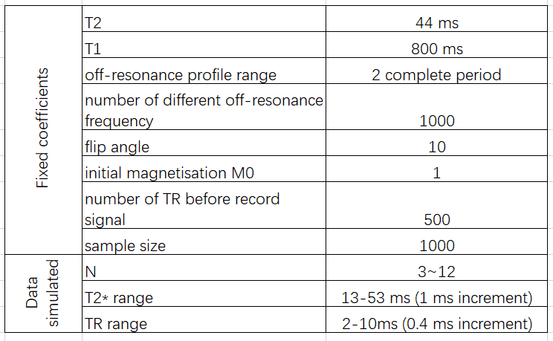

Using the well know Bloch equation [Method2], the performance of the spin with certain tissue properties (T1, T2) under different applied pulse sequences can be modelled by applying specific α, φ, TR and TE. As the project focused on SN region T2* mapping, SN’s T1 (800ms) and T2 (44ms) are used in the computer simulation model, suggested by previous research on SN [Method7] [Intro5]. A 10°optimal flip angle calculated from the Ernst equation is used [Method3], and RF-spoiling is applied by implementing phase shiftφ based on equation (1). Additionally, to ensure the steady state is fully reached, the spin is repeatedly excited 500 times before the acquisition of the signal. The pulse sequence structure is shown in the left first figure in Figure X, and the parameters used are listed in Table X. An off-resonance profile is then generated, which models the performance of spins under external disturbances by simulating spins with different extra phase shifts, and the Fourier transform of the off-resonance profile is equal to the configuration F-states [Method8].

* + 1. Magnetic field inhomogeneity modelling

The field inhomogeneous effect caused by iron overload in the tissue can be modelled by convolving the Lorentzian distributed field inhomogeneous with the off-resonance profile [Method10]. With a selected ground truth T2* and the known SN T2, the inhomogeneous effect related to the ground truth T2* can be calculated using the relationship [Method1],

 (3)

and applied to the Bloch simulation model. However, as shown in Figure X, in this computer simulation, multiplying the F-states signal with the Fourier transform of Lorentzian - an exponential curve with the time constant 1/T2’ = 1/γΔBinhomo is performed instead of the complicated convolution, as it is an equivalent operation supported by the property of Fourier transforms.

* + 1. Noise Modelling

In reality, an MRI scanner introduces noise while acquiring the signal [Method9]. For ka-SPGR with different periods and TR, the acquisition noise is modelled using zero-mean Gaussian with standard deviation equals F0/sqr(N)*5%. The F0 is the F-state magnitude simulated when T2* = 33ms, the PD and healthy SN T2*mean. Then the generated Gaussian noises are added to the imaginary and real parts of the simulated F-states signal. Figure X shows 3 times of F-state acquisition modelling, each different colour indicates one sample acquisition. While in the data simulation, 1000 acquisitions are made to perform the Monte Carlo experiment and analyse the performance.

* + 1. T2* measurement modelling

To model the T2* calculation of N-periodic ka-SPGR, the exponential fit should only use the first N F-state magnitude F_0…F_N-1, because only these F-states can be reconstructed from the acquired signal using N-periodic ka-SPGR. For example, in Figure 3, only the first 5 F-states are used to fit the exponential for 5-periodic ka-SPGR.

* 1. Data Simulation

The data is simulated for spins with ground truth T2* of 13-53ms when applying 3 ~ 12 periodic ka-SPGR sequences with different TRs from 2ms to 10ms. Table X summarised the conditions covered by the data simulation. The range of ground truth T2* is selected specifically for analysing PD biomarker detection accuracy, which is between the PD patients’ (13ms) and healthy SN T2* (53ms) [Intro5]. The above periodicity and TR ranges are selected for the simulation because a periodicity less than 3 is not able to provide enough data points for fitting the exponential curve, and a TR smaller than 2ms can’t be achieved by a scanner, also, periodicity greater than 12 or TR greater than 10ms both resulting in an unacceptable long acquisition time.

On top of the selected range, Monte Carlo experiments are performed and by fitting each group of acquired F-states, 1000 measured T2* can be obtained for each ground truth T2* value for different periodic ka-SPGR with different TR.



* 1. Simulated data analysis method

The simulated T2* are then further analysed using percentage bias and standard deviation to find optimal scan parameters. The percentage bias of the simulated T2* shows the accuracy of the T2* measurement and it hugely depends on the choice of period and TR. As shown in Figure X, the x-coordinate of points used for exponential fit is TE+F*TR, F = 0…(N-1), by using different periods and TRs, a different part and range of the exponential curve is sampled, which will affect the accuracy of the exponential fit. By locating the minimum average percentage bias, the optimal period and TR for ka-SPGR that maximises T2* measurement accuracy is found. The standard deviation of the measured T2* using the optimised parameter is then computed to evaluate the variation of the measurement and verify the reliability of the method. Once the accuracy and precision of the chosen parameter are proven, it is then used for the MRI phantom scanning experiment.

1. MRI data acquisition and analysis

MRI scan using ka-SPGR sequence with optimised scan parameter is performed on a phantom. The T2* values are calculated and compared with the ground truth T2* value obtained using the gold-standard Multi-echo GRE method. Followed by a comparison between the ka-SPGR and the Multi-echo GRE with controlled variables.

* 1. MRI scan setup
     1. Phantom

(LHS: picture of NIST/ISMRM Premium System Phantom Model (SN:130-102), RHS: MnCl2-containing fiducial spheres layer being scanned)

NIST/ISMRM Premium System Phantom Model (SN:130-102) is used as the scanning object, and a slice acquisition is performed at the MnCl2-containing fiducial spheres layer (Figure X), where fiducial spheres have different T2* values. Multi-echo FLASH (Siemens, 3T), one commonly used multi-echo GRE sequence, is used as the gold standard T2* measuring method to obtain the ground truth T2* value for each voxel inside the fiducial sphere. Each fiducial sphere can be visualised as groups of voxels with approximately the same ground truth T2* value, and the voxels inside the same sphere can be treated as test samples for the T2* measurement of known ground truth T2*.

* + 1. Scan parameters

MRI signals are acquired from a phantom using 7 and 12-periodic ka-SPGR sequences with TR = 6ms and 10° flip angle, which are the optimised results from the computer simulation. The middle F-state and amount of gradient spoiler shift are carefully selected (Table X) to make sure the required N F-states are within the k-space acquisition range.

MRI signals are also acquired using Muti-echo FLASH with parameters chosen to match with ka-SPGR. In order to minimise the influence of the exponential fitting efficiency, the number and position of data points used to fit the exponential curve should be consistent for the two methods. Therefore, to achieve the match shown in Figure X, the multi-echo FLASH TEs start with ka-SPGR’s TE and following by an increment equal to ka-SPGR’s TR as shown in Table X. Additionally, the number is kept consistent by using the first N acquisition of multi-echo FLASH to fit exponential fit when compare with N-periodic ka-SPGR. Also, the image and voxel sizes are matched for all scanning performed, as shown in Table X.

A 90° flip angle FLASH is used to obtain an accurate T2* ground truth value for evaluating ka-SPGR T2* accuracy, and a 20° flip angle FLASH is used to match with ka-SPGR’s low flip angle aiming at comparing the 2 methods’ efficiency under similar environment.

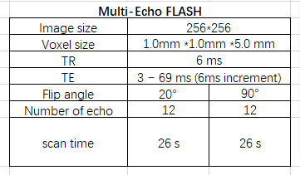 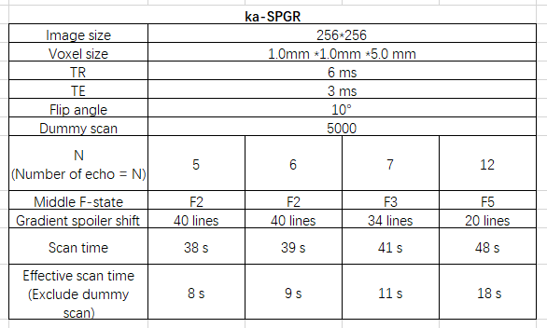

* 1. Image processing

The F-states images of ka-SPGR are reconstructed from raw data as described in theory and Figure X using MATLAB and transfer to Python for further processing [Intro10]. For consistency, the multi-echo FLASH images are also reconstructed from raw data using MATLAB, instead of directly using the default DICOM file from the scanner.

A mask shown in Figure X is extracted from the phantom MR image and used to exclude areas outside the fiducial spheres. The decay time-related images (multi-echo FLASH), or F-states (ka-SPGR) are masked, and then fitting is performed as shown in Figure X to compute T2* values for each pixel. As the range of interest for T2* is around 13ms - 53ms, the phantom spheres with T2* largely outside this range are excluded for further analysis.

The quantitative T2* mapping images for both methods are generated by colour-coding the T2* values obtained on top of a greyscale averaged image of the multiple acquisitions. It is used to prove the ability to distinguish PD and healthy biomarkers using a quantitative T2* mapping image.

* 1. Scan result analysis method

The T2* percentage error is computed to evaluate the accuracy of ka-SPGR T2* measurement in reality, with the ground truth for each voxel defined by the T2* measured with 90° flip angle multi-echo FLASH.

The Effective T2* SNR of ka-SPGR and Multi-echo GRE are calculated to compare their efficiency, it can be computed using the equation,

It includes factors that affect the scan’s efficiency - the effective acquisition time, the number of acquisitions required and the T2* measurement variation. In order to match the environment, 20 low flip angle Multi-echo GRE is used for the comparison.