**RESULT**

The computer simulation and MRI phantom scanning experiment results are presented below.

1. Model Simulation Result

* 1. Optimal ka-SPGR parameter

Caption:

Each line plot shows the changing of the averaged T2* percentage bias with TR for a specific periodic ka-SPGR sequence, and the plots for 5-12 periodic ka-SPGR are shown in the graph using different colours.

The average T2* percentage error in the PD biomarker detection range (13-53ms) is calculated for the simulated data of ka-SPGR with period and TR listed in Table X. By plotting the average percentage error against TR for each periodic ka-SPGR, it is found that the smallest bias of 0.1% can be achieved using 12-periodic ka-SPGR with TR = 3.5ms. However, constrained by the minimum 6ms TR that the MRI scanner used in this project can achieve, 7-periodic and 12-periodic ka-SPGR with TR = 6ms are used in the scan.

* 1. Optimal ka-SPGR accuracy and precision

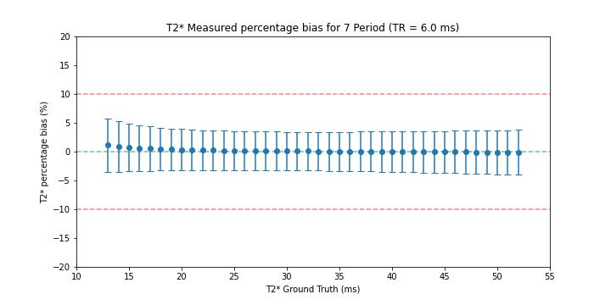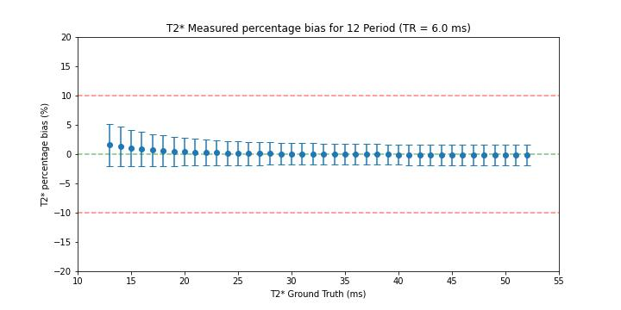

Caption:

The simulated T2* percentage bias and the error bar for the 7-periodic and 12-periodic ka-SPGR with TR = 6ms are shown in the plots. A green dotted line shows the zero bias and red dotted lines show +-10% bias.

The figure above shows the bias and variation of the simulated T2* values at different ground truth values using 7-periodic ka-SPGR (left) and 12-periodic ka-SPGR (right). As shown in the graph, for both ka-SPGR sequences the percentage bias approximately lay on the zero-bias line without obvious variations and the error bars are all strictly inside the +_10% bias line. The 2 ka-SPGR sequences have approximately the same percentage bias, however, the 7-periodic ka-SPGR has a significantly larger standard deviation than the 12-periodic.

1. MRI data acquisition and analysis
   1. Quantitative T2* mapping image

As shown by the Figures, the colours of each sphere are approximately the same in all 3 figures, which shows the ka-SPGR T2* mapping result (b,c) aligns with the gold standard (a). Additionally, there are no large variations of colour in each fiducial sphere.

Caption:

The quantitative T2* mapping images of the phantom using Gold-standard Multi-echo GRE, 7-periodic ka-SPGR and 12-periodic ka-SPGR with the same colourmap. Only the fiducial spheres with PD biomarker-related T2* are mapped on top of the greyscale image.

图形用户界面

* 1. Performance analysis
     1. Percentage error

The T2* percentage bias is computed for each voxel and plotted in Figure X, each group of points are voxels from the same fiducial sphere and distribute along the x-axis according to the voxel’s ground truth T2* value. Each group's mean and standard deviation are calculated and plotted as a red error bar on top of the scattered points. For both 7-periodic and 12-periodic ka-SPGR, the mean bias of each fiducial sphere (red dot) stays within +-5% bias, and all the error bars lay inside +-10% bias for both plots. Additionally, the 12-periodic ka-SPGR has smaller standard deviations compared with the 7-periodic, especially when measuring a higher T2* value.

Caption:

The percentage bias calculated for each voxel is scattered as blue dots, and the mean is plotted in red with an error bar for each fiducial sphere. A horizontal green dotted line is used to show the zero bias, with two red dotted lines showing the +_10% bias.

* + 1. Effective T2* Signal-to-Noise ratio

Caption:

The bar charts show the effective T2* SNR when using the 7-periodic/ 12-periodic ka-SPGR (orange) and the Multi-echo GRE (blue) for each fiducial sphere and the bars are arranged according to increasing T2* order, with the mean ground truth T2* for each sphere labelled on the x-axis.

The effective T2* SNR of 2 optimal ka-SPGR sequences and Multi-echo GRE are compared in the above bar chart, and the bars are arranged in increasing T2* order in the x-axis. Both 7-periodic and 12-periodic ka-SPGR have a higher effective T2* SNR than the Multi-echo GRE for measuring a small T2* value of around 5-15ms, notice that the 7-periodic ka-SPGR exhibits a significantly high-efficiency improvement of about 40% at this range. At higher T2* values, both ka-SPGR sequences have similar effective T2* SNR as the Multi-echo GRE, with no improvement observed.