Data Point Transfer: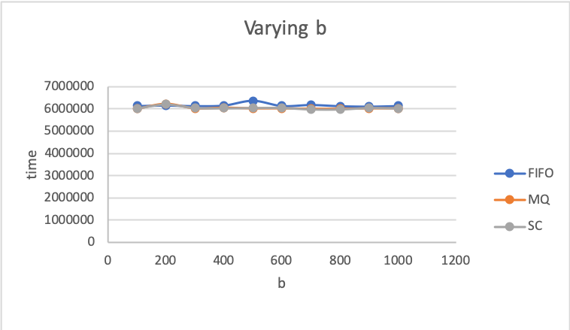

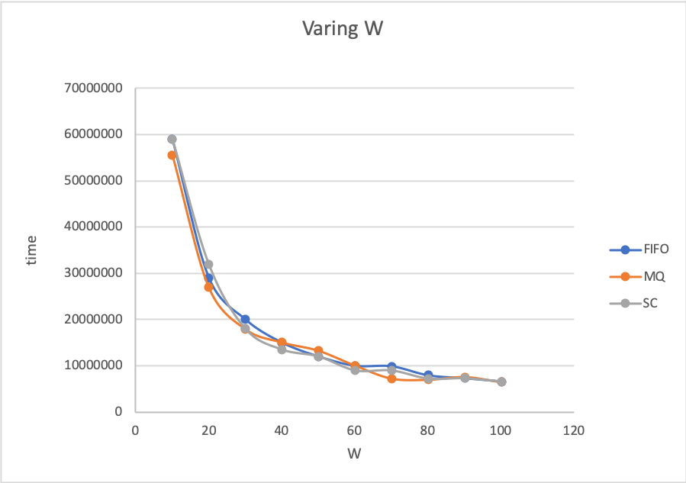

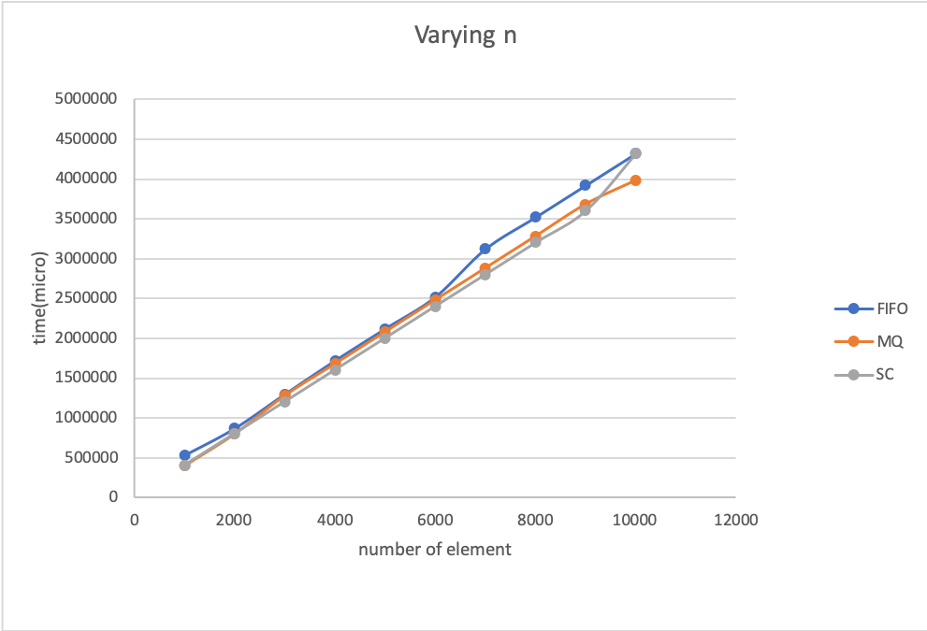

**Conclusion:**

**Varying B: B has no effect on the performance of the program.**

**Varying N: it is obvious that more data points will take more time to process, MQ has a small increase in performance compare to FIFO.**

**Varying W: More worker thread increases the performance of the program, however when the number of worker thread reaches some threshold, it’s incremental value decreases.**

**Varying M: Should not have any effect on the performance because a single data point is not large.**

**Base on the graph, it is obvious that MQ and FIFO and Shared Memeory has almost same performance , with MQ a little bit faster than the FIFO. However , it is a really small difference,thus cannot conclude that MQ has performance advantage over FIFO.**

**File Transfer:**

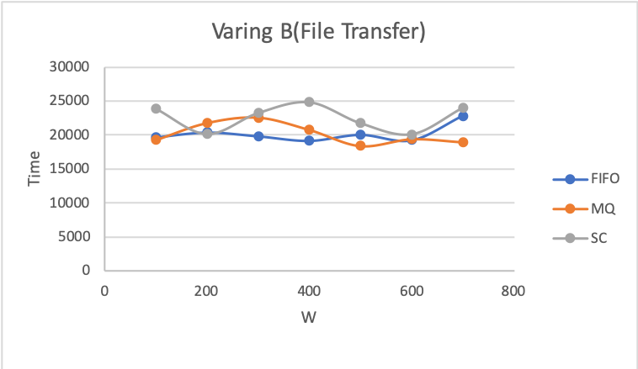

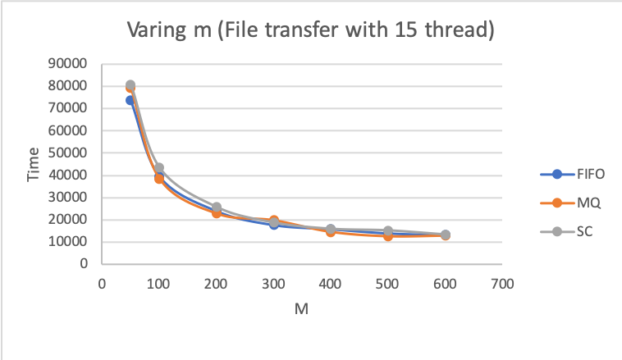

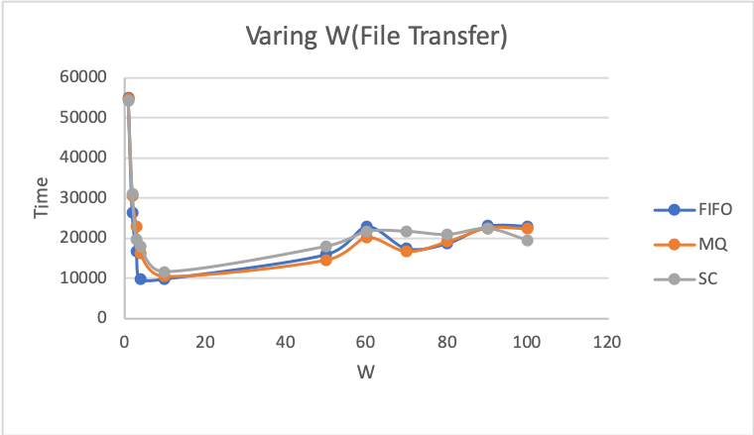

**Varying B: B has no effect on the performance of the program.**

**Varying M: More M means less communication among the client and server, which will increase the performance of the program**

**Varying W: Since it is not a lot of work load, a single thread can finish much faster than more threads, thus initializing more thread will have overhead when every thread is trying to compete for CPU time.**

**Base on the graph, it is obvious that MQ and FIFO has almost same performance , with MQ a little bit faster than the FIFO. However , it is a really small difference,thus cannot conclude that MQ has performance advantage over FIFO.**

Maximum W for FIFO:It really depends on the system’s limit. I can go up to 700 with the system command ulimit -n 10000

Maximum W for MQ: It is also depends on the system’s limit. With the default system setting I can go up to -127

Maximum W for SC: It is also depends on the system’s limit. With the default system setting I can go up to 500

System Limit:

For Fifo, when you have too man worker thread open, once it exceed the system’s limit , it will encounter “Too many open file “ message and stop functioning properl. It can be solve by using command u limit -n xxxxxx. Although if the number is too big, it might not functioning properly.

For MQ, It can only be set to 127 with the default system. I am sure that it can be higher by adjusting the maxMessageQueue variable in the system.

For SC, It can only be set to 500 with the default system. I am sure that it can be higher by adjusting the Some of the system variable in the system.

**Clean Up:**

I deleted all the MQ/FIFO channels in both Client and Server side. Also I ensured that the QUIT_MSG is sent from the client side to the server side. I checked with address sanitizer to ensure there is no memory leak in my program.