1. Flow Chart

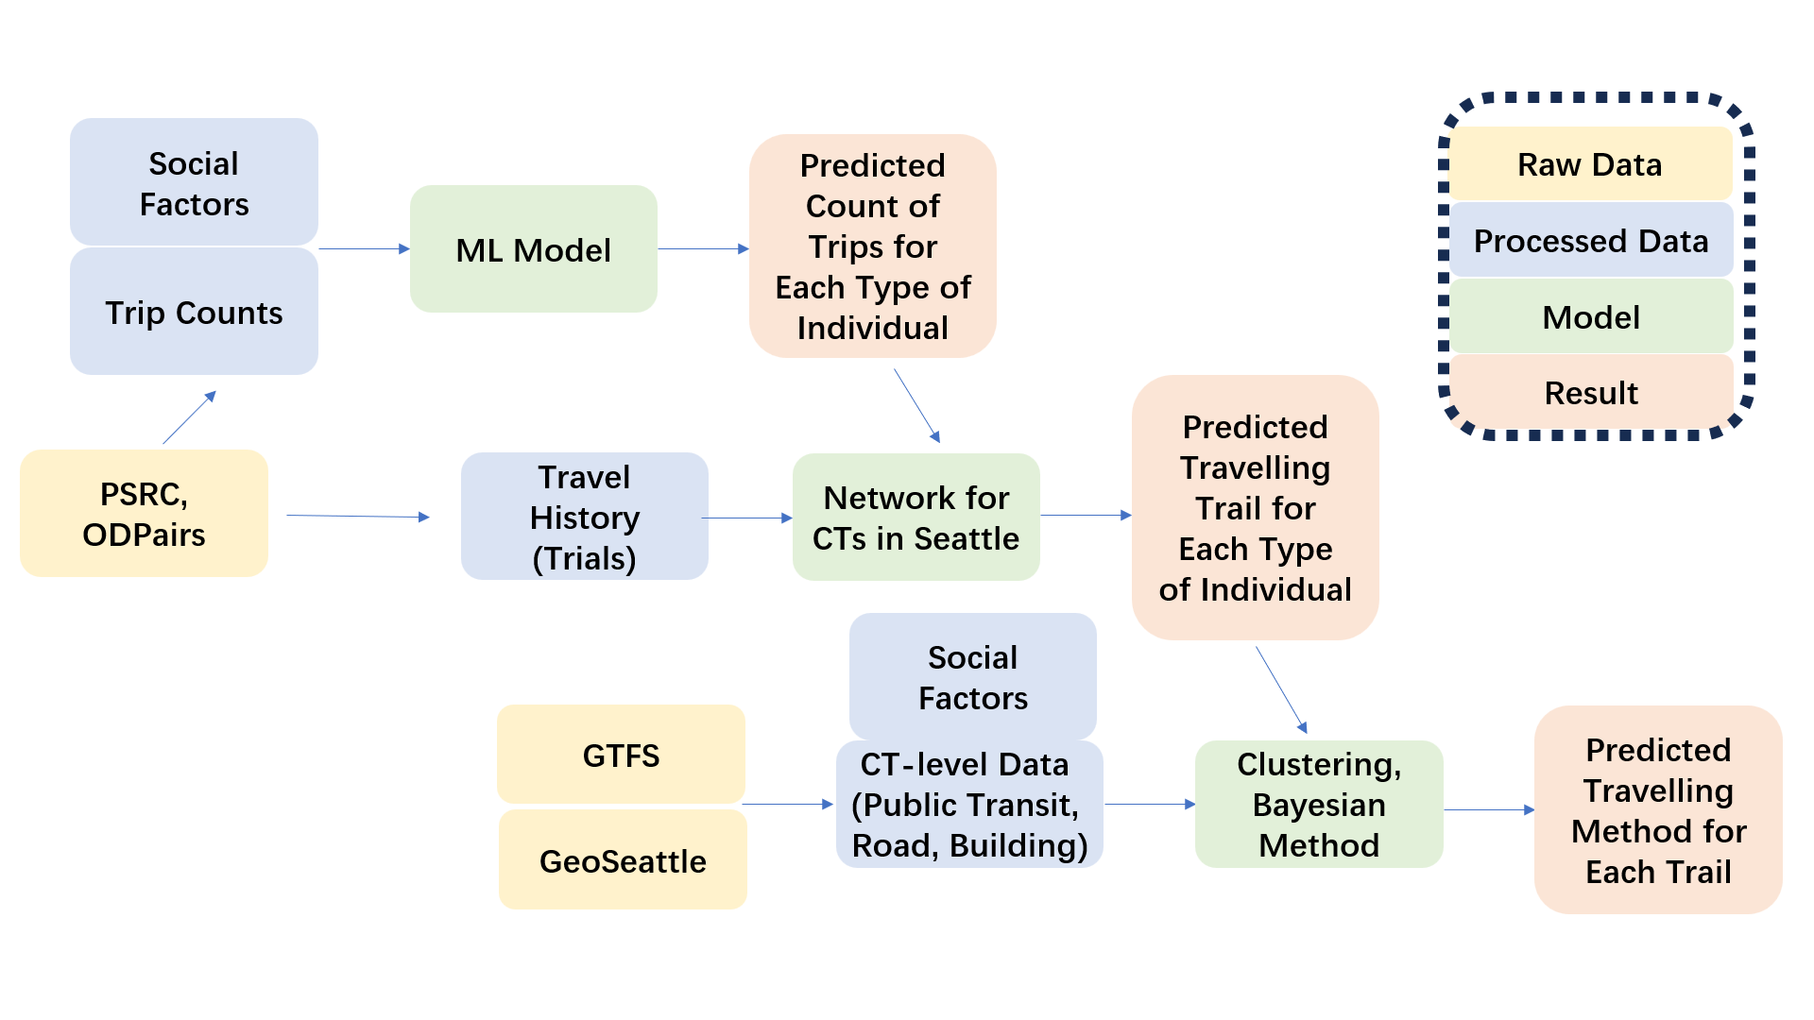

This is a flow chart illustrating the 3-section process of our project. Users will graph the important datasets, models (methods), and results generated.

1. Census Tract Clustering for King County, Washington

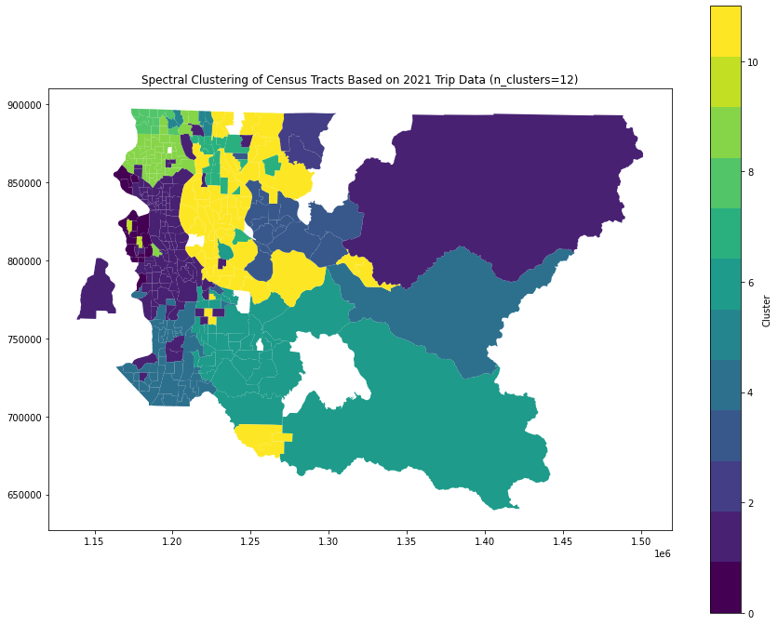

This graph uses a coloring map to illustrate our clustering results for the geographical area we are interested in. This will likely involve multiple coloring maps showcasing different clustering results and cluster numbers. Users can intuitively understand how many sub-divisions we are modeling for.

1. Feature Importance regarding Social Demographics Features

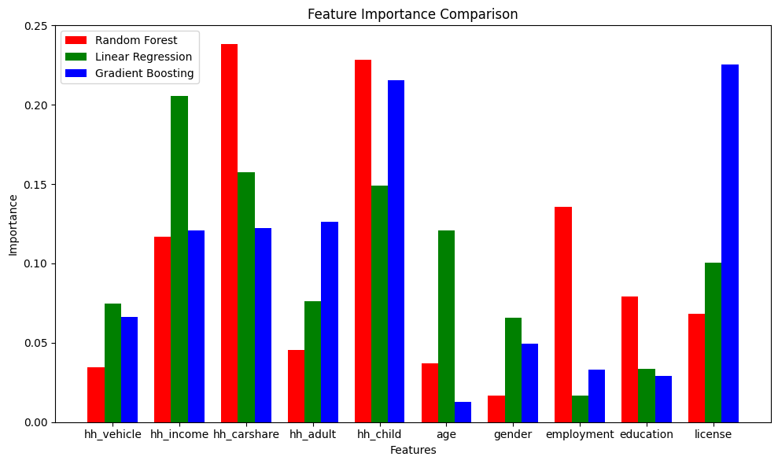

This multi-bar plot showcases the feature importance calculated from Python Package SHAP. Users would understand how different social demographics would affect the volume of traveling if modeled by different prediction methods.

1. Hodge Rank Potential Analysis

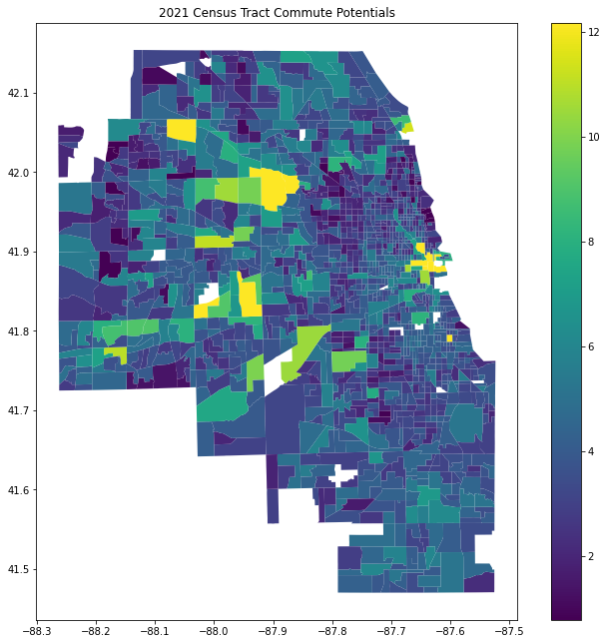

This is a potential heatmap calculated using the HodgeRank method. Users can get the potential for each Census Tract in this area and get to know how we model the trajectories of each individual in our prediction.

1. Website showcasing Traveling Method Inference

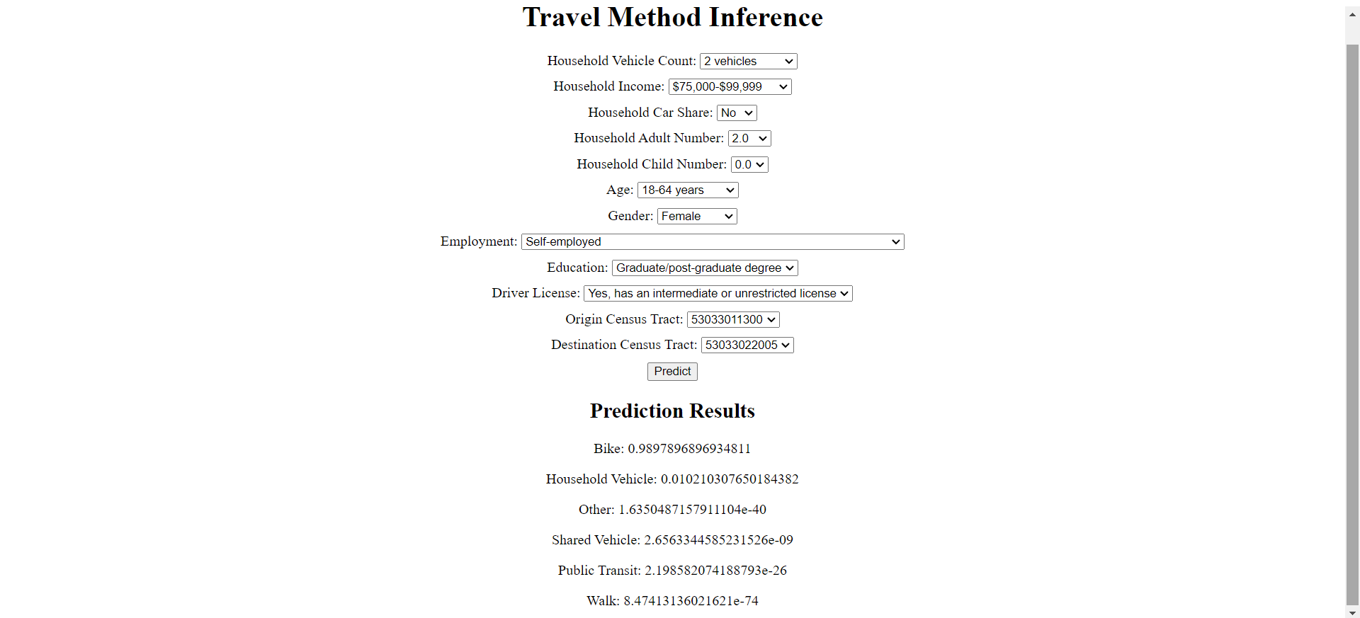

This is a user interface that will be continuously improved. This one shows the final part of our inference - given the characteristic and the Origin-Destination of an individual, it will infer the probability of them taking each transportation method. Ideally in the final version, users can freely adjust the social demographics of one person and the volume of trips, trajectories of trips, as well as corresponding traveling methods would show up.

1. Validation Graph (to be continued)

The result of our predictions would be validated against the Rakuten Data. It would probability be a line plot with a y-axis showcasing the error and an x-axis showcasing the sample size. As we tend to consider the larger population of King County, the error would be more likely to converge towards 0.