Weekly Report (updating)
Project objective: expression level Nicotiana benthamiana codon optimization using machine learning
Model selected: Encoder-Transformer
*The Transformer takes the full amino acid sequence and learns codon choices across positions. Codon optimization has both local and global constraints.

Environment: python3 + conda env for tRNA-Scan and MFE RnaFOLD
Device: MacOS CPU (ideally should be GPU)
Data source: Nicotiana benthamiana CDS
https://solgenomics.net/ftp/genomes/Nicotiana_benthamiana/LAB360

NbLab360.genome.fasta.gz (genome)
NbLab360.v103.gff3.CDS.fasta.AA.fasta.gz (CDS amino acid)
NbLab360.v103.gff3.CDS.fasta.gz (CDS DNA)
NbLab360.v103.gff3.gz (annotation file)

Input: protein and amino acid sequence pairs
Target: CDS DNA sequence / codon sequence

After 30 rounds of learning, the model initial generates a list/distribution of codon possibilities for each amino acid; argmax is used to select the highest possibilities for each codon, but that’s not always favorable.

Data processing:
- Load amino acid sequences and CDS DNA sequences from FASTA files.
- Match AA sequences with CDS sequences using gene IDs.
- Clean and validate the data:
- remove invalid sequences
- ensure CDS length is divisible by 3
- verify CDS translates back to the correct protein sequence

- Split CDS DNA into codons.
- Build vocabularies for amino acids and codons and encode amino acids and codons into numerical token IDs.
- Pad sequences to equal length and convert them into PyTorch tensors for model training.

Model biological parameters:
GC content loss:
The model calculates the expected GC content from predicted codon probabilities and compares it with the target GC.

GC loss = (predicted expected GC - target GC)^2

It keeps the optimized CDS close to the target N. benthamiana GC level (41%-45%)

tAI loss (proxy) using tRNAscan-SE:
tRNAscan-SE predicts tRNA anticodons using the plant genome data
anticodons are complemented into codons, and the gene counts are normalized. The results become tAI codon weights

tAI loss = (predicted expected tAI-like score - target tAI)^2

This is tAI proxy score, not experimentally measured tRNA abundance (tRNA-seq)

MFE proxy loss during training:
No real RNAfold MFE is calculated. The proxy is based on local codon base-pairing tendency, mainly GC/AU composition.

MFE proxy loss = (predicted expected MFE proxy - target MFE proxy)^2

MFE constraint avoids sequences that are too unstable or too strongly structured at the codon level. Since RNAfold is used after decoding, the selections are not directly inside backpropagation.

Total training loss:
Total loss =
synonymous codon loss + λGC × GC loss + λtAI × tAI loss + λMFE × MFE proxy loss

For example:
Total loss =
synonymous codon loss
+ 3.0 × GC loss
+ 0.6 × tAI loss
+ 0.1 × MFE proxy loss

GC has the strongest weight, tAI is moderate, and MFE proxy is weak.

Summary:
This model performs codon optimization for Nicotiana benthamiana using an encoder only Transformer. The input is an amino acid sequence, and the output is the codon sequence that encodes the same protein.
During preprocessing, CDS protein pairs were filtered to ensure correct translation and amino acid fidelity.
During training, the model used a multi objective loss function combining codon prediction, GC content control, tAI adaptation, and an MFE proxy. RNAfold was not used directly during training because it is not differentiable in the PyTorch training loop; instead, the MFE proxy was used as a trainable approximation.
After decoding, the model generated synonymous CDS candidates, which were then ranked using GC closeness, tRNA adaptation, and RNAfold MFE when the sequence length was suitable. If RNAfold was unavailable or the sequence was too long, the MFE proxy was used instead. The final output is an optimized CDS candidate for protein expression.

Progress and To-do List:
The main limitations are that the model is sensitive to hyperparameter tuning, tAI optimization remains weak after decoding, and the current outputs are based on expression related sequence proxies.
Although amino acid fidelity is preserved and GC control can be strong, the final decoded codons do not always improve tRNA gene-copy-based adaptation.
In addition, the model does not directly account for plant antibody expression factors such as signal peptide design, ER retention, heavy/light chain balance, glycosylation, secretion, or experimental agroinfiltration conditions. The model is more like a codon optimization tool rather than a validated predictor of antibody yield.

Pre-training results (from 2000 samples; 5 epoch):
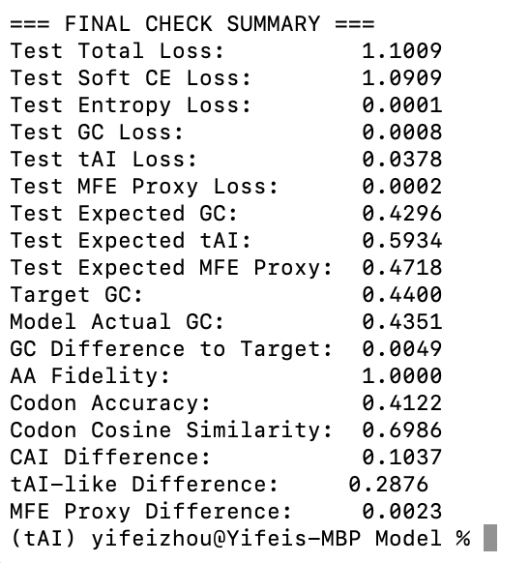
Should decrease tAI bonus or Lambda further
Improved by sampling and ranking methods

tRNA:
Working on ranking and sampling selection method instead of purely argmax
Added biological constraints (GC content, tAI, MFE). Fixing tAI constraint weight due to high tAI difference
Searching for more appropriate datasets for rRNA abundance

Latest result for tAI training:
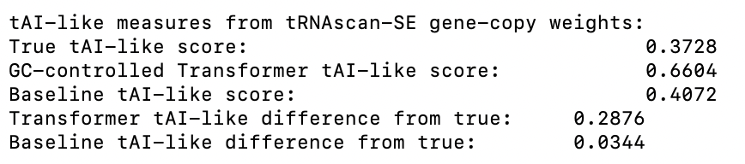
Previous tAI Bonus and Lambda setting is too high; dropped tAI Lambda below 0.1 should get better results.
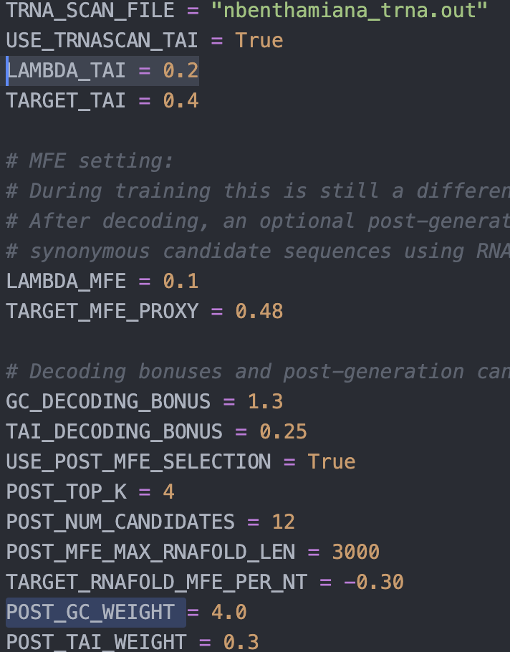

Training (Running; 45k samples and 25 epochs):
Applying to full dataset and 30 epochs: run-time errors fixed

Possible next step:
If the model generates 5–10 synonymous CDS designs, the next step should be measuring expression and use those measurements as labels for future training.
- Use the same antibody amino acid sequence and compare different synonymous CDS versions:
NCO/original CDS
published CO CDS
model candidate 1
model candidate 2
model candidate 3

- express them in N. benthamiana under identical conditions:
same vector
same promoter
same signal peptide
same terminator
same Agrobacterium strain
same infiltration OD
same extraction protocol

Data to collect:
For each generated CDS candidate, collect a table:
construct_id
CDS_sequence
AA_sequence
GC_content
CAI
tAI_score
RNAfold_MFE
repeat_penalty
forbidden_motif_count
mRNA_level_qRT-PCR
protein_expression_ELISA_or_Western
yield_weight
glycosylation_profile

The most important labels:
mRNA abundance by qRT-PCR
protein expression by Western blot or ELISA
purified yield
glycosylation by LC-MS glycopeptide analysis if applicable

* But with only 5–10 candidates, a reliable expression level prediction model cannot be trained. The model is only be evaluated for the expression.
For this task, with limited data, simpler models like Random Forest and XGBoost will work better (not learning the patterns), or RNN (local patterns); transformer (either encoder-only, codonBERT or Vision Transformer) is more fit for hundreds or thousands of labeled constructed data.

