Transformer-Based Codon Optimization for Antibody Expression in Nicotiana benthamiana: From Sequence Design to Experimental Evaluation
Yifei Zhou
Department of Bioinformatics, University of Guelph | Co-op Research, Plantform Corporation

Abstract
Synonymous codon choice affects translation efficiency, mRNA stability, and recombinant protein yield, yet conventional codon optimization tools rely on static substitution rather than sequence context. This work develops an encoder-only Transformer trained directly on native Nicotiana benthamiana coding sequences to learn contextual, host-specific codon usage, and develops a differentiable training loss that combines codon cross entropy, an entropy regularizer, and GC-content, tRNA adaptation (tAI), and RNA base pairing (MFE proxy) on top of the learned distribution. The heavy and light chain coding sequences of the therapeutic monoclonal antibody Adalimumab were used as a downstream test case for both computational benchmarking and wet-lab validation. Model candidates achieved complete amino-acid fidelity and target GC content on the test set, with favorable matched codon adaptation (tAI) and RNA-folding stability and were selected to span a GC gradient instead of top-scoring sequence. Nine of ten selected constructs were successfully cloned and verified across two independent digestion cycles. In transient expression trials, the top ranked heavy chain (HC2) paired against all five light chain candidates produced secreted IgG at 121–146 µg/mL, up to twice a Trastuzumab reference standard (71.3 µg/mL) and comparable to previously validated benchmark constructs (117–124 µg/mL). These results indicate that a learned, constraint-aware codon-optimization pipeline can achieve expression levels compared with manually optimized constructs in an initial experimental evaluation, closing the loop from model generated sequence to measured expression in planta.

1. Introduction
Synonymous codons are the multiple three nucleotide combinations that encode the same amino acid but with different translation efficiency. Codon choice influences ribosome elongation rate, mRNA secondary structure and stability, co-translational folding, and ultimately the yield of recombinant protein (Hanson & Coller, 2018; Plotkin & Kudla, 2011). Commercial and academic codon optimization tools typically address this by substituting each codon with the single most frequent synonym for the host organism, from a static codon usage table. This approach ignores the amino acids surrounding a given position, cannot represent the joint effect of neighboring codon choices on local RNA structure, and collapses a graded, context-dependent distribution into a single deterministic choice (Quax et al., 2015).
Transformer architectures, originally developed for language processing, are built specifically to model this kind of context: self-attention allows every position in a sequence to be weighted by every other position, rather than being restricted to a fixed local window (Vaswani et al., 2017). Because synonymous codon choice depends on both the identity of the encoded amino acid and the sequence context surrounding it, a coding sequence can reasonably be treated as a biological analogue of a language modeling problem.
This project develops an encoder-only Transformer codon optimization framework for Nicotiana benthamiana, a model host for transient recombinant protein expression via Agrobacterium leaf infiltration (Goodin et al., 2008). The model is trained directly on native N. benthamiana coding sequences from the chromosome-level LAB360 genome annotation (Ranawaka et al., 2023), so that the learned codon distribution reflects the host's own genome. A synonymous codon mask restricts the model's predictions at every position to codons that encode the correct amino acid, guaranteeing amino-acid fidelity. On top of this distribution, a multi-objective loss function trains GC-content, tRNA-adaptation, and RNA-base-pairing properties associated with efficient expression, while an entropy term discourages the model from collapsing onto the single most frequent codon.
The heavy chain (HC) and light chain (LC) coding sequences of the therapeutic monoclonal antibody Adalimumab serve as the downstream test case for this framework. They were chosen because five previously optimized HC and LC variants with known relative expression performance already existed for this construct, providing an experimental benchmark against model generated candidates. This historical benchmark originates from a 2017 PlantForm–PharmaPraxis joint-venture screen (M. Marit) that tested all 25 pairwise combinations of five manually designed HC and five LC variants (here labeled with an "MM" prefix) by BLItz, using a repeated HC1/LC1 control across infiltration weeks to normalize across batches. This paper describes the model architecture and training objective, the computational candidate generation and post selection pipeline, the molecular cloning and verification workflow used to move candidates into the plant, and the transient expression results.

2. Methods

2.1 Sequence Data and Preprocessing
Protein and coding-sequence (CDS) files for the N. benthamiana LAB360 genome annotation were downloaded from the Sol Genomics Network (Ranawaka et al., 2023; Sol Genomics Network, 2026; https://solgenomics.net/ftp/genomes/Nicotiana_benthamiana/LAB360/). Protein and CDS records were matched by sequence identifier. Sequences containing invalid nucleotides, non-standard amino acids, internal stop codons, or a protein/CDS length mismatch were discarded; each retained CDS was split into codons and re-translated to confirm agreement with its paired protein sequence. From the filtered pool, up to 20,000 amino-acid/codon pairs were sampled for training (fewer if the filtered pool itself was smaller) and split 80/10/10 into training, validation, and test sets using a fixed random seed. Amino acids and codons were tokenized into separate integer vocabularies with shared <SOS>, <EOS>, and <PAD> special tokens; the codon vocabulary spans all 64 codon triplets.

2.2 Model Architecture
The model is an encoder-only Transformer (embedding dimension d = 128, 4 self-attention heads, 4 encoder layers, feed-forward dimension 128, dropout 0.1) implemented in PyTorch. An amino-acid sequence is embedded and scaled by √d, and a scalar target GC-content value is separately projected into the same 128-dimensional space via a linear layer and added to every position as a global conditioning signal; sinusoidal positional encoding is added on top. The combined representation passes through the encoder stack, and a final linear layer projects the 128-dimensional output at each position to logits over the 64-codon vocabulary. At both training and inference time, a synonymous-codon mask sets the logits of every codon that does not translate to the correct amino acid at that position to a large negative value before the softmax. This process guarantees complete amino-acid fidelity by construction rather than as a learned behavior.

2.3 Multi-Objective Training Loss
Training uses a composite and differentiable loss instead of hard cross entropy. First, a soft target distribution mixes the one hot label for the observed codon with the empirical synonymous codon distribution q(codon | amino acid) estimated from the training set (mixing weight α = 0.7 toward the empirical distribution), and an entropy matching term penalizes the squared difference between the model's predicted per-position entropy and the empirical entropy for that amino acid, discouraging the model from collapsing onto a single dominant codon (weight λₑₙₜᵣₒₚᵧ = 0.2). Second, three additional terms are computed as expectations over the model's predicted softmax distribution and penalized by mean-squared error against a target value: a GC-content term (per-codon GC fraction weighted by predicted probability, averaged over the sequence; target 0.43, weight λ_GC = 3), a tAI-like adaptation term (codon weights derived from tRNAscan-SE-predicted gene copy numbers for N. benthamiana tRNAs, with a pseudocount for codons with no scanned tRNA (Lowe & Chan, 2016); target 0.373, weight λ_tAI = 0.1), and an RNA base pairing proxy term (a per-codon score of 0.7×GC + 0.3×AU fraction, intended to keep sequences from drifting to extreme GC or AU content; target 0.48, weight λ_MFE = 0.1). This base pairing proxy is explicitly a composition based approximation rather than true thermodynamic folding energy, since exact RNA secondary structure prediction is not differentiable; true minimum free energy (MFE) is instead computed post hoc with RNAfold (ViennaRNA; Lorenz et al., 2011) on realized candidate sequences after decoding, described in Section 2.4.
The five loss terms were combined as a single weighted sum and optimized jointly with Adam (learning rate 5×10⁻⁴) over 25 epochs at batch size 16. Table 1 summarizes the loss terms, targets, and weights used.
Loss term | Target value | Weight | Differentiable via
Soft codon cross-entropy | empirical q(codon|AA), α=0.7 | 1.0 (base) | softmax over predicted logits
Entropy-matching | empirical per-AA entropy | λ=0.2 | predicted-distribution entropy
GC content | 0.43 | λ=3.0 | expected GC from softmax probs
tAI-like adaptation | 0.373 | λ=0.1 | expected tAI from softmax probs
RNA base-pairing proxy | 0.48 | λ=0.1 | expected GC/AU-weighted score
Table 1. Composite training-loss terms, target values, and relative weights.

2.4 Candidate Generation and Post-Selection Filtering
This stage was implemented as a short pipeline of standalone scripts run in sequence. A training/evaluation script produced the trained model checkpoint and the test set evaluation reported in Section 3.1. A separate generation script then loaded that checkpoint and sampled a candidate pool for one fixed target GC value at a time (120–300 candidates per chain per run, as described above). Because a single target-GC value produces candidates clustered tightly around that value, three separate generation runs were performed with target GC set to 0.42, 0.45, and 0.48 respectively, so that the combined pool spanned the low, middle, and high end of the intended GC window. A third script ran RNAfold and the weighted post-selection scoring described below independently on each run's candidate pool, returning the top-ranked heavy and light chain candidates for that run. The five final heavy-chain and five final light-chain candidates reported in Section 3.1 were then selected across these three runs' outputs by GC value, so that the final set bracketed the full 0.42–0.48 range. A fourth script screened only this selected set of ten candidates for miRNA seed matches.
After training, candidate CDS were generated for the Adalimumab HC and LC amino-acid sequences by conditioning the trained model on a target GC value and decoding under the same synonymous-codon mask used in training. In addition to a single greedy (argmax) sequence, multiple diverse candidates per chain were produced by top k, temperature-scaled sampling at each position (k = 4–6 valid codons, temperature 0.8–1.0), yielding 120–300 candidate sequences per chain across generation runs.
Candidates were then passed through a post selection filter applied outside the training loop. Each candidate was scored with a weighted (lower) distance from the target GC content (with an additional steep penalty for exceeding a GC ceiling or falling below a GC floor, to prevent GC extreme sequences from ranking well purely on the strength of other terms), its distance from the target tAI-like score, its distance from a target RNAfold-derived MFE per nucleotide, and hard penalties for any occurrence of four forbidden restriction sites (BamHI, BglII, KasI, SacI) or canonical/variant poly(A) signals (AATAAA, ATTAAA). Codon usage cosine similarity to the previously validated HC/LC reference sequences was computed as an additional, non-penalized metric. A hard GC-range filter (approximately 0.43–0.48) was applied before ranking so that no candidate outside the biologically intended range could be selected regardless of its score on other terms. From the filtered, ranked pool, five heavy chain and five light chain candidates were retained, spanning the range of GC values within the target window.
As a final, retained candidates were checked for exact 7 nucleotide seed sequence matches against a panel of mature Arabidopsis miRNA seed regions. Exact seed matches are flagged and reported per candidate but are not treated as strong evidence of real miRNA targeting, and were not used as a hard exclusion criterion.
Before synthesis, each of the ten final HC/LC candidate sequences was additionally represented and checked as a set of silent (synonymous) point mutations relative to a reference coding sequence encoding the same amino acid chain. Re-translating every mutated position back to its source amino acid and confirming an exact match against the reference protein sequence that no non-synonymous (missense) change had been introduced at any position before a sequence was sent for synthesis.

2.5 Experimental Validation Workflow
The five selected HC and five LC coding sequences were commercially synthesized and independently transformed into chemically competent E. coli by heat shock transformation. Plasmid DNA was purified from single colonies and each construct was verified by restriction enzyme digestion and 1.0% agarose gel electrophoresis. The following fragment sizes were compared against the predicted digestion pattern from the intended plasmid map. Early extractions produced inconsistently low DNA concentrations; this was traced to insufficient incubation time during the alkaline lysis step and extending that step brought yields to a consistent 200–250 ng/µL, sufficient for downstream digestion and cloning. Verified inserts were subcloned into the p3905-based plant expression vector (EE-35S promoter, rbcS terminator, right-border T-DNA repeat) and re-verified through a second, fully independent cycle of transformation, plasmid extraction, and restriction digestion, reducing the risk that an incorrectly picked colony would advance undetected into the plant-expression stage.
One heavy-chain construct, HC4, repeatedly produced a digestion pattern resembling a light-chain profile rather than the expected heavy-chain pattern. Re-verification of additional colonies, together with confirmatory testing of HC3 and LC5 as controls, indicated that the cloning protocol itself was sound. The HC4 result was consistent with an incorrect colony or construct, although the exact cause was not conclusively determined; HC4 could not be confirmed and was excluded from further work. Verified expression vectors were transformed into electrocompetent Agrobacterium tumefaciens and recovered on selective medium ahead of leaf infiltration.
For transient expression, two independent infiltration batches were run six days apart. In the first (YF-HC2 batch), the top-ranked heavy chain (YF-HC2) was fixed and co-infiltrated into N. benthamiana leaves against each of the five light-chain candidates (YF-LC1–LC5) in turn, isolating the contribution of the light-chain sequence under a constant heavy-chain background. In the second (YF-HC5 batch), the same experiment was independently repeated with YF-HC5, fixed against the same five light-chain candidates. Both batches additionally included the same two previously validated historical benchmark constructs (MM-HC1/MM-LC1 and MM-HC3/MM-LC1) and a Trastuzumab reference construct as comparators. All treatments were co-infiltrated with the P19 silencing suppressor, strip-harvested at 7 days post-infiltration, with four plants per condition contributing usable data. Secreted IgG concentration was quantified from leaf extracts for each construct combination in both batches.
Secreted IgG concentration was quantified from crude leaf extracts by bio-layer interferometry (BLItz; Octet N1, Sartorius) using Protein A biosensors, with a 15 s association step at a 2200 rpm shake speed and 1.8 ms detector integration time. Binding rates for each sample were converted to concentration against a purified IgG standard curve (0.5–200 µg/mL, linear fit, R² > 0.99) run alongside each batch, with streptavidin and PBS included as negative controls.

3. Results

3.1 Computational Model Performance
On the test set, the trained model achieved complete amino-acid fidelity (100%), consistent with the hard synonymous-codon mask applied at every position. Codon accuracy against the true native codon at each position was 43.5%, somewhat below a most-frequent-codon baseline of 47.6% computed on the same test set (Table 2, Figure 6) — an expected consequence of the entropy-matching loss term (Section 2.3), which deliberately discourages the model from collapsing onto the single most common codon at each position rather than reproducing the graded, context-dependent distribution seen in the native genome. Codon-usage cosine similarity between the model’s predicted codon-frequency profile and the test profile — a metric more directly aligned with this design goal than single-codon match accuracy — was 0.72. Actual GC content of model output was 43.0%, closely matching the 0.43 training target. The model’s tAI-like score (0.452) was notably higher than both its own training target (0.373) and the tAI-like score of the true native test sequences (0.373) — indicating the model systematically favors more tRNA-adapted codons than the native genome average, rather than closely tracking the target. Table 2 summarizes these test-set metrics.
Metric | Value
AA sequence identity | 100%
Codon accuracy (vs. true codon) | 43.5%
Codon-usage cosine similarity | 0.72
GC content (actual) | 43.0%
tAI-like score | 0.452
Most-frequent-codon baseline accuracy | 47.6%
Table 2. GC-conditioned Transformer performance on the held-out test set.
Among the five final heavy-chain candidates selected for synthesis, GC content spanned 42.7–47.9% with codon-usage cosine similarity to native usage of 0.868–0.938; the five final light-chain candidates spanned 41.9–47.6% GC with cosine similarity 0.646–0.761. Across these ten final candidates, RNAfold-computed exact MFE per nucleotide averaged −0.278 kcal/nt (range −0.304 to −0.254), within the intended post-selection target range; however, the correspondence between the differentiable RNA base-pairing proxy used during training and true thermodynamic MFE was not formally evaluated (e.g., via a correlation analysis) in this study. This GC spread was a deliberate feature of the selection step rather than a limitation of the model: rather than selecting only the single top-ranked candidate per chain, five candidates bracketing a low-to-high GC gradient within the target window were retained, motivated by the historical observation (below) that the best-performing prior construct was high-GC without being the single highest-GC construct ever tested.

3.2 Molecular Cloning Validation
Nine of the ten synthesized HC and LC constructs were successfully cloned into the p3905 plant-expression backbone and verified across two independent digestion cycles, with restriction digestion and gel electrophoresis confirming the expected fragment pattern for each. As described in Section 2.5, HC4 could not be confirmed and was excluded; the result was consistent with an incorrect colony or construct rather than a failure of the cloning protocol itself, though the exact cause was not conclusively determined. HC2 and HC5 — the top-ranked candidate and the highest-GC candidate, respectively, among the four verified heavy chains (HC1, HC2, HC3, HC5) — were subsequently selected as the fixed heavy chains for the two infiltration batches (Section 2.5). All four verified heavy-chain and all five light-chain constructs were transformed into Agrobacterium tumefaciens and carried forward.
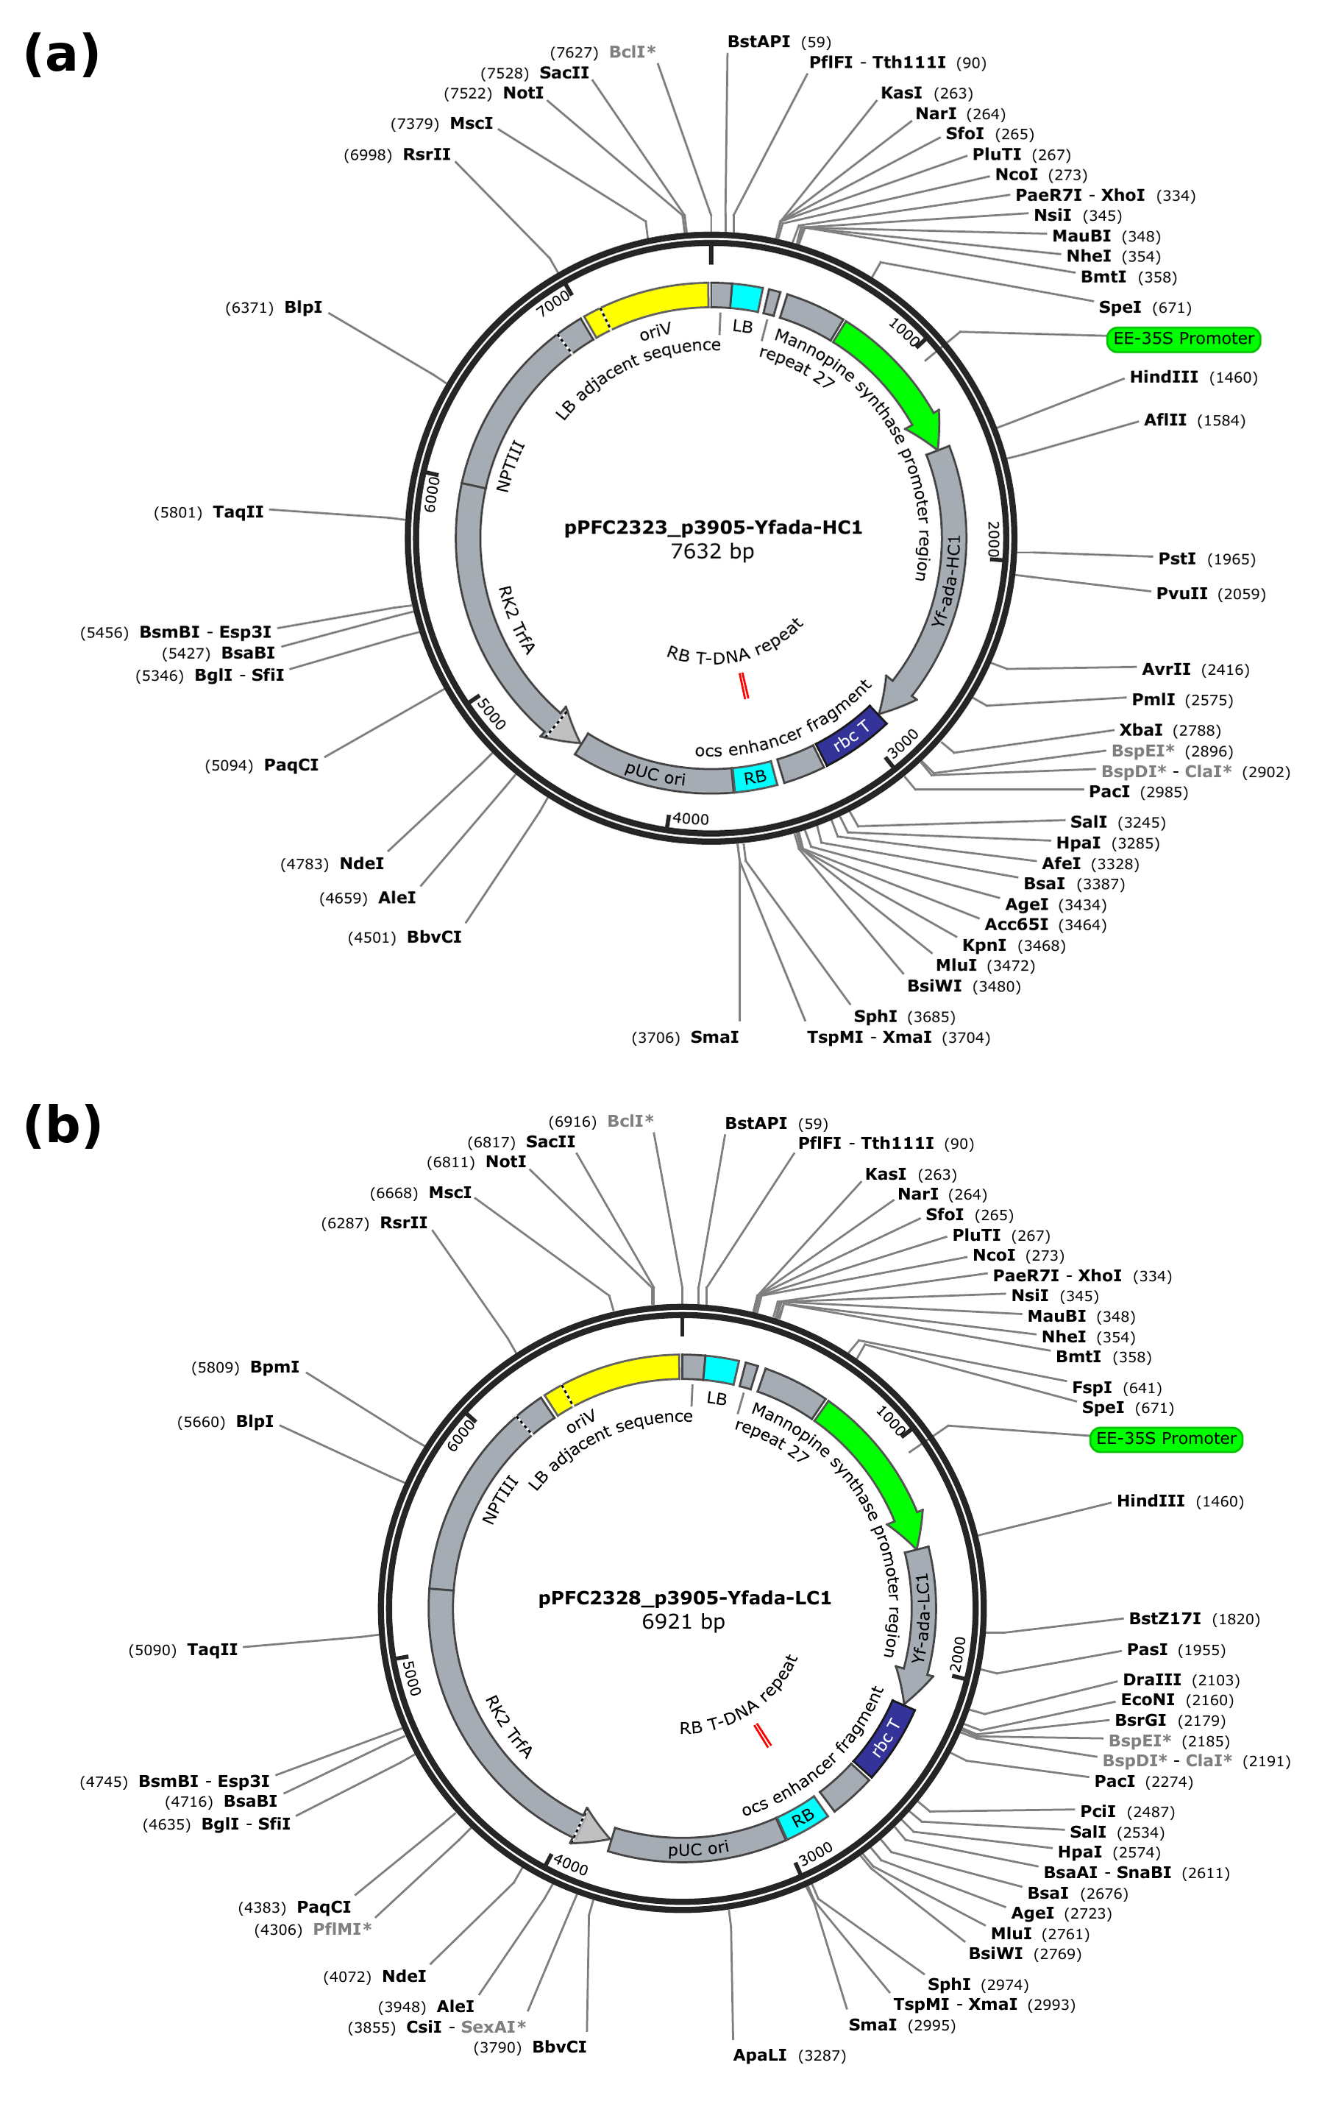
Figure 3. Annotated plasmid maps of the verified p3905-based expression vectors for (a) Yfada-HC1 (pPFC2323, 7632 bp) and (b) Yfada-LC1 (pPFC2328, 6921 bp), showing the EE-35S promoter, HC/LC coding sequence, rbcS terminator, right-border (RB) T-DNA repeat, and the unique restriction sites used for construct verification.
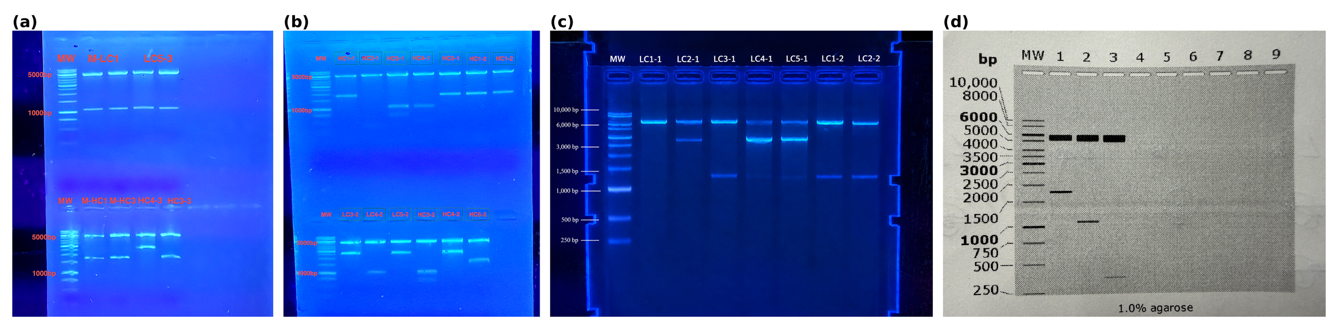
Figure 4. Restriction-digest gel verification (1.0% agarose) across two independent cycles for heavy- and light-chain candidates, including the anomalous HC4 lane that prompted re-verification and its subsequent exclusion. Observed fragment sizes were compared against the predicted digestion pattern for each construct.

3.3 Transient Expression and Protein Yield
In the infiltration trial, all five YF-HC2/LC combinations produced detectable, secreted IgG. Concentrations ranged from 121 to 146 µg/mL across the five light chain pairings, and up to roughly twice the concentration measured for the Trastuzumab reference construct (71.3 µg/mL), and directly comparable to the two previously validated historical benchmark constructs (117–124 µg/mL). Table 3 summarizes yield by construct group.
Construct group | Secreted IgG (µg/mL)
YF-HC2 + YF-LC1–LC5 (this work, n=5 combinations) | 121–146
MM-HC1/MM-LC1 + MM-HC3/MM-LC1 (historical benchmark) | 117–124
Trastuzumab reference | 71.3
Table 3. Secreted IgG concentration by construct group, 7 days post-infiltration. Five plants were infiltrated per condition; four yielded usable measurements and were included in analysis (n=4/condition).
Expression did not increase monotonically with light chain GC content across the five YF-HC2/LC combinations, matching with historical observation that the best construct was high GC without being the single highest GC construct tested. Taken together with the GC gradient design of the candidate set, this is consistent with GC content contributing to, but not fully determining, expression outcome (discussed further below).

3.4 Comparison Across Independent Infiltration Batches (HC2 vs. HC5)
Because the YF-HC5 batch was infiltrated independently, six days after the YF-HC2 batch, each batch was first normalized to its own Trastuzumab reference construct, included in both runs, and expressed as a percentage of that batch's Trastuzumab mean (Figure 5, Table 4). On this normalized basis, the YF-HC2 batch (166–206% across all constructs) appeared uniformly higher than the YF-HC5 batch (124–147%), including for the two MM historical controls that are identical constructs in both batches and unrelated to YF-HC5.
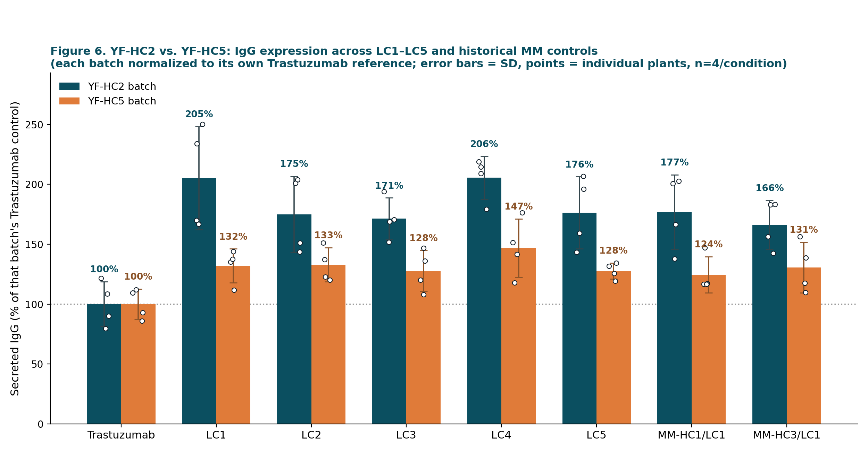
Figure 5. Secreted IgG (% of each batch's own Trastuzumab reference) for YF-HC2 (teal) vs. YF-HC5 (orange) across the five light-chain candidates and two historical MM controls. Error bars = SD; points = individual plants (n=4/condition).
Construct | YF-HC2 batch (% Trastuzumab) | YF-HC5 batch (% Trastuzumab)
Trastuzumab (reference) | 100 | 100
LC1 | 205 | 132
LC2 | 175 | 133
LC3 | 171 | 128
LC4 | 206 | 147
LC5 | 176 | 128
MM-HC1/LC1 (historical) | 177 | 124
MM-HC3/LC1 (historical) | 166 | 131
Table 4. Secreted IgG (% of that batch's Trastuzumab reference) by construct, YF-HC2 vs. YF-HC5 infiltration batches.
HC2's Trastuzumab control averaged 279.6 mg/kg while HC5's averaged 402.4 mg/kg. But the actual YF light chain constructs expressed similarly in both batches (479–575 vs. 514–591 mg/kg). So HC2 would "be stronger" because its Trastuzumab reference happened to be unusually low, not because HC5's constructs underperformed.
Construct | YF-HC2 batch (mg/kg FW, mean ± SD) | YF-HC5 batch (mg/kg FW, mean ± SD)
Trastuzumab (reference) | 279.6 ± 52.4 | 402.4 ± 50.8
LC1 | 573.9 ± 120.4 | 531.3 ± 56.7
LC2 | 489.0 ± 89.3 | 534.7 ± 57.3
LC3 | 479.0 ± 48.7 | 514.0 ± 69.2
LC4 | 574.7 ± 50.0 | 590.7 ± 97.8
LC5 | 493.1 ± 84.0 | 513.9 ± 26.9
MM-HC1/LC1 (historical) | 494.7 ± 86.6 | 500.8 ± 61.0
MM-HC3/LC1 (historical) | 465.0 ± 56.7 | 525.3 ± 85.2
Table 5. Fresh-weight-normalized IgG yield (mg/kg FW) by construct and batch, mean ± SD (n=4/condition), without normalization to the Trastuzumab control. This yield metric was reported directly by the BLItz workflow; the relationship between this fresh-weight-normalized value and the concentration values (µg/mL) reported in Table 3 was not independently verified in this study (leaf fresh weight and extraction volume per sample were not recorded in a form that would allow reconstructing this conversion).
To test statistically whether GC content of the light chain influences expression, one-way ANOVA (LC identity, five levels) was run separately within each batch on raw mg/kg values, and simple linear regression of expression against each LC's GC content (LC1/LC4 = 47.6%, LC2 = 42.1%, LC3 = 41.9%, LC5 = 44.9%) was run both within each batch and pooled across both batches with a batch indicator included. A two-way ANOVA (batch × LC identity) was also run on the pooled raw data. Table 6 summarizes these results.
Test | Statistic | p-value
One-way ANOVA, LC identity (YF-HC2 batch only) | F(4,15) = 1.34 | 0.299
One-way ANOVA, LC identity (YF-HC5 batch only) | F(4,15) = 0.93 | 0.475
Linear regression, expression ~ GC% (YF-HC2 batch) | R² = 0.231 | 0.032
Linear regression, expression ~ GC% (YF-HC5 batch) | R² = 0.066 | 0.273
Two-way ANOVA, batch main effect (pooled) | F(1,30) = 0.40 | 0.531
Two-way ANOVA, LC-identity main effect (pooled) | F(4,30) = 1.95 | 0.129
Two-way ANOVA, batch × LC interaction (pooled) | F(4,30) = 0.42 | 0.793
Multiple regression, expression ~ GC% + batch (pooled) | GC% coef. = 11.29 ± 4.51 (SE); 95% CI [2.16, 20.43] | 0.017
Table 6. Statistical tests for an effect of light-chain GC content and infiltration batch on secreted IgG (raw mg/kg).
LC identity was not significantly associated with expression in either batch's one-way ANOVA, nor as a main effect in the pooled two-way ANOVA (p = 0.13). In a separate, exploratory analysis treating GC content specifically as a continuous predictor, higher GC content was associated with higher expression within the YF-HC2 batch alone (p = 0.032, R² = 0.23) and in the pooled regression after controlling for batch (p = 0.017; coefficient = 11.29 ± 4.51 mg/kg per percentage point of GC, 95% CI [2.16, 20.43]), though not within the YF-HC5 batch alone (p = 0.27). The batch main effect was not significant in the two-way ANOVA on raw mg/kg (p = 0.53), consistent with the raw concentration comparison in Table 5 showing the YF constructs performing similarly across batches. The pooled analysis therefore identifies an exploratory association between LC GC content. (but need more testing results and better data analysis design)

4. Discussion
The infiltration results showed that this model achieved a functional outcome: sequences never directly optimized against a wet lab expression measurement matched (not outperformed) the yield of historical optimization constructs (121–146 vs. 117–124 µg/mL). This gap between favorable sequence-level metrics and unproven expression superiority echoes Constant et al. (2023), who found that optimizing for natural codon usage patterns alone does not reliably predict which synonymous sequence expresses best in E. coli. The functional expression data made their models predictive. The present pipeline optimizes only against sequence-level proxies (GC, tAI, an RNA-structure approximation) with no expression measurements in the training loop, which makes the parity result more notable but also means the pipeline cannot yet learn from the very data collected here. Feeding measured expression back into candidate scoring, as Constant et al. did for E. coli, is a more direct route to clearly outperforming the historical benchmark than further tuning of sequence-level proxies alone.
The GC-gradient result does not match an earlier assumption that the best prior construct was high-GC. But since we only varied the light chain while keeping one heavy chain (YF-HC2) fixed, we cannot tell whether it is the light chain driving the effect, or how that specific heavy and light chain work together. It is also worth being critical about how large a light chain effect should even be expected. Veber et al. (2025) compared light chain variants for these same two antibodies, Adalimumab and Trastuzumab, in HEK293 and CHO cells and found light chain selection had minimal impact on IgG expression in those mammalian systems. That result does not transfer directly to a plant host, but it is a useful prior for treating a small GC association as preliminary rather than as a design principle. A full HC × LC factorial run within a single Agrobacterium batch, with more plants per condition, is the most direct way to resolve this.
Several limitations should be considered when interpreting these results. First, the RNA-structure term used during training is an explicit composition-based proxy, not true thermodynamic folding energy; RNAfold-computed MFE was used only for post-hoc candidate scoring after decoding, not inside the training loop, so the training signal for RNA structure is weaker and less direct than the GC or tAI terms. Second, the training set used here (up to 20,000 amino-acid/codon pairs after filtering) is smaller than the full LAB360-derived annotation pool that could in principle be used, which may limit how finely the model has learned less common context-dependent codon preferences. Third, biological constraints (GC range, restriction sites, poly(A) motifs, miRNA seed matches) are applied at two different stages, differentiable loss terms during training and filters during post-selection, and the miRNA screen in particular is explicitly flagged in the implementation as weak evidence, appropriate for flagging candidates rather than excluding them outright. Finally, protein yield was measured from a single infiltration trial with five plants infiltrated per condition, of which four yielded usable measurements (n=4/condition); broader claims about reproducibility or generalization to other antibodies would require independent repeat trials. Besides, previous N. benthamiana codon modeling clustered sequences at 95% identity with CD-HIT before splitting data to prevent high-homology leakage between partitions (Tekle, 2025), but no reduction step was applied here, so some train/validation/test overlap from sequences cannot be ruled out

When testing whether GC content affects expression across all the infiltration data (Table 6), the result might be significant if GC content is treated as a continuous number (p = 0.017, R² = 0.15), but the same data show no significant difference when LC identity is instead treated as a categorical group and tested by ANNOVA, testing overall differences among the five LC sequences, not of GC specifically. Therefore, GC content appears to contribute to expression, but only modestly, and this association should be treated as exploratory given that only five LC sequences and four distinct GC levels were tested. One reasonable explanation is that GC affects how long the mRNA sticks around rather than how fast it's translated. Older work in tobacco showed that AU-rich sequences make mRNA break down faster (Ohme-Takagi et al., 1993), so higher-GC sequences might simply last longer in the cell.

Plant DNA language models are an active area. Liu et al. (2025) recently introduced PDLLMs, the DNA language models built specifically for plant genomes, motivated by the observation that general purpose genomic language models (e.g., DNABERT-2, the Nucleotide Transformer) are trained mainly on human or non-plant genomes, while the one existing plant foundation model, AgroNT, is too large for most individual labs to train or fine tune. Additionally, larger, multispecies-pretrained models (e.g., CodonTransformer (Fallahpour et al., 2025)) might modestly improve codon-level accuracy, and structure-aware networks could model RNA folding more directly than the composition-based proxy used here. A vision Transformer is a poor fit, because ViTs operate on patch-based attention over 2D image data, and a codon sequence has no natural spatial structure unless first converted into an image representation. More importantly, the real gaps are the lack of expression level feedback in training (Section 4) and the limited statistical power of the infiltration data (n = 4/condition). The more direct path forward is architecture-agnostic thst more expression data fed back into the objective, and a cleaner experimental design to interpret it.

5. Conclusion
This work developed and validated a Transformer-based codon optimization pipeline that conditions on plant genome context and target sequence properties during training, but not relying on static frequency tables or filtering. Applied to the Adalimumab heavy and light chains, the pipeline generated candidates with complete amino acid fidelity and near-target GC, tAI, and RNA-stability properties; nine of ten selected constructs were cloned and verified without protocol failure; and, in transient expression, model-generated sequences matched the secreted IgG yield of refined constructs with manual optimization, comparable to the loop closed by Constant et al. (2023) for E. coli once functional expression data was incorporated. A full HC × LC factorial infiltration, run within a single Agrobacterium batch with more plants per condition, is the most direct next step for resolving the GC and light chain questions raised in Sections 3.4 and 4, alongside feeding the resulting expression data back into the model's post-selection weighting. More broadly, these results support the feasibility of learned, biologically constrained codon design as a practical complement to manually optimized sequences in plant-based recombinant protein production.

References
Constant, D. A., Gutierrez, J. M., Sastry, A. V., Viazzo, R., Smith, N. R., et al. (2023). Deep learning-based codon optimization with large-scale synonymous variant datasets enables generalized tunable protein expression. bioRxiv. https://doi.org/10.1101/2023.02.11.528149
Fallahpour, A., Gureghian, V., Filion, G. J., Lindner, A. B., & Pandi, A. (2025). CodonTransformer: A multispecies codon optimizer using context-aware neural networks. Nature Communications, 16, Article 3205. https://doi.org/10.1038/s41467-025-58588-7
Goodin, M. M., Zaitlin, D., Naidu, R. A., & Lommel, S. A. (2008). Nicotiana benthamiana: Its history and future as a model for plant–pathogen and plant–microbe interactions. Molecular Plant-Microbe Interactions, 21(8), 1015–1026.
Hanson, G., & Coller, J. (2018). Codon optimality, bias and usage in translation and mRNA decay. Nature Reviews Molecular Cell Biology, 19(1), 20–30.
Liu, G. Q., Chen, L., Wu, Y. C., Han, Y. S., Bao, Y., & Zhang, T. (2025). PDLLMs: A group of tailored DNA large language models for analyzing plant genomes. Molecular Plant, 18(2), 175–178.
Lorenz, R., Bernhart, S. H., Höner zu Siederdissen, C., Tafer, H., Flamm, C., Stadler, P. F., & Hofacker, I. L. (2011). ViennaRNA Package 2.0. Algorithms for Molecular Biology, 6, Article 26.
Lowe, T. M., & Chan, P. P. (2016). tRNAscan-SE On-line: Search and contextual analysis of transfer RNA genes. Nucleic Acids Research, 44(W1), W54–W57.
Ohme-Takagi, M., Taylor, C. G., Newman, T. C., & Green, P. J. (1993). The effect of sequences with high AU content on mRNA stability in tobacco. Proceedings of the National Academy of Sciences, 90(24), 11811–11815.
Plotkin, J. B., & Kudla, G. (2011). Synonymous but not the same: The causes and consequences of codon bias. Nature Reviews Genetics, 12(1), 32–42.
Quax, T. E. F., Claassens, N. J., Söll, D., & van der Oost, J. (2015). Codon bias as a means to fine-tune gene expression. Molecular Cell, 59(2), 149–161.
Ranawaka, B., An, J., Lorenc, M. T., Jung, H., Sulli, M., Aprea, G., et al. (2023). A multi-omic Nicotiana benthamiana resource for fundamental research and biotechnology. Nature Plants, 9, 1558–1571. https://doi.org/10.1038/s41477-023-01489-8
Sol Genomics Network. (2026). Nicotiana benthamiana LAB360 genome assembly and annotation [Data set]. Retrieved August 11, 2026, from https://solgenomics.net/ftp/genomes/Nicotiana_benthamiana/LAB360/
Tekle, T. (2025). Optimizing biopharming operations using a transformer autoregressive deep learning model for codon prediction [Unpublished master's project]. University of Guelph.
Vaswani, A., Shazeer, N., Parmar, N., Uszkoreit, J., Jones, L., Gomez, A. N., Kaiser, Ł., & Polosukhin, I. (2017). Attention is all you need. Advances in Neural Information Processing Systems, 30, 5998–6008.
Veber, A., Lenau, D., Gkragkopoulou, P., Kornblüh Bauer, D., Focken, I., Leuschner, W. D., Beil, C., Weil, S., Rao, E., & Langer, T. (2025). Impact of light-chain variants on the expression of therapeutic monoclonal antibodies in HEK293 and CHO cells. Antibodies, 14(3), Article 53.
Additional Figures
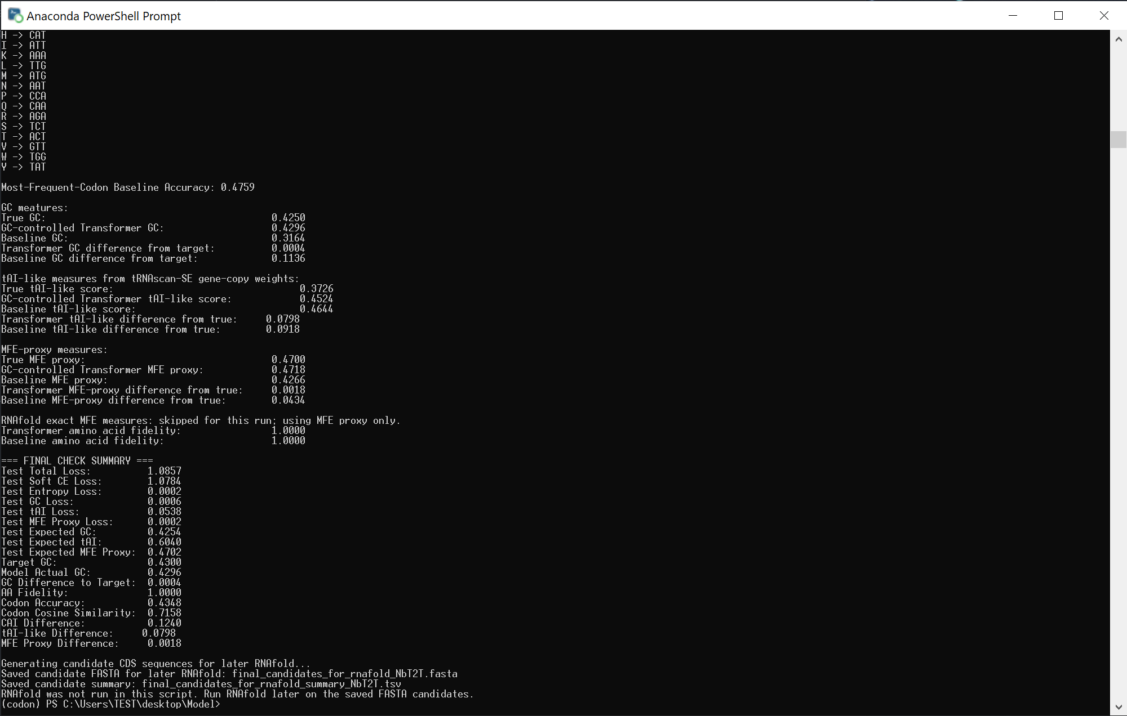
Figure 6. Console output from the final held-out test-set evaluation of the trained model, corresponding to the metrics reported in Table 2 (amino-acid fidelity, codon accuracy, GC/tAI/MFE-proxy differences from target and from the true native sequences, and the most-frequent-codon baseline comparison).
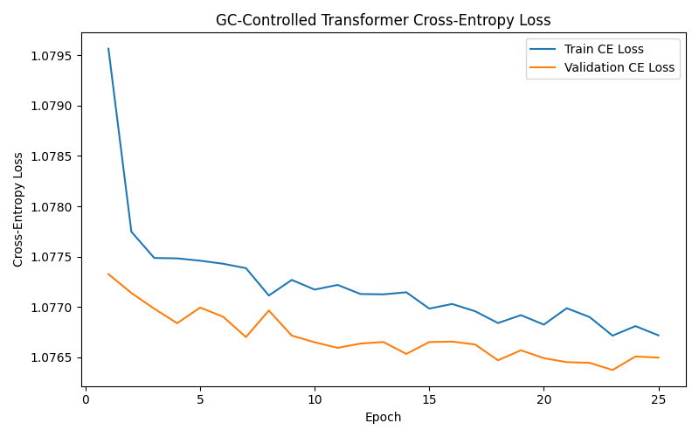
Figure 7. Training and validation cross-entropy loss (soft codon cross-entropy component of the composite loss, Table 1) over 25 training epochs on the training dataset (Section 2.1).
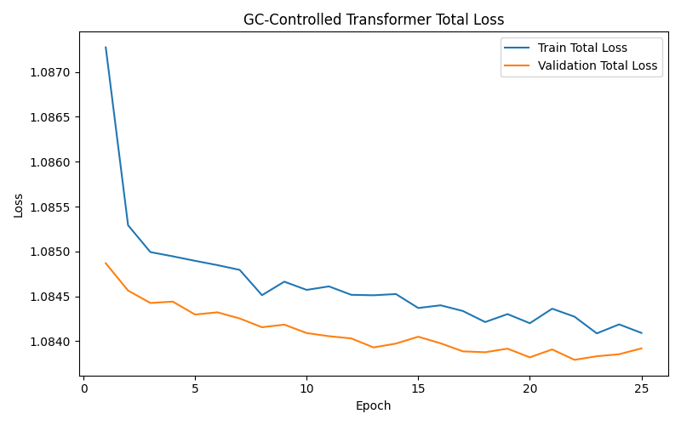
Figure 8. Training and validation total loss (the full composite objective, combining soft cross-entropy, entropy-matching, GC-content, tAI-like, and RNA base-pairing terms; Table 1) over 25 training epochs.

