A4Q1:

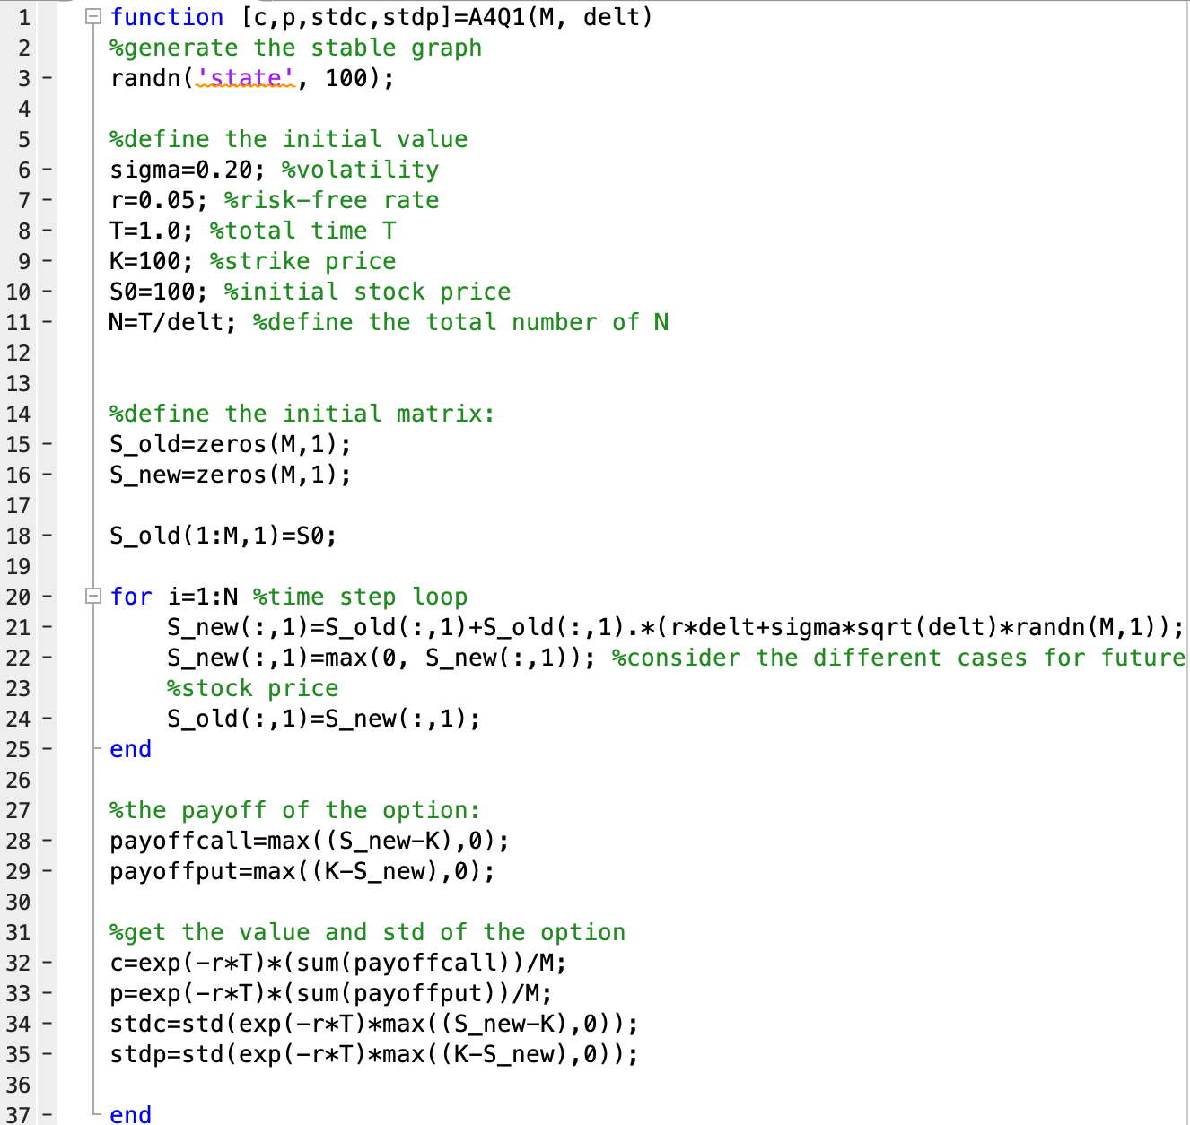

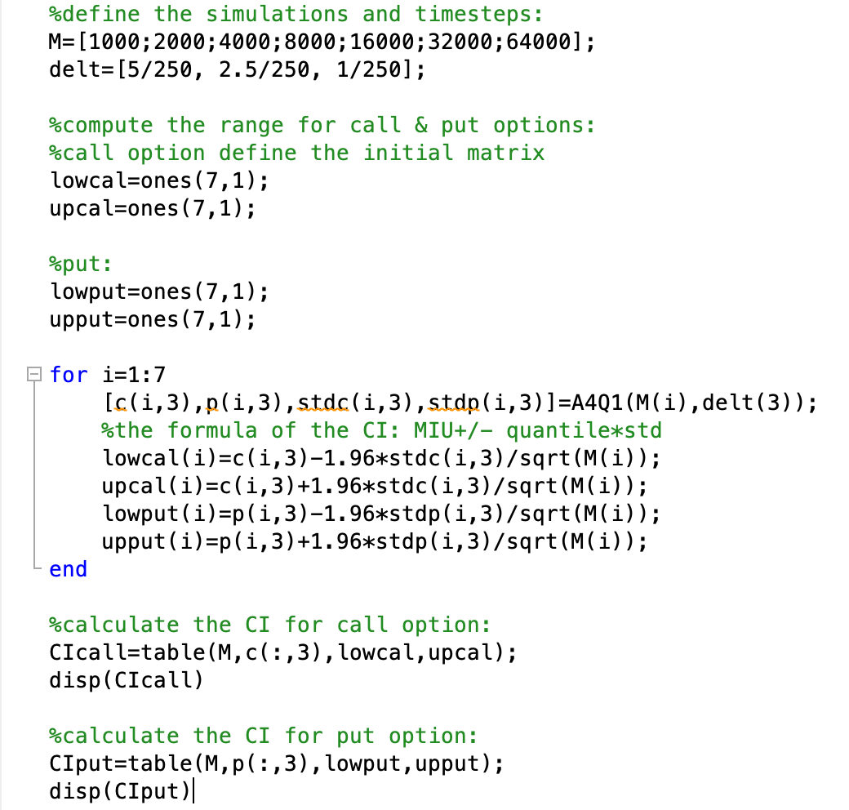

Output for call option:

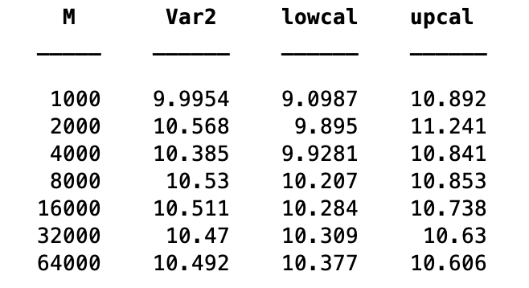

Output for put option:

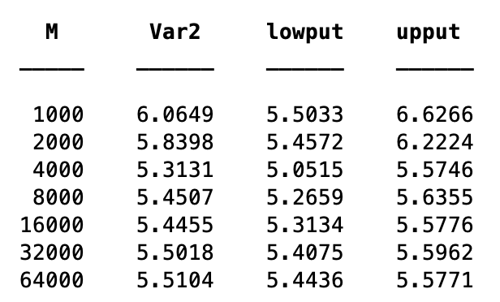

The tables tell us: when the number of simulations(M) increase, the mean of the option value will approach to the exact mean value.

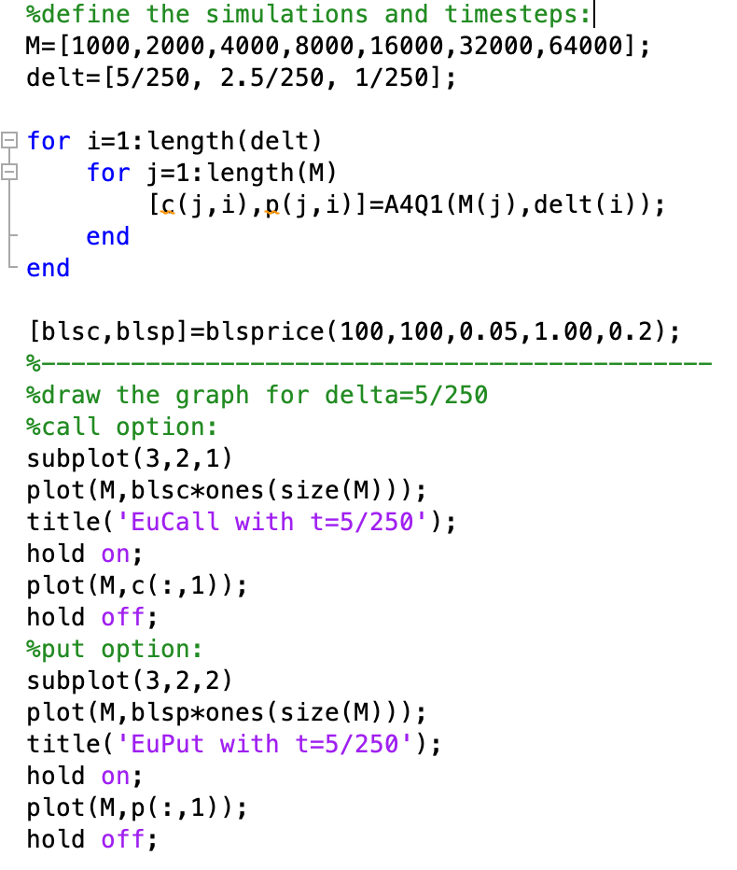

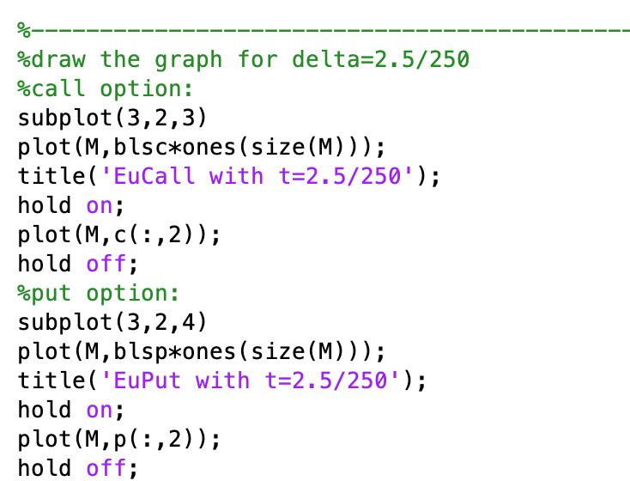

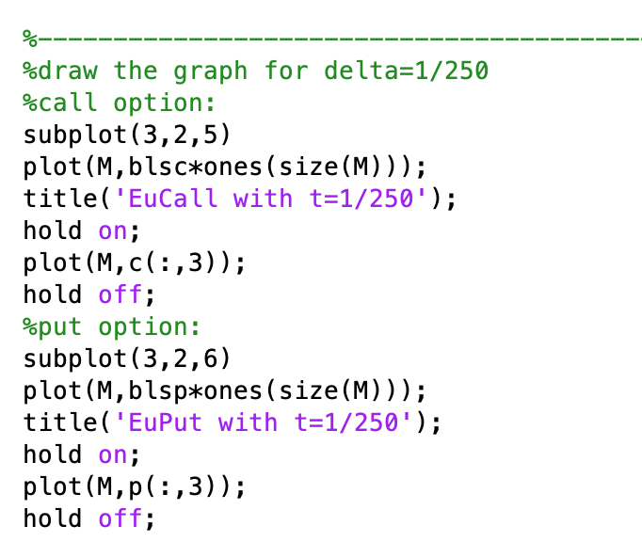

The graph output:

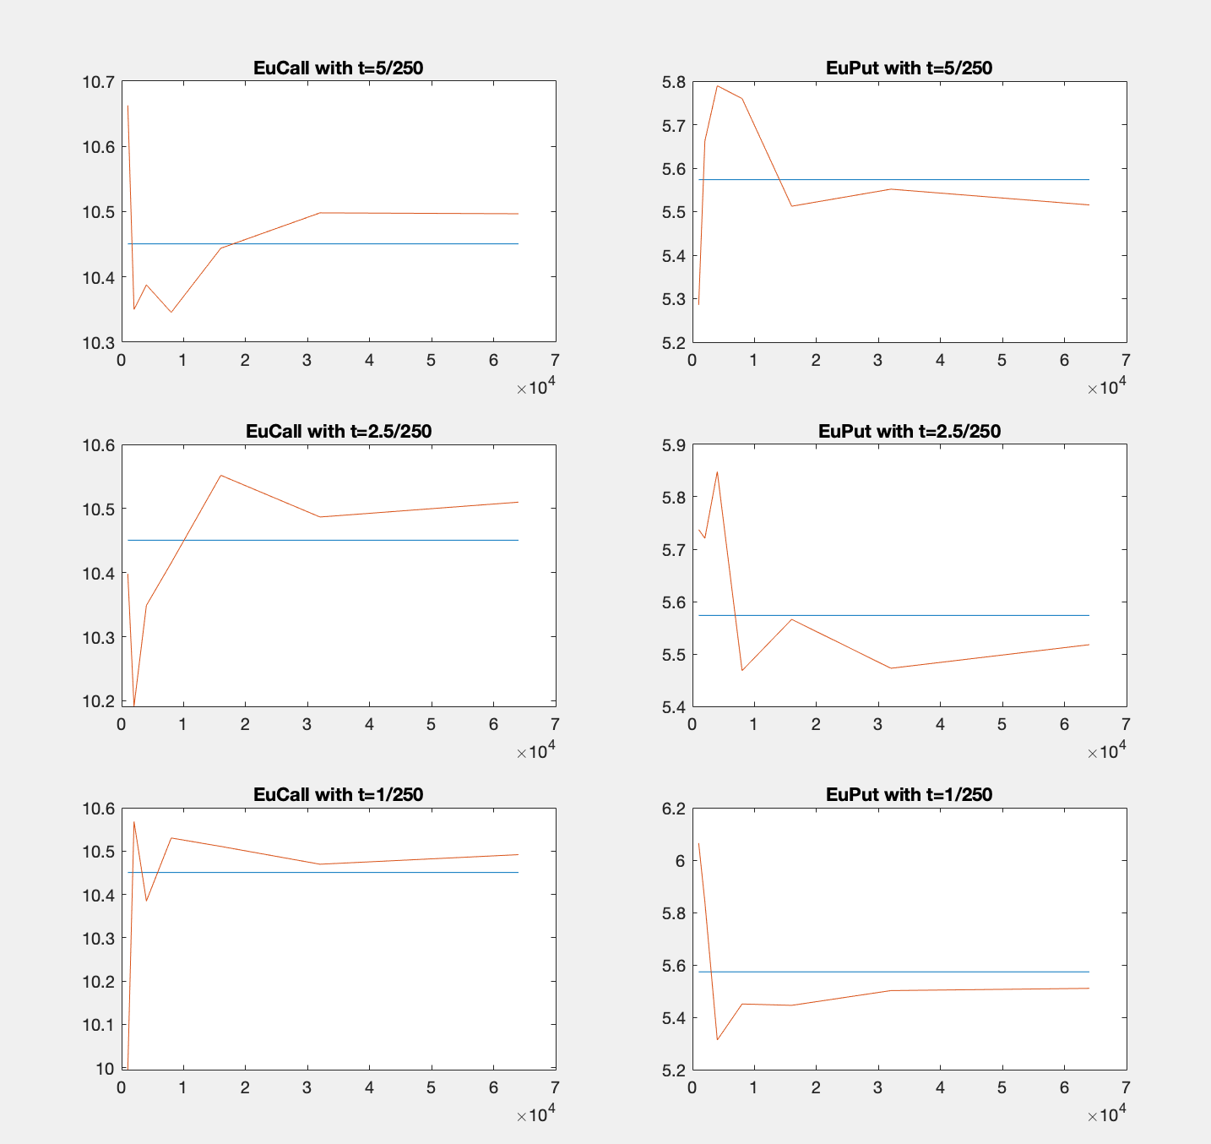

By observing from the graph, we find as the total number of simulations increases, the option price tends to approach to the exact value of option calculated by BS equation, which means as the total simulation increases, the error of the option prices will become smaller. In this case, we need to try more times of simulations to reduce the error when we use Monte Carlo method.