A4q3:





Graph:

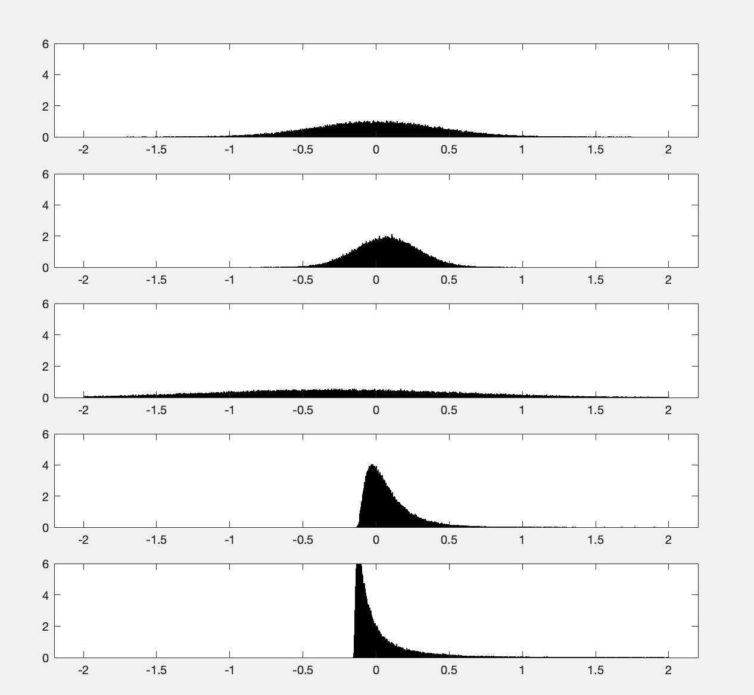

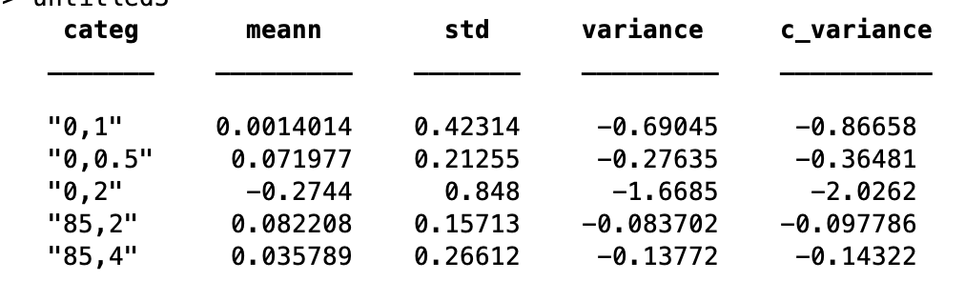

We observed that the mean with (F,M)=(0,2) is negative, which means this is a relative loss compared to the BS strategy, while all the rest of 4 cases are positive. When F is fixed and M increases, we will get a smaller mean, larger std, smaller Var and smaller cVAR. Our goal is to keep the smallest loss and high return. Among these 5 cases, we prefer the(F,M)=(85,2).

From the output table, the 4th and 5th graphs have heavy right tails (highly-skewed) comparing to the first 3 graphs. The 4th and 5th graph have less probability to face loss. Also, we find the 3th graph has the largest variance. Thus, in order to gain more profits, we prefer larger F.