SPRING 2023-2024
SE112 – INTRODUCTION TO SOFTWARE ENGINEERING
Class Attendance System
GROUP 33
22243810049 – YİĞİT ŞEVKİ KAPLAN
22244710058 – YUSUF ÖZDOĞAN
Table Of Contents
1.Project Proposal 2
2. Project Management 3
2.1 Project Plan 3
2.2 Risk Plan 3

Project Proposal

CLASS ATTENDANCE SYSTEM

Project/Problem Description: The aim of this project is to creating a system that allows the lecturer to see who participate in the class safe and accurate. For this instance, system through image processing will be developed (VISION/WHAT?). Class Attendance system is a image processing based application designed for the use of all kinds of lecturers. The data base on this system will contain student details (id number, name, surname, photograph). System will automatically detect the student and will update the data system. Users can see or search for all the details about the person in an efficent and consistant way (ISSUE/WHY?). The system will show the users most absent student at that time. Image processing and ChatGPT will be used to develop this project (SOFTWARE DEVELOPMENT METHODOLOGY/HOW?).

2. Project Management

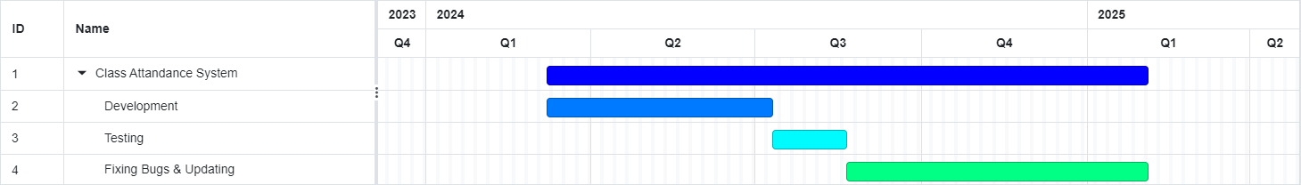
2.1 Project Plan

2.2 Risk Plan

Likelihood | Consequences
 | Insignificant | Minor | Moderate | Major | Catastrophic
Almost Certain |  |  | If he’s/she’s  wearing a  mask
Likely
Moderate | Users may  run out of  battery |  |  |  | The system  may mistake  similar people  for the same looks
Rare |  |  |  |  | Outdated data on the system
Never

High Risk, Significant Risk, Moderate Risk, Low Risk

Plan B for the “Outdated data on the system”
System may directly connect to the schools own system

