SAR Automatic Target Recognition Benchmark
From Handcrafted Features to Vision Transformers on MSTAR
MSTAR SOC 10-class SAR Automatic Target Recognition — Handcrafted + SVM vs ResNet18 (CNN) vs DeiT-Small (ViT)

Ali Yiğit Başaran
June 2026

Agenda
- Problem Statement
- Objectives and Claims
- Dataset (MSTAR SOC) and Exploratory Data Analysis
- Methodology: Experimentation Pipeline, Data Splitting, Preprocessing
- Models Investigation— Architectures, Parameters
- Benchmark & Evaluation Protocol
- Results: Metrics, Plots and Commentary
- Discussion, Limitations, Conclusions & Recommendations

Problem Statement
- Task: Recognize 10 military vehicle classes from Synthetic Aperture Radar (SAR) imagery — Automatic Target Recognition (ATR).
- SAR ≠ Optical: Images carry multiplicative speckle noise and encode geometry as bright scattering centers, not familiar texture.
- Fine-Grained Difficulty: Several vehicles (wheeled APCs) have nearly identical SAR signatures and vary strongly with aspect angle.
- Standard Protocol (SOC – Standard Operating Conditions): Train on a 17° depression angle, test on a different 15° angle — a genuine generalization test, not a random split.
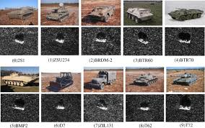
Objectives & Claims
- Objective: Benchmark three representative approaches for SAR target classification—Handcrafted + SVM, ResNet18, and DeiT-Small—using a common train/test split and evaluating both classification performance and computational cost.
- Claim 1: Learned feature is expected to representation significantly outperform handcrafted descriptors.
- Claim 2: Overall performance is expected following the ranking DeiT-Small > ResNet18 > SVM in both Accuracy and Macro-F1.
- Claim 3: The largest improvements are expected to be observed on the most challenging, visually similar vehicle classes.

Dataset — MSTAR SOC
- Dataset contains 10 military vehicle classes: 2S1, BMP2, BRDM2, BTR60, BTR70, D7, T62, T72, ZIL131, and ZSU234.
- Each sample is a single-channel 128×128 SAR image, with a small bright target on a mostly dark background.
- Pixel mean 0.0295, std 0.0346 (range 0–255) → dark frames, small bright target.
- 2747 train (17° Depression angle) / 2425 test (15° Depression angle).

Class | Train | Test
2S1 | 299 | 274
BMP2 | 233 | 195
BRDM2 | 298 | 274
BTR60 | 256 | 195
BTR70 | 233 | 196
D7 | 299 | 274
T62 | 299 | 273
T72 | 232 | 196
ZIL131 | 299 | 274
ZSU234 | 299 | 274

Dataset — Sample Imagery
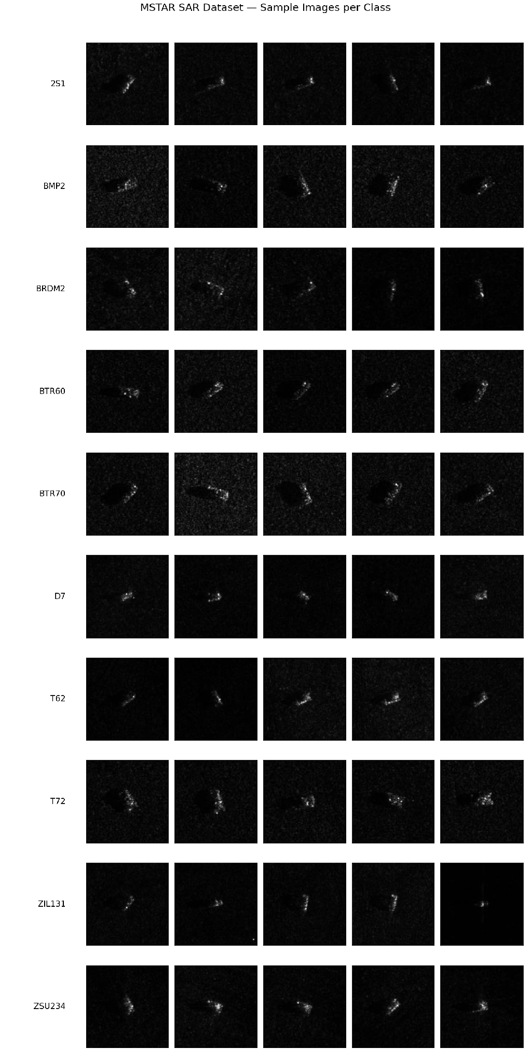
Five random chips per class. A bright target blob on a dark, speckled background; strong within-class aspect-angle variation.
EDA — Class Balance (Train 17° vs Test 15°)
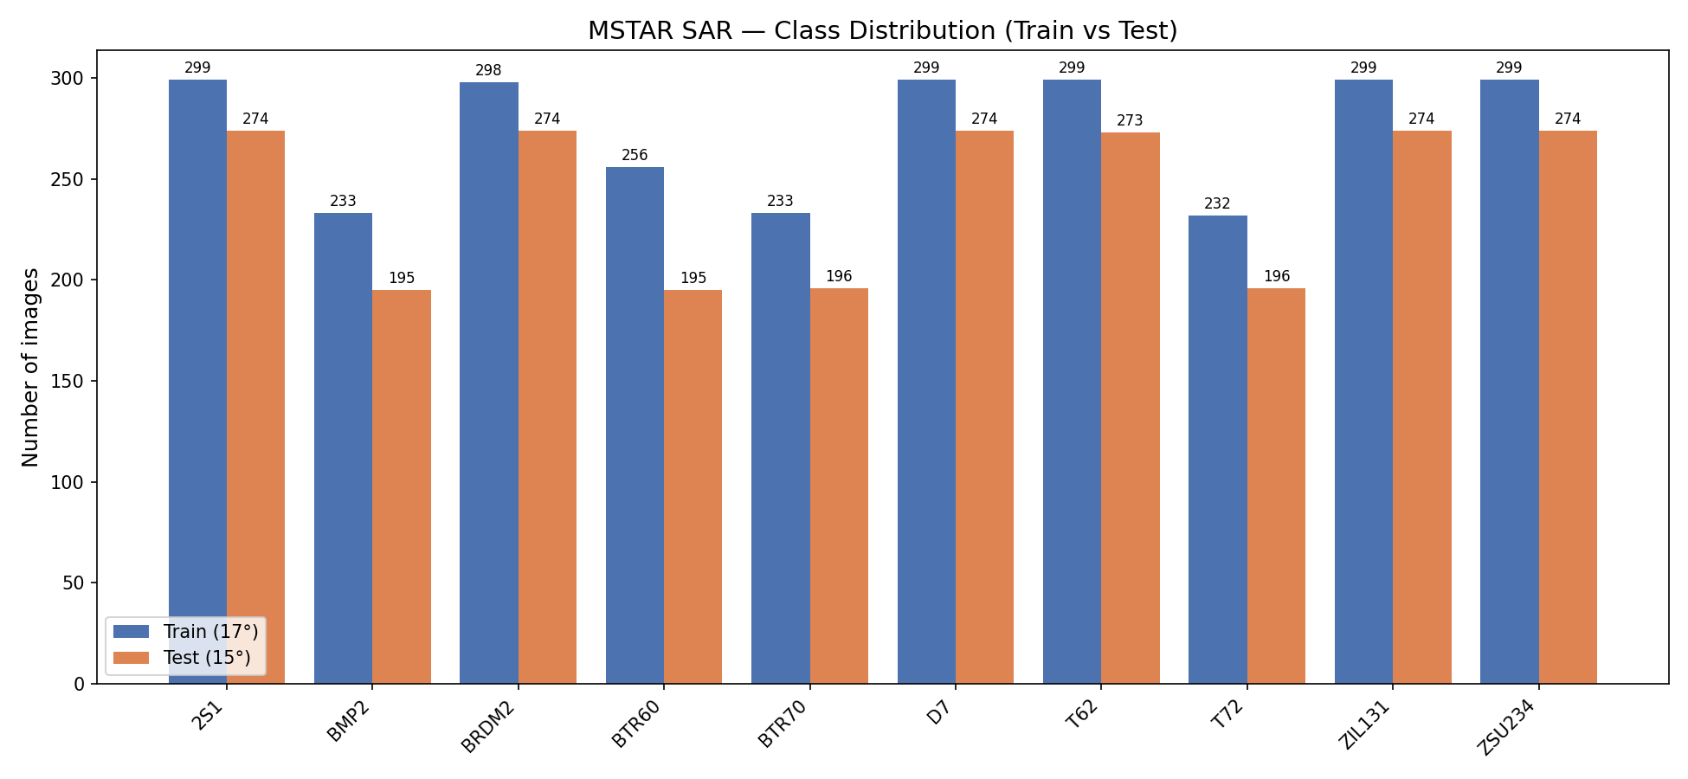
- Distributions are similar across splits and only mildly imbalanced (232–299 per class) → macro-averaged metrics are the right headline.

EDA — Per-Class Average Signatures
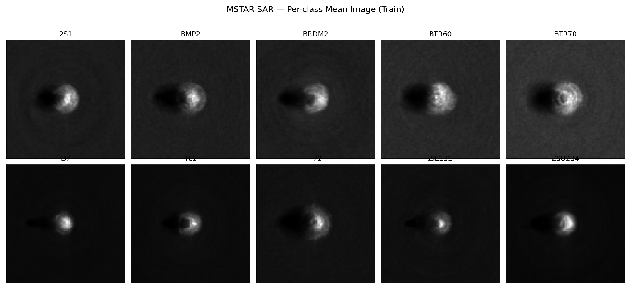
- Class-average images reveal characteristic target shapes and size patterns, such as long-barreled tanks versus more compact APC vehicles.
- The observed blur is caused by variations in viewing angle within each class, reflecting the diversity of target appearances (wrt aspect angle).
EDA — Pixel Intensity & Speckle
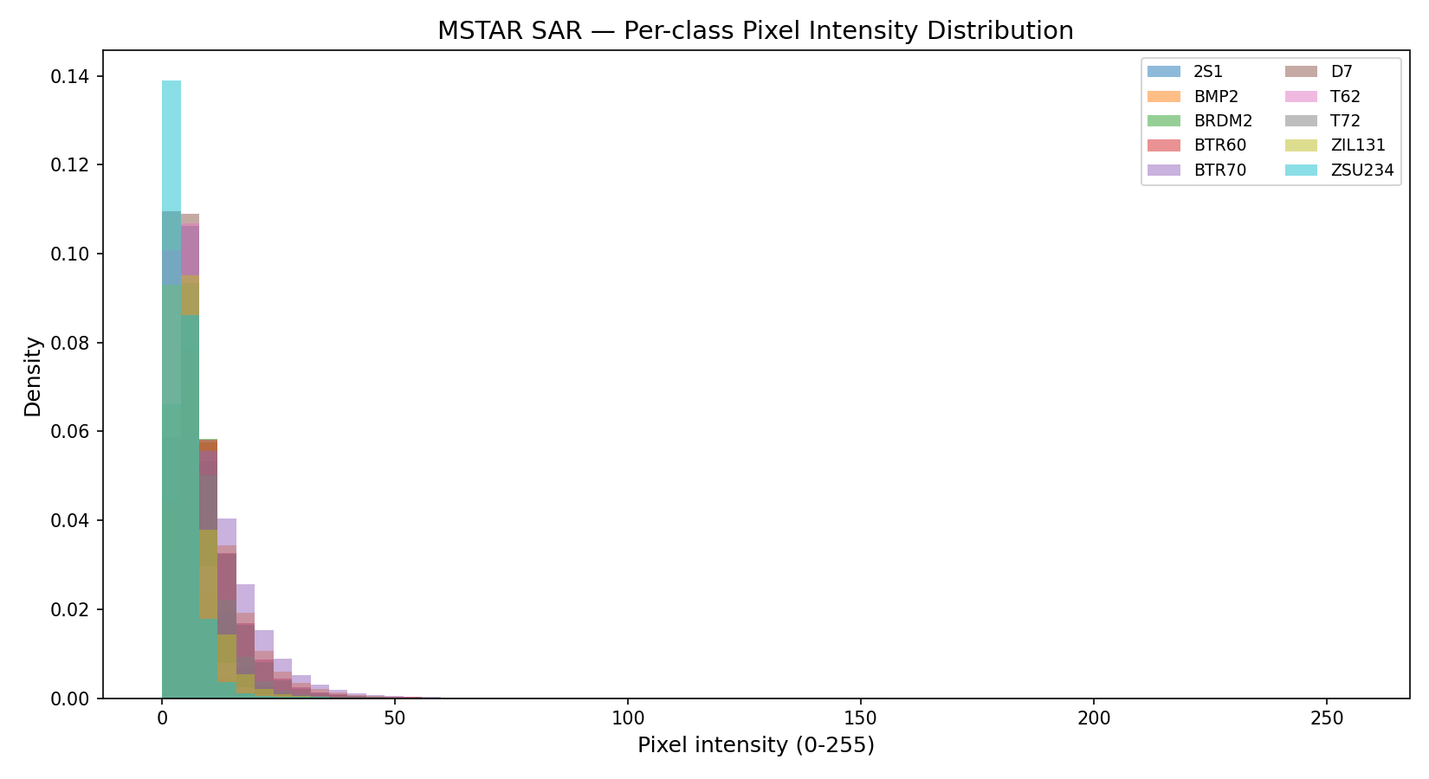
- All classes contain a large number of dark-background pixels, while differences mainly appear in the brighter intensity regions.
- This class-dependent intensity distribution motivates the use of histogram-based features to capture discriminative SAR target information.
EDA — Raw-Pixel Separability (t-SNE)
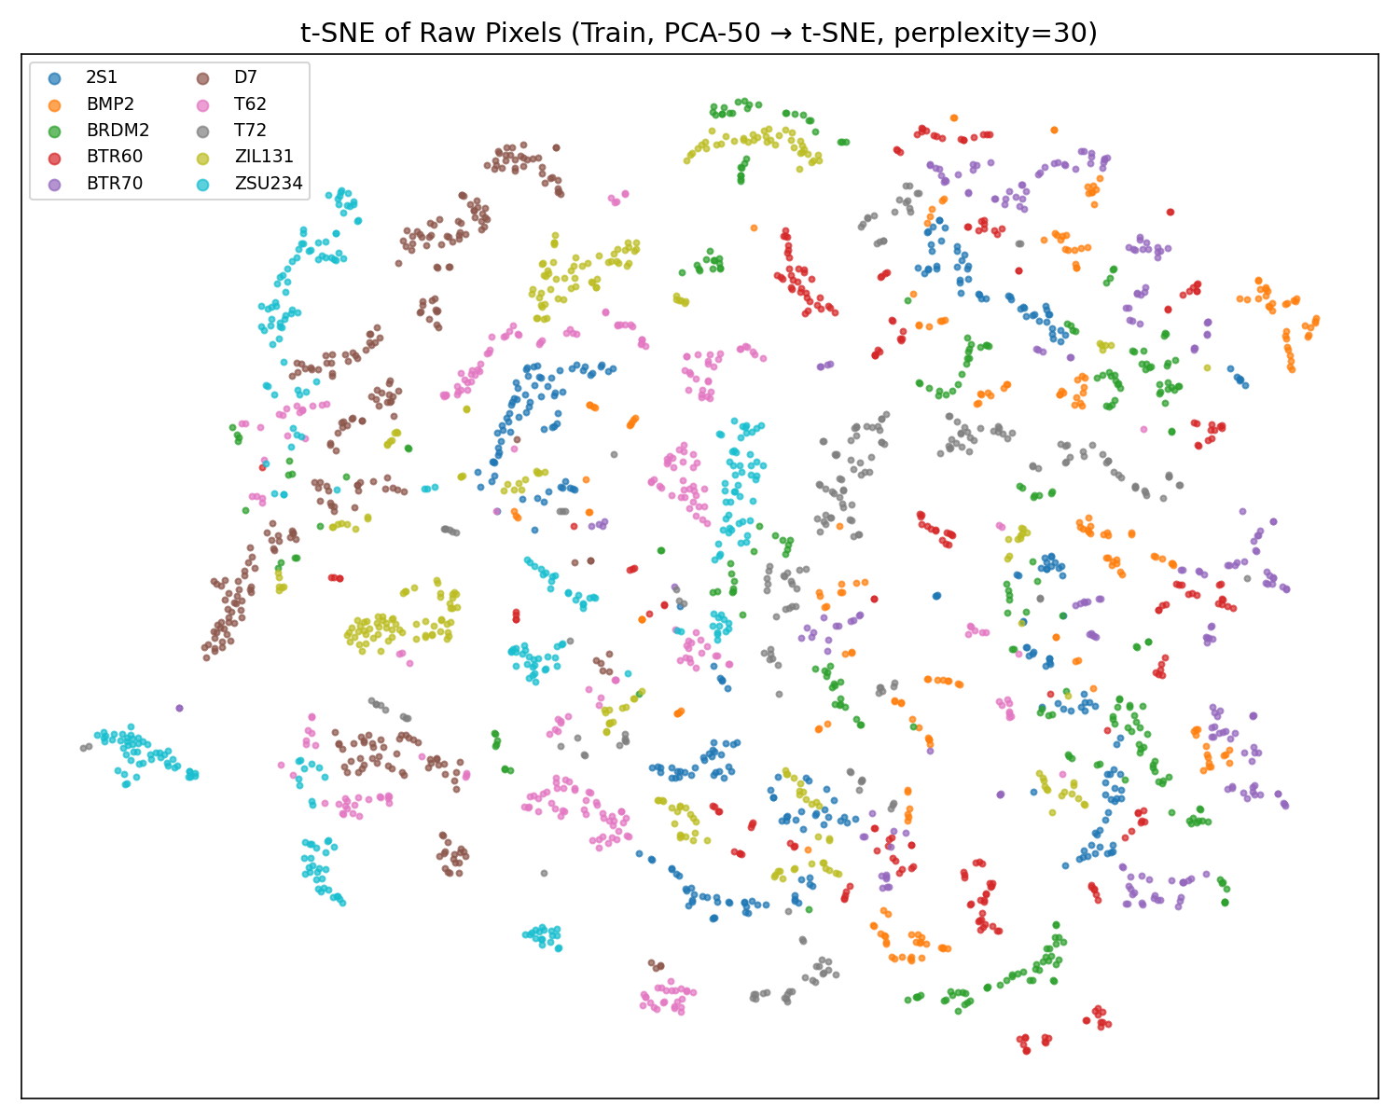
- Raw pixels (PCA-50 → t-SNE): Classes overlap heavily with no clean clusters → the central empirical argument for learned representations.

Experimentation Pipeline
- Shared library in source; one notebook per experiment; each writes its own results.

01 · EDA  stats + plots | → | 02 · SVM 03 · CNN 04 · ViT  train + evaluate | → | 05 · Comparison  plots

- Notebook 01 computes dataset statistics and normalization parameters, which are reused by the CNN and ViT training pipelines.
- Each model notebook (SVM, ResNet18, and DeiT-Small) generates its own metrics, predictions, and trained model files for later evaluation.
- Notebook 05 collects the outputs from all models and produces the final comparisons, tables, and visualizations.
- All notebooks are executed in a fixed order and use the same train/test split, evaluation metrics, plotting code, and shared library to ensure a fair comparison.

Methodology — Shared Pipeline
- Splitting: test = fixed 15° set (2425); training folder gets a stratified 85/15 train/val split (seed 42) → 2334 / 413 / 2425.
- Preprocessing: Grayscale → Resize (128 for CNN, 224 for ViT) → train-only augmentation → normalize → replicate to 3 channels.
- Augmentation: RandomHorizontalFlip, RandomVerticalFlip, RandomRotation(±15°). Eval = resize + normalize only.
- Normalization: Scalar mean/std computed in EDA.
- Reproducibility: Seeding everything (42). GPU runs ~±1% non-deterministic.
- Loss: Cross-entropy
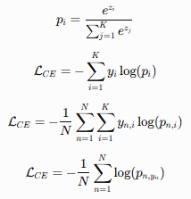
Model 1 — Handcrafted Features + RBF-SVM
Component | Parameters | Dims
Intensity histogram | 64 bins over [0,255], density | 64
HOG | 9 orient · 8×8 cell · 2×2 block · L2-Hys | 8100
Uniform LBP | P=24, R=3, 26-bin density | 26
Total feature vector | concatenated, float32 | 8190

- Classifier: StandardScaler → SVC(kernel=rbf, C=10, gamma=scale, one-vs-rest).
- Why: Strong, interpretable classical baseline mixing global intensity, local gradients and micro-texture.
- Note: All 2747 training points become support vectors → no clean margin; 172 MB model; inference is feature-extraction-bound.
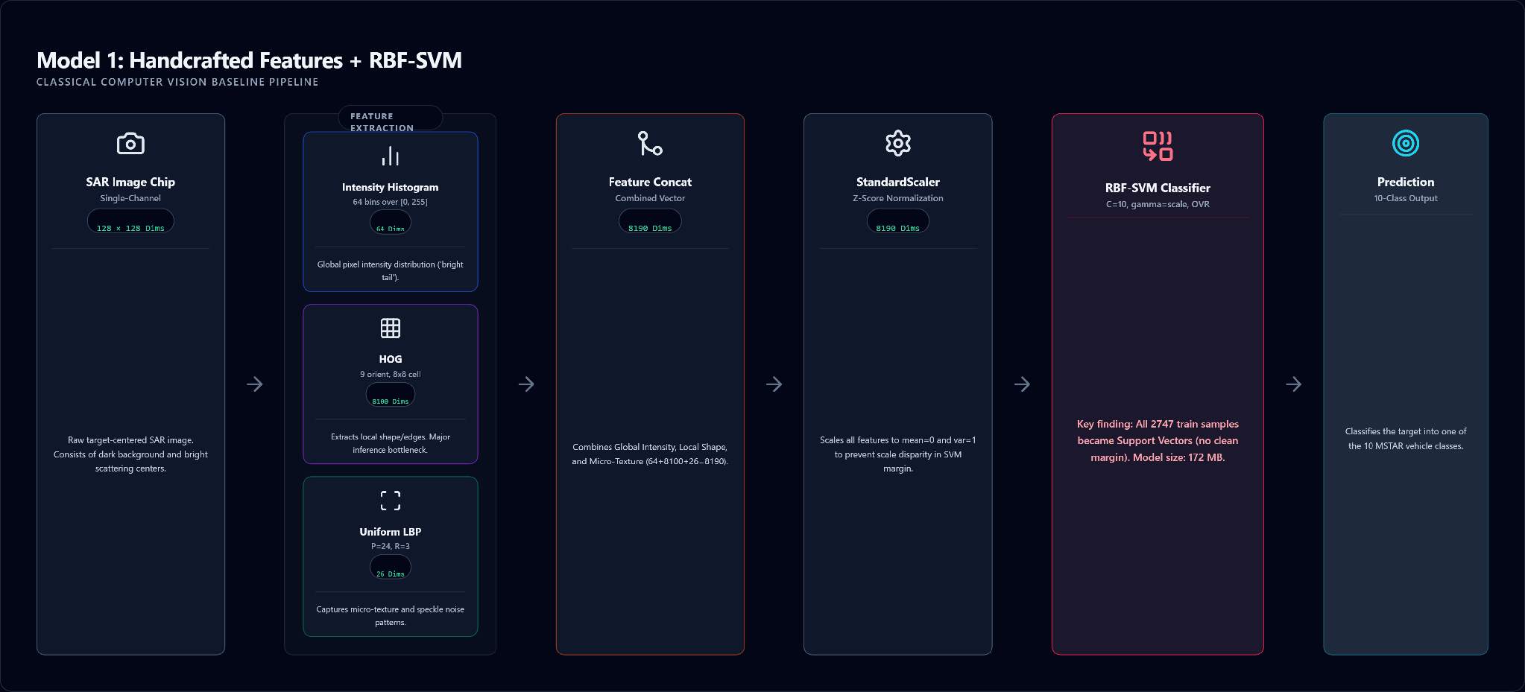
Model 2 — ResNet18 (CNN)
- ImageNet-pretrained ResNet18, FC head → 10 classes, 128×128 3-channel input; 512-d global-average-pool features.
- 11.18M params (10.50M trainable in Phase 2); AdamW, weight decay 1e-4, cross-entropy, early-stop patience 7, best-val checkpoint.

Phase | Trainable | Epochs | LR | Scheduler
1 — head warm-up | fc only | 10 | 1e-3 | none
2 —fine-tune | hidden layers + fc | 15 | 1e-4 | CosineAnnealing

- Frozen ImageNet backbone gives useful low/mid-level filters; unfreezing the deepest blocks re-specializes high-level features to SAR without destabilizing the rest or overfitting the small dataset.
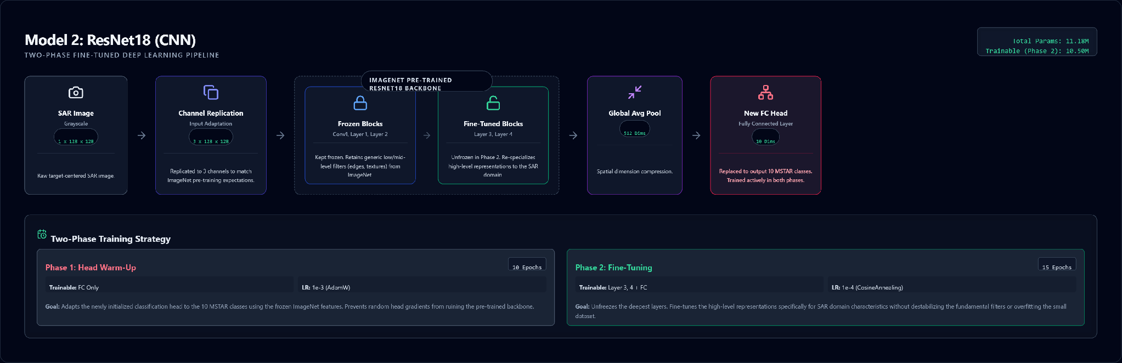
Model 3 — DeiT-Small (Vision Transformer)
- DeiT-Small (deit_small_patch16_224) processes 224×224 images as 196 patch tokens plus a CLS token and produces 384-dimensional feature embeddings using self-attention.
- With 21.67M parameters, it was fully fine-tuned in Phase 2 using AdamW (weight decay = 1e-4) and a batch size of 32.
Phase | Trainable | Epochs | LR | Scheduler
1 — head warm-up | head only | 10 | 1e-3 | none
2 — Full fine-tune | entire network | 15 | 5e-5 | CosineAnnealing
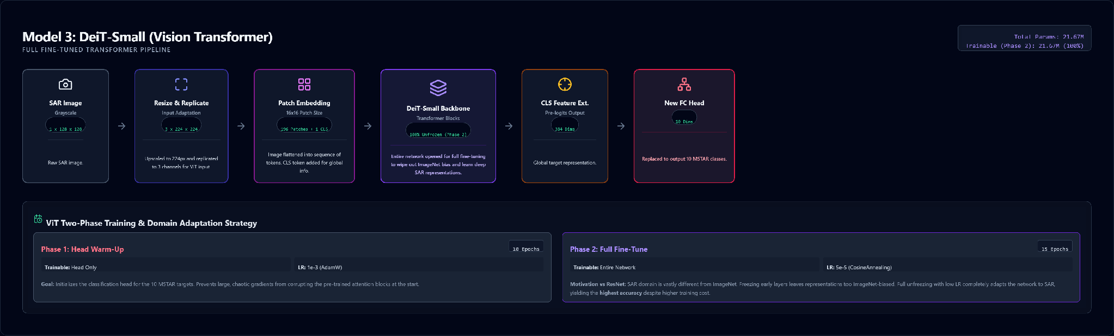
The Main Comparison — Three Paradigms
Aspect | Handcrafted + SVM | ResNet18 (CNN) | DeiT-Small (ViT)
Representation | Fixed descriptors | Learned conv features | Global self-attention
Input size | 128×128 | 128×128 | 224×224
Key idea | HOG/LBP/hist + RBF margin | Hierarchical local features | Long-range token attention
Capacity | 2,747 SVs | 11.18M params | 21.67M params

- Each model represents a different generation of computer vision, from handcrafted features to CNNs and Vision Transformers.
- All models were evaluated using the same dataset, train/test split, metrics, and visualization pipeline, enabling a fair comparison of both classification performance and computational cost.
Evaluation Protocol & Metrics
- Test Set: Single held-out 2425-image 15° test set.
- Quality: Classification quality was measured using Accuracy, Macro Precision, Macro Recall, Macro F1, per-class metrics, and a 10×10 confusion matrix.
- Cost: Inference latency (batch 1, up to 500 imgs, 10 warm-up, CUDA-synced), on-disk model size, parameter counts.
- Explainability: Feature-space t-SNE visualizations were used to analyze class separability and model representations.
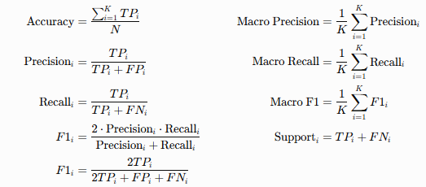
Results — Headline Comparison
Metric | Handcrafted+SVM | ResNet18 | DeiT-Small
Accuracy | 85.98% | 92.49% | 95.79%
Macro-F1 | 84.64% | 91.52% | 95.03%
Macro-Precision | 86.17% | 91.64% | 95.15%
Macro-Recall | 84.46% | 91.51% | 95.01%
Training time | 96.2 s | 156.1 s | 400.8 s
Inference (ms/img) | 50.03 | 6.41 | 10.18
Model size (MB) | 172.22 | 42.73 | 82.72
Parameters | 2,747 SVs | 11.18M | 21.67M
Feature dim | 8,190 | 512 | 384

- Performance improves consistently from SVM to CNN to ViT (85.98% → 92.49% → 95.79% accuracy).
- CNN offers the best efficiency, achieving strong accuracy while remaining the smallest and fastest model.
- DeiT-Small achieves the best classification performance with 95.79% accuracy and 95.03% Macro-F1.
- ViT improves accuracy, but with higher cost, requiring the longest training time and almost twice the parameters of ResNet18.
- SVM has the lowest accuracy and slowest inference, mainly because handcrafted feature extraction is computationally expensive.

Results — Per-Class F1
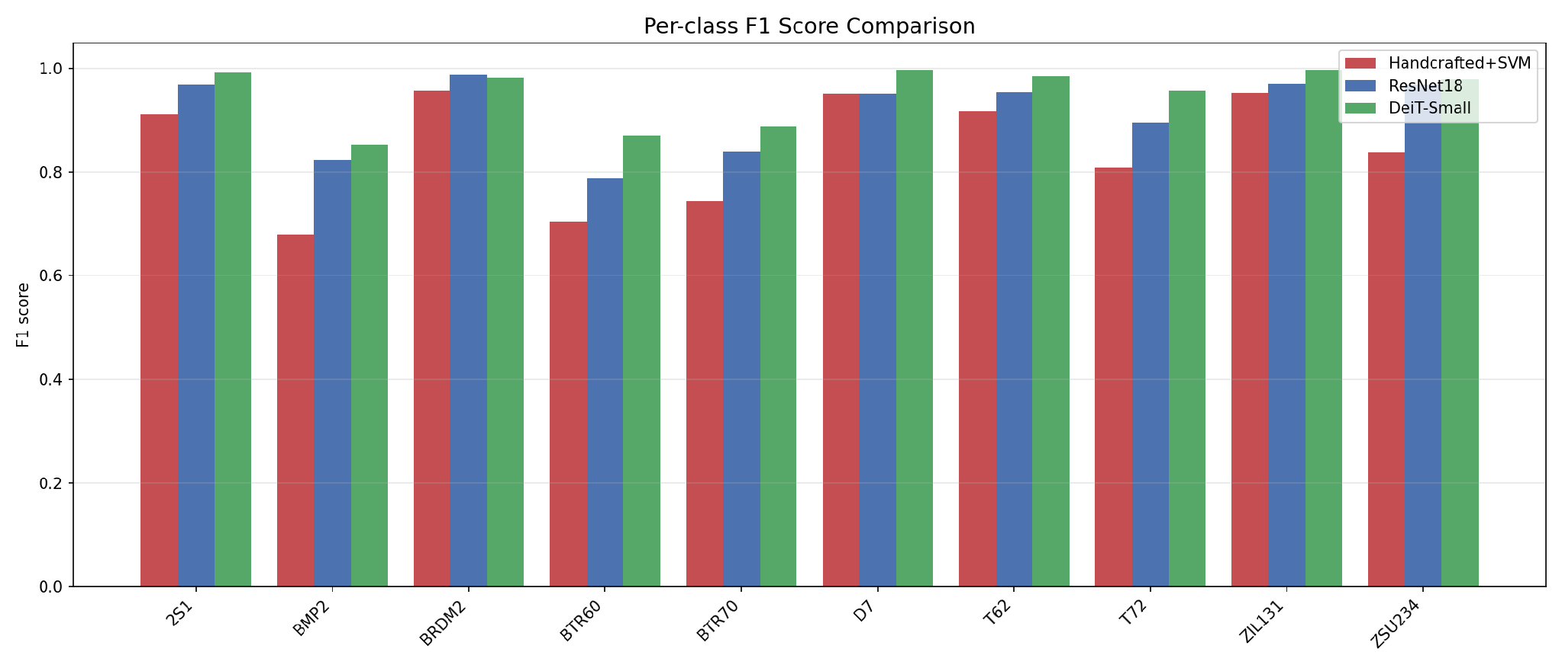
- Most challenging classes showed substantial improvement:
BMP2 (0.68 → 0.82 → 0.85), BTR60 (0.70 → 0.79 → 0.87), BTR70 (0.74 → 0.84 → 0.89), T72 (0.81 → 0.90 → 0.96) F1.
- Easy classes (BRDM2, D7, ZIL131, 2S1) achieved consistently high performance across all methods.
- SVM tended to over-predict ZSU234, resulting in very high recall (0.99) but relatively low precision (0.73).
Results — Confusion Matrices
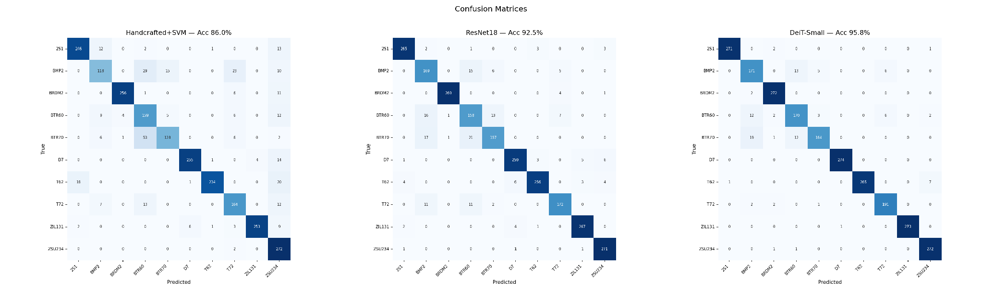
- Most errors occur between BMP2, BTR60, and BTR70 in all models, showing that these classes are difficult to separate.
- As model performance improves, the number of wrong predictions decreases and becomes more focused, suggesting that the remaining errors come from real visual similarities in SAR images rather than random mistakes.
Results — Training Dynamics
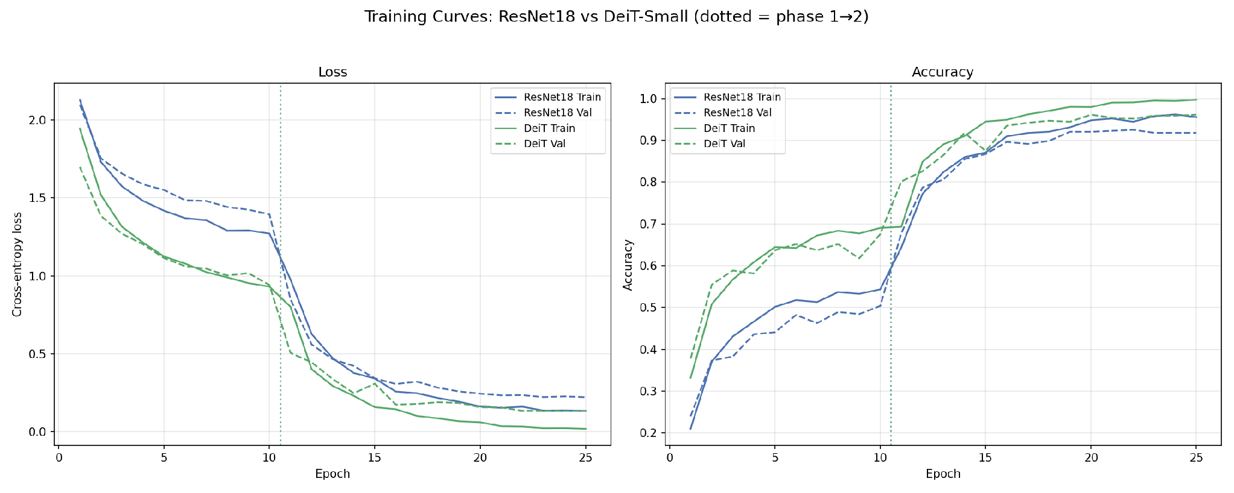
- Phase 1 with a frozen backbone reaches limited performance (CNN ~50%, ViT ~68% validation accuracy), showing that frozen features are not sufficient for SAR images.
- After unfreezing the backbone at Epoch 10, validation accuracy increases by 15–20 points in a single epoch.
Results — Efficiency & Complexity
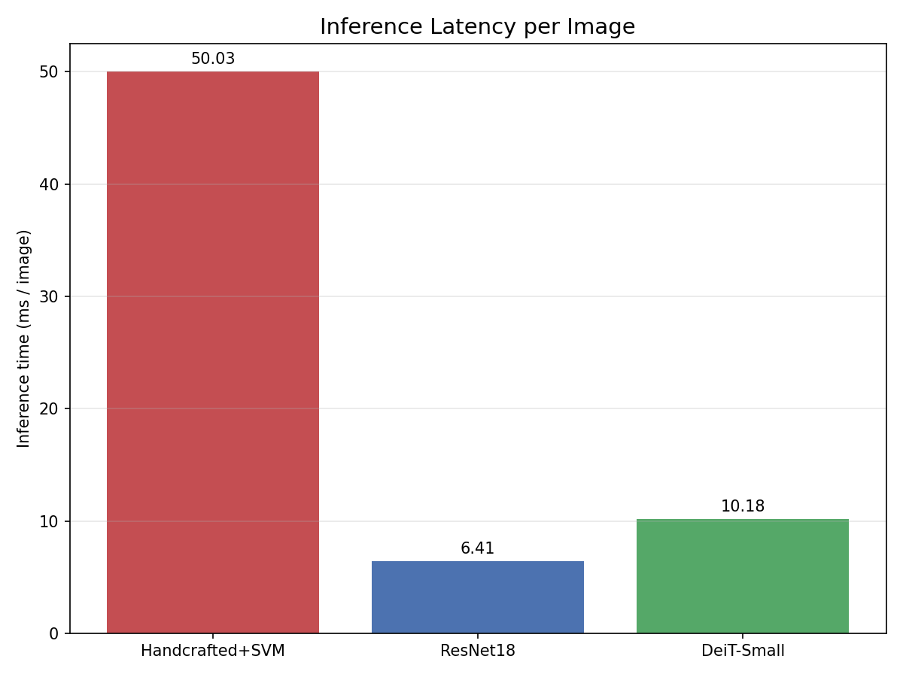 | 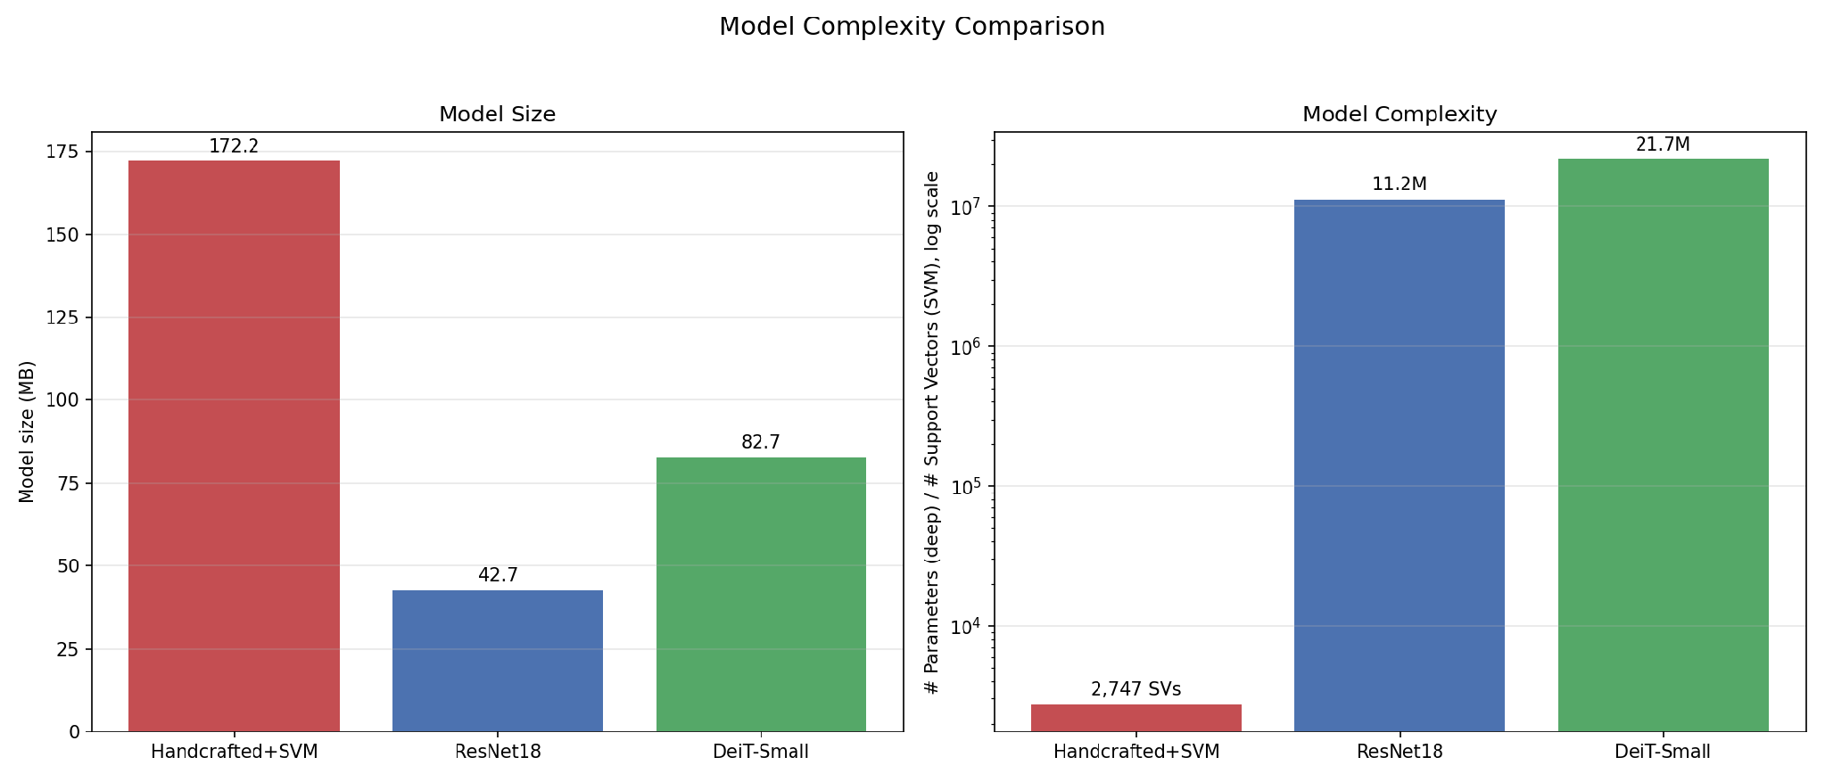
- CNN provides the best efficiency, requiring only 6.41 ms per image and 43 MB of storage.
- SVM is much slower (50 ms per image), mainly due to HOG/LBP feature extraction, not the classifier itself, and requires 172 MB of storage.
Explainability — Feature Space (t-SNE)
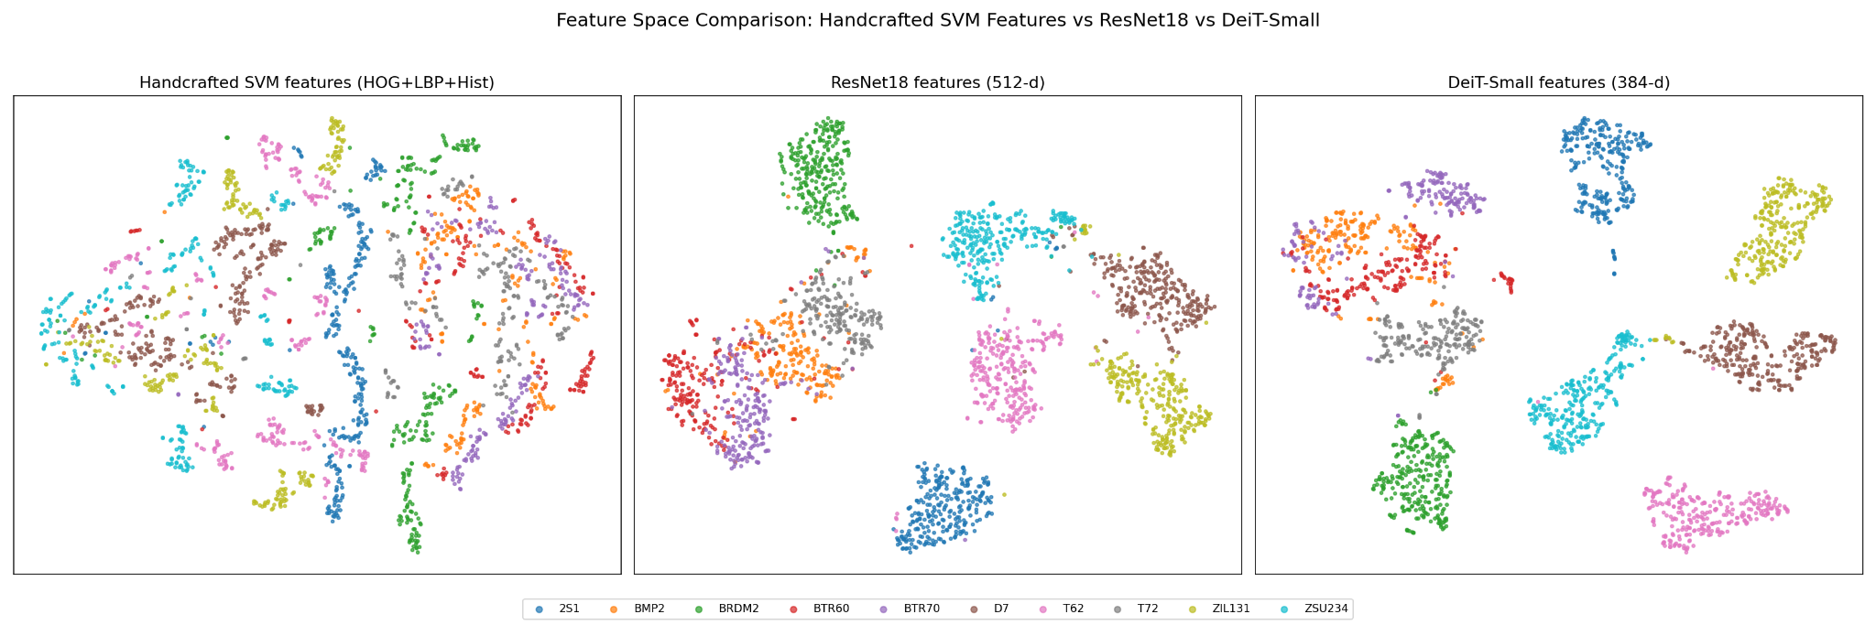
- Feature separation improves from raw pixels to ResNet and then to DeiT, matching the performance ranking of the models.
- DeiT produces the most compact and well-separated clusters, while raw pixel features show strong overlap between classes.
Discussion & Insights
- Handcrafted features struggle with very similar vehicles, because small structural differences in SAR images are difficult to capture with fixed features.
- CNN improves performance by learning more discriminative features, while also being the smallest and fastest model.
- ViT achieves the highest accuracy, especially on the most challenging classes such as BTR60 and T72.
- Higher accuracy comes with higher computational cost, as ViT requires more parameters, longer training time, and higher inference latency than CNN.
- The remaining errors are mainly within the APC vehicle group, indicating that these classes are inherently difficult to distinguish in SAR imagery.
Conclusion
- Learned feature representations clearly outperform handcrafted descriptors for SAR target classification. Both deep learning models achieved substantial improvements over the HOG/LBP + SVM baseline in Accuracy, Macro-F1, and per-class performance.
- The fully fine-tuned DeiT-Small delivered the best overall results, reaching 95.8% Accuracy and 95.0% Macro-F1, while showing the strongest performance on the most challenging lookalike vehicle classes.
- ResNet18 provided the best efficiency–performance trade-off, achieving competitive accuracy with the smallest model size and fastest inference speed.
- Most remaining errors were concentrated within the BMP2–BTR60–BTR70 APC cluster, suggesting that the primary challenge is intrinsic visual similarity rather than insufficient model capacity.

- Recommendation: Choose ViT when maximum accuracy is the priority. Choose ResNet18 for a better balance of accuracy, model size, and inference speed (92.5% accuracy, 43 MB, 6.4 ms/image). The SVM was outperformed by both deep learning models in accuracy and efficiency.

