Comp2Dust Test Document

**mozjpeg with default commands**

**-quality 60**

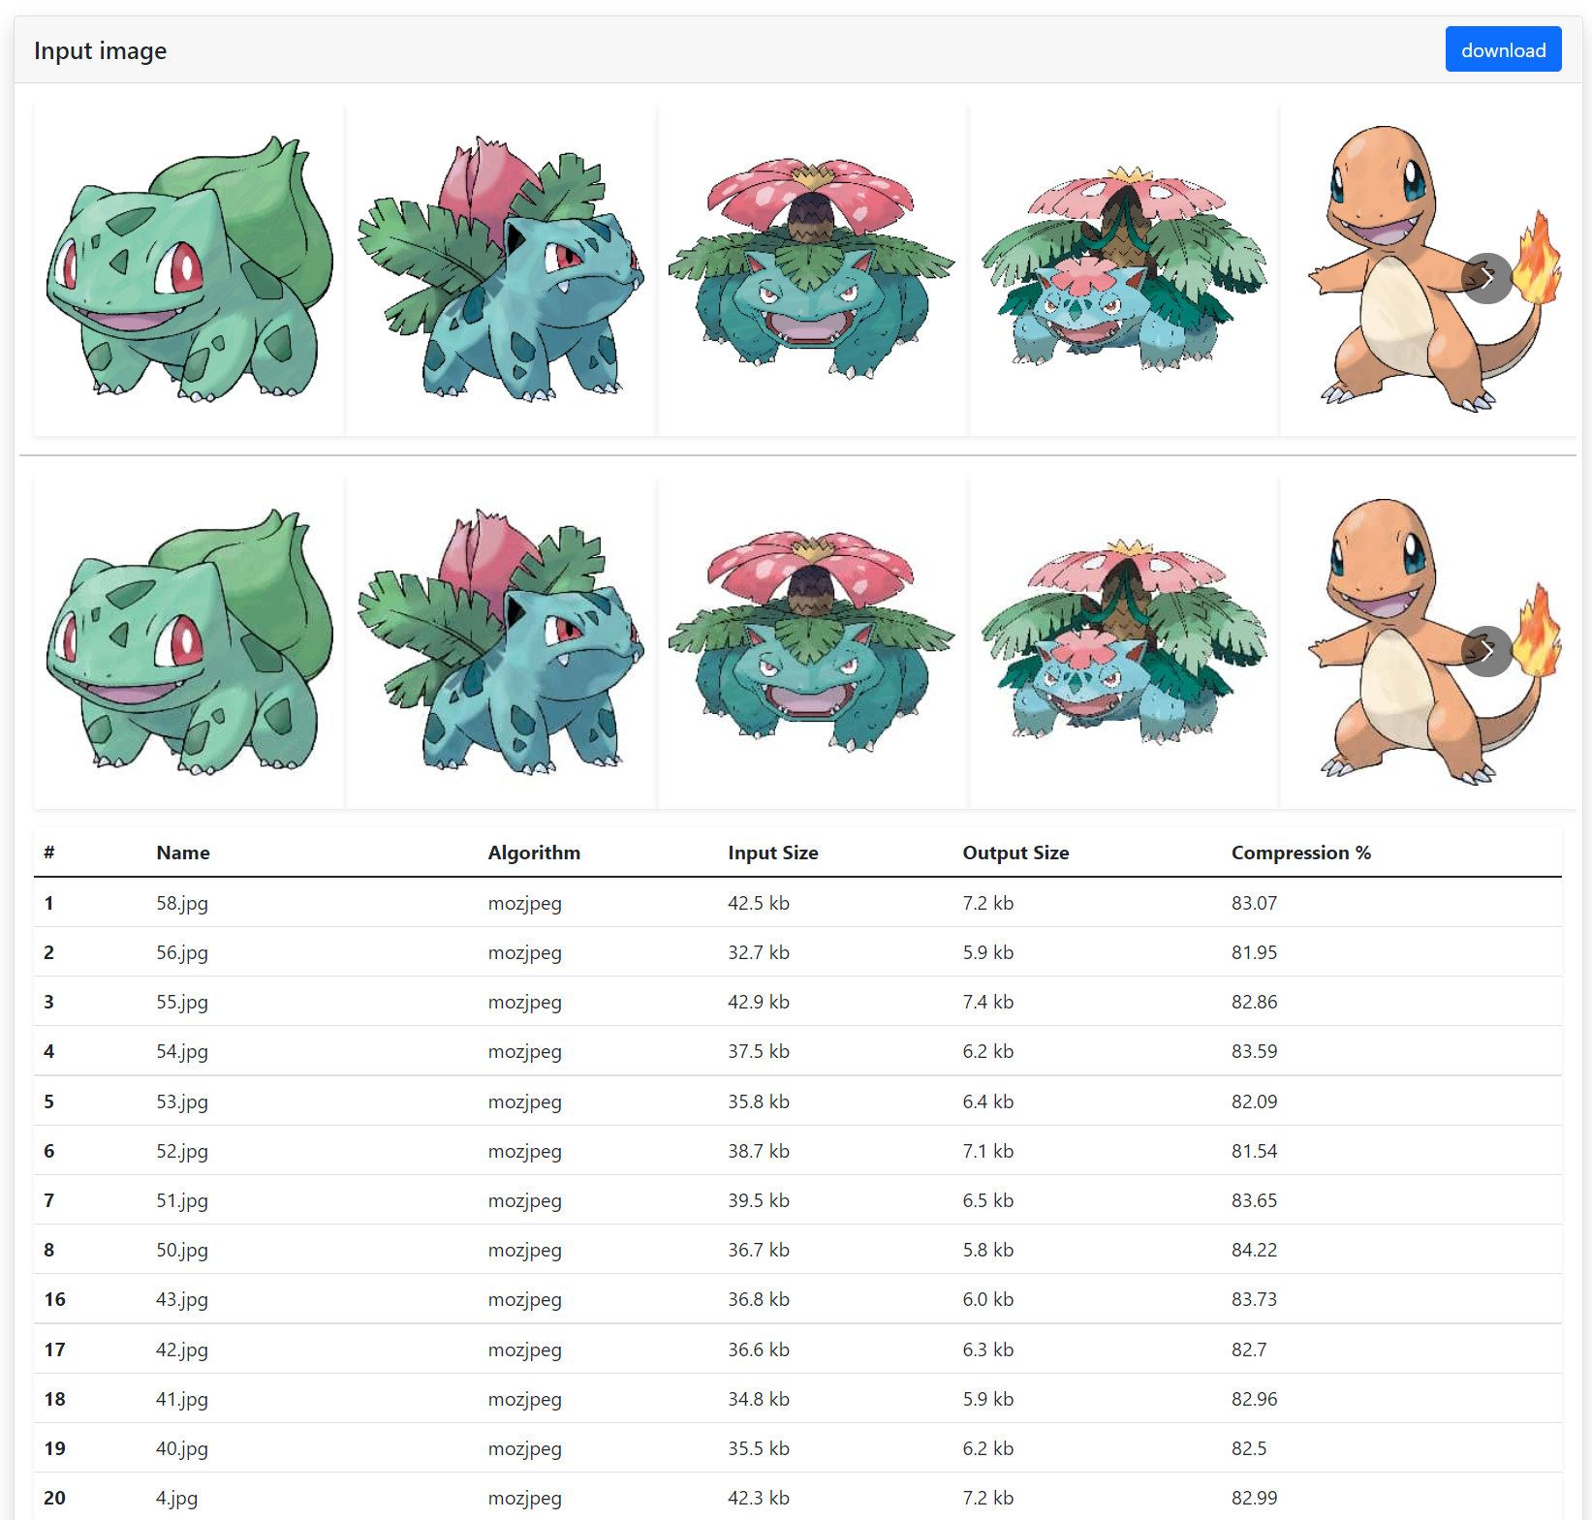

**pngquant with default commands**

**--quality=20-50 –o**

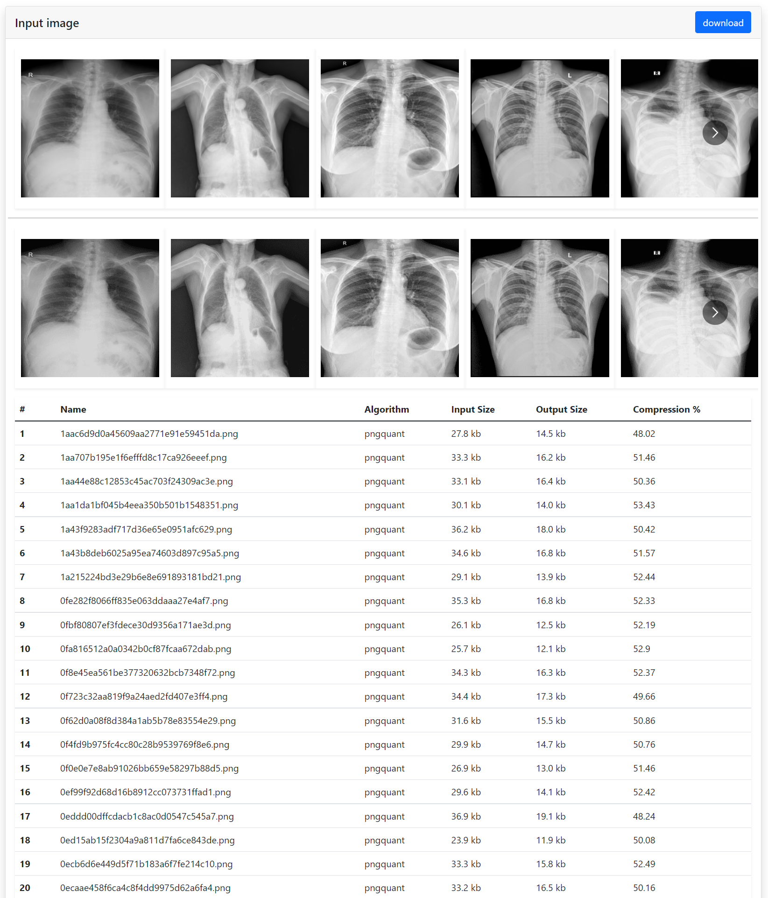

**gifsicle with default commands**

**--colors 64 --use-col=web**

