ORCA 4500 HW6

Yihang Ding, yd2459

[Yd2459@columbia.edu](mailto:Yd2459@columbia.edu)

1. The first table below shows the number of women (per 1000) between 15 and 44 years of age who have been married grouped by the number of children they have had. The second table below gives the same information for women who have never been married.

For each data set, compute the mean, median and standard deviation.

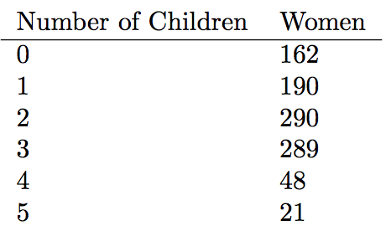

Table 1: Number of children for women who have been married

Mean= $\frac{190+2×290+3×289+4×48+5×21}{1000}=1.93$

As 162+190<500<162+190+290, Median=2

Std= $\sqrt{\frac{162×{\left(0-1.93\right)}^{2}+190×{\left(1-1.93\right)}^{2}+290×{\left(2-1.93\right)}^{2}+289×{\left(3-1.93\right)}^{2}+48×{\left(4-1.93\right)}^{2}+21×{\left(5-1.93\right)}^{2}}{1000}}=1.35$

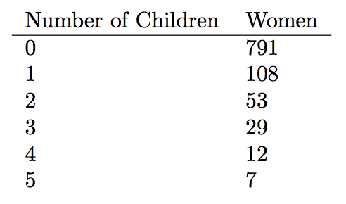

Table 2: Number of children for women who have never been married

Mean= $\frac{108+2×53+3×29+4×12+5×7}{1000}=0.38$

As 500<791, Median=0

Std=

3. We can generalize the Monte Hall problem to have 10 doors with g goats and c = 10 − g cars. First you choose a door. Monte Hall then shows you one with a goat, and then you have a choice to switch to a different curtain or not. The game then ends, and you win if you have now chosen the car. For each value of g from 2, . . . 9, compute the probability that you win if you switch, and the probability that you win if you don’t switch. You can either answer analytically or write code.

Answer: see the Jupyter Notebook.