C++ Cheat sheet
Defining Variables
In C++, I define a variable by writing its type followed by its name.

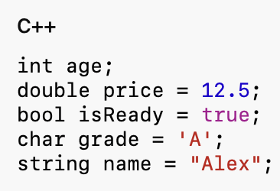
Common Variable Type
Type | Purpose | Example
int | Whole numbers | int age = 20;
double | Decimal numbers | double price = 3.14;
float | Decimal numbers with less precision | float value = 2.5f;
bool | True or false | bool passes = true;
char | One character | char grade = ‘A’;
string | Text | string name = “Sam”;

To use string:
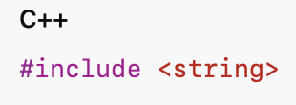

Arrays
An array stores multiple values of the same type.
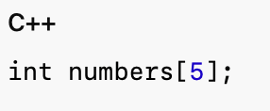
Assigning values:
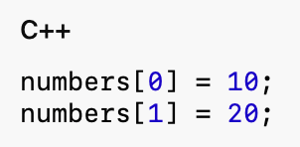
Reading a value:
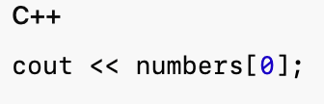
Array indexes begin at 0, so an array of size 5 has indexes 0 to 4.
An array can also be initialized directly:
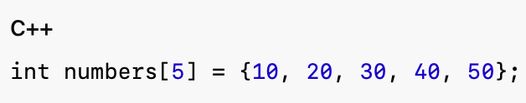

2D Arrays
A two-dimensional array stores values in rows and columns.
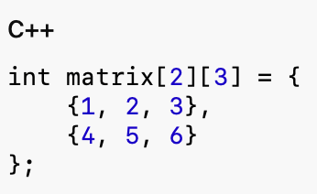
Accessing a value:
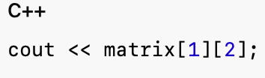
This prints 6.

Input and Output
Use cout to print output:
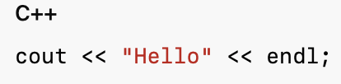
Use cin to read input:
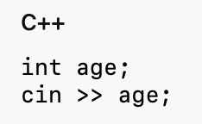
Multiple values could be read together:
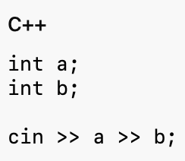

Conditions and If statements
An if statement runs code when a condition is true.
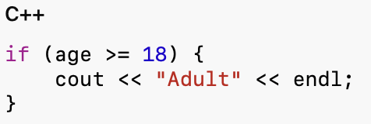
Using else:
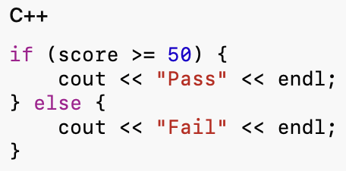
Using else if:
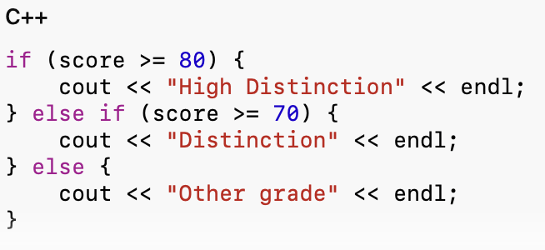

Common comparison operations:
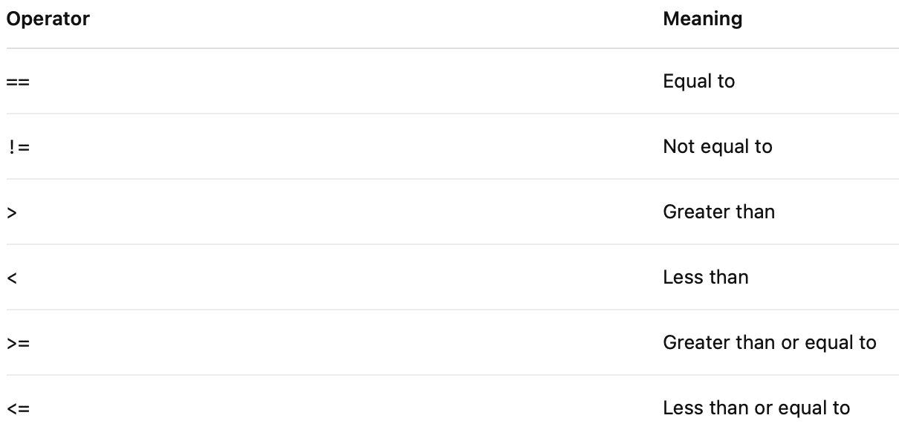
Logical operators:
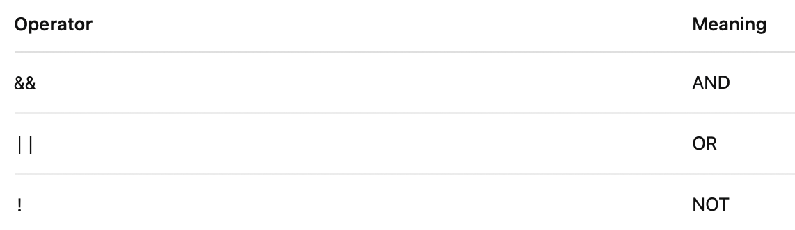
For loops:
A for loop is useful when the number of repetitions is known.
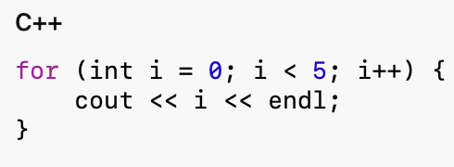

Reading values into an array:
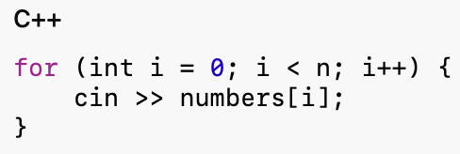
While Loops
A while loop continues while its condition is true.
