Engagement Contract
- Full Name: Yihao Yu
- Student ID: 35567082

How does learning about Data Structures and Algorithms support you in your future career and the rest of your studies?
Learning about Data Structures and Algorithms is essential because it provides me with the foundation of writing efficiency and maintainable software. From an academic perspective, Data structure helps students how to organise and process data efficiently. Many advanced subjects, such as operating systems, databases, artificial intelligence rely on concepts like trees, graphs, and so on. For future career, data structure and algorithm is widely used in software development. Choosing the right data structure would improve software’s performance significantly. Data structures and algorithms is of great importance in the interviews because it could demonstrate programming abilities and logical thinking.
Overall, learning Data structures and algorithms provides the theorical foundation and practical skills needed no matter in later university courses or in my future carer life.

What grade are you aiming for?
4K

What is your planned timeline of completing the tasks?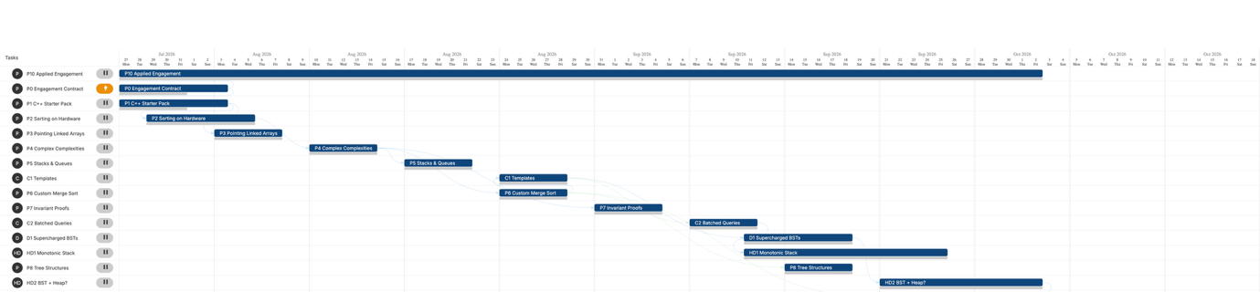

Have you read the provided engagement contract on this task, and reading material of Week 1, and understood how this unit operates, including the assessment regime and how the final marks will be calculated?
Yes, I have

Signature & Date
02/08/2026

