1. **MARCO MARKET RESPONSE**

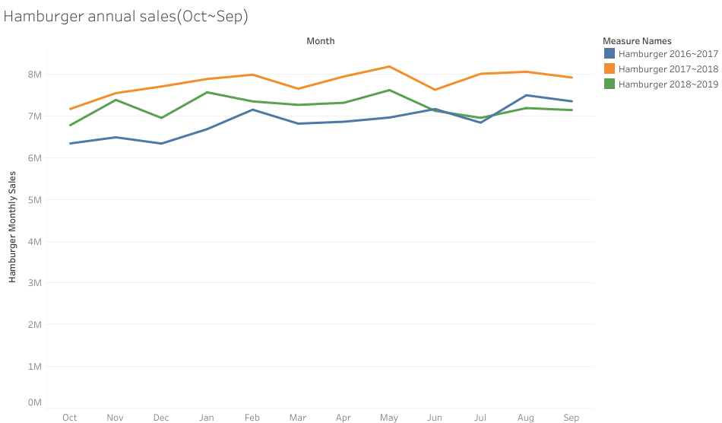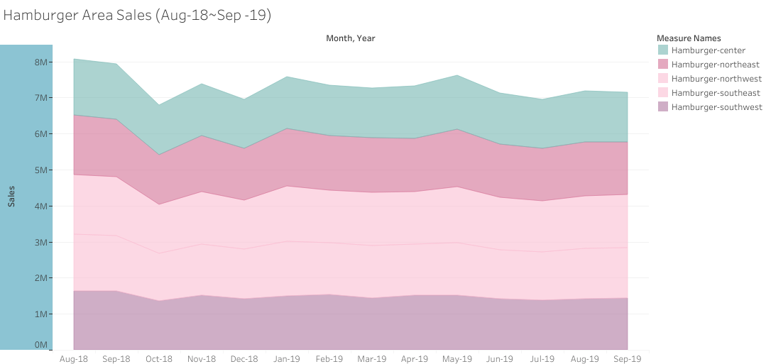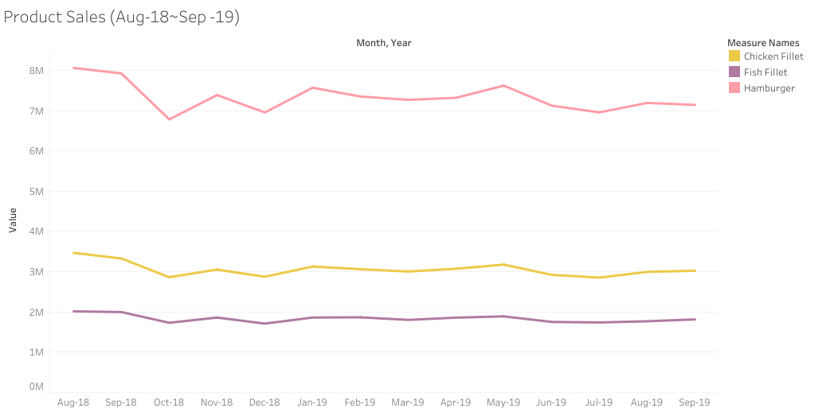

Analysis: As the main competitor with impossible whopper is our hamburger, we should focus our hamburger sales recent performance. However, I also provide the sales trends for all our 3 products since Aug-18, and you can see that the sales dropped a lot at Oct-18, when impossible whopper came out, but recovered slowly after that month, showing that the impossible whopper do not really change the fast food market landscape. Now we can look into the hamburger sales, which was the most influenced one when the new whopper came out.  The sales did not different that much based on area, and if we look at the annual sales, 2018~2019 sales was better than the 2016~2017 sales before May-19! So we can say that though impossible whopper brought some changes to the market,  it did not make a great impact but we still need to find a way to improve our hamburger sales if we want to get back to the high point last year as the sales do not perform well for the recent 5 months.

1. **MICRO CONSUMER TREND**

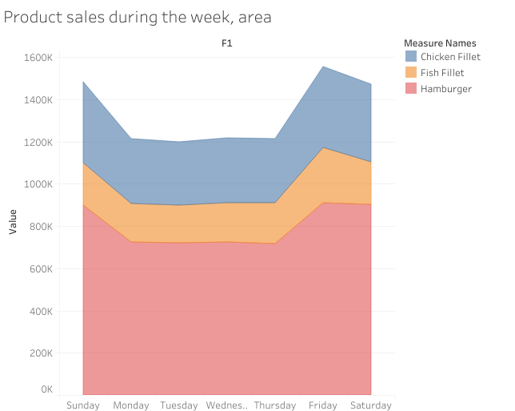

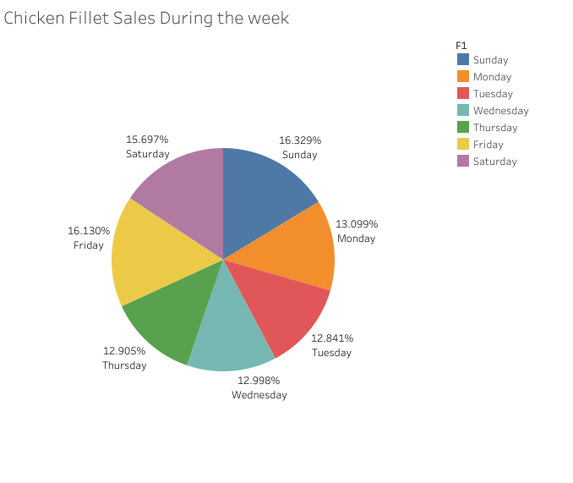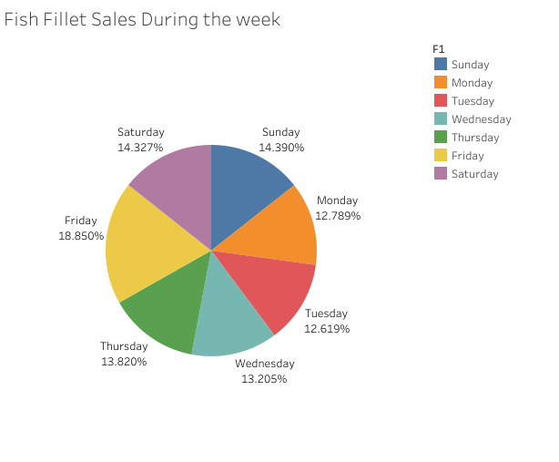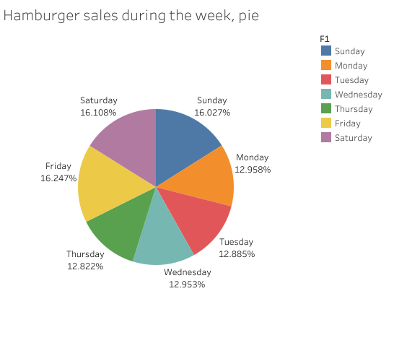

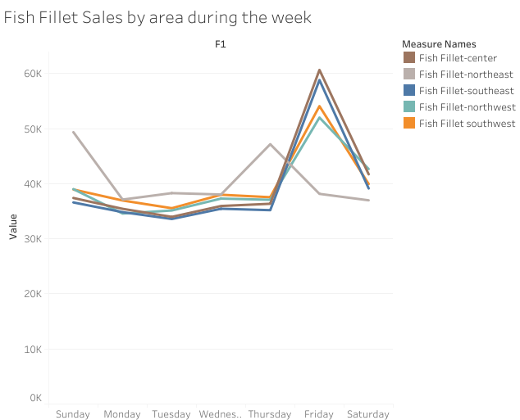

Analysis: We can clearly find that our products sales better at weekend (Friday, Saturday, Sunday). Those days take nearly half of our sales, and fish fillet sales especially well on Friday. However, if we look into the data, we find that people in the northeast actually likes to buy fish fillet on Sunday and Thursday. Based on the data, I think we should use some promotions like workday meals to increase our weekday sales and specialize our fish fillet selling strategy based on the areas, which means we should provide different fish fillet promotion time for people living in northeast (on Sunday and Thursday instead of Friday).