***Demo***

***Set up of the Game***

the following command “-load xxx”, “-board xxx” and “-random-board”, where “xxx” represents the filename.

If you run this game without inputting anything, the game will use the default board layout (layout.txt shown at the top of the picture to the left)

When using the command line argument “-random-load”, “-seed xxx” is optional. If the seed is the same, then you will always get the same board. If you change the seed, you will get a different board as the following two pictures shown

However, if you dose not input “-seed xxx”, we use the current time as the seed, which indicates that you will not get the same board every time you play the game.

“-load xxx”: represents that the game will be loaded from a saved file xxx. (savefile.txt shown at the top of the picture to the left)

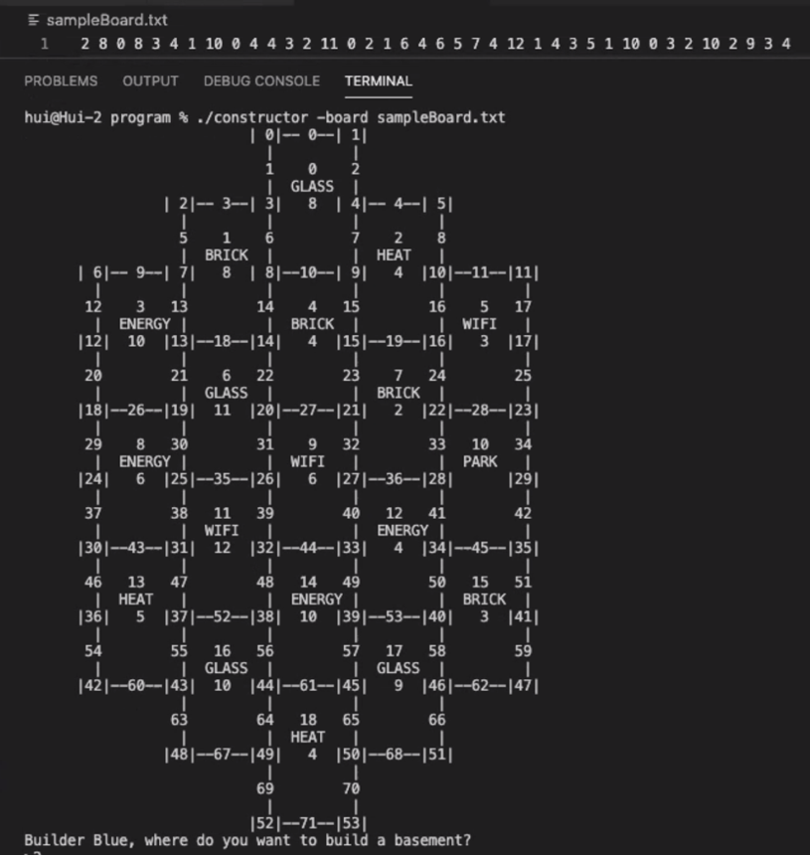

“-board xxx” represents loading the game with the board specified in the file xxx.

(sampleBoard.txt shown at the top of the picture shown to the left)

We will use the default board layout to display all commands in the game.

At the beginning of the game, players are required to input the location of their house. If the input is not valid (i.e. not an integer or a number out of scope), they are required to choose the location until it is valid.

Also, at the start of the game, players should follow the sequence “Blue-Red-Orange-Yellow-Yellow-Orange -Red-Blue” to choose their first two residences.

***Beginning of the turn:***

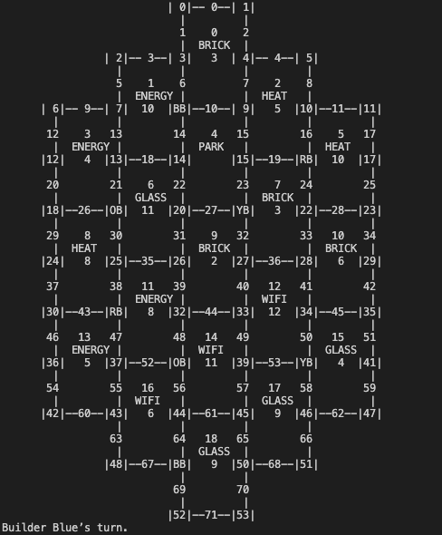After all players have successfully build their first two residences, the current board will be displayed immediately.

Each player can choose whether to use a fair dice or a loaded dice at the beginning of each turn. Once they have already chosen the type of dice, the setting of the dice will be saved until the player changes it for the next time.

Since they must choose their first two residences, default type of is loaded dice. If the player chooses to use a loaded dice, he/she must input a number between 2 and 12 inclusively. Otherwise, the player will be prompted to input until there is a valid one.

If the player chooses to use a fair dice, the game will randomly generate the points.

After rolling the dice, players will receive a message of “<which player> gained <how many resources>”.

In addition, if players are confused about what commands they can use, inputting “help” allows them to see all valid commands.

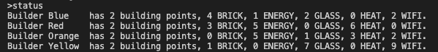

“status” displays all information of each player regarding the total points, resources they gained.

***During the turn***

Players can input any of the following commands:

“board”, “status”, “residences”, “build-road <road#>”, “build-res <housing#>”, “improve <housing#>”, “trade <colour> <give> <take>”, “next”, “save <file>” and “help”.

If players are confused about what commands they can use, inputting “help” allows them to see all valid commands.

“board” allows the player to see the current situation of the game (functioned as a map)

In order to describe remaining methods, we name this picture as graph 1.

“status” remains the same functionality as described above.



“residences” allows the active player to see the information of all residences he/she has built. (including the location and the type of each residence)

“build-road <road#>”, where <road#> stands for the position of the road, allows players to build a road at the position <road#>.

Based on the rule of this game, if a player tries to build a road at xx, there are three possible outcomes.

* Successfully built a road at the position.
* You do not have enough resources.
* You cannot build here.

Similarly, “build-res <housing#>”, where <housing#> stands for the position of the residence, allows players to build a house at <housing#>.

Based on the rule of this game, if a player tries to build a residence at <housing#>, there are three possible outcomes.

* You do not have enough resources.

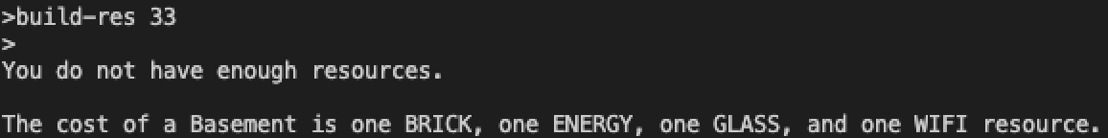

* You cannot build here.

Player cannot build at 39 since Yellow has a basement at 40 (a neighbor).

Player cannot build at 40 since Yellow has a basement at 40 (itself).

Player cannot build at 15 since there is no neighbor road build by the same player.

* Successfully built a basement at xx.

After building a road at 39, 44 and building a residence at 33, the board becomes graph1 shown in the previous page.

“improve <housing#>”, where <housing#> stands for the position of the residence, allows players to improve the residence located at <housing#>.

Based on the rule of this game, if a player tries to improve the residence at <housing#>, there are three possible outcomes.

* Successfully built a <type of the residence after improving it> at the position

At 21, House -> Tower

At 40, Basement -> House -> Tower

* You cannot improve here. location does not exist.

59 out of scope

* You can’t improve that building.

Residence at 33 is already a Tower

* You do not have enough resources.

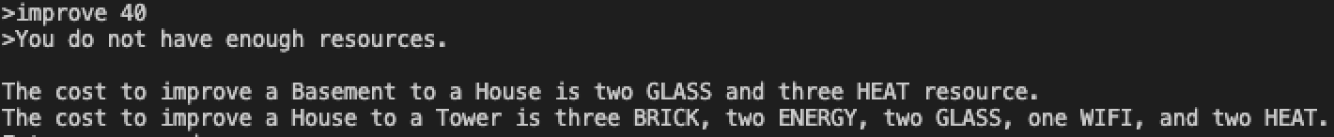

Before improving the residences (left) and after improving the residences (right)

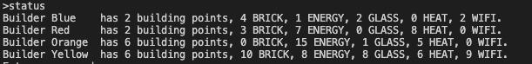

“trade(<colour> <give> <take>)” allows the current player to trade with <colour> giving one resource of type <give> and receiving one resource of type <take>

Based on the rule of this game, if a player tries to trade with <colour>, there are possible outcomes.

* You cannot trade with yourself
* <colour> does not have enough <take>
* You do not have enough <give>
* <color> accept this offer

trade is successful, current player gains one <take> and loses one <give>

* <color> does not accept this offer

nothing happened

Note: When inputting <colour>, players can input the abbreviation of <colour>. (i.e. the first character of colour, both upper and lower case are valid)

“next” passes control onto the next builder in the game.

It follows the sequence “Blue-Red-Orange-Yellow”.

“save <file>” saves the current game state to <file>.

Here is the current information of the game.

After inputting the command, the current status will be written into the saveSample.txt

If <file> exists, then all contents will be overwritten. However, if <file> does not exist, the computer will automatically create a <file> file and then write all the information into it.

***The Geese Event***

Here, we use a loaded dice to trigger the Geese Event.

If 7 is rolled, Geese Event will happen.

All players who have more than ten resources in total (include 10) will lose half of their resources. And the active player can choose a tile to place the geese.

Then the current player can choose to steal resources from the player who has residences at the chosen tile. The type of stolen resources is randomly selected.

After handling the geese, the current player will complete his/her turn as normal.

***End of the Game***

When a player has a total of at least 10 building pointers, he/she becomes the winner.

At this time, builders are asked whether they want to play again.

If the response is “yes”, the game will start from the beginning.

If the answer is “no”, the game will exit.