Case Study Report 1: Academic Performance Analysis

MSSP 6070
Dr. Hartwell
October 2025
Yize Peng

1. Executive Summary
This case study analyzes how social, economic, and academic variables influence the educational outcomes of Colombian engineering students. Using national assessment data from SABER 11 (high school) and SABER PRO (university), we find that socioeconomic stratum is the strongest determinant of performance, parental education contributes positively though indirectly, and gender differences are small. High school achievement remains the dominant predictor of success.

2. Purpose and Objectives
The Department of Education requested an analysis to evaluate how gender, parental education, and socioeconomic conditions relate to performance outcomes. The goal is to inform data-driven educational policies and identify interventions that enhance equity in engineering education.

3. Data Overview
Total Observations | 12,411
Source | Colombian Institute for the Evaluation of Education
Assessment Stages | SABER 11 (High School) and SABER PRO (University)
Key Variables | Gender, Parental Education, Socioeconomic Stratum (STRATUM), SISBEN aid program
Outcome Variable | Global Professional Score (G_SC)

4. Statistical Analysis
Analyses include descriptive statistics, Welch’s t-test for gender differences, one-way ANOVA for socioeconomic stratum, and multiple regression controlling for parental education, gender, and prior high school achievement (SABER 11).

4.1 Gender Comparison
Table 1
Gender | n | Mean (G_SC) | SD
Male | 7,368 | 163.69 | 23.58
Female | 5,043 | 161.28 | 22.33
Note. Welch’s t(12409)=5.78, p<.001. Males scored slightly higher; effect is statistically significant but small.

4.2 Socioeconomic Stratum
Table 2
Stratum | Mean (G_SC) | SD | n
1 | 152.35 | 21.94 | 1,709
2 | 158.20 | 22.28 | 4,029
3 | 163.82 | 21.69 | 4,045
4 | 172.00 | 21.47 | 1,578
5 | 177.39 | 21.54 | 633
6 | 181.51 | 21.88 | 403
Note. Performance improves steadily across higher strata. ANOVA F(6,12404)=238.77, p<.001.

4.3 Parental Education
Table 3
Parental Education | Mean (G_SC) | n
None | 154.99 | 427
Primary | 155.40 | 2,029
Technical | 161.88 | 519
Postgraduate | 175.25 | 1,586
Note. Each higher parental education level corresponds to higher student performance.

4.4 Regression Analysis
Table 4
Variable | Coefficient (β) | SE | z | p
Intercept | 54.60 | 4.39 | 12.44 | <.001
Parental Education | +0.22 | 0.14 | 1.65 | .10
High School Score | +1.81 | 0.03 | 69.25 | <.001
Gender (M) | -0.70 | 0.43 | -1.62 | .10
Note. Model R²≈.74. High school achievement remains the strongest predictor.

5. Discussion
Socioeconomic background shows the steepest gradient in outcomes, reflecting disparities in educational opportunity. Parental education correlates with better results, largely through its impact on earlier preparation. Gender differences are minimal. Overall, success is path-dependent, emphasizing the importance of early academic readiness.

6. Recommendations
- 1. Launch bridge programs in high school to strengthen critical reading and quantitative reasoning for Strata 1–3 students.
- 2. Provide SISBEN-based scholarships and academic mentorship to mitigate economic barriers.
- 3. Implement parent workshops to encourage involvement and support study habits at home.
- 4. Promote gender-inclusive teaching methods and mentoring in quantitative disciplines.
- 5. Establish dashboards linking SABER 11–PRO results for annual monitoring of equity initiatives.

7. Limitations
The dataset is cross-sectional, preventing causal inference. It only covers engineering students, limiting generalization. Self-reported socioeconomic variables may contain bias, and contextual factors such as institutional quality are unobserved.

8. Conclusion
Educational performance in engineering programs is shaped by socioeconomic status and prior academic preparation. Equitable outcomes require early intervention, support for low-income students, and inclusive teaching to ensure all learners reach their potential.
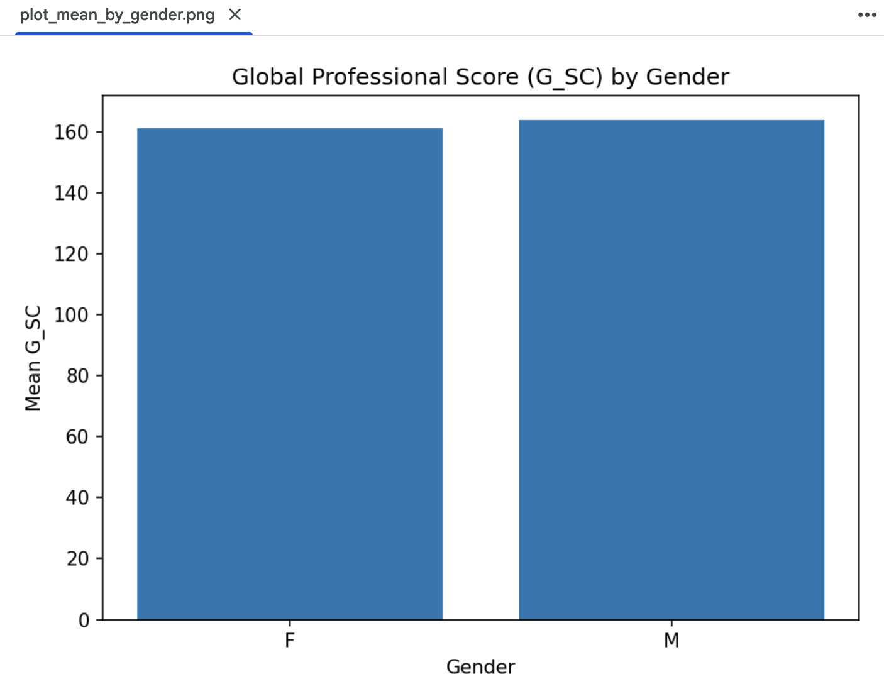
9. Appendices

