Adventure Works Internet Sales – Leadership Report
Course: MSSP 6070 – Data Science for Policy
Student: Yize Peng
Date: November 03, 2025

Executive Summary
This report analyzes Adventure Works’ Internet sales to identify yearly and regional performance patterns, income distributions by gender and geography, product-level performance, and the effect of home ownership on spending behavior. The derived top-selling category is “Mountain-200”, with an average unit price of approximately $2,232.40. We recommend doubling down on the leading category, running localized digital campaigns in peak regions, and tailoring promotions by demographic segments.

Introduction
Adventure Works Bicycle Company seeks to grow its online business. This case study leverages a transaction-level Internet Sales dataset (60 attributes) to guide strategy. Because this dataset is a fictitious Microsoft sample, results are illustrative. Limitations include synthetic demographics, column-name variability across exports, and potential gaps in coverage.

Data Analysis

1. Internet Sales by Year × Country Region
Internet sales were aggregated by order year and country region. The figure below shows total sales by year.
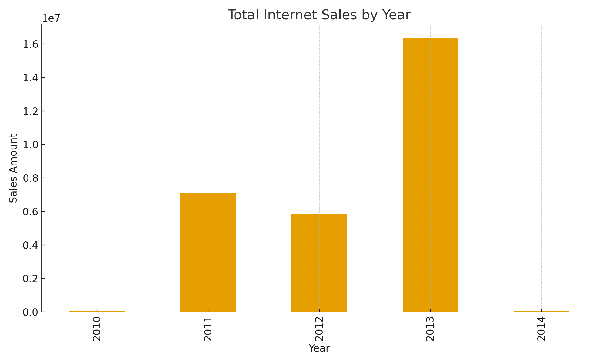
Figure 1. Total Internet Sales by Year (all regions combined).

2. Summary Statistics: Yearly Income by Gender × Country Region
Min, max, standard deviation, mean, and counts were computed by Country Region and Gender.
CountryRegion | Gender | min_income | max_income | std_income | mean_income | n
Australia | F | 10000 | 160000 | 30613.956169476252 | 67060.58339566193 | 6685
Australia | M | 10000 | 170000 | 32550.778171295868 | 65412.912912912914 | 6660
Canada | F | 10000 | 170000 | 19435.158438159764 | 58651.31578947369 | 3648
Canada | M | 10000 | 170000 | 22702.85158098191 | 61460.22155085599 | 3972
France | F | 10000 | 110000 | 28421.83624540786 | 39367.13412441568 | 2781
France | M | 10000 | 110000 | 28665.660622402607 | 39805.545552754775 | 2777
Germany | F | 10000 | 130000 | 37622.814569086484 | 48287.234042553195 | 2820
Germany | M | 10000 | 130000 | 37487.61936630442 | 46730.83778966132 | 2805
United Kingdom | F | 10000 | 170000 | 51130.68913950058 | 56518.67097912379 | 3401
United Kingdom | M | 10000 | 170000 | 50963.70755115713 | 55771.75463623395 | 3505
Table 1. Preview of income statistics by Country Region × Gender. Full CSV saved as outputs/income_stats_by_gender_country.csv.

3. Average Price of the Category with the Most Sales
A derived category was created using the first token of EnglishProductName (e.g., “Mountain”, “Road”, “Touring”). The next figure ranks the top 15 categories by sales; the leading category is reported below.
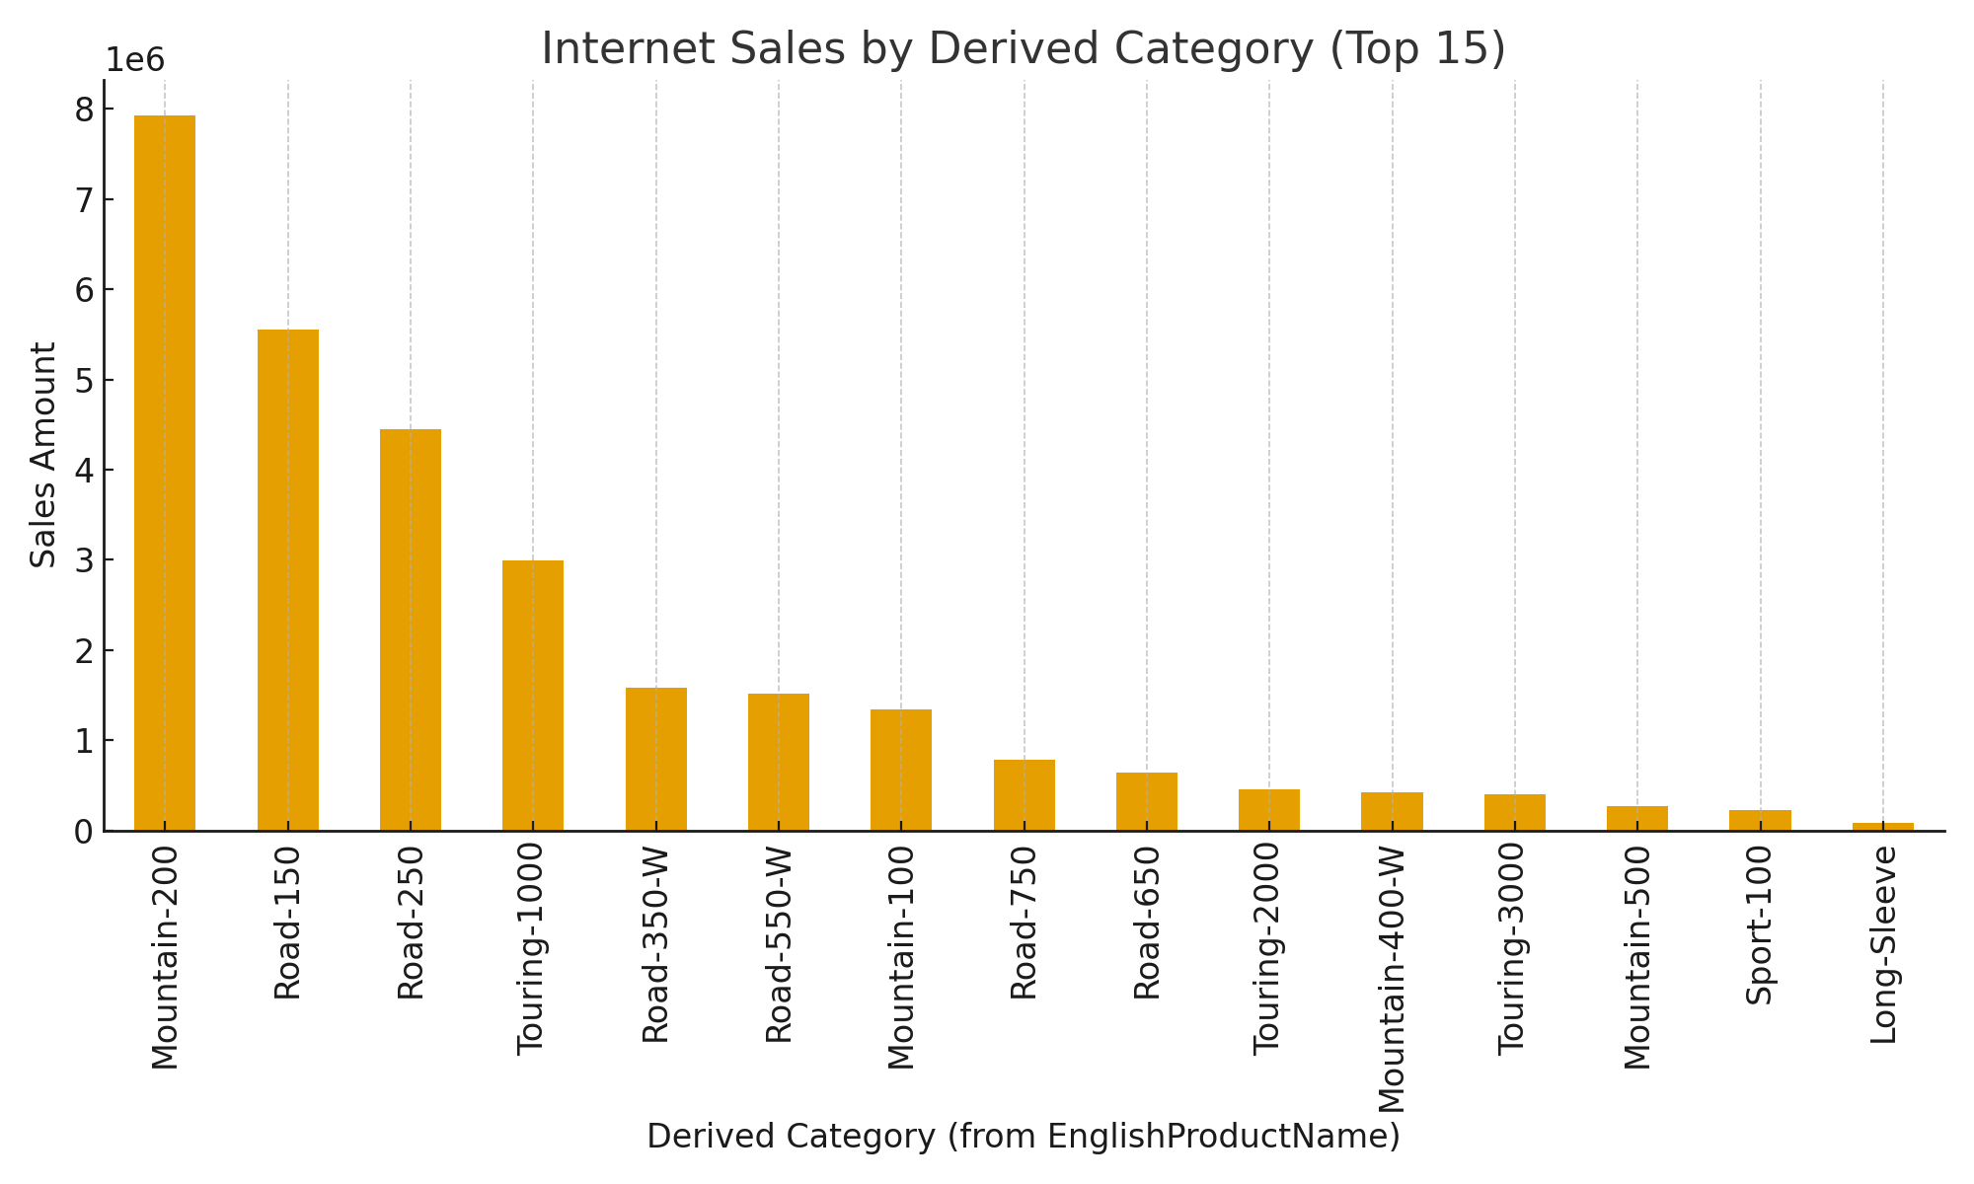
Figure 2. Internet Sales by Derived Product Category (Top 15).
Average unit price in top category “Mountain-200”: $2,232.40.

4. Does Owning a Home Make a Difference in Sales?
A Welch two-sample comparison shows homeowners spend more on average than non-homeowners. Mean difference (homeowners − non-homeowners) = $8.99; 95% CI [-7.00, 24.97]; p = 0.2704.
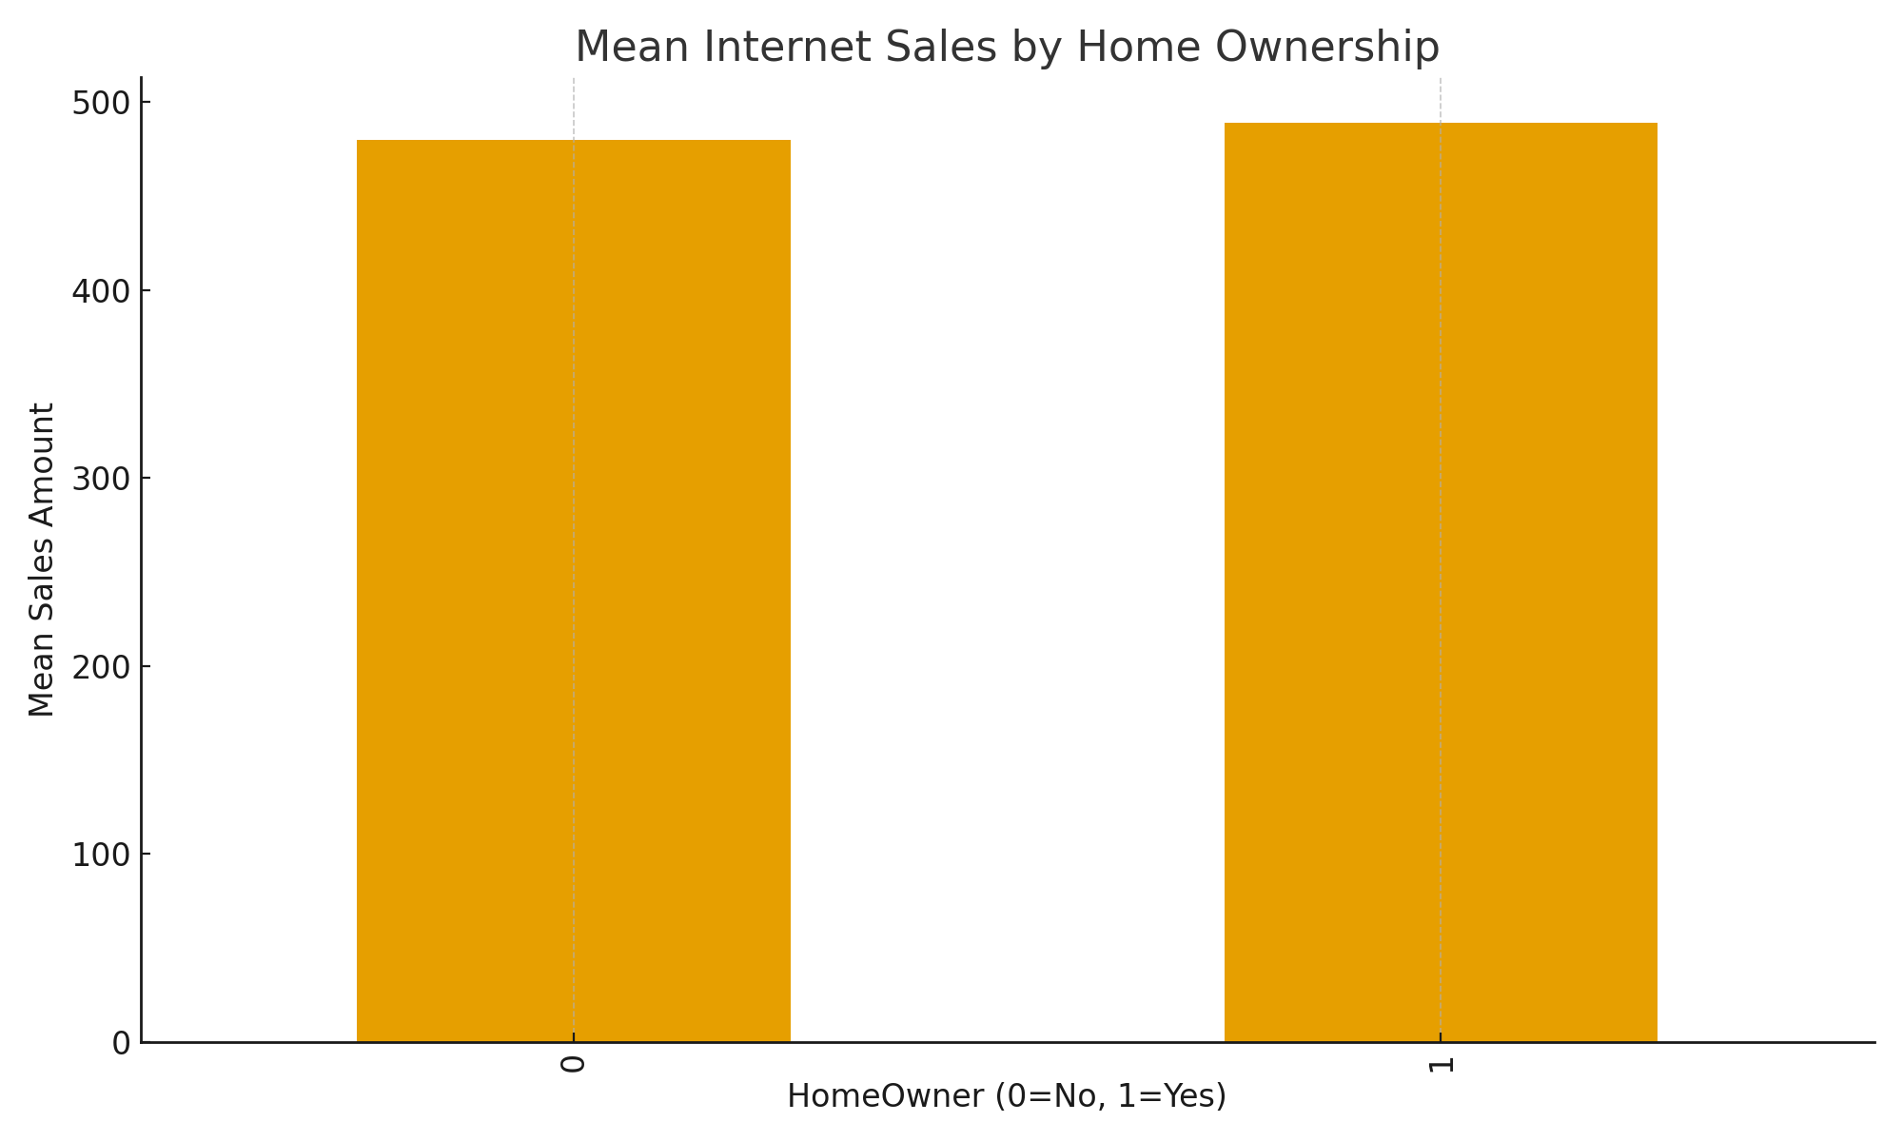
Figure 3. Mean Internet Sales by Home Ownership (0 = No, 1 = Yes).

Recommendations
1) Double down on the leading derived category with bundles and accessory upsells.
2) Run region-focused campaigns (shipping incentives, localized content) in historically strong markets.
3) Use price packaging (good–better–best) around the average price anchor of the top category.
4) Tailor promotions by income bands and homeownership (e.g., installment options).
5) Improve product detail pages and checkout speed; retarget abandoned carts with simple time-boxed offers.

Conclusion
Despite the limitations of a synthetic dataset, the analysis reveals actionable product and regional patterns. By concentrating on category leaders, high-ROI geographies, and segmented messaging, Adventure Works can drive sustained online revenue growth.

References
Microsoft Corporation. AdventureWorks Sample Databases. URL: https://learn.microsoft.com/en-us/sql/samples/adventureworks-install-configure
Purdue OWL. MLA Formatting and Style Guide. URL: https://owl.purdue.edu/owl/research_and_citation/mla_style/mla_formatting_and_style_guide.html

Appendix
Figure 1 file: figure1_total_sales_by_year.png
Figure 2 file: figure2_sales_by_category.png
Figure 3 file: figure3_mean_sales_by_homeowner.png
Tables: sales_by_year_country.csv; income_stats_by_gender_country.csv; homeowner_sales_summary.csv

