
Assignment1
Assignment1

February 17, 2026
YIJIA WANG
6105795

Get all Vehicles:
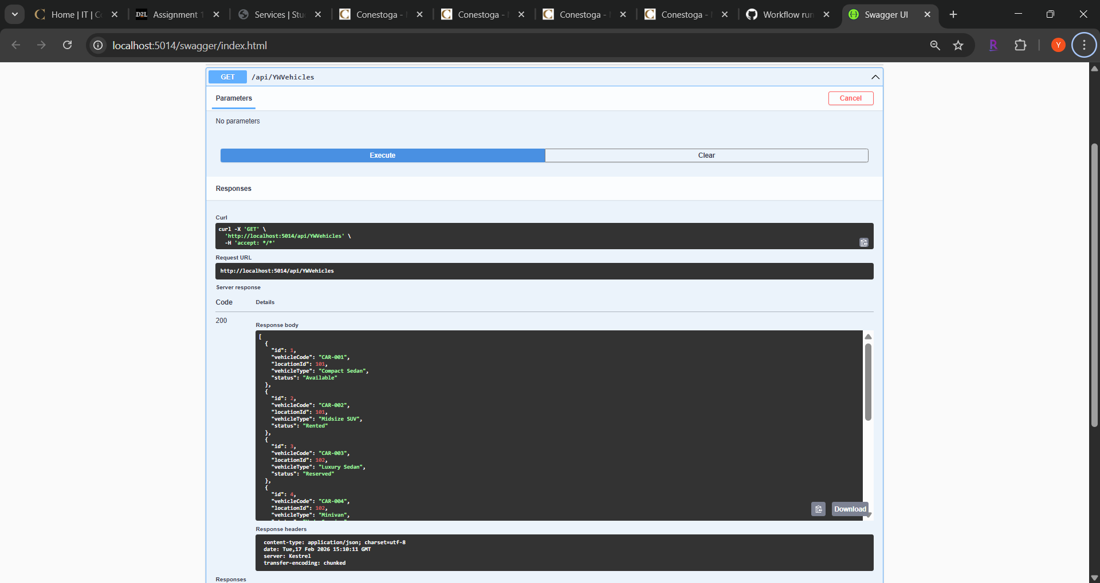

Add: vehicle:
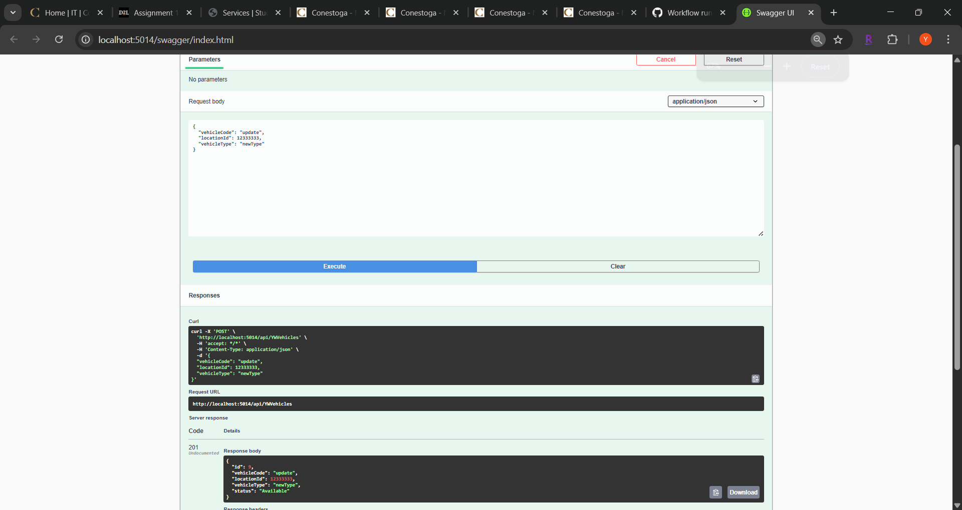

Get Vehicle by id:
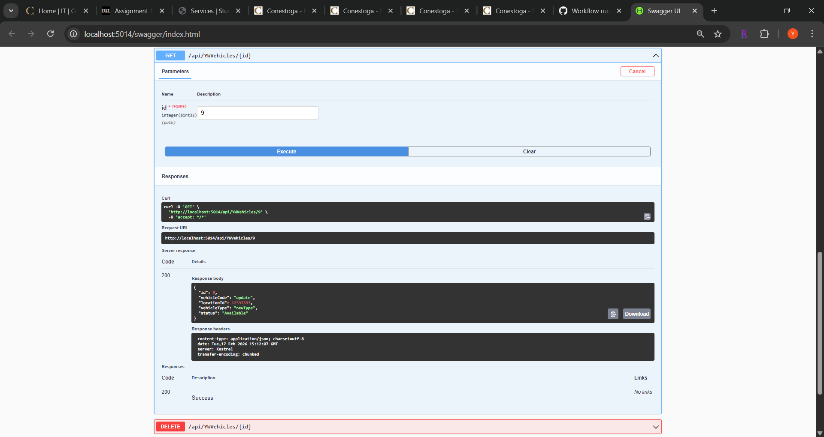

Update the Status by id:
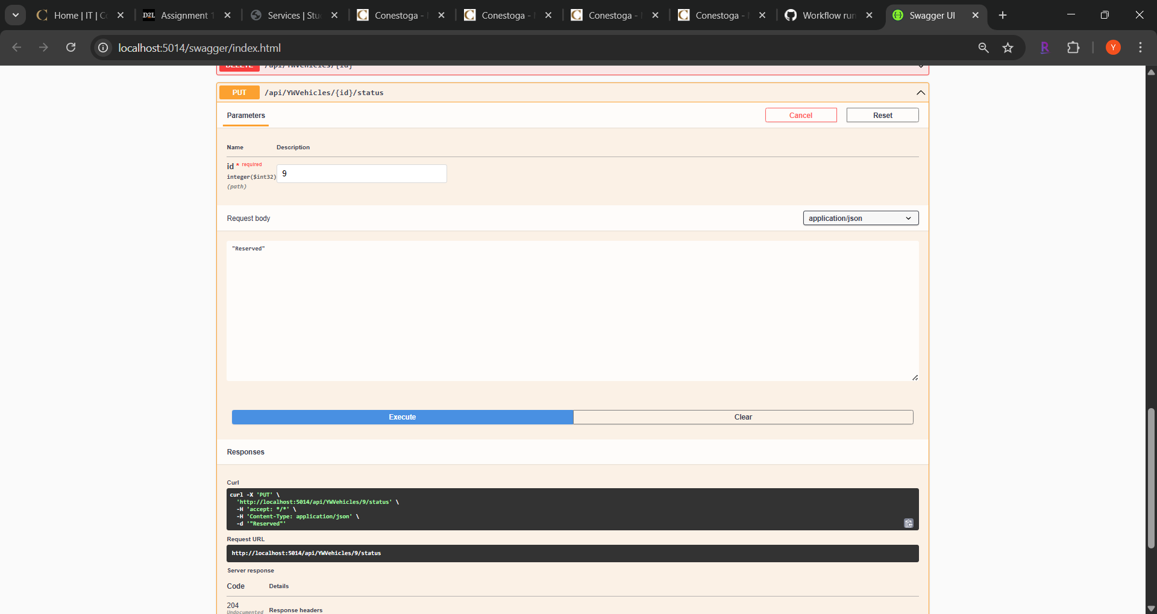

Delete vehicle:
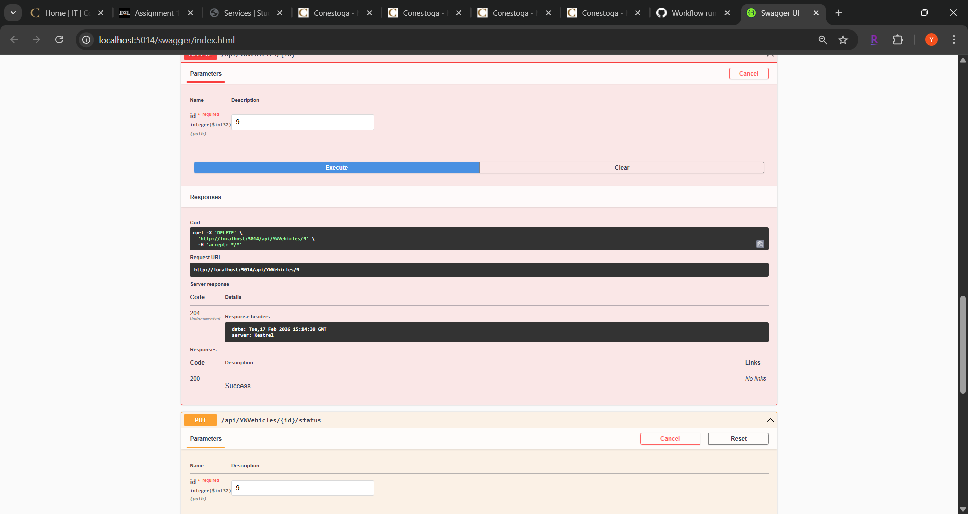

Database on SSMS:
Vehicles table:
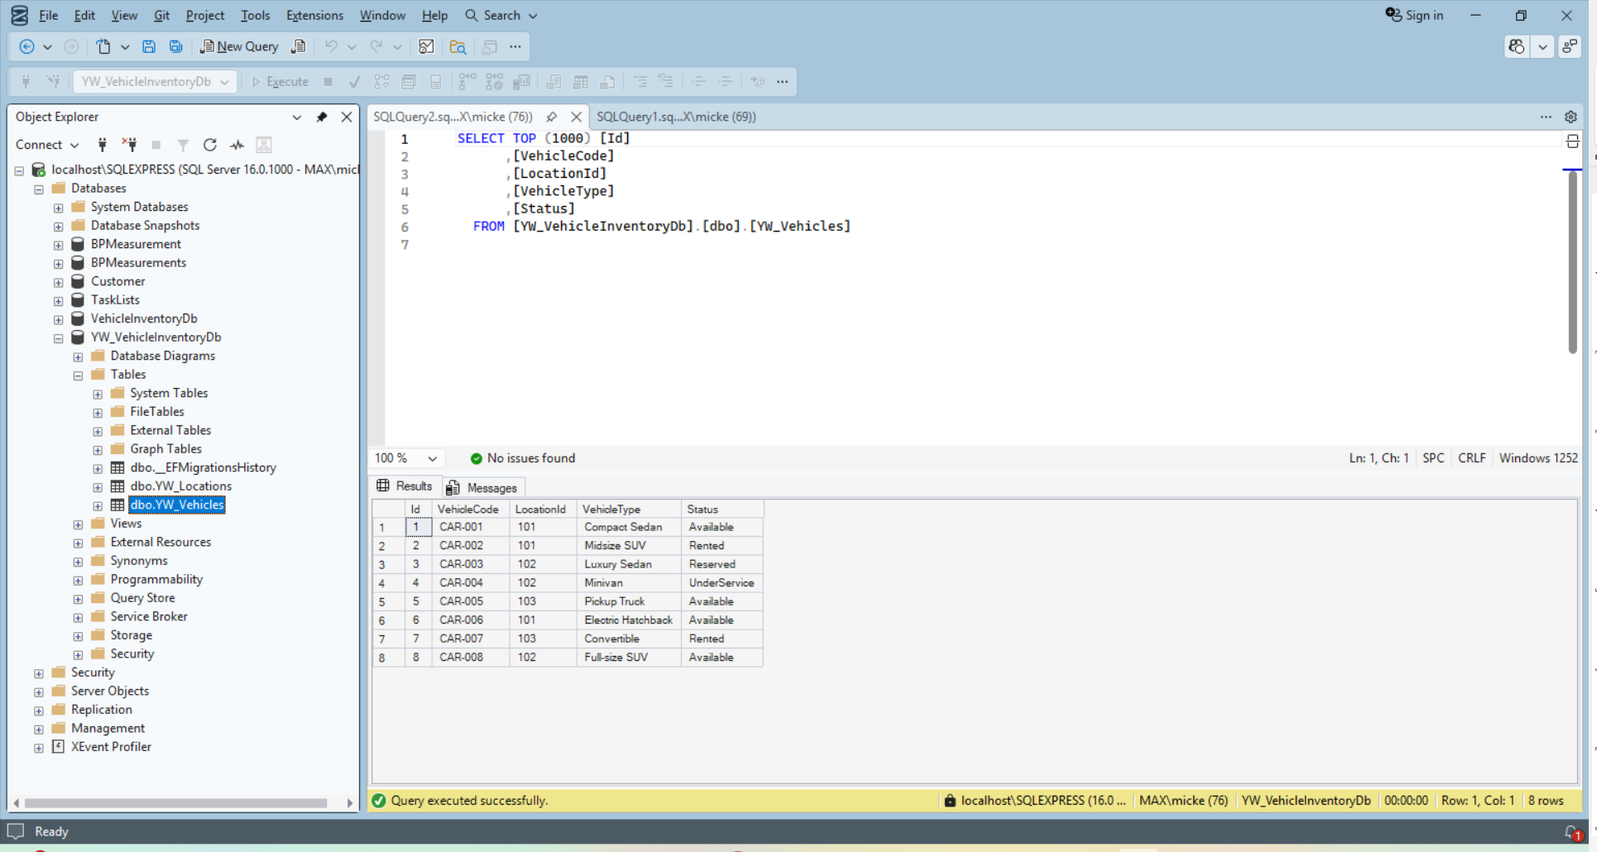

Location Table:
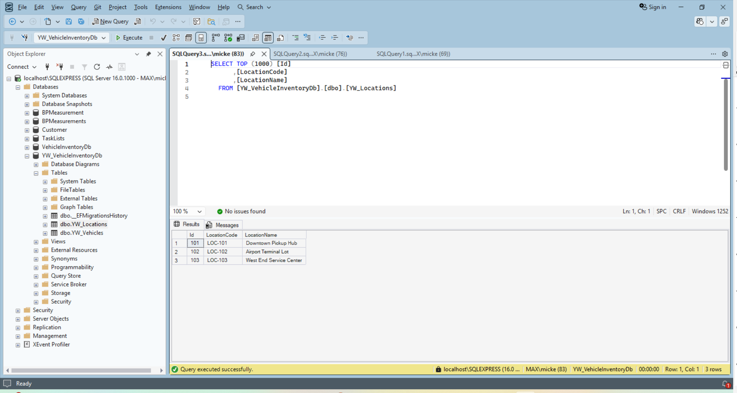

Part 1: Contract-First Planning
Why is a contract-first approach appropriate for the Vehicle Inventory Service?
A contract-first approach makes sense for the Vehicle Inventory Service because it acts as the main source of truth for the entire platform. Several teams—like Reservations, Maintenance, and Analytics—depend on the data it provides. By defining the contract first, all of these teams can start building and testing their features at the same time using mock data, instead of waiting for the backend to be fully implemented.
What risks are avoided by defining the contract before implementation?
Defining the contract before writing code helps avoid a lot of potential issues down the line. It reduces the risk of integration problems by making sure things like data formats, field names, and error responses are clearly agreed on from the start. It also helps prevent breaking changes later, since developers have to think about compatibility and versioning before making updates to the service.
What teams or systems might rely on this service contract?
Several teams and systems rely on this service contract. The Reservations team uses it to check whether vehicles are available, while the Maintenance team depends on it to track vehicles that need repairs or servicing. The Branch Management System also relies on it to manage inventory at different locations and handle vehicle transfers between branches.

Part 2: Data Contracts
1. InventoryQueryRequest
Used by clients to search for vehicles based on specific criteria.
Field Name | Data Type | Required | Constraints | Description
locationId | String | Yes | UUID format | The ID of the branch to search.
status | String | No | Available, Reserved, Rented | Filter by vehicle state.
category | String | No | Economy, Luxury, SUV | Filter by vehicle class.
minMileage | Integer | No | Min: 0 | Minimum odometer reading.

Example JSON:
{
"locationId": "loc-550e84",
"status": "Available",
"category": "SUV"
}

Versioning: Future enhancements (like fuelType or isElectric) will be added as optional fields to maintain backward compatibility.

2. VehicleInventoryResponse
Represents the detailed state of a vehicle in the system.
Field Name | Data Type | Always Present | Description
id | String | Yes | Internal system UUID (Primary Key).
vin | String | Yes | 17-char Vehicle Identification Number.
tagId | String | Yes | Physical identifier (License plate/sticker).
status | String | Yes | Current state (Available/Reserved/Rented).
lastUpdated | String | Yes | ISO 8601 timestamp.

Example JSON:
{
"id": "7721-afba",
"vin": "1G1RC6E41B",
"tagId": "ABC-1234",
"status": "Reserved",
"lastUpdated": "2026-02-06T10:00:00Z"
}
Error Rules:

404 Not Found: If the requested ID or Location does not exist.

400 Bad Request: If query parameters fail validation (e.g., invalid UUID).

Part 3: Service Contract
Operation 1: GetAllInventory
- Description: Retrieves a full list of all vehicles across all locations.
- Inputs: None (Optional pagination parameters).
- Outputs: 200 OK with an array of VehicleInventoryResponse.
- Pattern: Request-Response.
- Example: GET /v1/inventory -> [ {Vehicle1}, {Vehicle2} ].
Operation 2: GetInventoryById
- Description: Retrieves details for one specific vehicle using its unique system ID.
- Inputs: id (Path parameter, String, Required).
- Outputs: 200 OK with VehicleInventoryResponse; 404 Not Found.
- Pattern: Request-Response.
- Example: GET /v1/inventory/7721-afba.
Operation 3: GetInventoryByLocation
- Description: Filters vehicles based on their physical branch location.
- Inputs: InventoryQueryRequest (Query parameters).
- Outputs: 200 OK with a filtered array of VehicleInventoryResponse.
- Pattern: Request-Response.
- Example: GET /v1/inventory?locationId=loc-550e84
Operation 4: UpdateVehicleStatus
- Description: Updates the operational state of a vehicle (e.g., from Available to Rented).
- Inputs: id (Path), status (Body, String, Required).
- Outputs: 200 OK with updated VehicleInventoryResponse; 409 Conflict (if status transition is illegal).
- Pattern: Request-Response.
- Example: PATCH /v1/inventory/7721-afba with body {"status": "Rented"}.
Versioning Note: All operations are prefixed with /v1/. If breaking changes are needed, a new /v2/ set of endpoints will be deployed.

Part 4: Deployment Decision
Choice: Container-based Deployment (Docker/Kubernetes)
A container-based deployment strategy using Docker and Kubernetes is a good fit for the Vehicle Inventory Service because it can easily scale during peak booking periods. It also helps keep the environment consistent across development, testing, and production, which reduces deployment-related issues.
Although this approach requires a moderate level of operational knowledge, it provides strong flexibility. Individual containers can be scaled based on traffic needs, such as handling a high number of read requests when users are searching for available cars. This makes it more cost-effective than relying on cloud virtual machines that may sit underused during slower periods.

Part 5: Addressing Strategy
We will use an API Gateway with URL-based addressing. This provides a single entry point for clients and hides the complexity of the backend container instances.
- Base Address Structure: https://api.carrental.com/inventory/
- Example Endpoints:
  - https://api.carrental.com/inventory/v1/all
  - https://api.carrental.com/inventory/v1/search?locationId=123
- Stability: The API Gateway ensures that even if the backend container IP changes during a deployment, the URL remains the same for the client.

Part 6: Binding Selection
Choice: REST over HTTP
REST was chosen because it’s widely used and works well with most web-based systems. Since it’s an industry standard, it makes integration easier for both internal teams and third-party partners. JSON is used as the data format because it’s lightweight, easy to read, and supported by all major programming languages like Java, .NET, and Python.
Although gRPC can offer better performance, REST has better tooling and is simpler to work with overall. Tools like Postman and Swagger make testing and documentation easier, and the larger client ecosystem helps frontend and partner teams integrate with the Inventory Service more quickly.

Part 7: Final Summary
This design keeps the Vehicle Inventory Service loosely coupled, scalable, and easy for other systems to integrate with. By defining the data and service contracts upfront, we created a clear blueprint that allows teams to work independently without stepping on each other’s toes. This approach reduces integration issues and provides a stable, well-defined foundation for the overall car rental platform.

Repo: https://github.com/YijiaWW/CarRentalPlatform

