PBF - Consider both prediction error and delay
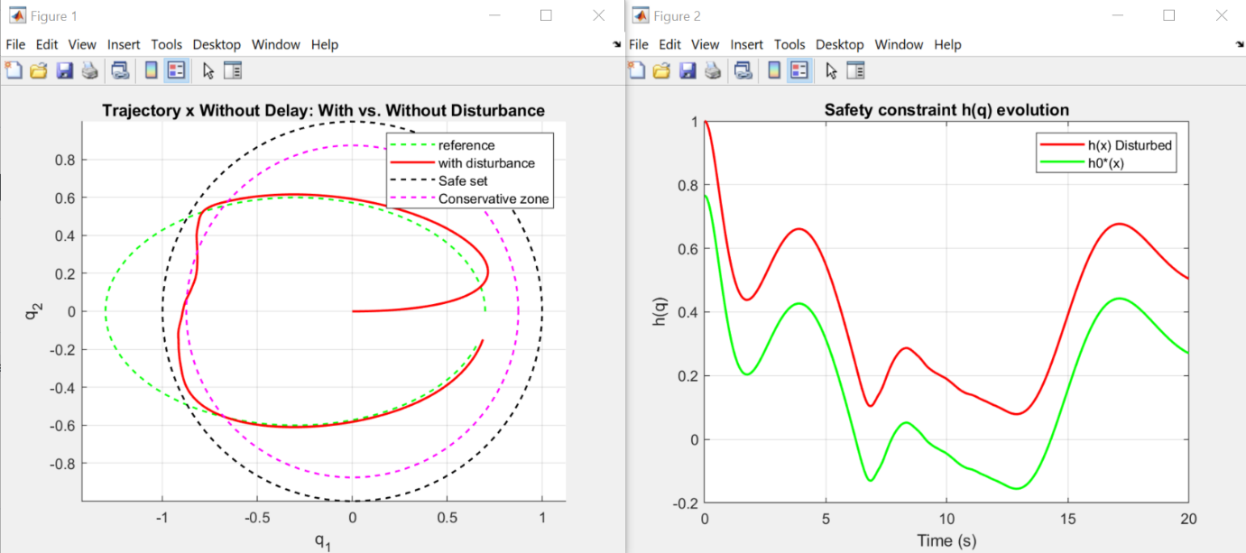
PBF - Consider only delay
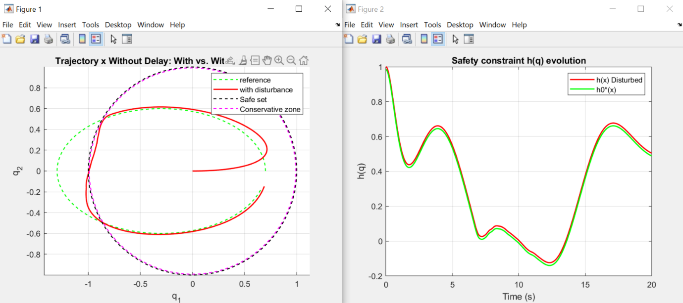
PBF - Consider only prediction error
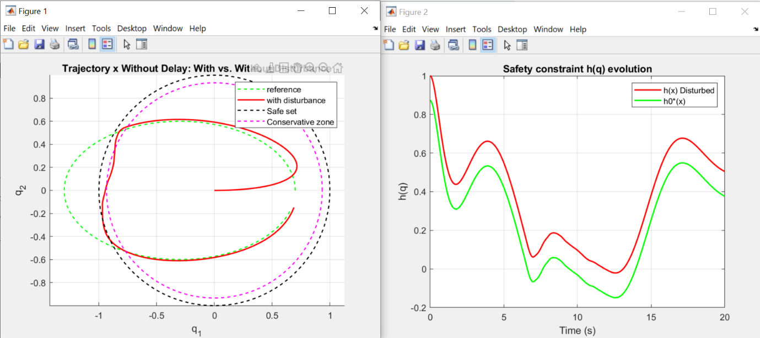
ISSf-HOCBF – Not consider either prediction error or delay
