**Visual Analytics**

**Week 6 Lectorial Exercises**

**Exercise 1**

For this exercise, you will be performing a **design critique** of 3 interactive visualizations, aided by some guiding questions. The examples we have selected demonstrate different techniques for handling complexity, to help you think about the strengths and weaknesses of different approaches.

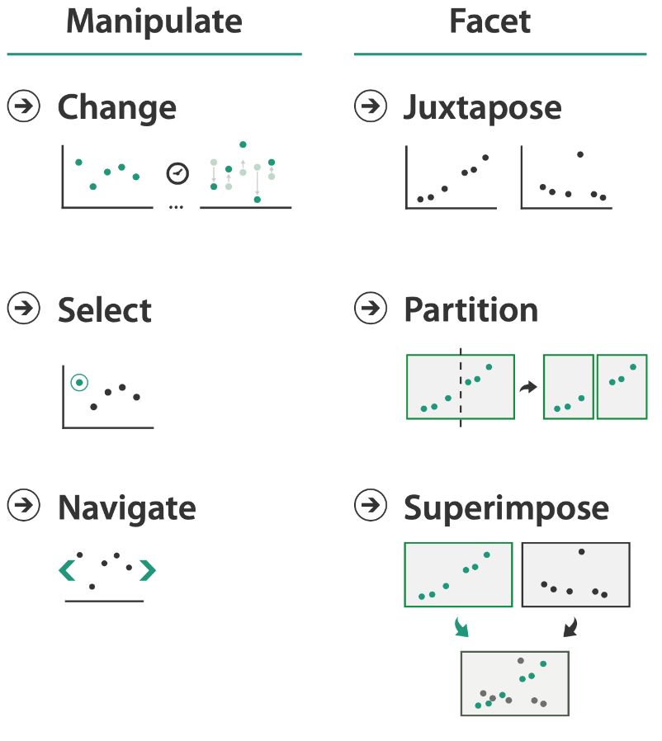 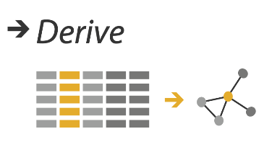

This figure from the Munzner book reminds you of three families of techniques for handling complexity: deriving new data, interactive manipulation, and faceting into multiple views. There are 7 approaches in total. For each visualization, consider: *Of these approaches, which is being used? Why?*

Familiarize yourselves with the first three visualizations, [Gapminder Interactive](https://www.gapminder.org/tools/#$chart-type=bubbles) (1A: click on link), Gapminder Single Static (1B), and Gapminder Multiples Static (1C). For the interactive version, just use the arrow in the lower left corner to play through the animation, and move the mouse around that the view (feel free to explore the many other options later on, if you're curious!).

Critique the visualizations with the following questions to guide discussion:

* **Which of the approaches to handling complexity (of the 7 shown in the intro above) are used in each version?**
* **What are the costs of these versions in terms of pixels required (information density) and user time to interact with them?**
* **What are the other strengths and weaknesses of these different versions? Your critique can include discussion of the approaches and which tasks they might be suitable for.**

Graphic B: Gapminder Single Static

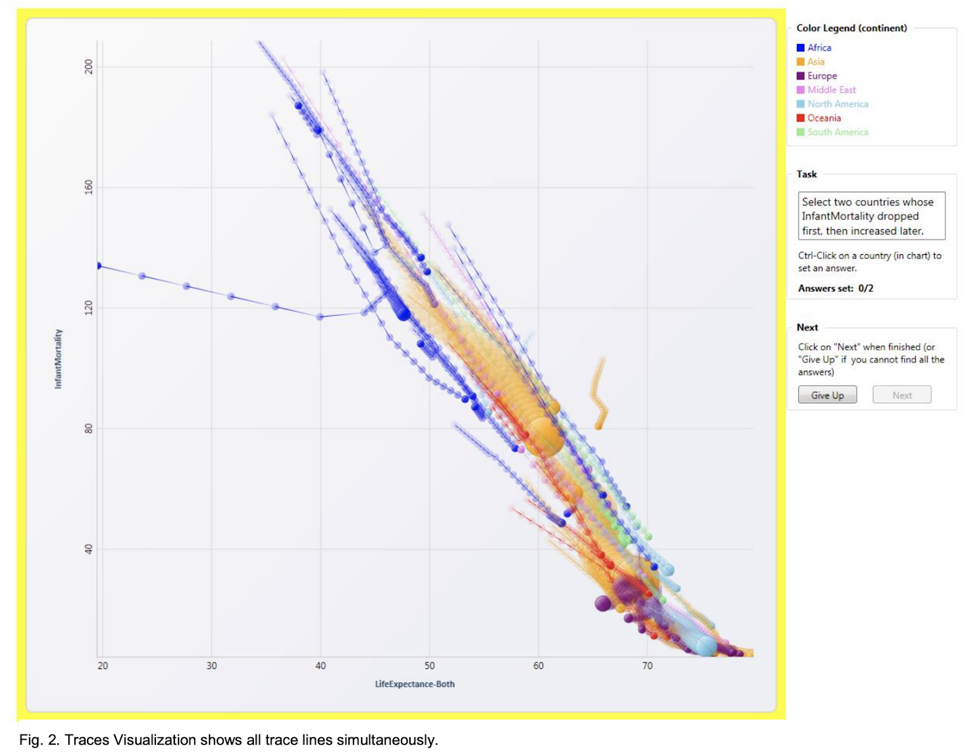

Graphic C Gapminder Multiples Static

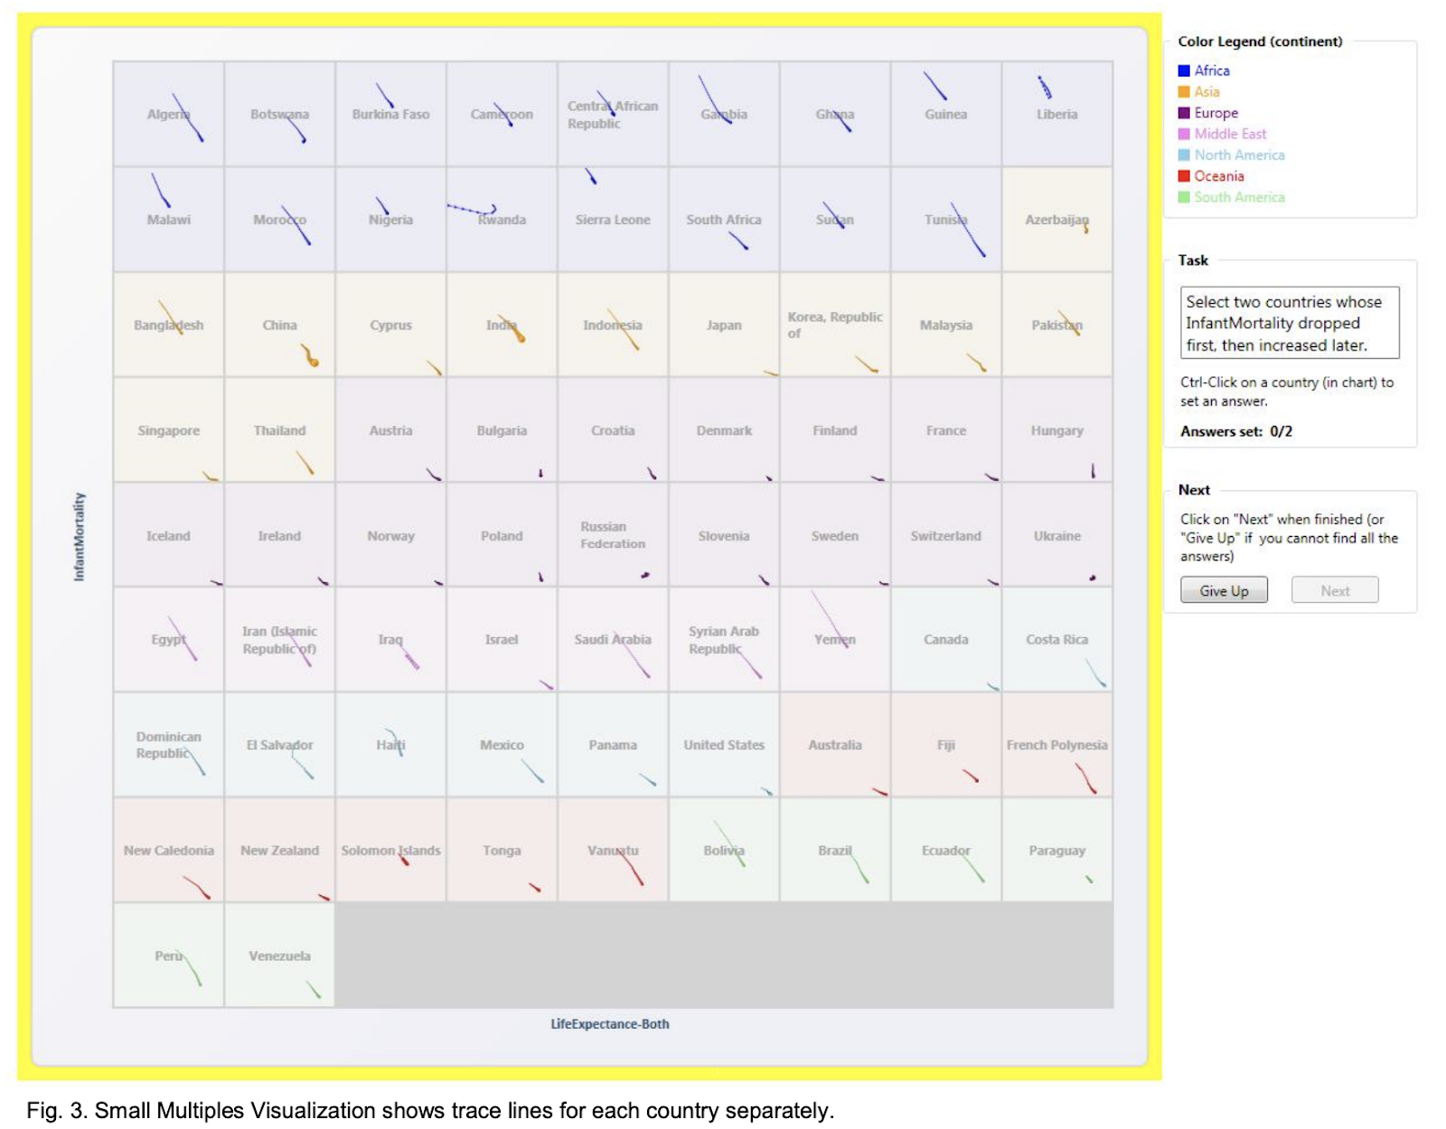

**Exercise 2**

Multiple views analysis. Download and run the Improvise toolkit (as described and demonstrated in the MultipleViews lectures). Write a short analysis of this interface in terms of the different types of view, the role of interaction, and linkage between views. How successful do you think it is at supporting key tasks?

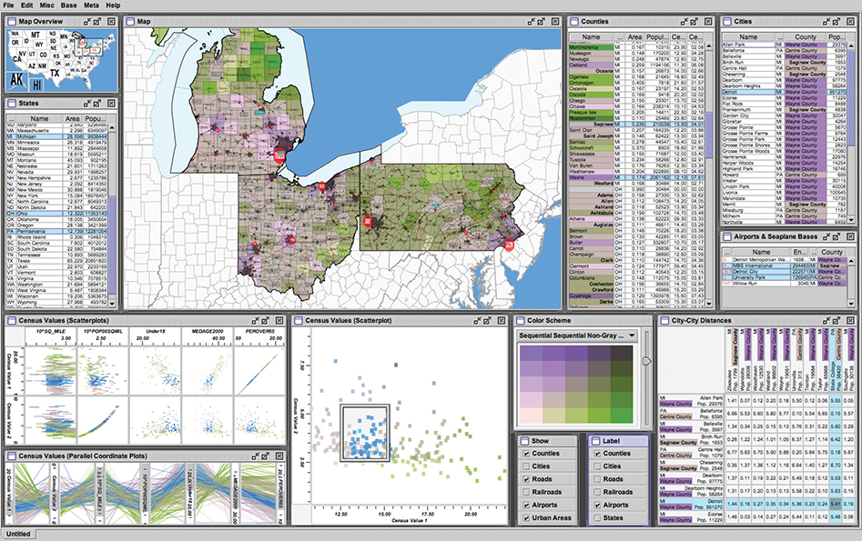

The Improvise toolkit was used to create this census vis that has many forms of coordination between views. It has many multiform views, some of which use small multiples, and some of which provide additional detail information. From <http://www.cs.ou.edu/~weaver/improvise/examples/census>.

Software (as a jar file) can be found at <https://www.cs.ou.edu/~weaver/improvise/downloads.html> You will also need a Java Runtime Environment (JRE) installed.

<https://stackoverflow.com/questions/354664/executing-a-jar-on-vista-with-a-double-click>

**Exercise 3**

Visualisation of genealogical data. You can download the paper from Blackboard and read it later if you wish. The system designers created a video <https://www.youtube.com/watch?v=-FkRzDegzAo> to demonstrate its usage (this is often a requirement for visualisation conferences). Please excuse the somewhat dated graphics!

Write down an analysis of the way that the interaction of the user controls and changes the display of information. Evaluate how effective you think it is.